**CSCI 4550 Homework 1**

The purpose of this homework is to make sure that you installed the FreeGLUT + OpenGL libraries in your computer properly for future programming assignments.

OpenGL is the actual graphics library including only core functionality. It does not provide functions for I/O systems such as window creation and keyboard/mouse interactions. For those operations, we need another helper library called FreeGLUT. This is the reason, I am asking you to install both. Some alternatives to FreeGLUT is GLFW, GLOW, and GLT. However, in this class, we will only be using FreeGLUT.

Please search internet for how to install these libraries on your machine and follow those steps. I do not have specific steps for installations, because there are different instructions for different operating systems and programming IDEs.

Once your computer is ready, download my sample code (squareEx.cpp) on blackboard and run it. This sample code is a basic FreeGLUT+OpenGL program generating an image of a “black square” object on the output window. You do not need to change the code. Just run it and take a screenshot of your output screen and submit it to the Blackboard. This way, I can see your computer is running the program. Here is the image you should see on your output screen.

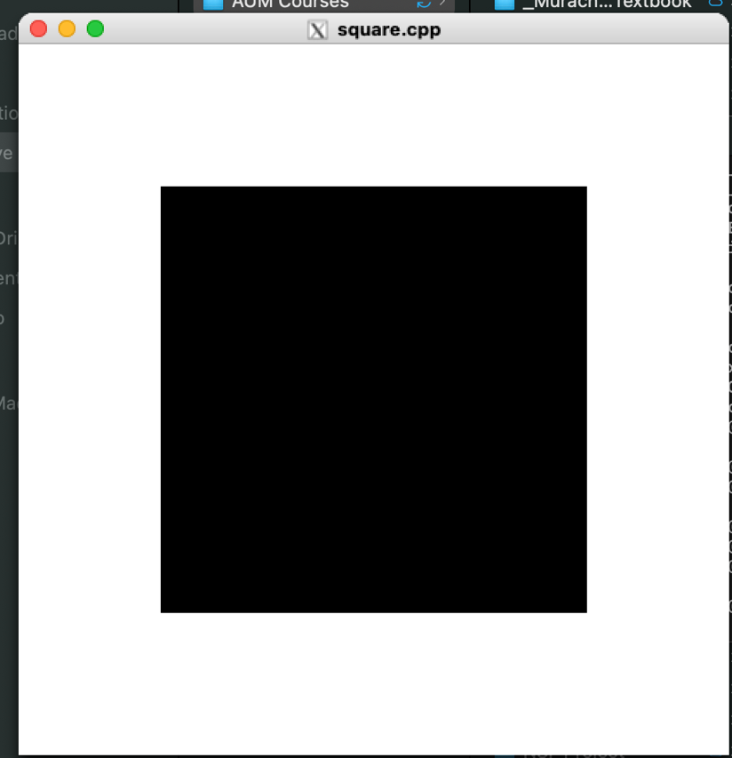

If you have any trouble installing FreeGLUT and OpenGL, you can talk to your friends who could install it. Feel also free to contact me for questions.