CSCI 4550 Homework 4

In this assignment, you will implement a simple driving game. First, you will design your truck (or a car) and a racing track, which is only a straight road. The road will have some obstacles that the driver (player) should avoid. Player earns points by successfully passing each obstacle, and he/she loses the game if truck hits one of them. Following figure shows a sample:

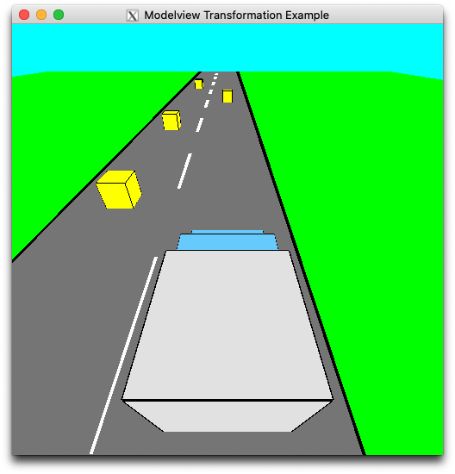

~~Truck moves forward without user intervention~~. But to avoid obstacles, ~~the player will be able to move the truck left or right using the arrow keys~~. ~~After successfully reaching to the end of the track, player wins the game~~. Here are some details:

1. ~~The race track will have 1000 units long~~. ~~Track width will be 16 units~~ (~~8 units left lane and 8 units right lane)~~. ~~And the truck width will be 4 units~~. ~~The length of the truck can change between 4 to 8 units~~. Please note that you can use an existing model from internet. I am expecting you to impress me with your truck design!
2. There will be 20 obstacles that are randomly located at different distances on the left or the right lane of the track. Obstacles will be colored cubes having size of 2 units.
3. The user should be able to see the current score at top left of the screen.
4. ~~Space key pauses the game.~~
5. Extra Features: I am open to any possible extra feature that makes the game more fun! Please do not limit your imagination! Some examples might be creating a curved road, or putting a map of the track on the right side of the screen.

Here is the link for textbook exercises (<http://www.sumantaguha.com/downloads>) in case you need. You will submit your source code in a single .cpp file to the blackboard. Please feel free to contact me if you have any questions.