Lab03_4

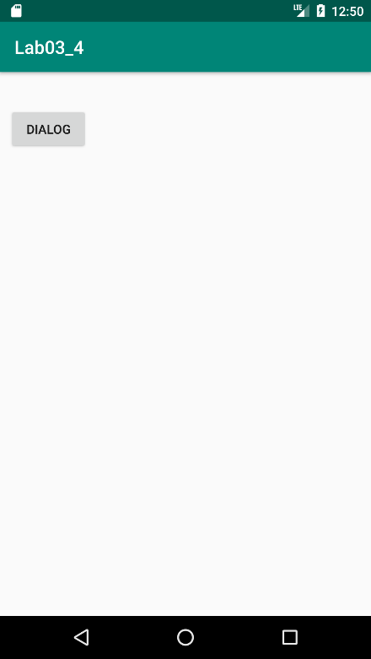 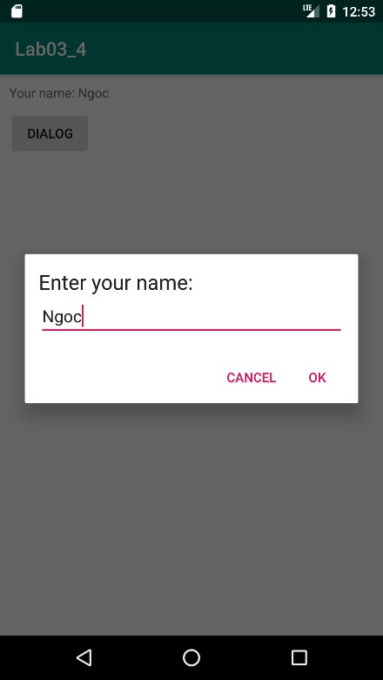 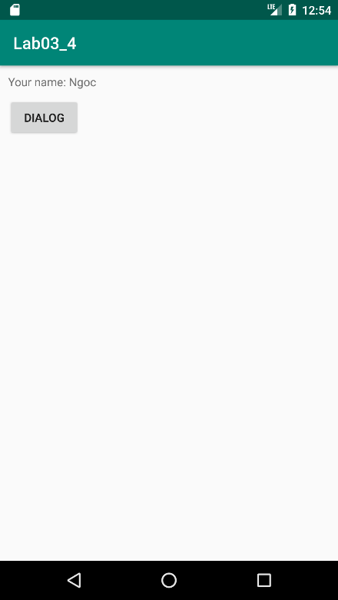

File MainActivity.java

package com.example.lab03_4;  
  
import androidx.appcompat.app.AlertDialog;  
import androidx.appcompat.app.AppCompatActivity;  
  
import android.content.DialogInterface;  
import android.os.Bundle;  
import android.view.LayoutInflater;  
import android.view.View;  
import android.widget.Button;  
import android.widget.EditText;  
import android.widget.TextView;  
  
public class MainActivity extends AppCompatActivity {  
 private Button btnDialog;  
 private TextView tvContent;  
  
 @Override  
 protected void onCreate(Bundle savedInstanceState) {  
 super.onCreate(savedInstanceState);  
 setContentView(R.layout.*activity_main*);  
  
 btnDialog = (Button) findViewById(R.id.*btn_dialog*);  
 tvContent = (TextView) findViewById(R.id.*tv_content*);  
  
 btnDialog.setOnClickListener(new View.OnClickListener(){  
 @Override  
 public void onClick(View v){  
 LayoutInflater li = LayoutInflater.*from*(MainActivity.this);  
 View customDialogView = li.inflate(R.layout.*custom_dialog*, null);  
  
 AlertDialog.Builder alertDialogBuilder = new AlertDialog.Builder(MainActivity.this);  
 alertDialogBuilder.setView(customDialogView);  
  
 final EditText etName = (EditText) customDialogView.findViewById(R.id.*et_name*);  
  
 alertDialogBuilder.setCancelable(false)  
 .setPositiveButton("OK",  
 new DialogInterface.OnClickListener() {  
 @Override  
 public void onClick(DialogInterface dialog, int which) {  
 tvContent.setText("Your name: " + etName.getText().toString());  
 }  
 })  
 .setNegativeButton("Cancel",  
 new DialogInterface.OnClickListener() {  
 @Override  
 public void onClick(DialogInterface dialog, int which) {  
 dialog.cancel();  
 }  
 });  
  
 AlertDialog alertDialog = alertDialogBuilder.create();  
 alertDialog.show();  
 }  
 });  
 }  
}

Lab03_5

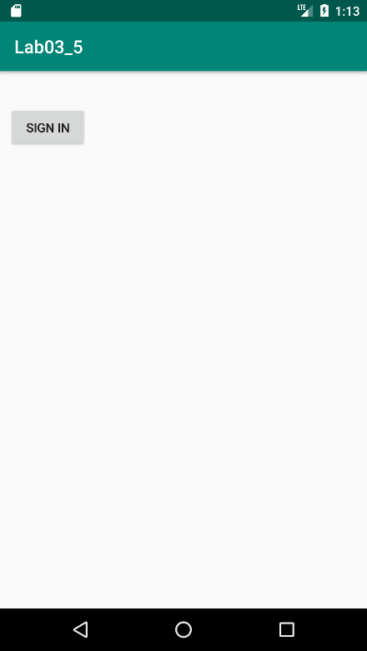 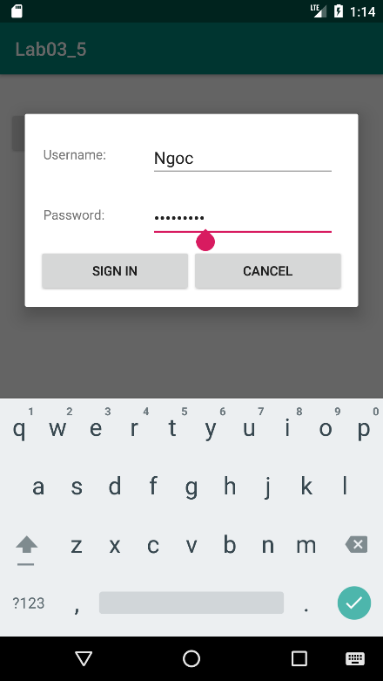 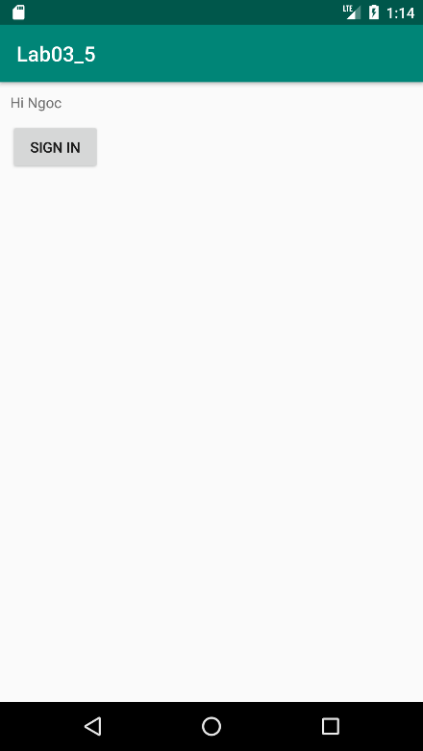

File strings.xml

<resources>  
 <string name="app_name">Lab03_5</string>  
 <string name="username">Username:</string>  
 <string name="password">Password: </string>  
 <string name="sign_in">Sign in</string>  
 <string name="cancel">Cancel</string>  
</resources>

File dimens.xml

<?xml version="1.0" encoding="utf-8"?>  
<resources>  
 <dimen name="activity_horizontal_margin">16dp</dimen>  
 <dimen name="activity_vertical_margin">16dp</dimen>  
 <dimen name="margin_base">5dp</dimen>  
 <dimen name="margin_basex2">10dp</dimen>  
 <dimen name="margin_basex3">15dp</dimen>  
</resources>

File custom_dialog.xml

<?xml version="1.0" encoding="utf-8"?>  
<LinearLayout xmlns:android="http://schemas.android.com/apk/res/android"  
 android:layout_width="match_parent"  
 android:layout_height="match_parent"  
 android:orientation="vertical"  
 android:padding="@dimen/margin_basex3">  
  
 <LinearLayout  
 android:layout_width="match_parent"  
 android:layout_height="wrap_content"  
 android:orientation="horizontal">  
  
 <TextView  
 android:layout_width="100dp"  
 android:layout_height="wrap_content"  
 android:layout_margin="@dimen/margin_base"  
 android:text="@string/username"/>  
  
 <EditText  
 android:id="@+id/et_username"  
 android:layout_width="match_parent"  
 android:layout_height="wrap_content"  
 android:layout_margin="@dimen/margin_basex2"  
 android:inputType="text" />  
  
 </LinearLayout>  
  
 <LinearLayout  
 android:layout_width="match_parent"  
 android:layout_height="wrap_content"  
 android:orientation="horizontal">  
  
 <TextView  
 android:layout_width="100dp"  
 android:layout_height="wrap_content"  
 android:layout_margin="@dimen/margin_base"  
 android:text="@string/password"/>  
  
 <EditText  
 android:layout_width="match_parent"  
 android:layout_height="wrap_content"  
 android:inputType="textPassword"  
 android:layout_margin="@dimen/margin_basex2"  
 android:password="true"  
 android:id="@+id/et_password"/>  
  
 </LinearLayout>  
  
 <LinearLayout  
 android:layout_width="match_parent"  
 android:layout_height="wrap_content"  
 android:orientation="horizontal">  
  
 <Button  
 android:layout_width="match_parent"  
 android:layout_height="wrap_content"  
 android:text="@string/sign_in"  
 android:layout_weight="1"  
 android:id="@+id/btn_signin"/>  
  
 <Button  
 android:layout_width="match_parent"  
 android:layout_height="wrap_content"  
 android:layout_weight="1"  
 android:text="@string/cancel"  
 android:id="@+id/btn_cancel"/>  
 </LinearLayout>  
  
</LinearLayout>

File activity_main.xml

<?xml version="1.0" encoding="utf-8"?>  
<LinearLayout xmlns:android="http://schemas.android.com/apk/res/android"  
 xmlns:tools="http://schemas.android.com/tools"  
 android:layout_width="match_parent"  
 android:layout_height="match_parent"  
 android:paddingBottom="@dimen/margin_basex2"  
 android:paddingLeft="@dimen/margin_basex2"  
 android:paddingRight="@dimen/margin_basex2"  
 android:paddingTop="@dimen/margin_basex2"  
 android:orientation="vertical"  
 tools:context=".MainActivity">  
  
 <TextView  
 android:layout_width="wrap_content"  
 android:layout_height="wrap_content"  
 android:id="@+id/tv_content"/>  
  
 <Button  
 android:layout_width="wrap_content"  
 android:layout_height="wrap_content"  
 android:id="@+id/btn_dialog"  
 android:layout_marginTop="@dimen/margin_basex2"  
 android:text="@string/sign_in"/>  
  
</LinearLayout>

File MainActivity.java

package com.example.lab03_5;  
  
import androidx.appcompat.app.AlertDialog;  
import androidx.appcompat.app.AppCompatActivity;  
  
import android.content.DialogInterface;  
import android.os.Bundle;  
import android.view.LayoutInflater;  
import android.view.View;  
import android.view.Window;  
import android.widget.Button;  
import android.widget.EditText;  
import android.widget.TextView;  
  
public class MainActivity extends AppCompatActivity {  
 private Button btnDialog;  
 private TextView tvContent;  
  
 private Button btnSignin;  
 private Button btnCancel;  
  
 @Override  
 protected void onCreate(Bundle savedInstanceState) {  
 super.onCreate(savedInstanceState);  
 setContentView(R.layout.*activity_main*);  
  
 btnDialog = (Button) findViewById(R.id.*btn_dialog*);  
 tvContent = (TextView) findViewById(R.id.*tv_content*);  
  
 btnDialog.setOnClickListener(new View.OnClickListener(){  
 @Override  
 public void onClick(View v){  
 LayoutInflater li = LayoutInflater.*from*(MainActivity.this);  
 View customDialogView = li.inflate(R.layout.*custom_dialog*, null);  
  
 final AlertDialog.Builder alertDialogBuilder = new AlertDialog.Builder(MainActivity.this);  
  
 btnSignin = (Button) customDialogView.findViewById(R.id.*btn_signin*);  
 btnCancel = (Button) customDialogView.findViewById(R.id.*btn_cancel*);  
  
 alertDialogBuilder.setView(customDialogView);  
  
 alertDialogBuilder.setCancelable(true);  
  
 final EditText etName = (EditText) customDialogView.findViewById(R.id.*et_username*);  
  
 final AlertDialog alertDialog = alertDialogBuilder.create();  
 alertDialog.getWindow().requestFeature(Window.*FEATURE_NO_TITLE*);  
 alertDialog.show();  
  
 btnSignin.setOnClickListener(new View.OnClickListener() {  
 @Override  
 public void onClick(View v) {  
 tvContent.setText("Hi " + etName.getText().toString());  
 alertDialog.dismiss();  
 }  
 });  
  
 btnCancel.setOnClickListener(new View.OnClickListener() {  
 @Override  
 public void onClick(View v) {  
 alertDialog.dismiss();  
 }  
 });  
 }  
 });  
 }  
}