DBMS Project

**R.S. Drycleaners**

Submitted To:

**Dr. Parteek Bhatia**

Submitted By:

Naman Ahuja(101203059)

Nishant Gupta(10203066)

Nitesh Singh(101203067)

Sarah Afrin(101213048)

**Department Of Computer Science and Engineering**

**ACKNOWLEDGEMENT**

It gives us a great sense of pleasure to present the report of DBMS Project undertaken during the 5th semester. We owe special debt of gratitude to our mentor Dr.Parteek Bhatia, Assistant Professor, Department of Computer Science & Engineering, Thapar University, Patiala for his constant support and work throughout the course of our work .His sincerity, thoroughness and perseverance have been a constant source of inspiration for us.We would like to acknowledge and thank our group members and seniors of our college for their sincere advice, constant guidance, supervision and continuous encouragement throughout the preparation of the project.At last, but not the least we would like to thank our college management for providing us the good environment to do this report.

**CONTENTS**

1. **ACKNOWLEDGEMENT**
2. **REQUIREMENT ANALYSIS**
3. **E-R DIAGRAM**
4. **CONVERSION OF E-RDIAGRAM TO TABLES**
5. **FUNCTIONAL DEPENDENCE DIAGRAMS**
6. **NORMALIZATION**
7. **TABLES AFTER NORMALIZATION**
8. **FUNCTIONAL DEPENDENCY DIAGRAM AFTER NORMALIZATION**
9. **PL-SQL CODE**
10. **CREATION OF TABLES**
11. **TRIGGERS**
12. **CURSORS ,FUNCTIONS AND PROCEDURES**

**REQUIREMENT ANALYSIS**

1. Introduction

In this project we Aim to Automate the Laundry Service in Thapar University. Currently it is a manually operated shop located in COS Complex whose customers are both students and faculty members.

2. Current system

A) Currently the laundry service is manual and there is no way of verifying the ownership of the clothes.

B) The Process of tagging clothes of a customer is not fool proof .It is prone to error and clashes.

C) The billing System is manual sometimes leading to mistakes in calculation.

3. Proposed system

3.1 Overview

We plan to automate this laundry system by :

A) Making a system for tagging of clothes

B) Method for Verifying Identity

C) Generating Bills

D) Online status of the job

3.2 Functional requirements

What the laundry requires:

1. Unique tagging of clothes from a single customer.
2. Easy entering of data.
3. To enter no of clothes along with the job to be done.
4. Automatic billing of all clothes.
5. Online updating whether the job is done or not.
6. Fool proof technique to return clothes to the right customer.
7. To include all the chores that can be done by the laundry shop.
   1. Nonfunctional requirements
8. Accessibility: this software will be available for all vendors.
9. Secure :Admin and user logins
10. Easy To use (made for people with little knowledge of Computers)
11. Training the staff to use the software
12. Software should ask only the most important details enabling least time spent per customer
13. Error handling to prevent incorrect information entering the system

The complete working of the system is explained for easy understanding.

**Home Page**

As soon as the admin opens the application an admin login page appears. It verifies the administrator using the system and his permissions. After logging in the home page appears. The title of this page is the name of the shop ‘RS Drycleaners’.

This page has four tabs which link to other pages. A brief description of these pages are(complete description explained later) :

1. Take in:

This is clicked when a customer gives an order. When this tab is clicked the user is asked for the roll no (for students), faculty id (for faculty) or any other unique id corresponding to the customer. This id is searched in the database. If a match is found then it’s a registered customer otherwise the customer is new. Then the admin is redirected to two different pages depending whether it is a new user or an already registered one. If the user is new his/her details are to be entered in the new page which further opens the next page where order is placed. If the customer is a student the details to be added include his name, roll no (both mandatory fields), room no and mobile number. Similar details are required for an entry of faculty member. A unique tag id is generated automatically as soon as a new customer is registered. This id is used for all transactions and also identification of clothes.

If the customer is already registered, the page where order is to be placed is opened directly. The number of clothes, items etc are added along with the chore associated to it. The expected date of return or delivery is eneterd. Then admin proceeds to the billing page. The total bill is calculated and a softcopy of bill is generated.

1. Delivery:

This tab is clicked when the shopkeeper returns the clothes to a customer and asks for unique id of the customer (eg. Roll no, Faculty id etc). It retrieves from the database the details of customer order and displays it in the form of bill. This bill includes the the tag code assigned to that customer. The shopkeeper searches the items corresponding to the code. If customer is a student direct cash payment at the shop is done and if it is a faculty member then bill is added to faculty account and items are delivered at residence.

1. Status Updates:

When the job is completed this status has to be updated in the database. When the admin clicks on this tab the list of all items grouped by customer appears whose delivery date is the current day. There are two options regarding this list: job done, delay. The entries whose job (like dry-cleaning) is done are selected and job doe button is clicked. If the job is not done and the date of delivery is to be postponed then delay is clicked. By default one day is increased. The option of search for entries is also available on this page.

1. Reports:

The admin can view daily and monthly reports of his shop. He can check his monthly or daily earnings.

Also he can check how many items are pending to be delivered on any day. By this the shopkeeper can check which items have been pending for a long time (delayed) and deliver them first. The date is selected in a drop down menu.

**Status Update**

When the job is completed this status has to be updated in the database. When the admin clicks on this tab the list of all items grouped by customer appears whose delivery date is the current day ,the admin can select other date as per his needs. There are two options regarding this list: job done, delay. The entries show are grouped by the unique id .The fields shown here are:

Roll No. Key No. of Clothes Bill Expected Date of Delivery

101203067 NSJ 12 328 19/11/2014

101203066 NGJ 4 28 20/11/2014

101203059 NAJ 1 38 18/11/2014

101213048 SAP 1 38 17/11/2014

The entries whose job (like dry-cleaning) is done are selected and job done button is clicked. If the job is not done and the date of delivery is to be postponed then delay is clicked. By default one day is increased. The option of search for entries is also available on this page. In search field ,the shopkeeper has a option to type Key or the unique id row corresponding to that entry is shown up and the above possible option are applied .

The Rows shown will be color coded

Red: Order Received

Yellow: Order Complete but not delivered

Green: Order Delivered

When the user will select REPORT tab from the home page , he will be taken to the report page which will have a simple and nice user interface . This page can be used by the shop owner to see what all clothes have to be delivered and what all clothes are pending for job.

This can be sorted according to the dates which will be a drop – down list .

Suppose user selects ‘Pending For Job’ and he selects today from date drop-down then all the jobs which are pending for today will be displayed along with yesterday’s job .

Roll No Key No. of clothes Bill Expected date of delivery

101203066 NGJ 13 324 19/11/2014

Now if he selects ‘Pending For Delivery’ and he selects today from date drop-down then all the jobs which are pending for delivery will be displayed along with tomorrow’s job .

Roll No Key No. of clothes Bill Expected date of delivery

101203063 NJK 11 456 21/03/2014

Color Coding will be followed in the whole application . Color Coding is as follows :

Green - Order Delivered

Yellow - Order Completed but not Delivered

Red - Order Received

On clicking the TAKE IN Button On The Home Page , a drop down text box opens in which the user enters his/her roll number or faculty id.

If the user is not registered then he will be taken to the New User Page where there will be various fields like

* Roll Number
* Name
* Hostel
* Phone Number
* Gender
* Room Number

Which he will have to fill. After submitting those details he will be taken to a new page same as below.

If the user is already registered then he will be taken to Already Registered Page. That Page Will be divided in three sections . On the rightmost section , there will be tabs of various services available to the user like

* Dry Cleaning
* Alteration
* Washing
* Ironing

Suppose the user clicks Washing , then a scrollable drop – down meu will appear in which there will be options of selecting

* Shirt
* Pants
* Jeans
* Shoes
* Others
* Jacket

Now when the user select an item ( say shirt) then on left section of the page entry corresponding to Washing machine -> Shirt -> Qty :1 will be inserted . However if the user selects shirt again in washing machine tab then the quantity will be increased by one i.e. Washing machine -> Shirt -> Qty :1 . will be updated to Washing machine -> Shirt -> Qty :2 . Similar is for the other items.

There is also available a remarks section in which any remarks regarding the condition of clothes or any other remark can be entered.

After that when the user clicks on the submit button a computerised bill will be generated .

That Particular bill can now be printed .

**Flow Diagram**

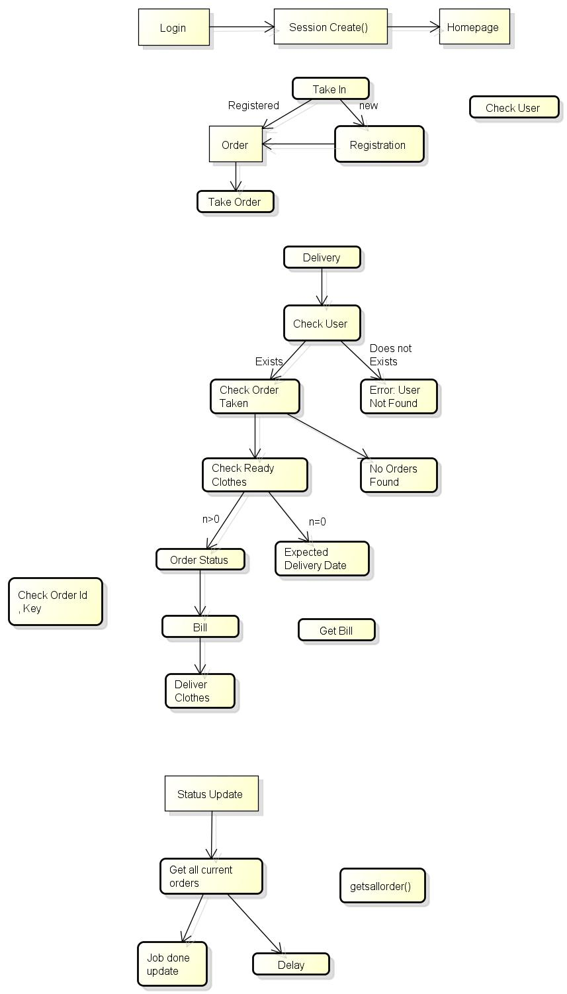

**E R Diagram**

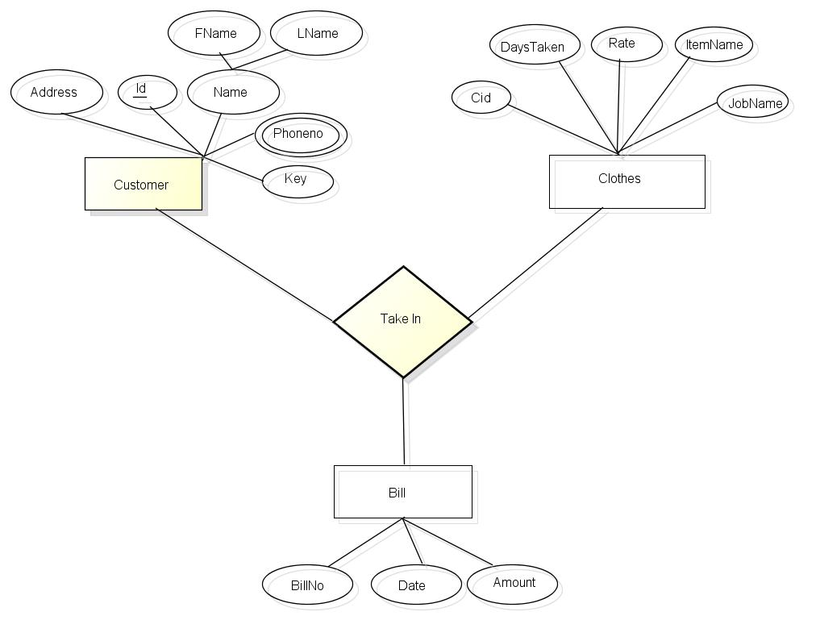

**ER To Tables**

**Customer**

|  |  |
| --- | --- |
| Id | Varchar2 |
| Firstname | Varchar2 |
| Lastname | Varchar2 |
| Key | Varchar2 |

Primary Key : Id

**Phoneno**

|  |  |
| --- | --- |
| Id | Varchar2 |
| Phoneno | Number(12) |

Primary Key : Id

**Clothes**

|  |  |
| --- | --- |
| Ak | Number(5) |
| Itemname | Varchar2 |
| Jobname | Varchar2 |
| Rate | Number(5) |
| Daystaken | Number(4) |

Primary Key: ak

**Takein**

|  |  |
| --- | --- |
| Key | Varchar2 |
| Ak | Number(5) |
| Quantity | Number(5) |
| Datein | Date |
| Status | Varchar2 |
| Remark | Varchar2 |

(key,ak): Primary Key

**Bill**

|  |  |
| --- | --- |
| Billno | Number(7) |
| Key | Varchar2 |
| Quantity | Number(5) |
| Edd | Date |
| Balance | Number(4) |
| Total | Number(4) |
| Status | Varchar2 |

Billno: Primary Key

**Report**

|  |  |
| --- | --- |
| Ak | Number(5) |
| Quantity | Number(5) |
| Months | Number(4) |

Ak: Primary Key

**Functional Dependence Diagrams**

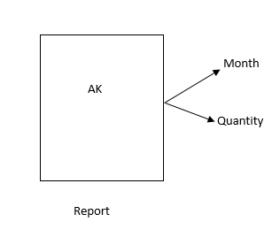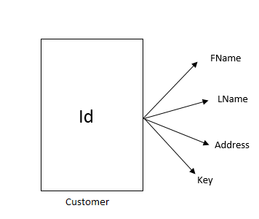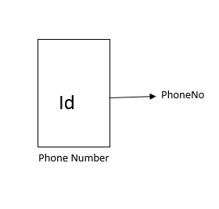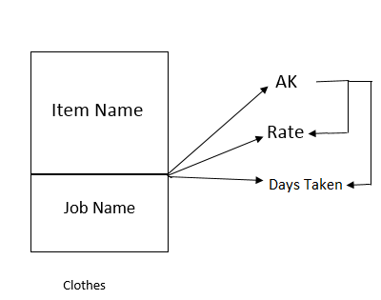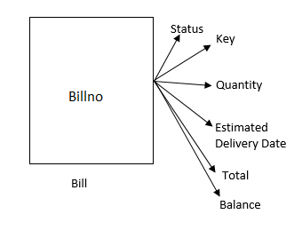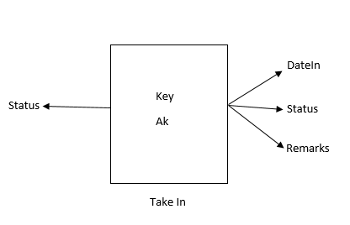

**Normalization**

**First Normal Form**

A relation is said to be in First Normal Form (1NF) if and only if every entry of the relation (the intersection of a tuple and a column) has at most a single value. In other words “a relation is in First Normal Form if and only if all underlying domains contain atomic values or single value only.”

**Second Normal Form**

A relation R is in second normal form (2NF) if and only if it is in 1NF and every non-key attribute is fully functional dependent on the primary key.

**Third Normal Form**

A relation R is in Third Normal Form (3NF) if and only if the following conditions are satisfied simultaneously:

(1) R is already in 2NF

(2) No nonprime attribute is transitively dependent on the key.

**BCNF**

A relation R is in Boyce/Codd N/F (BCNF) if and only if every determinant is a candidate key. Here determinant is a simple attribute or composite attribute on which some other attribute is fully functionally dependent.

**Fourth Normal Form**

A relation R is in Fourth Normal Form (4NF) if and only if the following conditions are satisfied simultaneously:

(1) R is already in 3NF or BCNF.

(2) If it contains no multi-valued dependencies

**Fifth Normal Form**

A relation R is in Fifth Normal Form (5NF) if and only if the following conditions are satisfied simultaneously:

(1) R is already in 4NF.

(2) It cannot be further non-loss decomposed.

1. **Customer Table**

* The table is in 1st Normal Form.
* The Table is in 2nd Normal Form.
* The Table is in 3rd Normal Form.
* The Table is in Boyce/Codd Normal Form.
* The Table is in 4th Normal Form.
* The Table is in 5th Normal Form.

1. **Phoneno Table**

* The table is in 1st Normal Form.
* The Table is in 2nd Normal Form.
* The Table is in 3rd Normal Form.
* The Table is in Boyce/Codd Normal Form.
* The Table is in 4th Normal Form.
* The Table is in 5th Normal Form.

1. **Clothes Table**

* The table is in 1st Normal Form.
* The Table is in 2nd Normal Form.
* The table is **not** 3rd Normal Form. So we break the tables in three tables as shown on next page.
* The Table is in 4th Normal Form.
* The Table is in 5th Normal Form.

1. **Takein**

* The table is in 1st Normal Form.
* The Table is in 2nd Normal Form.
* The table is in3rd Normal Form.
* The Table is in 4th Normal Form.
* The Table is in 5th Normal Form.

1. **Bill**

* The table is in 1st Normal Form.
* The Table is in 2nd Normal Form.
* The table is in3rd Normal Form.
* The Table is in 4th Normal Form.
* The Table is in 5th Normal Form.

1. **Report**

* The table is in 1st Normal Form.
* The Table is in 2nd Normal Form.
* The table is in3rd Normal Form.
* The Table is in 4th Normal Form.
* The Table is in 5th Normal Form.

**Updated Table and FD After Normalization**

|  |  |
| --- | --- |
| Ak | Number(5) |
| Item name | Varchar2 |
| Job name | Varchar2 |

|  |  |
| --- | --- |
| Ak | Number(5) |
| Rate | Number(5) |

|  |  |
| --- | --- |
| Ak | Number(5) |
| Daystaken | Number(4) |

Rate

Ak

Itemname

Ak

Jobname

Daystken

Ak

**Creation of Tables**

Create table customer_ns(

id varchar(10) primary key,

firstname varchar(20),

lastname varchar(20),

address varchar(40),

key varchar(10) not null

);

Create table phoneno(

id varchar2(10) references customer_ns(id),

phoneno number(12),primary key(id,phoneno));

Create table clothes_ns(

itemname varchar(10) not null ,

jobname varchar(15),

rate number(3),

ak number(6) primary key,

daystaken number(2)

);

Create table takein(

key varchar(10),

ak number(6),

quantity number(2),

datein date,

remark varchar(40),

status varchar(10) check (status in (‘taken’,jobdone’,’delivered’)),

primary key(key,ak)

);

Create table bill(

key number(6),

edd date,

billno number(7) primary key,

total number(4),

quantity number(2),

status varchar(10) check (status in (‘taken’, ‘pending’,’delivered’)

);

Create table report(

months varchar(3),

quantity number(2),

ak number(6) references clothes_ns(ak)

);

create sequence c_seq

increment by 1

start with 1

nocycle;

create sequence b_seq

increment by 1

start with 200

nocycle;

INSERT

Insert into table clothes_ns values(‘Shirt/Tshirt’,’Wash’,10,c_seq.nextval,2);

Insert into table clothes_ns values(‘Trouser’,’Wash’,10, c_seq.nextval,2);

Insert into table clothes_ns values(‘Jeans’,’Wash’,15, c_seq.nextval,2);

Insert into table clothes_ns values(‘Towel’,’Wash’,10, c_seq.nextval,2);

Insert into table clothes_ns values(‘Shoes’,’Wash’,80, c_seq.nextval,2);

Insert into table clothes_ns values(‘Jacket/Sweater’,’Wash’,30, c_seq.nextval,2);

Insert into table clothes_ns values(‘Bedsheet’,’wash’,30, c_seq.nextval,2);

Insert into table customer_ns(id,firstname,lastname,address) values(‘101213048’,‘sarah’,’afrin’,’pg hostel’);

Insert into table customer_ns(id,firstname,lastname,address) values(‘101203067’,‘nitesh’,’singh’,’j hostel’);

Insert into table customer_ns(id,firstname,lastname,address) values(‘101203060’,‘naman’,’ahuja’,’j hostel’);

Insert into table customer_ns(id,firstname,lastname,address) values(‘101203066’,‘nishant’,’gupta’,’j hostel’);

Insert into table customer_ns(id,firstname,lastname,address) values(‘101’,‘varun’,’sharma’,’teacher quarters’);

Insert into phoneno values(‘101213048’,9876702523);

Insert into phoneno values(‘101213048’,9875348222);

Insert into phoneno values(‘101203067’,8288838038);

Insert into phoneno values(‘101203066’,9876754432);

Insert into takein values(‘nsj’,2,3,to_date(‘dd/mm/year’,’4/12/2014’),null,’taken’);

Insert into takein values(‘naj’,4,1,to_date(‘dd/mm/year’,’4/12/2014’),null,’jobdone’);

Insert into takein values(‘vsp’,5,1, to_date(‘dd/mm/year,’4/12/2014’),null,’delivered’);

**Procedure**

Procedure to display information of user by id

Create or replace procedure find_userinfo_id(id1 in varchar)

is

user1 customer_ns%rowtype;

Begin

select * into user1 from customer_ns where id=id1;

dbms_output.put_line(user1.id ||" "||user.firstname||" " ||user1.lastname||" "||user.address||" " ||user1.key);

check_order_id(id1);

Exception

When TOO_MANY_ROWS then

dbms_output.put_line("Invalid");

When NO_DATA_FOUND then

dbms_output.put_line(id1||" is a Invalid Id");

When others then

dbms_output.put_line("Try again later");

end;

Procedure to display information of user by key

Create or replace procedure find_userinfo_key(key1 in varchar)

is

user1 customer_ns%rowtype;

Begin

select * into user1 from customer_ns where key=key1;

dbms_output.put_line(user1.id||" " ||user1.firstname||" "||user1.lastname||" " ||user1.address||" " ||user1.key);

check_order_key(key1);

Exception

When TOO_MANY_ROWS then

dbms_output.put_line("Invalid");

When NO_DATA_FOUND then

dbms_output.put_line(key1||" is a Invalid key");

When others then

dbms_output.put_line("Try again later");

end;

Procedure to display all the orders

create or replace procedure getallorders() is

cursor c1 is select * from takein where status<>'delivered' order by key,datein desc;

BEGIN

for r in c1 loop

EXIT when c1%nodatafound;

dbms_output.put_line(r.key||" "||r.ak||" "||r.quantity||" "||r.datein||" "||r.status||" "||r.remark);

end loop;

EXCEPTION

WHEN NO_DATA_FOUND then

dbms_output.put_line('There are no orders');

END;

create or replace procedure getreport_mnth(m1 in number(3)) is

cursor c1 is select * from report where months=m1 ;

j clothes_ns%rowtype;

BEGIN

for r in c1 loop

EXIT when c1%NODATAFOUND;

select * into j from clothes_ns where ak=r.ak;

dbms_output.put_line(r.ak||" "||r.quantity||" "||m1||" "||j.rate*quantity||" "j.itemname||" "||j.jobname);

end loop;

EXCEPTION

WHEN NO_DATA_FOUND then

dbms_output.put_line('There are no reports!!');

END;

**Functions**

Q. Function to check whether user is registered

Create or replace function check_user(id1 in varchar) return number

is

a customer_ns%rowtype;

Begin

Select * into a from customer_ns where id=id1;

dbms_output.put_line('User already exists!!');

Return(1);

Exception

When NO_DATA_FOUND then

dbms_output.put_line('User does not exists!!');

Return(0);

When others then

dbms_output.put_line('Try again later');

Return(0);

End;

Q. Function to get user registered

Create or replace function create_user(id1 in varchar , firstname in varchar ,lastname in varchar , phoneno in number ,address in varchar ) return number is

--Localkey varchar(5);

Begin

---- Trigger for key

Insert into customer_ns(id,firstname,lastname,address) values(id1,firstname,lastname,address);

Insert into phoneno(id,phoneno) values(id1,phoneno);

dbms_output.put_line('Succesfully inserted!!');

Return(1);

Exception

When others then

dbms_output.put_line('Try again later');

Return(0);

End;

Q. Function to take order from customer_ns

CREATE OR REPLACE TYPE Items AS VARRAY(200) OF VARCHAR(50);

CREATE OR REPLACE TYPE quantities AS VARRAY(200) OF Number(5);

CREATE OR REPLACE TYPE jobs AS VARRAY(200) OF VARCHAR(50);

CREATE OR REPLACE TYPE rates AS VARRAY(200) OF Number(5);

CREATE OR REPLACE TYPE remarks AS VARRAY(200) OF VARCHAR(50);

Create or replace function take_order(id in varchar2,item in items,quantity in quantities,job in jobs,remark in remarks) return number is

localkey varchar(5);

ak number(5);

total number(4):=0;

edd date;

date1 date;

quantity1 number(5):=0;

rate number(5);

begin

Select daystaken into edd from clothes_ns where job=job(1);

For i in 1..id.count loop

Select key into localkey from customer_ns where id=id(i);

Select ak into ak from clothes_ns where jobname=job(i) and itemname=item(i);

Insert into takein(key,ak,quantity,remark,status) values(localkey,ak,quantity(i),remark(i),'taken');

quantity1:=quantity1+quantity(i);

Select rate into rate from clothes_ns where ak=ak;

total:=total+rate*quantity(i);

Select daystaken into date1 from clothes_ns where jobname=job(i);

if date1>=edd then

edd:=date1;

end if;

end loop;

Insert into bill(key,quantity,edd,total,status) values(localkey, quantity1,edd,total,'taken');

dbms_output.put_line('Order Succesfully taken');

Return(1);

Exception

When NO_DATA_FOUND then

dbms_output.put_line('No data found ');

return(0);

When TOO_MANY_ROWS then

dbms_output.put_line('Try again later');

return(0);

When OTHERS then

dbms_output.put_line('try again later');

return(0);

End;

Q. Function to update status of clothes_ns of customer_nss

CREATE OR REPLACE TYPE aka AS VARRAY(200) OF number(5);

CREATE OR REPLACE TYPE key AS VARRAY(200) OF varchar(50);

CREATE OR REPLACE TYPE checka AS VARRAY(200) OF number(50);

Create or replace user function updatestatus(keyq in key , check1 in checka, ak in aka,quantity in quantities) return number is

--Localkey varchar(5);

Begin

for i in 1..id.count loop

if check1(i)=1 then

update takein set status='jobdone' where key=keyq(i) and ak=ak(i);

else

null;

end if;

end loop;

dbms_output.put_line('Status updated!!');

return(1);

Exception

When NO_DATA_FOUND then

dbms_output.put_line('No data found ');

When TOO_MANY_ROWS then

dbms_output.put_line('Try again later');

When others then

dbms_output.put_line('Try again late');

Return(0);

End;

Q. Function to check whether a user has given clothes_ns by id

Create or replace function check_order_id(id1 in varchar) return number

is

keyy varchar(10);

Begin

keyy:=find_key(id1);

Select * from takenin where key=keyy and status<>'delivered';

dbms_output.put_line(id1||"Has Given clothes_ns");

Return(1);

Exception

When TOO_MANY_ROWS then

dbms_output.put_line(id1||"Has Given clothes_ns");

Return(1);

When NO_DATA_FOUND then

dbms_output.put_line(id1||"Has not Given clothes_ns");

Return(0);c

When others then

dbms_output.put_line('Try again later');

end;

Q. Function to check whether a user has given clothes_ns by key

Create or replace function check_order_key(key1 in varchar) return number

is

idd varchar(10);

Begin

idd:=find_id(key1);

Select * from takenin where key=key1 and status<>'delivered';

dbms_output.put_line(key1||"Has Given clothes_ns"||" The customer_ns Id is "||idd);

Return(1);

Exception

When TOO_MANY_ROWS then

dbms_output.put_line(key1||"Has Given clothes_ns");

Return(1);

When NO_DATA_FOUND then

dbms_output.put_line(idd||"Has not Given clothes_ns");

Return(0);

When others then

dbms_output.put_line("Try again later");

end;

Q.Function to find id from key

Create or replace function find_id(key1 in varchar) return varchar

is

id1 customer_ns.id%type;

Begin

select id into id1 from customer_ns where key=key1;

dbms_output.put_line(key1||" Has id"||id1);

Return id1;

Exception

When TOO_MANY_ROWS then

dbms_output.put_line("Invalid");

Return null;

When NO_DATA_FOUND then

dbms_output.put_line(key1||" is a Invalid Key");

Return null;

When others then

dbms_output.put_line("Try again later");

return null;

end;

Q.Function to find key from id

Create or replace function find_key(id in varchar) return varchar

is

key1 customer_ns.key%type;

Begin

select key into key1 from customer_ns where id=id;

dbms_output.put_line(id||" Has key"||key1);

Return key1;

Exception

When TOO_MANY_ROWS then

dbms_output.put_line("Invalid");

Return null;

When NO_DATA_FOUND then

dbms_output.put_line(id||" is a Invalid id");

Return null;

When others then

dbms_output.put_line("Try again later");

return null;

end;

Q. Function to get all the bills by id

create or replace function getbills(idd in varchar) return number is

bill_t bill%rowtype;

Begin

Select * into bill_t from bill where id=idd ;

if(check_order_id(idd)=1) then

{

checkstatus_id(id);

dbms_output.put_line(bill_t.key||" "||bill_t.quantity||" "||bill_t.edd||" " ||bill_t.total||" "||bill_t.balance||" "||bill_t.status);

return (1);

}

else

dbms_output.put_line("");

endif;

Exception

When NO_DATA_FOUND then

Return (0);

When others then

dbms_output.put_line("Try again later");

Return (0);

End;

**Cursors**

Q. Cursor to check status of clothes_ns pending by passing id

create or replace function checkstatus_id(id in varchar) return number is

Cursor checkstatusid(keyy varchar) IS Select * from takein where key=keyy ;

jobname takein.jobname%type;

itemname takein.jobname%type;

Begin

if(check_order_id(id)=1)

{

foreach order1 in checkstatusid( find_key(id)) loop

--if (order.status='jobdone') then

select itemname,jobname into itemname,jobname from clothes_ns where ak=order1.ak;

dbms_output.put_line(itemname||" "||jobname||" "||order1.status||" "||order1.datein);

--endif;

end loop;

Return (1);

}

else

dbms_output.put_line("No clothes_ns pending");

end if;

Exception

When NO_DATA_FOUND then

Return (0);

When others then

dbms_output.put_line("Try again later");

Return (0);

End;

Q. Cursor to check status of clothes_ns pending by passing key

create or replace function checkstatus_key(key1 in varchar) return number is

Cursor checkstatuskey(keyy varchar) IS Select * from takein where key=keyy ;

jobname takenin.jobname%type;

itemname takenin.jobname%type;

Begin

if(check_order_key(key1)=1)

{

foreach order1 in checkstatuskey loop

-- if (order.status='jobdone') then

select itemname,jobname into itemname,jobname from clothes_ns where ak=order.ak;

dbms_output.put_line(itemname||" "||jobname||" "||order1.status||" "||order1.datein);

--endif;

end loop;

Return (1);

}

else

dbms_output.put_line("No clothes_ns pending");

endif;

Exception

When NO_DATA_FOUND then

Return (0);

When others then

dbms_output.put_line("Try again later");

Return (0);

End;

Q. Cursor to deliver clothes_ns and update status of clothes_ns which are delivered

create or replace function deliver(id in varchar) return number is

Cursor delivering(key1 varchar) is Select * from takein where key=key1;

jobname takenin.jobname%type;

itemname takenin.jobname%type;

total number(10);

keyy varchar(10);

count1 number(10);

Begin

if(check_order_id(id)=1) then

count1:=0;

getbills(id);

keyy:=find_key(id);

foreach dv in delivering(keyy) loop

if (dv.status='jobdone') then

update takein set status ='delivered' where ak=dv.ak and key=keyy;

Select rate into rate from clothes_ns where ak=dv.ak;

total:=total+rate*dv.quantity;

end if;

count1:=count1+1;

end loop;

dbms_output.put_line("The Total For clothes_ns ready is "||total);

if(count1=(select count(ak) from takein group by key)) then

update bill set status='delivered' where key=keyy;

else if(count1>0) then

update bill set status='pending' where key=keyy;

end if;

else

dbms_output.put_line("No clothes_ns pending");

end if;

Return (1);

Exception

When NO_DATA_FOUND then

Return (0);

When others then

dbms_output.put_line("Try again later");

Return (0);

End;

Q. Cursor to get all the orders.

create or replace procedure getallorders() is

cursor c1 is select * from takein where status<>'delivered' order by key,datein desc;

BEGIN

for r in c1 loop

EXIT when c1%nodatafound;

dbms_output.put_line(r.key||" "||r.ak||" "||r.quantity||" "||r.datein||" "||r.status||" "||r.remark);

end loop;

EXCEPTION

WHEN NO_DATA_FOUND then

dbms_output.put_line('There are no orders');

END;

Q. Cursor to get report month wise

create or replace procedure getreport_mnth(m1 in number(3)) is

cursor c1 is select * from report where months=m1 ;

j clothes_ns%rowtype;

BEGIN

for r in c1 loop

EXIT when c1%NODATAFOUND;

select * into j from clothes_ns where ak=r.ak;

dbms_output.put_line(r.ak||" "||r.quantity||" "||m1||" "||j.rate*quantity||" "j.itemname||" "||j.jobname);

end loop;

EXCEPTION

WHEN NO_DATA_FOUND then

dbms_output.put_line('There are no reports!!');

END;

**Triggers**

--Foreign key constrain of ID in phoneno

--We use trigger as id is not a Primary in the customer_ns

Create or replace trigger foreign_id_phone

Before insert or update on phoneno for each row

Declare

id customer_ns.id%type;

Begin

Select id into id from customer_ns where id=:new.id;

Exception

When no_data_found then

Raise_application_error(-20004, 'FOREIGN KEY VIOLATED

BECAUSE VALUE IS NOT FOUND IN THE PARENT TABLE');

end;

<><><><><><><><><><>

--Foreign key constrain of key in takein

--We use trigger as id is not a Primary in the parent table

Create or replace trigger foreign_key_key

Before insert or update on takein for each row

Declare

key customer_ns.id%type;

Begin

Select key into key from customer_ns where key=:new.key;

Null;

Exception;

When NO_DATA_FOUND THEN

RAISE_APPLICATION_ERROR(-20004, 'FOREIGN KEY VIOLATED

BECAUSE VALUE IS NOT FOUND IN THE PARENT TABLE');

End;

<><><><><><><><><><><><><><><><><><><><><><><><><><><><><>

Create or replace trigger foreign_key_ak

Before insert or update on takein for each row

Declare

ak1 clothes_ns.ak%type;

Begin

Select ak into ak1 from clothes_ns where ak=:new.ak;

Exception

When NO_DATA_FOUND THEN

RAISE_APPLICATION_ERROR(-20004, 'FOREIGN KEY VIOLATED

BECAUSE VALUE IS NOT FOUND IN THE PARENT TABLE');

end;

<><><><><><><><><><><><><><><><><><><><><><><><><><><><><>

--Foreign key constrain of key in takein

--We use trigger as id is not a Primary in the parent table

Create or replace trigger foreign_key_bill_key

Before insert or update on bill for each row

Declare

key customer_ns.id%type;

Begin

Select key into key from customer_ns where key=:new.key;

Null;

Exception

When NO_DATA_FOUND THEN

RAISE_APPLICATION_ERROR(-20004, 'FOREIGN KEY VIOLATED

BECAUSE VALUE IS NOT FOUND IN THE PARENT TABLE');

End;

<><><><><><><><><><><><><><><><><><><><><><><><><><><><><><>

<><><><><><><><><><><><><><><><><><><><><><><><><><><><><><>

Trigger to update date:

Create or replace trigger date_takein

After insert on customer_ns for each row

Declare

date1 takein.datein%type;

Begin

select sysdate into date1 from dual;

Update takein set datein=date1 where key=:new.key;

Exception

When NO_DATA_FOUND THEN

RAISE_APPLICATION_ERROR(-20004, 'FOREIGN KEY VIOLATED

BECAUSE VALUE IS NOT FOUND IN THE PARENT TABLE');

End;