**LA GRANDEE INTERNATIONAL COLLEGE**

**Simalchaur-8, Pokhara Nepal**

**A Proposal Defense on**

**Room Rental App**

*At Proposal Defense Submitted to Pokhara University in partial fulfillment of the*

*requirement for the degree of*

**Bachelor of Computer Application (BCA)**

**Submitted By:**

**Bishal D.C Tripathi Prakash Kumar Basnet Rupesh Thapa**

2018-1-53-0105 2018-1-53-0121 2018-1-53-0124

BCA Eight (8th Sem)

**Date: June 15, 2023**

**ABSTRACT**

The "Online Property Rental System" is an Android-based application designed to simplify the process of searching, managing, and booking various types of rental properties. This comprehensive system offers users a convenient platform to explore and secure accommodations such as rooms, flats, houses, land, hostels, and buildings. By leveraging the power of technology and the internet, the app aims to streamline the property rental experience for both tenants and property owners.

The motivation behind developing this system stems from the challenges faced by individuals and organizations in finding suitable rental properties. Traditional methods of property hunting often involve time-consuming searches, limited options, and inefficient communication between tenants and property owners. Additionally, property owners struggle to effectively promote their available rentals to a wider audience. These issues create frustration, delays, and missed opportunities in the rental market.

To address these challenges, the "Online Property Rental System" provides a centralized platform that overcomes the limitations of traditional rental processes. The system offers a comprehensive database of rental properties, allowing users to access a wide range of options based on their specific preferences and requirements. Users can search for properties, view detailed descriptions, compare features, and make inquiries or booking requests directly through the application.

The system facilitates efficient communication between tenants and property owners, eliminating the need for time-consuming physical visits or reliance on word-of-mouth recommendations. It provides a messaging system that enables users to connect and communicate with property owners, streamlining the rental process and enhancing transparency.

For property owners, the system offers tools to effectively promote and manage their rental listings. They can showcase property details, set rental terms, and reach a larger audience of potential tenants. This increases the chances of securing tenants quickly and minimizing vacancy periods.

**Table of Contents**

1. Introduction 5

1.1. Background 5

1.2. Motivation 5

2. Problem Statement 6

3. Objectives 7

4. Methodology 8

4.1 Phases in the Iterative and Incremental Model 8

5. Requirement Analysis 10

5.1 Functional Requirements 10

5.2 Non-Functional Requirements 10

6. System Design 11

6.1 DFD 11

6.2 ER Diagram 14

6.3 Gantt chart 15

7. References 16

# Introduction

The " Rental App" is an Android-based application designed to facilitate the management, search, and booking of various types of properties such as rooms, flats, houses, land, hostels, and buildings. This system aims to provide users with easy access to find rooms, flats, house, building, and land based on their preferences, such as location, number, facilities and much more. This comprehensive system provides users with easy access to a wide range of rental options, allowing them to find and secure their desired accommodations quickly and conveniently.

## 1.1. Background

In today's fast-paced world, finding suitable rental properties can be a challenging and time-consuming task. Whether individuals are looking for a single room, an entire flat, a house, land, a hostel, or a commercial building, the process of locating and securing these properties can be overwhelming. Traditional methods often involve visiting multiple locations, relying on word-of-mouth recommendations, or scouring through various online platforms to find the desired rental options.

The " Rental App" recognizes the need for a centralized platform that brings together a diverse range of rental properties. By harnessing the power of technology and the convenience of smartphones, this Android-based application aims to simplify the property rental process for both tenants and property owners.

## 1.2. Motivation

The motivation behind developing the "Rental App" arises from the need to provide users with a comprehensive and user-friendly platform to search and rent various types of properties. The system caters not only to students seeking nearby rooms or hostels but also to individuals, families, and businesses looking for flats, houses, land, or commercial spaces.

By offering a wide range of rental options within a single application, the system eliminates the need for users to navigate multiple platforms or rely on different sources to find different types of properties. This streamlines the search process and provides users with a centralized hub where they can explore and compare various options based on their specific requirements.

Additionally, by reaching a larger audience through the app, property owners have the opportunity to attract potential tenants and secure rental agreements more efficiently.

# Problem Statement

The process of finding suitable rooms, flats, houses, land, hostels, and buildings can be a time-consuming task for individuals and families. There are several challenges and limitations that both tenants and property owners face, which the "Rental App" aims to address.

* Difficulty in Locating Rental Properties: Finding rental properties can be hard. People have trouble finding places that match what they want. Going around different places in person takes a lot of time and doesn't show everything available. Not having all the information makes it frustrating and takes longer to find a good place to live.
* Limited Options and Comparison: When searching for rentals, people don't always have access to a wide range of choices. They might only have a few sources or websites to check, which makes it difficult to compare different properties. Without complete information, it becomes challenging for renters to make informed decisions about factors like location, price, amenities, and other specific needs they have.
* Inefficient Communication Between Tenants and Property Owners: Renters often find it hard to communicate with property owners, which can be a hassle and take up a lot of time. They might struggle to contact multiple owners, ask questions, arrange property visits, and complete rental agreements. This lack of smooth communication slows down the rental process and causes delays and uncertainties for both tenants and owners.

# Objectives

Overall objectives of this project includes:

* To design a system that can generate a list of places of user’s preferences.
* To develop a system based on algorithms.
* To build a medium of communication between homeowner and tenant.
* To save money and time searching for rooms and flats here and there in the city.

# Methodology

The methodology chosen for the development of the "Rental App" is the Iterative and Incremental Model. This model is well-suited for projects that require flexibility and continuous improvement, which aligns with the goals and requirements of the system.

The Iterative and Incremental Model is an approach to software development that involves breaking the project into smaller, manageable iterations. Each iteration consists of the development and implementation of a subset of features, allowing for early feedback and continuous improvement throughout the development process.

## Phases in the Iterative and Incremental Model

**4.1.1 Requirements Gathering and Analysis**

In this phase, the project team identifies and analyzes the requirements for the " Rental App". This involves understanding the needs of both the renters and the landlords or owners, as well as defining the functionalities and features of the system. The team gathers comprehensive requirements for the system.

**4.1.2 Implementation and Testing**

Based on the design specifications, the development team starts implementing the system in this phase. The functionalities and features identified in the requirements phase are translated into working code. As each iteration focuses on a subset of features, testing is conducted to ensure the implemented functionalities meet the specified requirements.

**4.1.3 Evaluation and Feedback**

After the completion of each iteration, the system is evaluated to gather feedback from users, ents, landlords, owners or other person who uses this system. This feedback helps identify areas for improvement and guides the development team in making necessary adjustments. The evaluation process may involve usability testing, user surveys, and feedback analysis to ensure the system meets the expectations of its users.

**4.1.4 Iterative Development and Enhancement**

Based on the feedback received, the development team iterates over the previous phases to enhance the system. This iterative approach allows for continuous improvement and refinement of the system's functionalities and features. The team prioritizes the implementation of new requirements, fixes any identified issues, and adds additional features to enhance the overall user experience.

**4.1.5 Iterative Development and Enhancement**

Based on the feedback received, the development team iterates over the previous phases to enhance the system. This iterative approach allows for continuous improvement and refinement of the system's functionalities and features. The team prioritizes the implementation of new requirements, fixes any identified issues, and adds additional features to enhance the overall user experience.

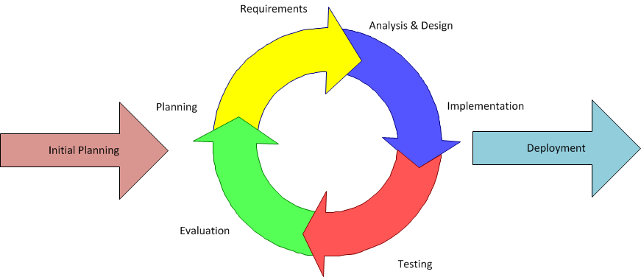

Figure 4.1 Iterative Methodology

Benefits of the Iterative and Incremental Model

* Flexibility and Adaptability
* Early and Continuous Feedback
* Faster Time-to-Market
* Continuous Improvement and Enhancement

In conclusion, the Iterative and Incremental Model provides a suitable methodology for the development of the "Rental App." It allows for flexibility, continuous improvement, and adaptability to meet the requirements of both renters and landlords.

# Requirement Analysis

Requirement analysis is a critical phase in the development process of the " Rental App." It involves identifying, documenting, and analyzing the needs and expectations of the renters, landlords, owners and administrators.

## Functional Requirements

Functional requirements specify the specific functionalities and features that the system must possess in order to meet the needs of its users.

* User Registration and Login

Users should be able to create accounts and register with the system. Users should be able to log in using their credentials.

* Search and Filtering

Users should be able to search for available rental properties based on location, rent, number of rooms, and other relevant criteria. The system should provide advanced filtering options to refine search results.

* Property Listings

Landlords should be able to create listings for their rental properties, providing details such as location, contact information, rent, number of rooms, and available facilities. Users should be able to view comprehensive property listings with relevant information and images.

## 5.2 Non-Functional Requirements

Requirement Specification:

* Operating System: Android (App), any compatible browsers (Web)
* Database: MySQL
* Frontend: Flutter (App), Nestjs (Web)
* Backend: Nestjs

# System Design

## 6.1 DFD

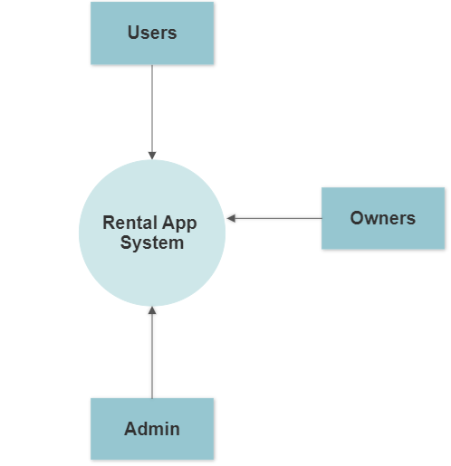

**Figure 6.1.1: DFD Level 0**

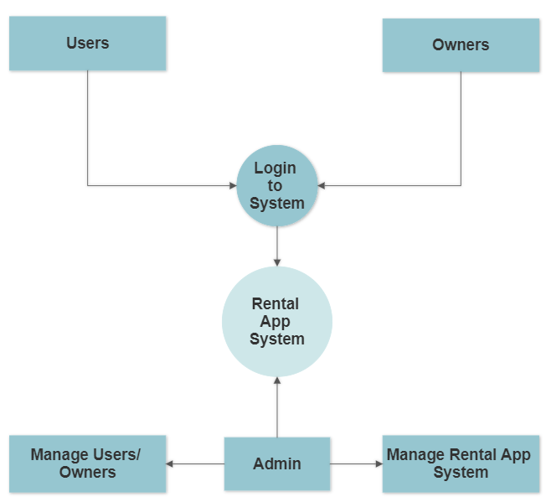

**Figure 6.1.2: DFD Level 1**

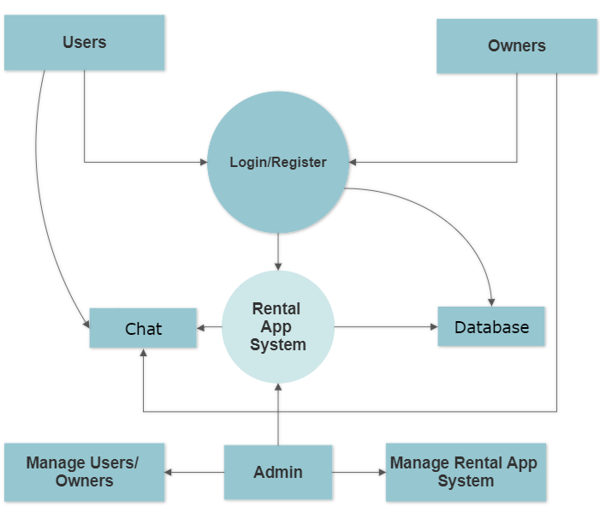

**Figure 6.1.3: DFD Level 2**

## 6.2 ER Diagram

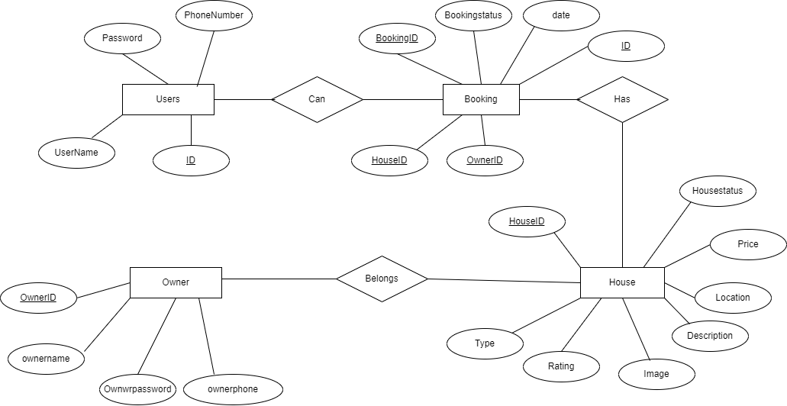

**Fig 6.2.1: ER Diagram**

## 6.3 Gantt chart

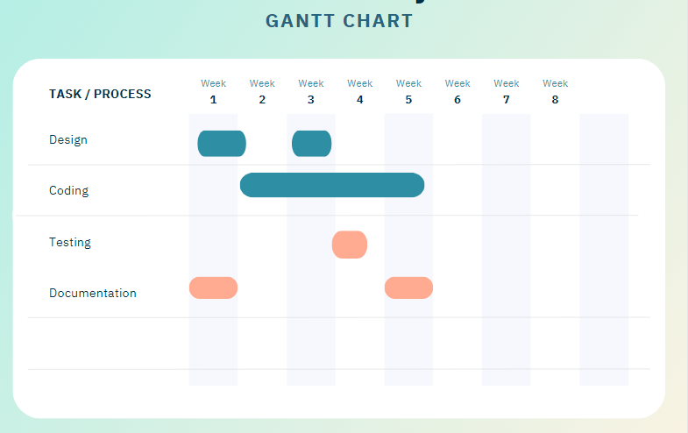

**Fig 6.3.1: ER Diagram**

# References

**1.** Voumik, D., Deb, P., Sutradhar, S., & Khan, M. M. (2021, July 8). Development of online based

Smart House renting web application. Journal of Software Engineering and Applications.

Retrieved June 14, 2022, from

https://www.scirp.org/journal/paperinformation.aspx?paperid=110723

**2.** Trasad, A. (2019, June 17). Flowchart in software engineering/testing. TechBytes.

Retrieved June 14, 2022, from

https://mundrisoft.com/tech-bytes/flowchart-in-software-engineering-testing/

**3.** Gommans, H. P., Njiru, G. M., & Owange, A. N. (1970, January 1). [PDF] Rental House

Management System: Semantic scholar. [PDF] Rental House Management System | Semantic

Scholar.

Retrieved June 14, 2022, from

https://www.semanticscholar.org/paper/Rental-House-Management-System-Gommans-Njir

u/fe4a87307d05aa186e0ab0fd7b03b58948f81b56