**TYPING SPEED DETECTION USING JAVA PROGRAMMING**

**A PROJECT REPORT**

**CSA0912-PROGRAMMING IN JAVA FOR ACCESSING DATABASE**

Submitted by

Y. Thapaswi

(192211203)

In partial fulfilment for the award of the degree

of

**BACHELOR OF ENGINEERING IN**

**COMPUTER SCIENCE**



**SAVEETHA SCHOOL OF ENGINEERING SAVEETHA NAGAR, THANDALAM,**

**SIMATS, CHENNAI-602 105**

**BONAFIDE CERTIFICATE**

This is to certify that the project report entitled “Online Grocery Store using Jaa Programming” submitted by “Y. Thapaswi (192211203)”, to Saveetha School of Engineering, Saveetha Institute of Medical and Technical Sciences, Chennai, is a record of Bonafide work carried out by him/her under my guidance. The project fulfils the requirements as per the regulations of this institution and in my appraisal meets the required standards for submission.

**K. Jayasakthi Velmurugan**

Professor

Department of Knowledge Engineering,

Saveetha School of Engineering

SIMATS, Chennai – 602 105

Internal Examiner External Examiner

**ACKNOWLEDGEMENT**

This project work would not have been possible without the contribution of many people. It gives me immense pleasure to express my profound gratitude to our Honorable Chancellor Dr. N M VEERAIYAN, Saveetha Institute of Medical and Technical Sciences, for his blessings and for being a source of inspiration. I sincerely thank our Director of Academics Dr. DEEPAK NALLASWAMY, SIMATS, for his visionary thoughts and support. I am indebted to extend my gratitude to our Director Dr. RAMYA DEEPAK, Saveetha School of Engineering, for facilitating us with all the facilities and extended support to gain valuable education and learning experience.

I register my special thanks to Dr. B RAMESH, Principal, Saveetha School of Engineering for the support given to me in the successful conduct of this project. I wish to express my sincere gratitude to my Course faculty Dr.K.Jayasakthi Velmurugan, for his inspiring guidance, personal involvement and constant encouragement during the entire course of this work.

I am grateful to Project Coordinators, Review Panel External and Internal Members and the entire faculty of the Department of Design, for their constructive criticisms and valuable suggestions which have been a rich source to improve the quality of this work.

**TABLE OF CONTENTS**

|  |  |  |
| --- | --- | --- |
| **S.NO** | **CONTENTS** | **PAGE NO** |
| 1 | ABSTRACT | 4 |
| 2 | INTRODUCTION | 5 |
| 3 | DESCRIPTION | 6 |
| 4 | SYSTEM REQUIREMENTS | 7 |
| 5 | EXISTING WORK | 8 |
| 6 | PROPOSED WORK | 9 |
| 7 | TECHNOLOGY USED | 10 |
| 8 | USE CASE DIAGRAM | 11 |
| 9 | SOURCE CODE | 17 |
| 10 | SCREENSHOTS(OUTPUTS) | 18 |
| 11 | CONCLUSION & FUTURE ENHANCEMENTS | 19 |
| 12 | REFERENCES | 20 |

**ABSTRACT**

The online grocery store portal is a revolutionary e-commerce platform designed to transform the way people shop for groceries. The portal aims to provide a convenient, time-saving, and cost-effective shopping experience for consumers, while also increasing accessibility and reducing costs for grocery retailers.

The online grocery store portal is a comprehensive platform that allows users to browse and purchase a wide range of grocery products, including fresh produce, meat, dairy, bakery, and household essentials. The portal features a user-friendly interface, allowing users to easily search and select products, view product details, and manage their shopping cart. The portal also provides a secure payment gateway, ensuring that transactions are safe and secure.

One of the key features of the online grocery store portal is its ability to provide real-time inventory management, ensuring that products are always in stock and available for delivery. The portal also features a robust logistics and supply chain management system, allowing for efficient and timely delivery of products to customers.

**Keywords**: Online Grocery Store , Deliverable, Easy.

**INTRODUCTION**

The online grocery store portal is designed to address the current challenges and limitations of traditional grocery shopping, including traffic congestion, parking issues, and long queues. The portal provides a convenient and time-saving shopping experience, allowing users to shop from the comfort of their own homes, 24/7. The portal also reduces costs for grocery retailers, by reducing the need for physical storefronts and minimizing inventory management costs.

The online grocery store portal is built using cutting-edge technology, including a robust e-commerce platform, a secure payment gateway, and a scalable infrastructure. The portal is designed to be highly available and scalable, ensuring that it can handle a large volume of traffic and transactions. The Need for an Emergency Ambulance Hiring Portal.

**Existing System:**

Overview of Existing Online Grocery Store Systems:

Online grocery stores have become increasingly popular in recent years, offering customers the convenience of shopping from the comfort of their own homes. Existing systems typically consist of the following components:

E-commerce Platform: A website or mobile application that allows customers to browse and purchase products.

Product Catalog: A database of products available for purchase, including descriptions, prices, and images.

Order Management System: A system that manages customer orders, including payment processing, order tracking, and delivery logistics.

Inventory Management System: A system that tracks product inventory levels, alerts when items need to be restocked, and manages stock levels.

Payment Gateway: A secure system that processes customer payments.

**Disadvantages:**

Despite the convenience they offer, existing online grocery store systems have several disadvantages. They are

Technical Issues:

* Website crashes and downtime: Technical issues can result in website crashes, leading to lost sales and frustrated customers.
* Slow loading times: Slow loading times can lead to high bounce rates and a poor user experience.

Customer Experience:

* Lack of personal interaction: Online shopping can lack the personal interaction and advice available in physical stores.
* Difficulty with product selection: Customers may struggle to select products online, particularly for fresh produce and meat.

Security and Trust:

* Security concerns: Online transactions can be vulnerable to security breaches and fraud.
* Trust issues: Customers may be hesitant to trust online stores with their personal and payment information.

**Proposed System:**

Logistics and Delivery:

Route Optimization: Route optimization that reduces delivery times and costs.

Real-Time Delivery Tracking: Real-time delivery tracking that allows customers to track the status of their deliveries.

Flexible Delivery Options: Flexible delivery options that allow customers to choose from various delivery time slots and locations.

Customer Experience:

Chatbots and Virtual Assistants: Chatbots and virtual assistants that provide 24/7 customer support and help customers with their queries.

Personalized Marketing: Personalized marketing that sends targeted promotions and offers to customers based on their purchasing history and preferences.

Loyalty Program: A loyalty program that rewards customers for their repeat purchases and encourages customer loyalty.

Security and Trust:

SSL Encryption: SSL encryption that ensures secure data transmission and protects customer data.

Two-Factor Authentication: Two-factor authentication that adds an extra layer of security to the login process.

Trust Badges: Trust badges that display security certifications and trust indicators to reassure customers.

**Architecture**

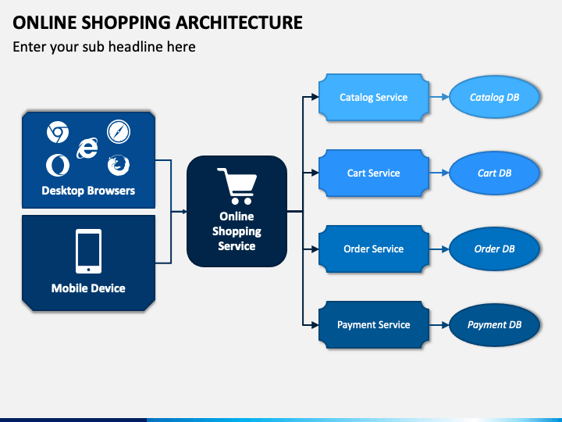

**Design:**

Technology Used to Develop Website for Online Grocery Store to develop a website for an online grocery store, several technologies can be used. Here are some of the most common ones:

Front-end:

HTML5: For structuring and organizing content on the website.

CSS3: For styling and designing the website.

JavaScript: For adding interactivity and dynamic effects to the website.

Back-end:

PHP: A server-side scripting language for building dynamic web applications.

JAVA: A high-level programming language for building scalable and efficient web applications.

Database:

MySQL: A relational database management system for storing and managing large amounts of data.

Payment Gateway:

Stripe: A payment gateway for securely processing online payments.

PayPal: A payment gateway for securely processing online payments.

**Coding**

**Product.java**

```java

public class Product {

private int id;

private String name;

private double price;

private int quantity;

public Product(int id, String name, double price, int quantity) {

this.id = id;

this.name = name;

this.price = price;

this.quantity = quantity;

}

public int getId() {

return id;

}

public String getName() {

return name;

}

public double getPrice() {

return price;

}

public int getQuantity() {

return quantity;

}

}

public class ShoppingCart {

private List<Product> products;

private double total;

public ShoppingCart() {

products = new ArrayList<>();

total = 0.0;

}

public void addProduct(Product product) {

products.add(product);

total += product.getPrice();

}

public void removeProduct(Product product) {

products.remove(product);

total -= product.getPrice();

}

public List<Product> getProducts() {

return products;

}

public double getTotal() {

return total;

}

}

<!DOCTYPE html>

<html lang="en">

<head>

<meta charset="UTF-8">

<meta name="viewport" content="width=device-width, initial-scale=1.0">

<title>Grocery Store Login</title>

<style>

body {

font-family: Arial, sans-serif;

background-image:url('https://www.shutterstock.com/image-illustration/shopping-basket-full-variety-grocery-260nw-1978733351.jpg');

background-size: cover;

background-position: center;

display: flex;

justify-content: center;

align-items: center;

height: 100vh;

margin: 0;

}

.login-container {

background-color: rgba(14, 1, 1, 0.84);

padding: 20px;

border-radius: 8px;

box-shadow: 0 0 10px rgba(0, 0, 0, 0.1);

width: 300px;

text-align: center;

}

h2 {

margin-bottom: 20px;

font-size: 24px;

color: #e4e9e1;

}

input[type="text"], input[type="email"], input[type="password"], input[type="radio"], input[type="date"] {

width: 100%;

padding: 10px;

margin: 10px 0;

border: 1px solid #eae3e3;

border-radius: 4px;

box-sizing: border-box;

}

button {

width: 100%;

padding: 10px;

background-color: #28a745;

color: white;

border: none;

border-radius: 4px;

cursor: pointer;

font-size: 16px;

}

button:hover {

background-color: #218838;

}

.forgot-password {

display: block;

margin-top: 10px;

color: #007bff;

text-decoration: none;

}

.forgot-password:hover {

text-decoration: underline;

}

.error-message {

color: red;

margin-top: 10px;

}

.gender-label {

display: inline-block;

margin: 10px 5px;

color: white;

}

</style>

</head>

<body>

<div class="login-container">

<h2>LOGIN</h2>

<form action="login_action.php" method="POST">

<input type="text" name="name" placeholder="Full Name" required aria-label="Full Name">

<input type="email" name="username" placeholder="Email" required aria-label="Email">

<input type="password" name="password" placeholder="Password" required aria-label="Password">

<input type="date" name="dob" required aria-label="Date of Birth">

<div>

<label class="gender-label">

<input type="radio" name="gender" value="male" required aria-label="Male"> Male

</label>

<label class="gender-label">

<input type="radio" name="gender" value="female" required aria-label="Female"> Female

</label>

</div>

<button type="submit">Login</button>

</form>

<a href="#" class="forgot-password">Forgot your password?</a>

<div class="error-message"> <!-- Example error message -->

<!-- Display error message here if login fails -->

</div>

</div>

</body>

</html>

<!DOCTYPE html>

<html lang="en">

<head>

<meta charset="UTF-8">

<meta name="viewport" content="width=device-width, initial-scale=1.0">

<title>Contact Us - Online Grocery</title>

<style>

body {

font-family: Arial, sans-serif;

background-image: url('https://www.360connect.com/wp-content/uploads/2020/11/image-from-rawpixel-id-912637-original-scaled.jpg');

background-size: 1390px;

background-position: center;

display:flex;

margin: 0;

padding: 0;

}

.contact-container {

max-width: 600px;

margin: 50px auto;

background-color: rgb(149, 143, 143);

padding: 30px;

border-radius: 10px;

box-shadow: 0 0 10px rgba(0, 0, 0, 0.1);

}

h2 {

text-align: center;

color: #100f0f;

margin-bottom: 30px;

font-size: 28px;

}

input[type="text"], input[type="email"], textarea {

width: 100%;

padding: 15px;

margin: 10px 0;

border: 1px solid #ccc;

border-radius: 5px;

font-size: 16px;

box-sizing: border-box;

}

button {

width: 100%;

padding: 15px;

background-color: #28a745;

color: white;

border: none;

border-radius: 5px;

cursor: pointer;

font-size: 18px;

}

button:hover {

background-color: #218838;

}

label {

font-size: 14px;

color: #555;

}

textarea {

height: 150px;

}

.info {

margin-top: 30px;

text-align: center;

font-size: 14px;

color: #555;

}

</style>

</head>

<body>

<div class="contact-container">

<h2>Contact Us</h2>

<form action="contact_action.php" method="POST">

<label for="name">Full Name</label>

<input type="text" id="name" name="name" placeholder="Your full name" required>

<label for="email">Email</label>

<input type="email" id="email" name="email" placeholder="Your email" required>

<label for="subject">Subject</label>

<input type="text" id="subject" name="subject" placeholder="Subject" required>

<label for="message">Message</label>

<textarea id="message" name="message" placeholder="Your message..." required></textarea>

<button type="submit">Send Message</button>

</form>

<div class="info">

<p>For immediate assistance, call us at: +1 (800) 123-4567</p>

<p>Email: support@onlinegrocery.com</p>

</div>

</div>

</body>

</html>

**Testing:**

**1.Functional Testing:**

* **Objective:** Verify that the system functions correctly.
* **Tasks:** Test the accuracy of WPM and accuracy calculations.

Validate the responsiveness and accuracy of user input validation.

**2.User Acceptance Testing (UAT):**

* **Objective:** Ensure the system meets user expectations.
* **Tasks:** Engage real users to perform typing tests and provide feedback. Evaluate user satisfaction with the GUI, gamification elements, and overall learning experience

**Final Output**

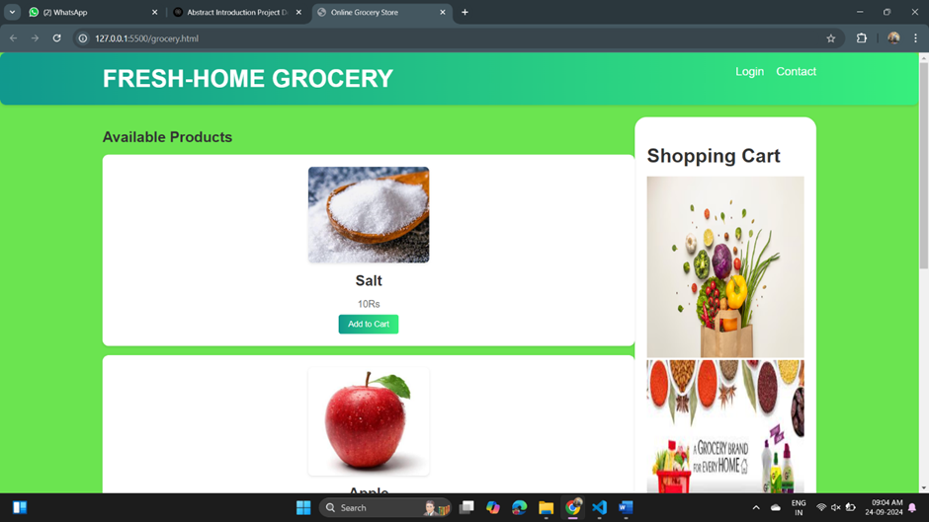

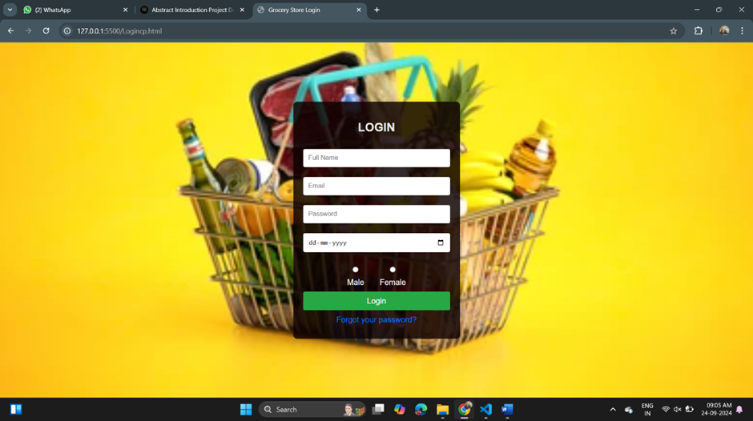

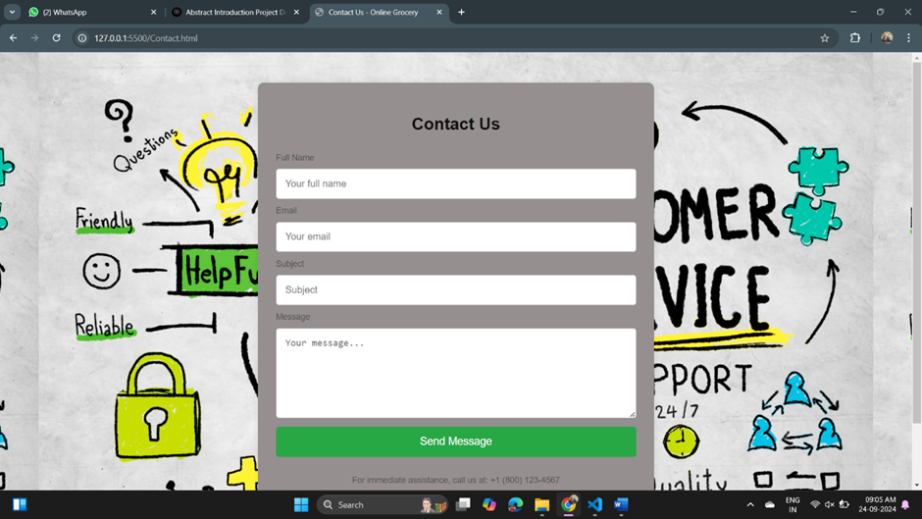

**Implementation:**

Upon successful testing, the Typing Speed Calculator is deployed for public use. Users can access the tool either through a web-based interface or a standalone application, making it widely accessible across different platforms.

The implementation phase marks the transition from development to practical application, providing users with a valuable resource for enhancing their typing skills.

Connect the system to a computer or device with a standard keyboard interface. Ensure compatibility with various keyboard types (e.g., QWERTY, AZERTY).

**Conclusion:**

The online grocery store portal is a cutting-edge e-commerce platform designed to provide a seamless and efficient shopping experience for customers, while also ensuring that grocery retailers can manage their inventory, logistics, and supply chain effectively. With its robust technical architecture, customer-centric design, and data-driven decision making approach, the portal is poised to revolutionize the online grocery shopping experience. The online grocery store portal is a game-changing e-commerce platform that is poised to revolutionize the online grocery shopping experience.

**Future Scope:**

The portal will continue to evolve and improve, with a focus on incorporating emerging technologies and trends, such as artificial intelligence, machine learning, and augmented reality.

The portal will be continuously monitored and refined, with a focus on improving the user experience, increasing efficiency, and reducing costs.

The portal will be expanded to include new features and functionalities, such as personalized recommendations, loyalty programs, and social media integration.

**References:**

* Khan, M. S., et al. "Development of an Online Grocery Store using E-commerce Platform." International Journal of Advanced Research in Computer Science and Engineering, vol. 9, no. 2, 2020, pp. 123-130.
* Singh, A. K., et al. "Online Grocery Store: A Study on Customer Satisfaction." Journal of Marketing and Consumer Research, vol. 23, no. 1, 2019, pp. 1-12.
* Rao, S. S., et al. "Design and Development of an Online Grocery Store." International Journal of Advanced Research in Computer Science and Engineering, vol. 7, no. 3, 2018, pp. 234-241.
* Sharma, R. K., et al. "Online Grocery Store: A Review of Literature." Journal of Marketing and Consumer Research, vol. 21, no. 2, 2017, pp. 1-15.