SURVEY NOTEBOOK

Date: October 30, 2023
Site Location: Neon Bouy, near Cypress cove road over Black Warrior River
Survey Start Time:
Trimble DGPS and Garmin GPS Data Collection: 9:30-10:00
Drone Data Collection: 10:30- 11:00 pm
Survey End Time: Returned around 1:30 from the site
Overpassing Satellite Name and Time: Landsat 8, Sentinel 2, SWOT
Weather condition: Mostly cloudy with wind
Participants: Pawan Thapa
Types of collected data: UAV data from Mavic Pro at different positions generally at an altitude of 90m, 100, and 110 m above the river.
A video of more than 20 seconds up to 1 minute for three different altitudes was taken, pointing the drone camera vertically downward and orientation towards its downstream.
Use Trimble DGPS and Garmin GPS to collect three ground control points: one buoy corner, two traps on the right bank and the left bank use yellow traps for ground control points observation.
Encountered problems:
The problem with the connection of the GNSS receiver with the new antenna DGPS, it did not get any satellite for one hour, we took the paid version for 1 hour but did not get any satellite connection, might be a cloudy day is the reason for it.
Another not using sim card phone that Trimble mobile manager.
Forget to take traps, use Sechi disk and other artificial and natural objects like buoy corner for ground control points, those are visible and distinct in drone video and images.
Ground Control Points:
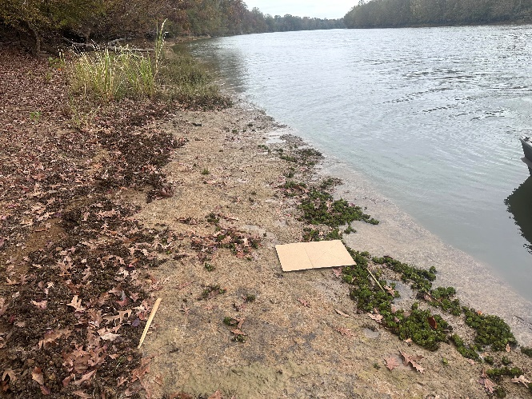 | 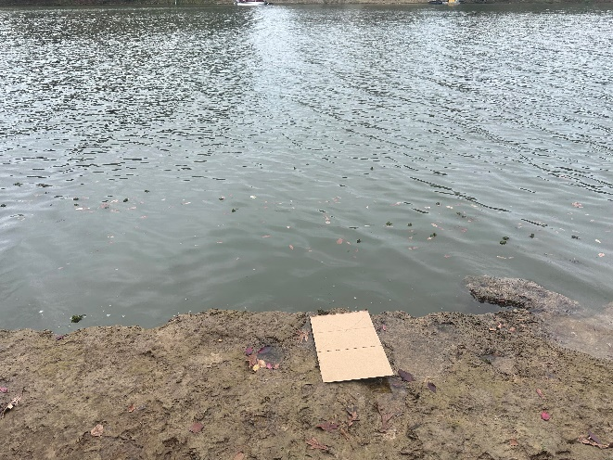
Left bank GCP 1 (right) and GCP 2 (left)
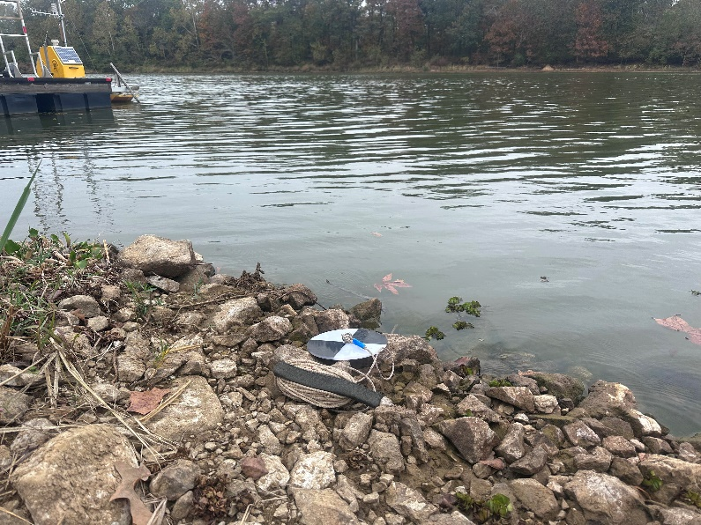 | 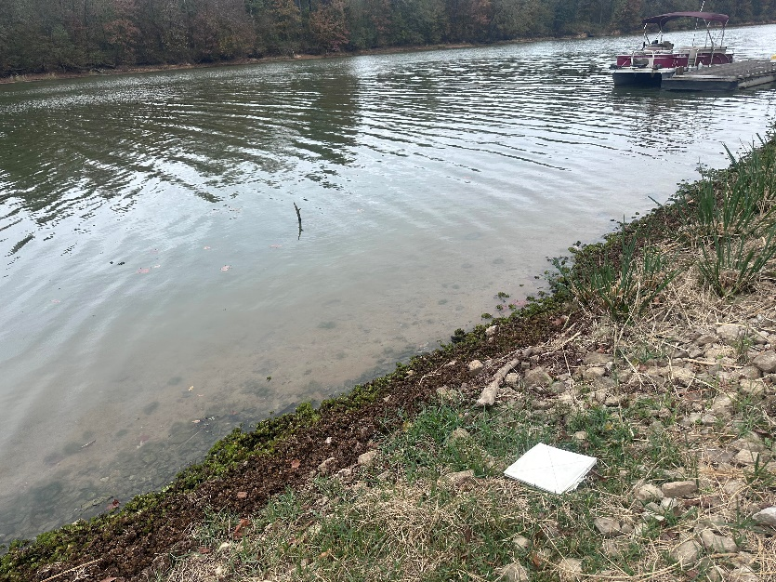
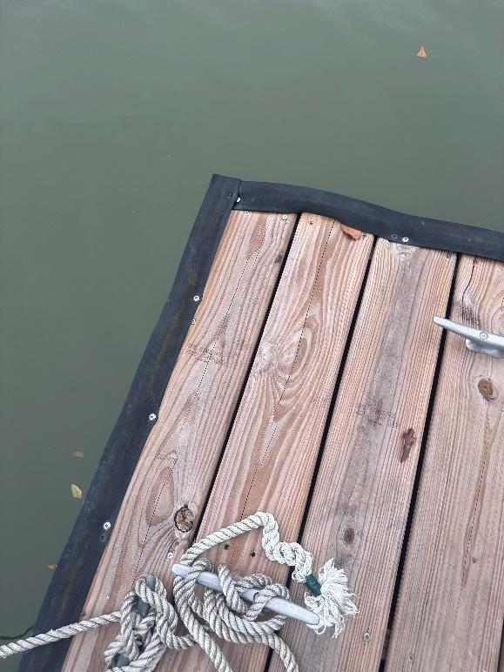
Right Bank GCP (Ground Control Points)

Geoprocessing DGPS points plot in ArcGIS Pro

