SURVEY NOTEBOOK

Date: September 17, 2023
Site Location: Hurricane Creek Park, 7005 Old Birmingham Hwy, Tuscaloosa, AL 35404
Survey Start Time:
Total Data Collection: 10:30 a.m. – 1:30 p.m.
YSI Data Collection: 11:00- 12:00 p.m.
RS5 Data Collection: 12:00 – 1:30 p.m.
Survey End Time: 1:45 p.m.
Weather condition: Sunny day
Participants: Pawan Thapa
Types of collected data: YSI and RS5
Rangefinder distance: 45.5 meters of river width
Encountered problems:
Problem with the connection of the GNSS receiver with the handheld.
Disconnected, Reconnected, Connected
Software hangs once or twice, during measurement might be low memory space in C drive
Notes:
Check the Antenna, and battery, plug and re-run software.
Use the recommended laptop.
Take level measurements rod, some paper towels/towels, scissors, Surveying umbrellas/normal umbrellas.
RS5 measurements were taken in both left and right banks of the river around 3 transects.
RS5 measurement was carried out using ropes on both banks.
Images:
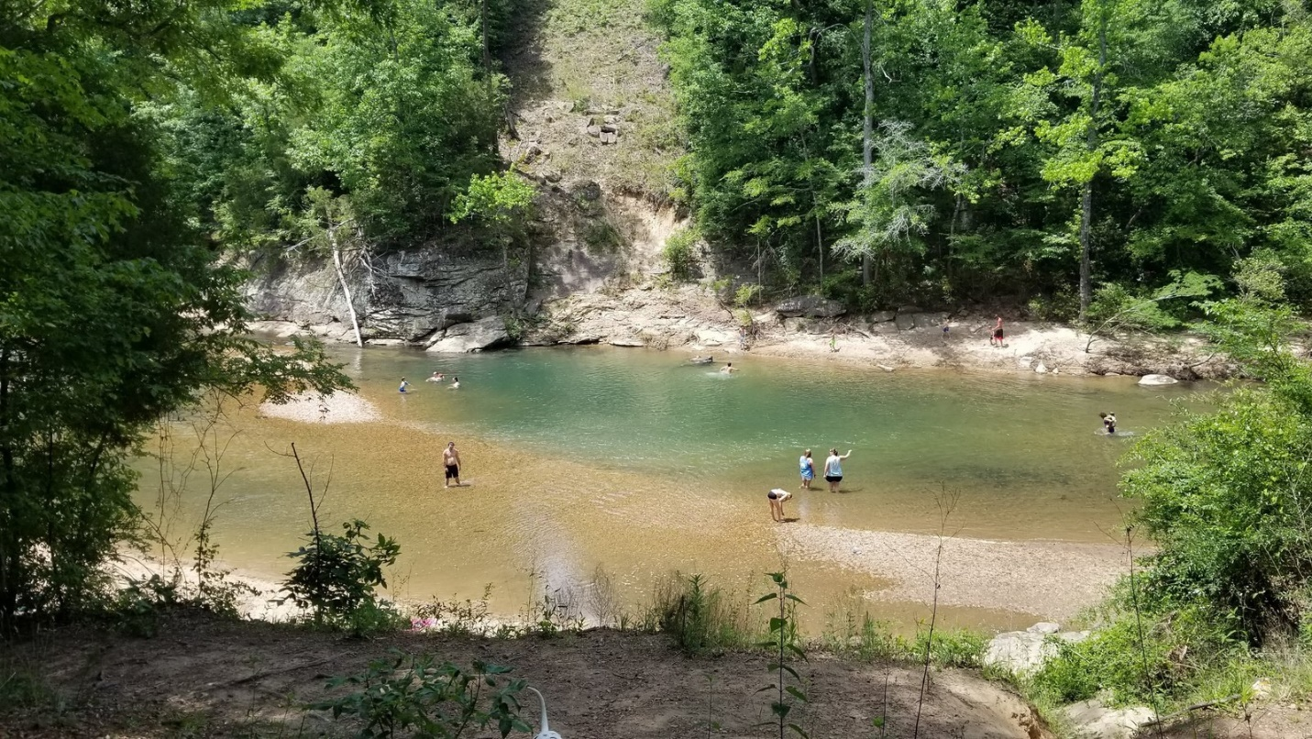
Transects
In this field site, we took three transects (red line in the figure) starting from left bank to right with RS5 and measured water quality parameters in 15 points (blue dots in the figure) using YSI (10 footsteps distance between the neighboring measurement points; measurements for 2 minutes at each point with 1 second interval)
Post Processed:
The total duration of transects is 3 minutes 36 seconds with a width of 29.134 meters. The boat's speed was 0.1403 meters per second and the average speed of the boat is -0.028 meters per second. The maximum speed is 0.4296 meters per second and maximum depth is 1.351 meters. The total discharge is -0.6187 cubic meters per second.

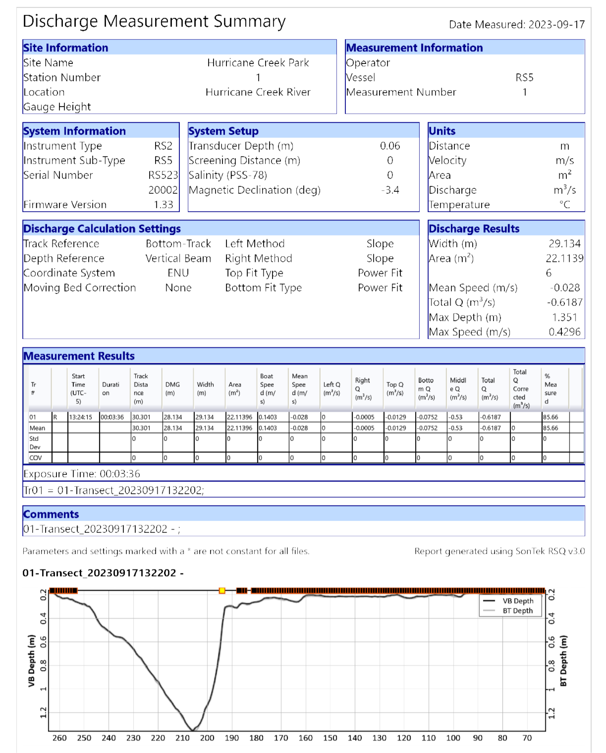

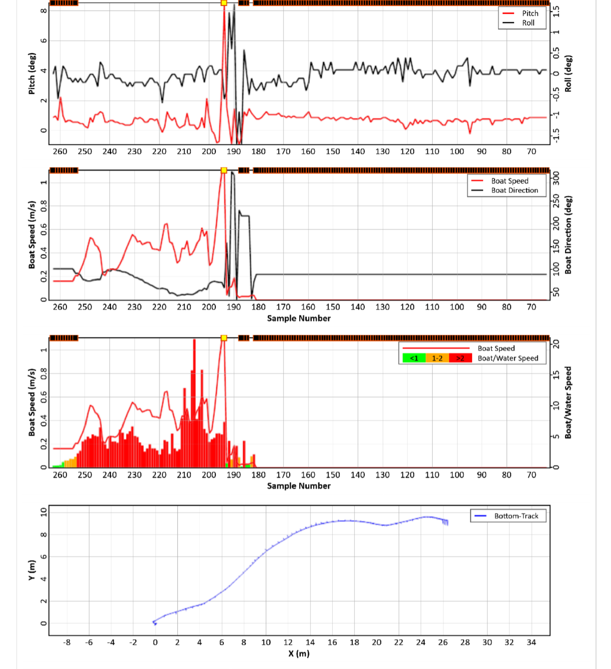

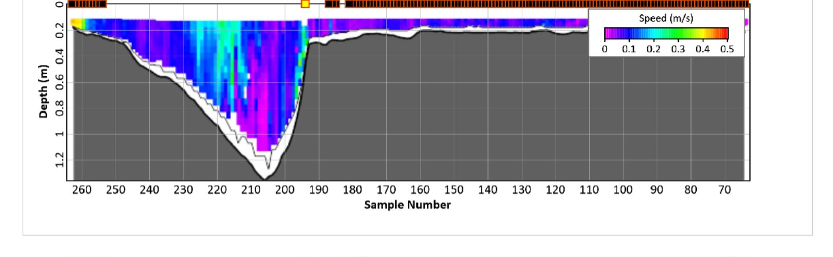

The data gathered at the 15 measurement points were averaged for each indicator for each point. The obtained results showed that the water is basic (ph∼8.65) with relatively low turbidity (FNU ∼ 5.38) and Specific Conductance value ∼ 684.25 (uS/cm) (freshwater stream) and has almost no algae blooms (BGA, Chl has very low values ∼ 0.02 and 0.78 ug/L respectively), fDOM values are also low ∼ 30.35 QSU.

Water quality measurements summary:

