**INTERACTIVE WHITEBOARD**

**A Project Report**

***Submitted by:***

***Mukesh kumar (1809413)***

***In partial fulfillment for the award of the degree of***

**BACHELOR OF TECHNOLOGY**

**IN**

**COMPUTER SCIENCE AND ENGINEERING**

**at**

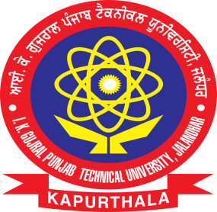

**Department of Computer Science & Engineering**

SRI SAI COLLEGE OF ENGINEERING & TECHNOLOGY, BADHANI,

PATHANKOT

**(AFFILIATED TO I.K.G. PUNJAB TECHNICAL UNIVERSITY, KAPURTHALA, PUNJAB (INDIA)**

**JUNE & 2021)**

**INTERACTIVE WHITEBOARD**

**A Project Report**

***Submitted by:***

***Mukesh kumar (1809413)***

***In partial fulfillment for the award of the degree of***

**BACHELOR OF TECHNOLOGY**

**IN**

**COMPUTER SCIENCE AND ENGINEERING**

**at**

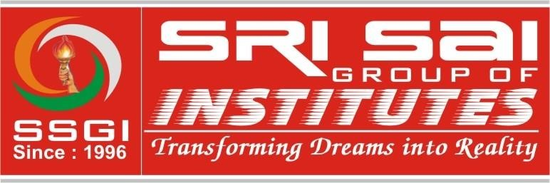

**Department of Computer Science & Engineering**

SRI SAI COLLEGE OF ENGINEERING & TECHNOLOGY, BADHANI,

PATHANKOT

**(AFFILIATED TO I.K.G. PUNJAB TECHNICAL UNIVERSITY, KAPURTHALA, PUNJAB (INDIA)**

**JUNE & 2021)**

## Sri Sai College of Engineering & Technology, Badhani – 145001 (Pathankot)



**(Affiliated to IKG Punjab Technical University, Jalandhar (Punjab)**

**Candidate’s Declaration**

I hereby certify that the project entitled “ **INTERACTIVE WHITEBOARD** ” submitted by **(MUKESH KUMAR )** & **(1809413)** (Student name) & (University Roll no) in partial fulfillment of the requirement for the award of degree of the B. Tech. (Computer Science & Engineering) submitted in I.K. Gujral Punjab Technical University, Kapurthala at **SRI SAI COLLEGE OF ENGINEERING & TECHNOLOGY, BADHANI PATHANKOT** is an authentic record of my own work carried out during a period from January, 2021 to May, 2021 under the guidance of Prof. **RAKESH GUPTA**  (Guide name, Designation, Department of Computer Science & Engineering). The matter presented in this project has not formed the basis for the award of any other degree, diploma, fellowship or any other similar titles.

I further declared that in case of any violation of an intellectual property right or copyright I as the candidate would be fully responsible for the same. My Department and Institute/College should not be held for full or partial violation of copyright if found at any stage of my degree.



**MUKESH KUMAR**

**1809413**

## Sri Sai College of Engineering & Technology, Badhani – 145001 (Pathankot)



**(Affiliated to IKG Punjab Technical University, Jalandhar (Punjab)**

**CERTIFICATE**

This is to certify that the project titled “ **INTERACTIVE WHITEBOARD** ” is the bona fide work carried out by (Student name) & (University Roll no) in partial fulfillment of the requirement for the award of degree of the B. Tech. (Computer Science & Engineering) submitted in I.K. Gujral Punjab Technical University, Kapurthala at Sri Sai College of Engineering & Technology, Badhani – 145001 (Pathankot) is an authentic record of my own work carried out during a period from January, 2021 to May, 2021/ under the guidance of Prof. **RAKESH GUPTA** (Guide name, Designation, Department of Computer Science & Engineering). The Minor Project Viva-Voce Examination has been

held on ____________ (DD/MM/YYYY)

**Signature of the Guide**

**Signature of the HoD,**

**Department of CSE**

**Acknowledgment**

"I have taken efforts in this project. However, it would not have been possible

without the kind support and help of many individuals and organizations.I

would like to extend my sincere thanks to all of them.

I am highly indebted to ER. RAKESH GUPTA for their guidance

and constant supervision as well as for providing necessary information

regarding the project & also for their support in completing the project.

I would like to express my gratitude towards my parents & member of

SRI SAI COLLEGE OF ENGINEERING AND TECHNOLOGY for their kind

co-operation and encouragement which help me in completion of this project.

I would like to express my special gratitude and thanks to industry persons for

giving me such attention and time.

My thanks and appreciations also go to my colleague in developing the project

and people who have willingly helped me out with their abilities."

MUKESH KUMAR

1809413

#### CONTENTS

**Topic**

*Declaration of the Student (Signed by Student)*

*Certificate of the Guide (Signed by Guide, HoD)*

*Acknowledgement*

*List of Figure*

*List of Table*

**CHAPTER 1. INTRODUCTION**

1.1 Introduction of interactive whiteboard

1.2 Problem Definition

1.3 Hardware Specification

1.4 Software Specification

1.5 About Programming Language used in project

**CHAPTER 2. LITERATURE SURVEY**

2.1 Existing System

2.2 Proposed System

2.3 Feasibility Study

**CHAPTER 3. SYSTEM ANALYSIS & DESIGN**

3.1 Requirement Specification

3.2 Design and Test Steps

3.3 Testing Process and Result

**CHAPTER 4. RESULT AND DISCUSSION**

**CHAPTER 5. CONCLUSION / RECOMMENDATIONS**

5.1 Conclusion & Future

**Chapter 1. Introduction**

**1.1 INTRODUCTION OF WHITE BOARD :**

An interactive whiteboard also known as a smartboard , is an interactive display format of a whiteboard that reacts to user input either directly or through other devices.

It is something similar to real-whiteboard using in classroom for teaching purpose. It work as the same as real-whiteboard. But difference is that the real-whiteboard is totally hardware and the white is software . And this software(whiteboard ) have some extra feature as compare to real-whiteboard. We can do all the work on whiteboard that we done on real-whiteboard.

Whiteboard work very well with mouse and keyboard. It means by using mouse and keyboard we can draw different type of shapes. We can draw or write with finger if we have touch screen. But for writing text , it is difficult . then we can use digital pen

**1.2 Problem definition: -**

There is a list of problem that we faces while working with real-whiteboard. Some of them is given as …….

* **Limited size :-**

The size of real-whiteboard is limited , so we have to erase the content written on real-whiteboard while teaching or meeting to write new content on real-whiteboard.

* **Difficult to draw shapes :-** Everyone face difficulty to draw shapes on real-whiteboard if he or she is not good in drawing .

It is also time consuming to draw shapes on real-whiteboard.

* **Copy the content written on real-whiteboard :-** It is very important to copy the content written on real-whiteboard. Because the content can’t be save or have erase the content to add new content, the previous content have to copied.

**1.3 Hardware Requirement: -**

* Standard Pentium Series Processor. (Recommended Pentium III or Advanced).
* Minimum 256 MB RAM. (Recommended 512 MB)
* HDD Storage capacity of 4 GB with 5400 rpm or more.
  1. **Software Requirement: -**
* **Operating System:** Windows 8.1 or Above
* **Programming Tool:** jdk and Notepad
* **Documentation Tool:** java
  1. **About Programming Language used in project:**

In my project (Interactive Whiteboard ), I use Programming language i.e JAVA and some package of java that I use are discuss below.

* + 1. **JAVA :**

JAVA is a high-level programming language originally developed by Sun Microsystems and released in 1995. Java runs on a variety of platforms, such as

Windows, Mac OS, and the various version of UNIX. Java is object-oriented and secure programming language. I will list down some of key advantages of Java Programming language.

* **Object – Oriented :** In Java, everything is an Object. Java can be easily extended since it is based on the Object model.
* **Platform Independent :**  Unlike many other languages including C and C++, when Java is Compiled , it is not compiled into platform specific machine, rather into platform independent byte code. This byte code is distributed over the web and interpreted by the Virtual Machine (JVM) on whichever platform it is being run on.
* **Simple :** With Java’s secure feature it enables to develop virus free, tamper free system. Authentication techniques are based on public key encryption.
* **Architecture neutral:** Java compiler generates an architecture neutral object file format, which makes the compiler code executable on many processors with presence of Java runtime system.
* **Portable :** Being architecture neutral and having no implementation dependent aspects of the specification makes Java is written in ANSI C with a clean portability boundary, which is a POSIX subset.
* **Robust :** Java makes an effort to eliminate error prone situations by emphasizing mainly on compile time error checking and runtime checking.

The Packages and their class used in project (Interactive WhiteBoard ) are shown as below.

|  |  |
| --- | --- |
| **PACKAGES** | **CLASS AND INTERFACES** |
| java.awt | Container, Color, Graphics, Polygon, Point, FlowLayout, Dimension, GrideLayout. |
| java.awt.event | ActionListener , MouseListener,  MouseMotionListener,  ActionEvent, MouseEvent |
| Java.io | File, IOException |
| Java.awt.image | BuffferedImage |
| Java.util | Arraylist |
| Java.awt.geom | Rectangle2D, Ellipse2D, Point2D |
| Javax.swing | JFrame, JPanel, JMenu, JMenuItem, JMenuBar, JButton, JTextFeild, JLabel, Icon, ImageIcon, BorderFactory, Graphics2D |
| Javax.imageio | ImageIO |

**JAVA AWT:-**

Java AWT (Abstract Window Toolkit) is an API to develop GUI or window-based application in java. Java AWT components are platform-dependent i.e. components are displayed according to the view of operating system. AWT is heavyweight i.e. its components uses the resources of system. The Abstract Window Toolkit(AWT) support for applets. The AWT contains numerous classes and methods that allow you to create and manage windows.

The java.awt package provides classes for AWT API such as Frame, Panel, Color, Button, Menu, MenuItem, MenuBar, TextField, Label, TextArea, RadioButton, CheckBox, Choice, List etc.

**JAVA SWING:-**

Swing API is a set of extensible GUI Components to ease the developer's life to create JAVA based Front End/GUI Applications. It is build on top of AWT API and acts as a replacement of AWT API, since it has almost every control corresponding to AWT controls. Swing component follows a Model-View-Controller architecture to fulfill the following criterias.

* A single API is to be sufficient to support multiple look and feel.

* API is to be model driven so that the highest level API is not required to have data.

* API is to use the Java Bean model so that Builder Tools and IDE can provide better services to the developers for use.

The java.swing package provides classes for API such as JFrame, JPanel, JColor, JButton, JMenu, JMenuItem, JMenuBar, JTextField, JLabel, JTextArea, JRadioButton, JCheckBox, JChoice, JList etc.

**SWING FEATURES :-**

* Light Weight - Swing components are independent of native Operating System's API as Swing API controls are rendered mostly using pure JAVA code instead of underlying operating system calls.

* Rich Controls - Swing provides a rich set of advanced controls like Tree, TabbedPane, slider, colorpicker, and table controls.

* Highly Customizable - Swing controls can be customized in a very easy way as visual apperance is independent of internal representation.
* Pluggable look-and-feel - SWING based GUI Application look and feel can be changed at run-time, based on available values.

**JAVA UTIL:-**

Java.util package contains the collections framework, legacy collection classes, event model, date and time facilities, internationalization, and miscellaneous utility classes. This reference will take you through simple and practical methods available in java.util package.

The java.util package provides classes Array, ArrayList, Calendar, Date, Locale, Random, Timer, Scanner, Vector etc.

The java.util package provides interfaces Collection, Deque, EventListener, Iterator, List RandomAccess etc.

**JAVA AWT GEOM :-**

Provides the Java 2D classes for defining and performing operations on objects related to two-dimensional geometry. Some important features of the package include:

* classes for manipulating geometry, such as AffineTransform and the PathIterator interface which is implemented by all Shape objects.
* classes that implement the Shape interface, such as CubicCurve2D, Ellipse2D, Line2D, Rectangle2D, and GeneralShape.
* the Area class which provides mechanisms for add (union), subtract, intersect, and exclusiveOR operations on other Shape objects

The java.awt.geom package provides classes AffineTransform, Arc2D, Area, Ellipse2D, Rectangle2D, GeneralPath, Path2D, Line2D, RoundRectangle2D etc

**JAVAX IMAGEIO:-**

The main package of the Java Image I/O API.Many common image I/O operations may be performed using the static methods of the ImageIO class.

This package contains the basic classes and interfaces for describing the contents of image files, including metadata and thumbnails (IIOImage); for controlling the image reading process (ImageReader, ImageReadParam, and ImageTypeSpecifier) and image writing process (ImageWriter and ImageWriteParam); for performing transcoding between formats (ImageTranscoder), and for reporting errors (IIOException).

The javax.imageio package provides classes IIOImage, IIOParam, ImageIO, ImageReader, ImageReadParam, ImageTypeSpecifier, ImageWriteParam, ImageWriter.

The javax.imageio package provides interfaces IIOParamController, ImageTranscoder.

All implementations of javax.imageio provide the following standard image format plug-ins:

|  |  |  |  |  |
| --- | --- | --- | --- | --- |
|  | **Reading** | **Writing** | **Notes** | **Metadata** |
| [JPEG](http://www.jpeg.org/) | yes | yes | none | [JPEG metadata format](https://docs.oracle.com/javase/7/docs/api/javax/imageio/metadata/doc-files/jpeg_metadata.html) |
| [PNG](http://www.libpng.org/pub/png/spec/) | Yes | yes | none | [PNG metadata format](https://docs.oracle.com/javase/7/docs/api/javax/imageio/metadata/doc-files/png_metadata.html) |
| BMP | Yes | yes | none | [BMP metadata format](https://docs.oracle.com/javase/7/docs/api/javax/imageio/metadata/doc-files/bmp_metadata.html) |
| [WBMP](http://www.wapforum.org/what/technical/SPEC-WAESpec-19990524.pdf) | Yes | yes | none | [WBMP metadata format](https://docs.oracle.com/javase/7/docs/api/javax/imageio/metadata/doc-files/wbmp_metadata.html) |
| [GIF](http://www.w3.org/Graphics/GIF/spec-gif89a.txt) | Yes | Yes | [GIF plug-in notes](https://docs.oracle.com/javase/7/docs/api/javax/imageio/package-summary.html#gif_plugin_notes) | [GIF metadata format](https://docs.oracle.com/javase/7/docs/api/javax/imageio/metadata/doc-files/gif_metadata.html) |

**JAVA AWT EVENT:-**

The java.awt.event package defines classes and interfaces used for event handling in the AWT and Swing. The members of this package fall into three categories:

**Events**

The classes with names ending in "Event" represent specific types of events, generated by the AWT or by one of the AWT or Swing components.

**Listeners**

The interfaces in this package are all event listeners; their names end with "Listener". These interfaces define the methods that must be implemented by any object that wants to be notified when a particular event occurs. Note that there is a Listener interface for each Event class.

**Adapters**

Each of the classes with a name ending in "Adapter" provides a no-op implementation for an event listener interface that defines more than one method. When you are interested in only a single method of an event listener interface, it is easier to subclass an Adapter class than to implement all of the methods of the corresponding Listener interface.

The java.awt.event package provides classes ActionEvent, AdjustmentEvent, InputEvent, ItemEvent, KeyEvent, MouseEvent, MouseAdapter etc.

The java.awt.event package provides interfaces ActionListener, AdjustmentListener, ItemListener, KeyListener, MouseListener etc

**JAVA IO:-**

This package provides for system input and output through data streams, serialization and the file system. Unless otherwise noted, passing a null argument to a constructor or method in any class or interface in this package will cause a NullPointerException to be thrown.

The java.io package provides classes File, FileWriter bufferedInputStream, Writer, OutputStream etc,

The java.io package provides interfaces DataInput, Externalization, FileFilter etc.

**JAVA AWT IMAGE :-**

Provides class for creating and modifying images. Images are processed using a streaming framework that involves an image producer, optional image filters, and an image consumer. This framework make it possible to progressively render an image while it is being fetched and generated . Moreover, the framework allows an application to discard the storage used by an image and to regenerate it at any time. This package provide a number of image producers, consumer, and filters that you can configure for your image processing needs.

The java.awt.image package provides classes BufferedImage, ColorModel, ImageFilter, Kernal, etc.

The java.awt.image package provides interfaces BufferedImageOP, ImageConsumer, ImageObserver, RenderImage etc

**APPLICATION OF JAVA:-**

According to Sun, 3 billion devices run Java. There are many devices where Java is currently used. Some of them are as follows:

1. Desktop Applications such as acrobat reader, media player, antivirus, etc.
2. Web Applications such as irctc.co.in, javatpoint.com, etc.
3. Enterprise Applications such as banking applications.
4. Mobile
5. Embedded System
6. Smart Card
7. Robotics
8. Games, etc.

**Chapter 2 Literature Survey**

**2.1 Existing System: -**

The Whiteboard we are using in class is old fashion whiteboard. It have some limitation like

We have to erase the content written on whiteboard for writing new content. The

whiteboard using in class have limited size. We can’t draw perfect shapes Or we can say

that it take more time to draw shapes . We have to copy the content written in whiteboard.

**2.2 Proposed System: -**

* We can set unlimited size of whiteboard.
* We don’t have to erase the content written on whiteboard for new writing new content.
* We can draw pre defined shapes with correct way.
* We don’t have to copy the content written on whiteboard because it have a feature to save content with pre defined extensions.

**2.3 Feasibility Study: -**

The prime focus of the feasibility is evaluating the practicality of the proposed system keeping in mind a number of factors. The following factors are taken into account before deciding in favor of the new system.

**Chapter 3. System Analysis & Design**

**3.1 Requirement Specification: -**

**3.1.1 Functional Requirements:**

* It use to draw free hand style line with different colors and also can change or adjust the width of line.
* It have feature like draw some different types of shapes like triangle, rectangle etc. It also provide color option for choosing different color for different shapes.
* It provide a feature to draw or write text on the screen on whiteboard. Or we can select different color for fonts

**3.1.2 Software Quality Attributes:**

* **AVAILABILITY:**The project works offline, so one can use it any time
* **CORRECTNESS:**It can draw shapes , write text and also free hand style line without wasting time.

**3.2 Design and Test Steps: -**

**3.2.1Waterfall Model**

[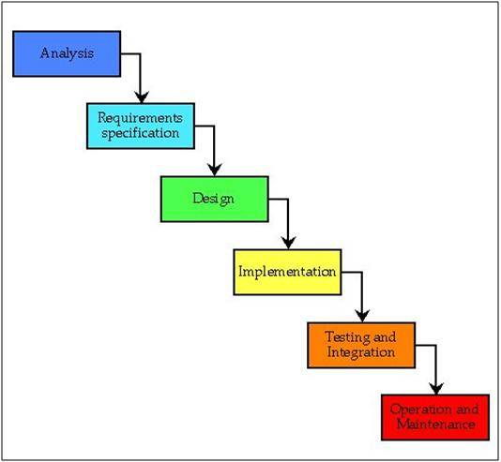](https://d3nqmfhxc38njt.cloudfront.net/wp-content/uploads/112.jpg)

**Fig. Waterfall Model**

The waterfall model is a sequential design process, often used in software development processes, in which progress is seen as flowing steadily downwards (like a waterfall) through the phases of  Analysis, Requirement Specification, Design, Implementation, Testing and Integration, and Operation and Maintenance.

If at the beginning of the project failures are detected, it takes less effort (and therefore time and money) for this error. In the waterfall model phases to be properly sealed first before proceeding to the next stage. It is believed that the phases are correct before proceeding to the next phase. In the waterfall model lay the emphasis on documentation. It is a straightforward method. The way of working ensures that there are specific phases. This tells you what stage it is. One can use this method of milestones. Milestones can be used to monitor the progress of the project to estimate.

In our Project, all the requirements are clear and well known and the project is large. All the activities in our project are carried out in the above-mentioned phases of the waterfall model.

**3.2.2 Feasibility Study**

The prime focus of the feasibility is evaluating the practicality of the proposed system keeping in mind a number of factors. The following factors are taken into account before deciding in favor of the new system.

**3.2.3 Economic Feasibility**

Report generation in the proposed system in precise that is reports are generated as per user requirements, which reduces the use of papers and manual labor.

**3.2.4 Technical feasibility**

Keeping in view the above fact, nowadays all organizations are automating the repetitive and monotonous works done by humans. The key process areas of the current system are nicely amenable to automation and hence the technical feasibility is proved beyond doubt.

**3.2.5 Operational Feasibility**

The present system has automated most of the manual tasks. Therefore the proposed system will increase the operational efficiency of the administrator and instructors.

**3.3 Testing Process & Result: -**

The reason behind testing was to find errors. Every program or software has errors in it, against the common view that there are no errors in it if the program or software is working. Executing the programs with the intention of finding the errors in it is therefore testing; hence a successful test is one which finds errors. Testing is an activity, however, it is restricted to being performed after the development phase is complete, but is carried parallel with all stages of system development, starting with requirement specification.

Test cases were devised with a purpose in mind. A test case is a set of data that a system will process as normal input. The software units developed in the system are modules and routines that are assembled and integrated to perform the required function of the system. Test results once gathered and evaluated, provide a qualitative indication of the software quality and reliability and serve as the basis for design modification if required. In this phase, testing is done at different levels. Actually testing phase of the implementations works accurately and efficiently before live operation commences.

**3.3.1 Unit Testing**

Unit testing was done after the coding phase. The purpose of the unit testing was to locate errors in the current module, independent of the other modules. Some changes in the coding were done during the testing phase. Finally, all the modules were individually tested following bottom to top approach, starting with the smallest and lowest modules and then testing one at a time.

**3.3.2 Black Box Testing**

This method of software testing tests the functionality of an application as opposed to its internal structures or working (i.e. white box testing). Specific knowledge of the application’s code/internal structure and programming knowledge, in general, is not required. Test cases are built to specifications and requirements, i.e., what the application is supposed to do. It uses external descriptions of the software, including specifications, requirements, and design to derive test cases. These tests can be functional or non-functional, though usually functional. The test designer selects valid and invalid inputs and determines the correct output. There is no knowledge of the test object’s internal structure.

**3.3.3 White Box Testing**

This method of software testing tests internal structures or workings of an application, as opposed to its functionality (i.e. black-box testing). In white-box testing, an internal perspective of the system, as well as programming skills, are required and used to design test cases. The tester chooses inputs to exercise paths through the code and determine the appropriate outputs.

**3.3.4 Integration Testing**

Once the unit was over, all the modules were integrated for integration testing. External and internal interfaces are implemented and work as per design, the performance of the module is not degraded.

**3.3.5 Validation Testing**

At the culmination of integration testing, the software is said to be completely assembled as a package; interfacing errors have been uncovered and corrected. Then as a final series of software test, validation tests were carried out.

**3.3.6 Acceptance Testing**

This is the final stage in the testing process before the system is accepted for operational use. Any requirement problem or requirement definition problem revealed from acceptance testing are considered and made error free.

**Chapter 4. Result AND Discussion**

Following represents the User Interface of Interactive Whiteboard and its working explaining with the help of screenshots or pictures.

**User Interface of Interactive whiteboard :-**

Following picture is first look of Interactive Whiteboard.

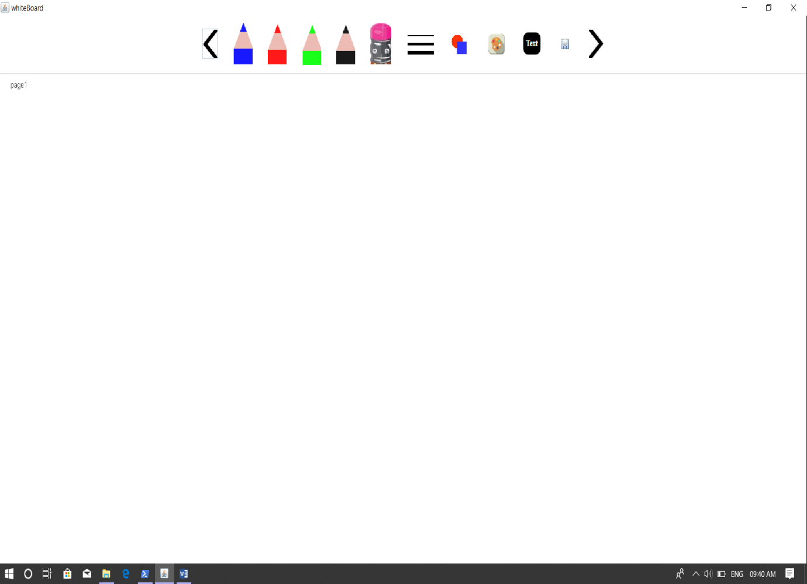

In this picture as you see

* The first and last Icon use for previous and next page respectively.
* Second, Third Four And Fifth Icon looks like pencil, These icon are used to draw free hand style line of color blue, red, green and black respectively on the whiteboard.
* Sixth Icon, that is look erase, is used as eraser to erase some unwanted or unnecessary content from the whiteboard.
* The next is Seventh Icon that is use to select the size of free hand style line. After click on this icon, it shows some options of different size of line, you have select one of them to change the size of line.
* The next one is Eight Icon that is use for select the shape you want to draw. After click on this Icon, it will show some different kinds of pre-defined shapes. You have to select one shape out of them to draw on whiteboard.
* The next Icon is for selecting different color for your needs. After click on this Icon you can select color.
* The next Icon is for draw or writing text on whiteboard.
* And finally the next Icon is use to save the pages of whiteboard .

**Drawing free hand line :-**

To draw the free hand line, you just have to click on one of the four icon that look like pencil If you click on blue one then the color of line is blue, if you click on red one then the color of line is red, if you click on black one then color of line is black.

After selecting the free hand line by click on it, you just have to press mouse on whiteboard and drag the mouse to draw line.

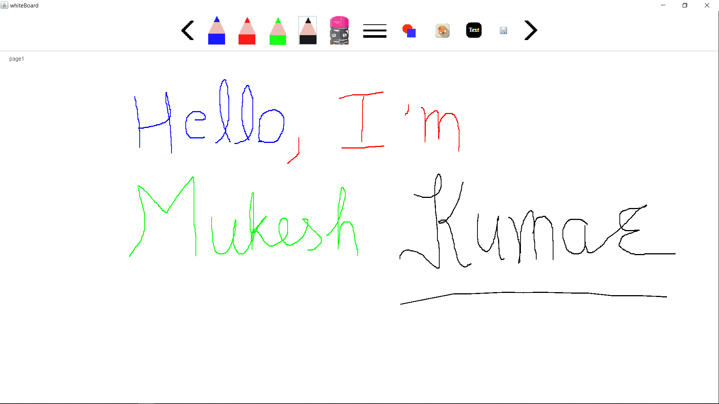

You can also change the width of line. The next picture show how to select width of line.

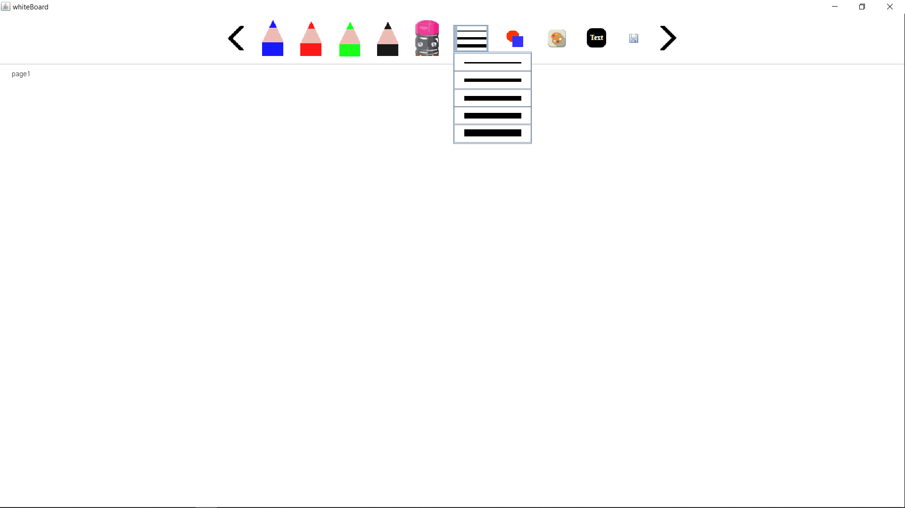

After click on icon that is for size line, it will show some option. You just have to click one of them to change the size of line. After change the size of line it will be like this ( see next picture).

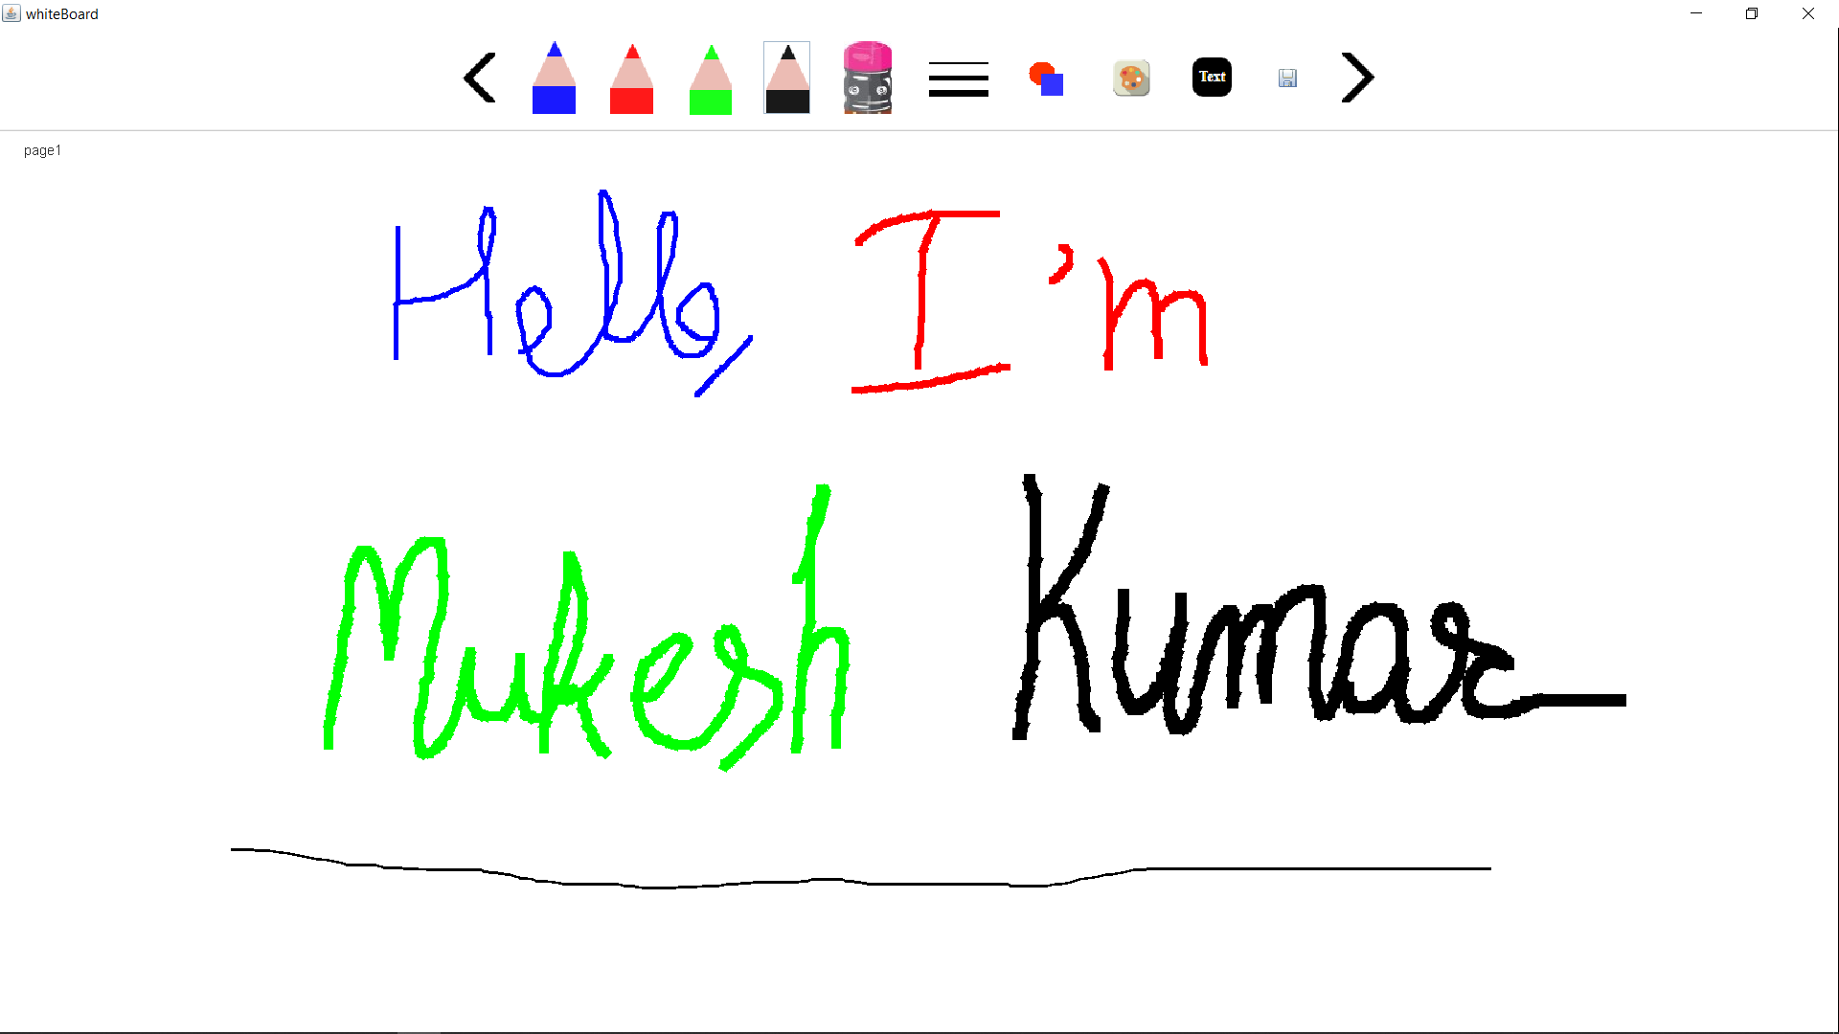

The next is eraser, If you are teaching in class using this whiteboard and you are writing on it. If you want to erase some content from the whiteboard, then it is possible for you, you can erase it. You just have select eraser by click on eraser icon. Press and Drag the mouse where you want to erase. As an example show in next picture.

In the previous picture I write some content, and now I erase some of them, the next picture will be explain it very well.

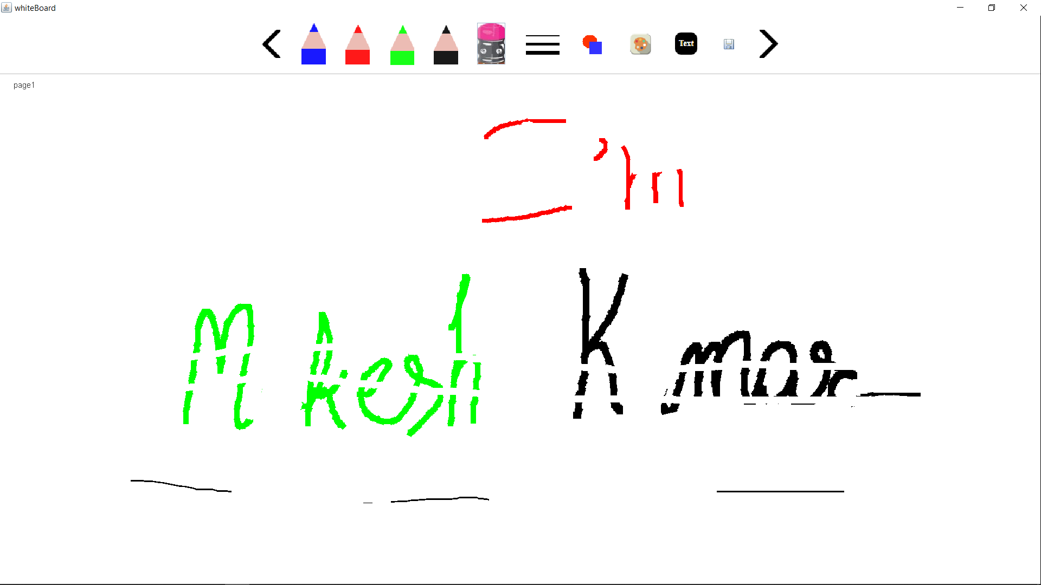

After see the picture you will notice the some content is erased and that erased by using the eraser function of whiteboard.

**Drawing shapes:-**

To draw the shapes you just have to use the shape icon of whiteboard. When you click on shape icon to select shapes it will show some different shapes like triangle, rectangle etc.

The next picture show the different shapes .

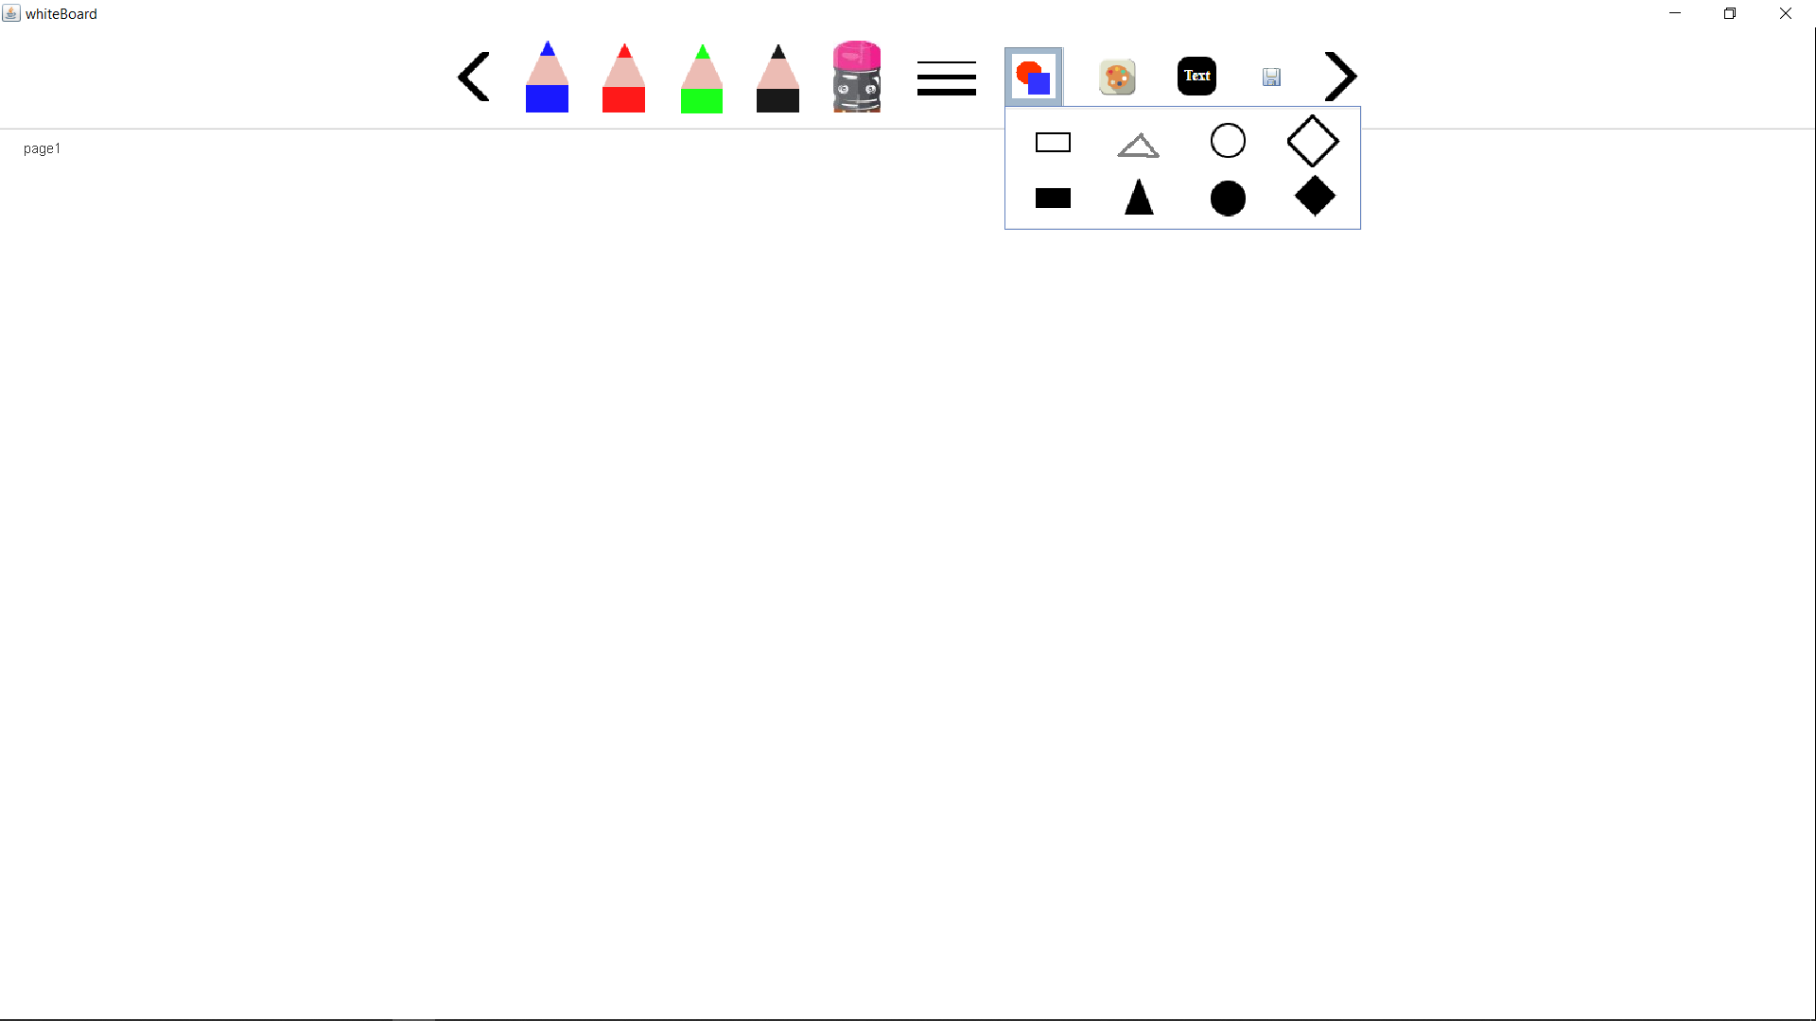

You just have to click on one shape out them to select the shape. After selecting the shapes. Press and Drag the mouse on whiteboard to draw the shape.

The next picture show drawing of shape.

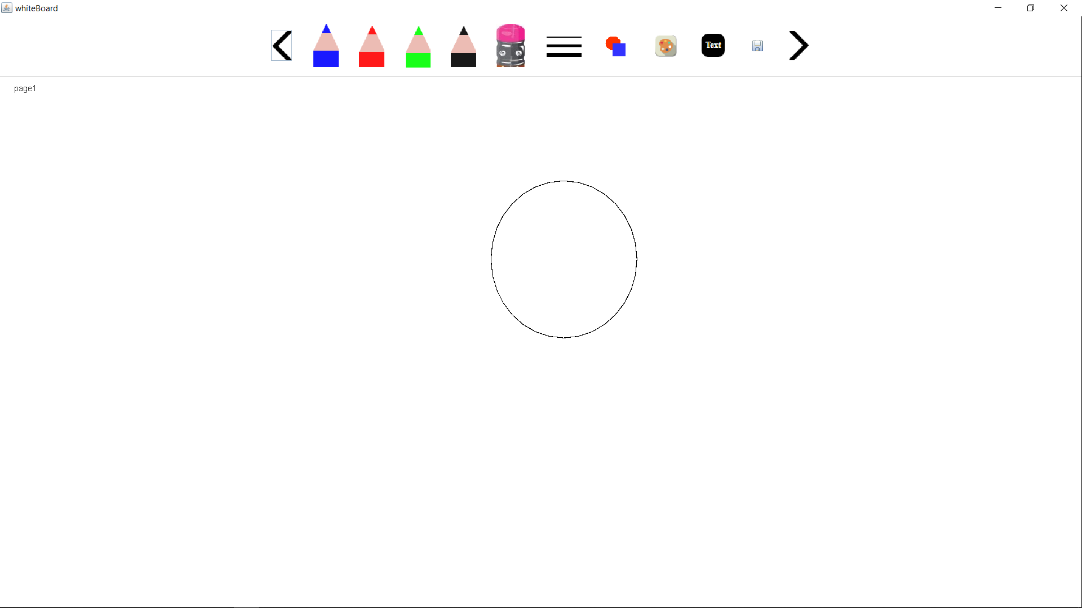

You can select the shape by one click on it as show in following picture. The selected shape will look like the shape is show in next picture.

To deselect the shape you have to click anywhere on whiteboard except the selected shape.

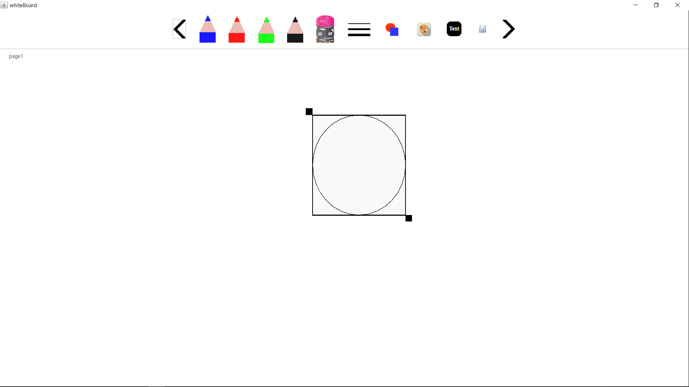

You can change the size of shape using the two small rectangle shown in above picture. To change the size of shape you have to press mouse on one of the small rectangle and drag the mouse. After changing the size of shape. The shape will look like this shown in next picture.

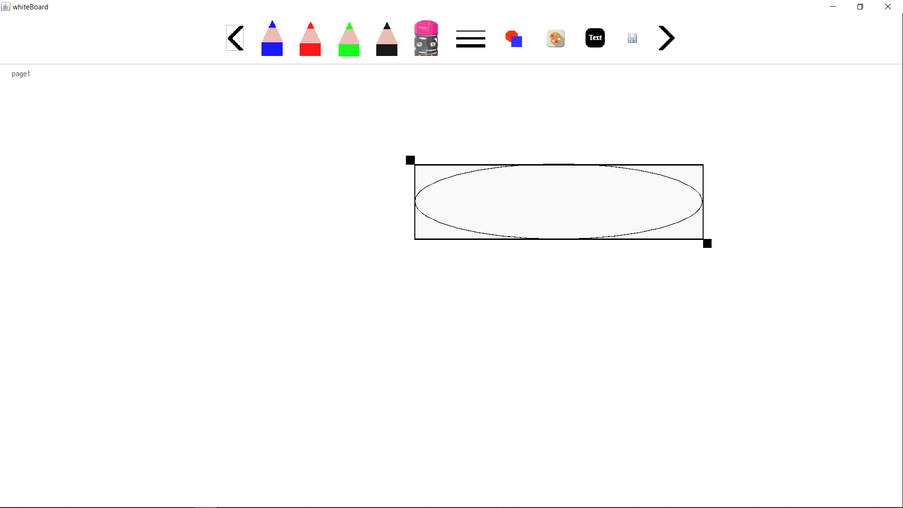

You can also change the position of shape, After selecting the shape by click on it. You have to press the mouse anywhere on the shape and drag the mouse where you want to place the shape.

The next picture show changed position of shape.

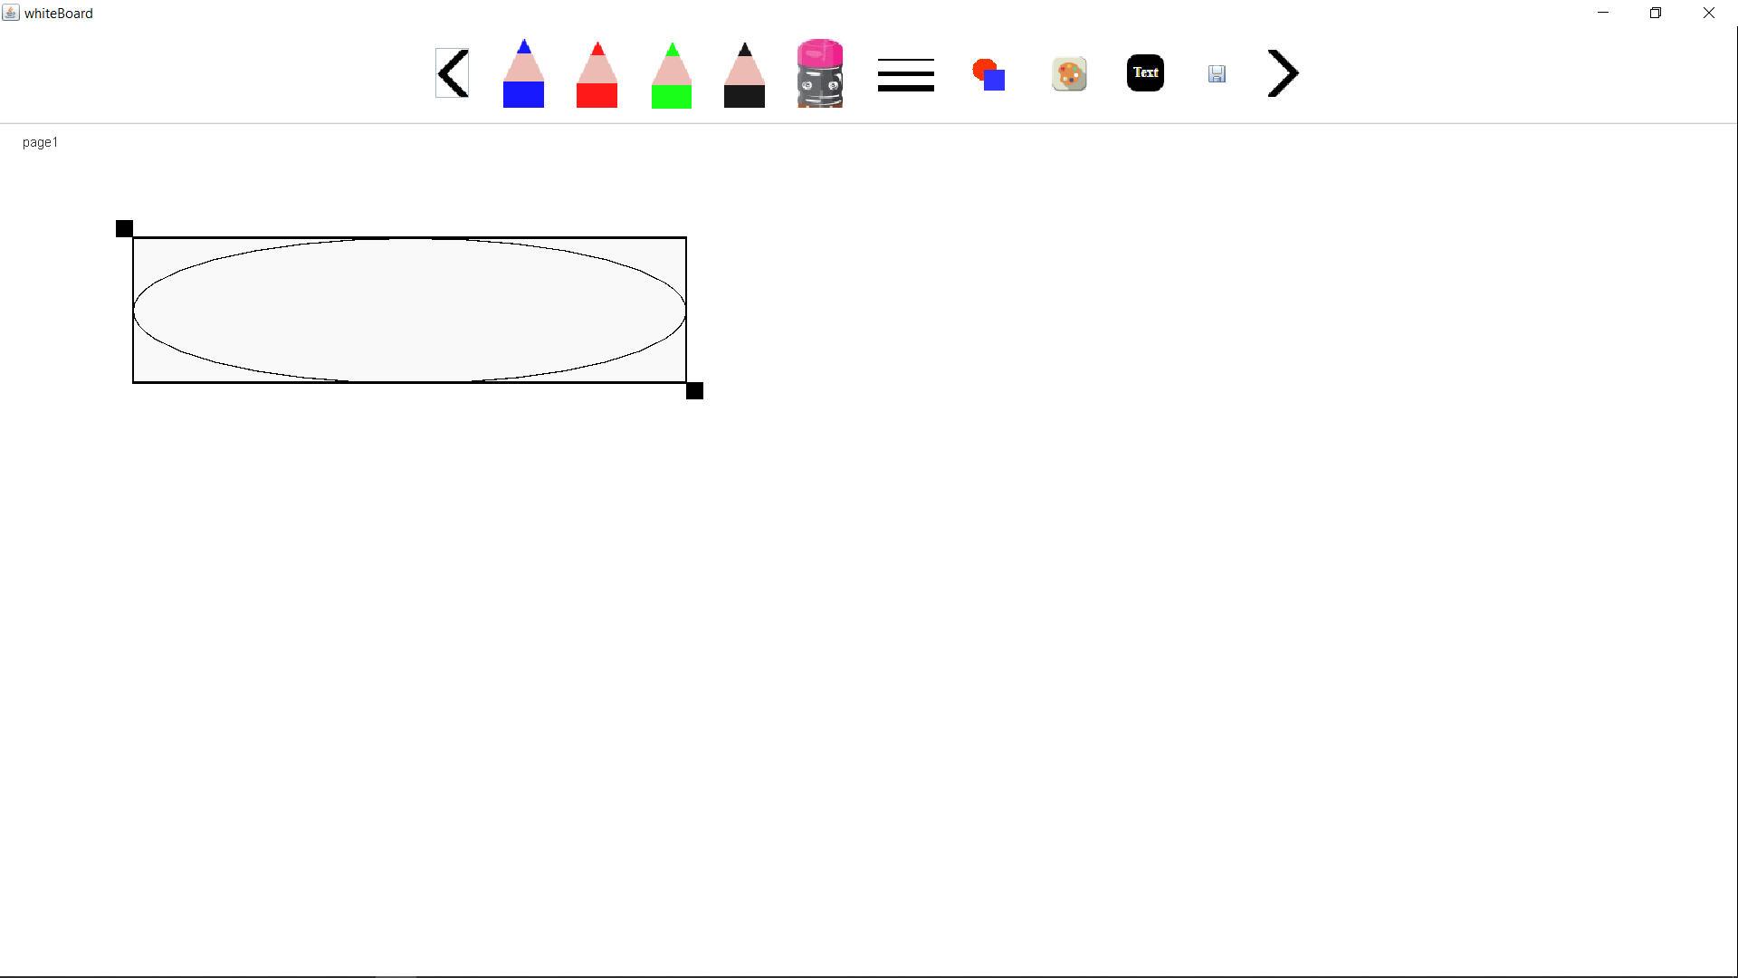

You can also remove the shape by three time click on the shape. After three time click on selected shape the whiteboard look like this as show in picture.

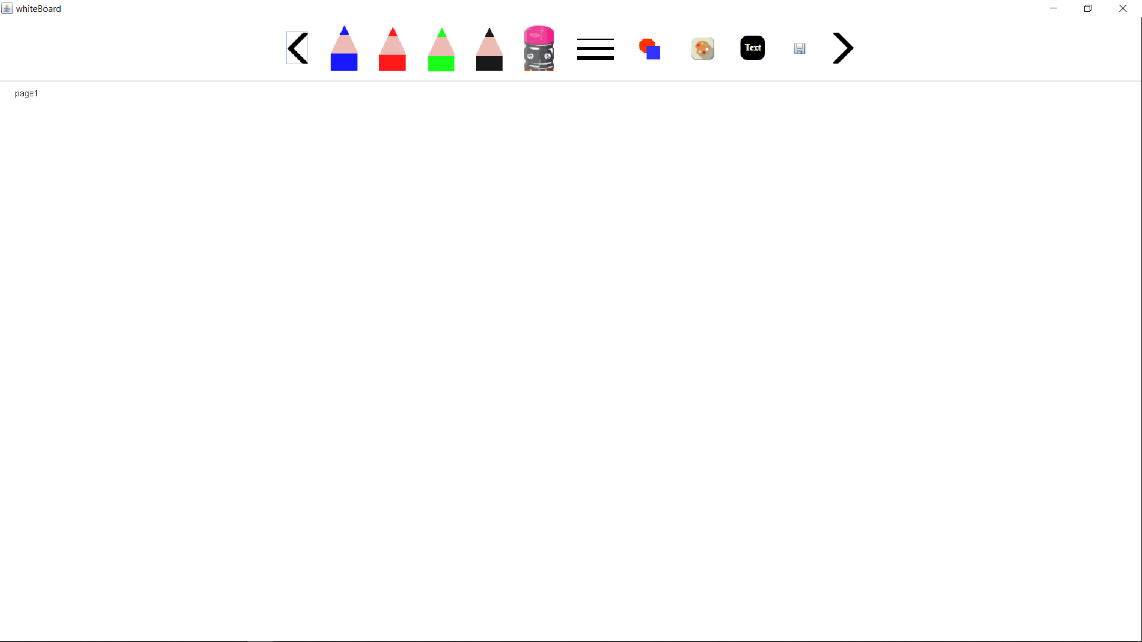

The picture above shows that there is no shape is drawn. That mean the shape is removed.

You can also draw different shapes on single page. Next picture shows the different shapes.

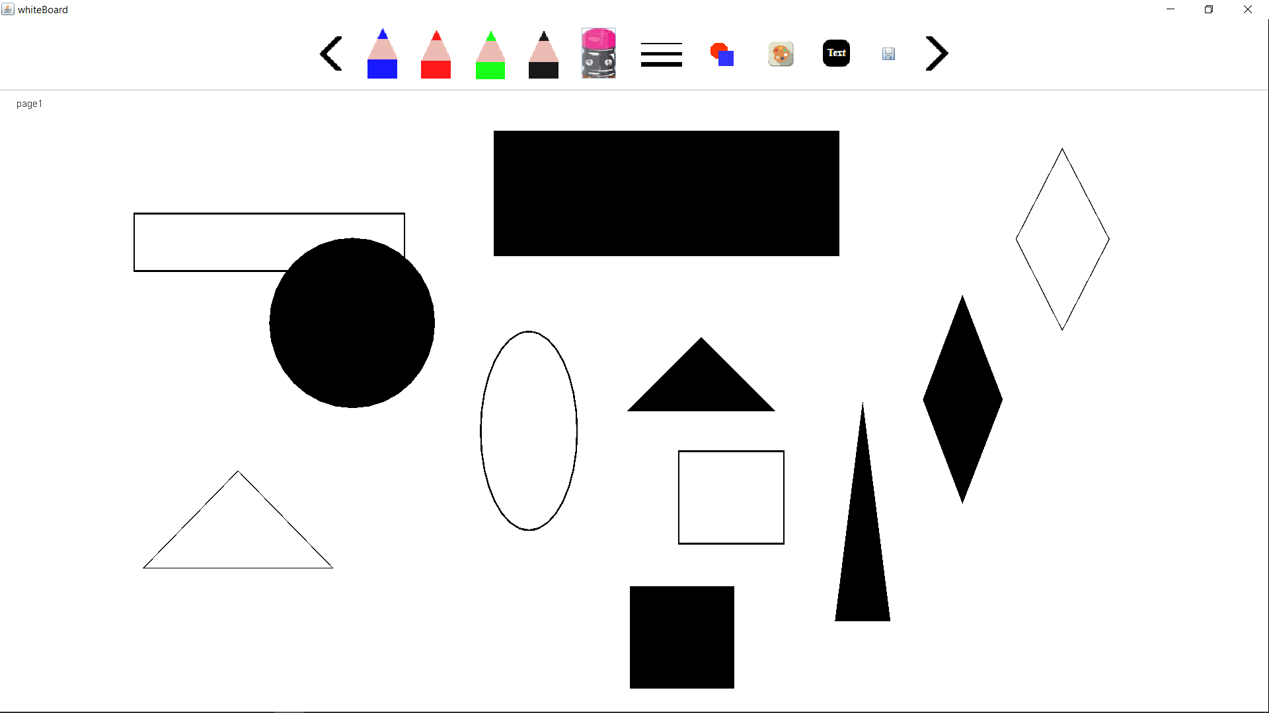

**Selecting Different Colors:-**

You can select different color according your requirement. You just have click on color option. After click on color option, it will show dialog box to select color. After select the color you to click on ‘OK’ button in dialog box to set the selected color.

The picture will show the selection of color.

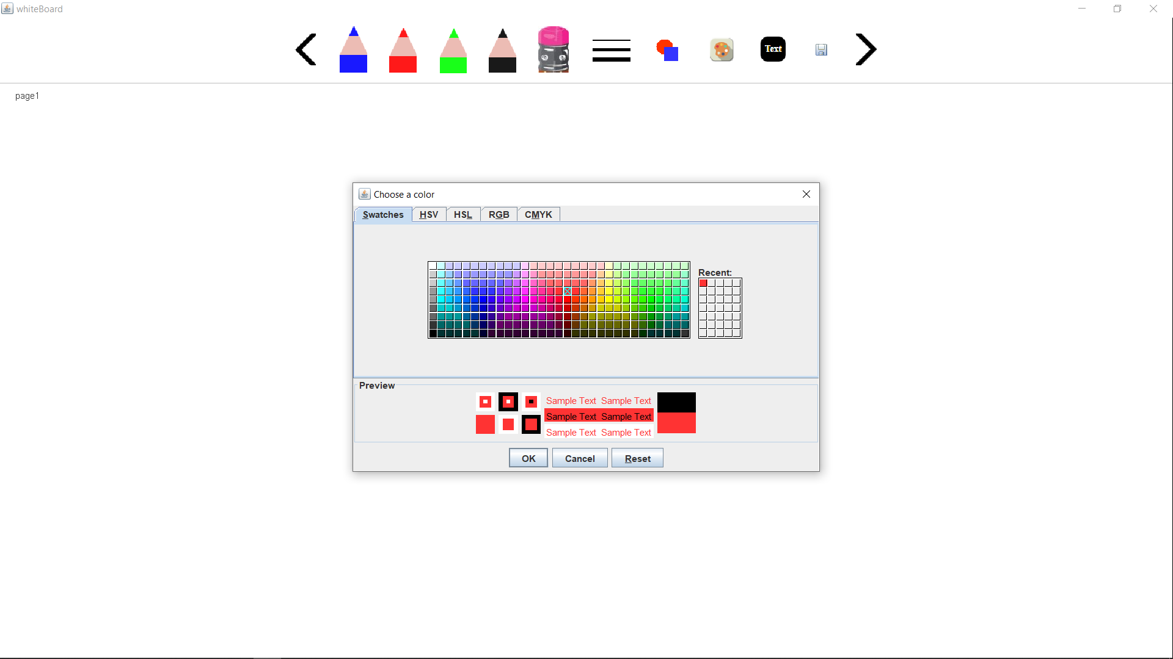

After selecting the color you can draw shapes with different color as show in picture.

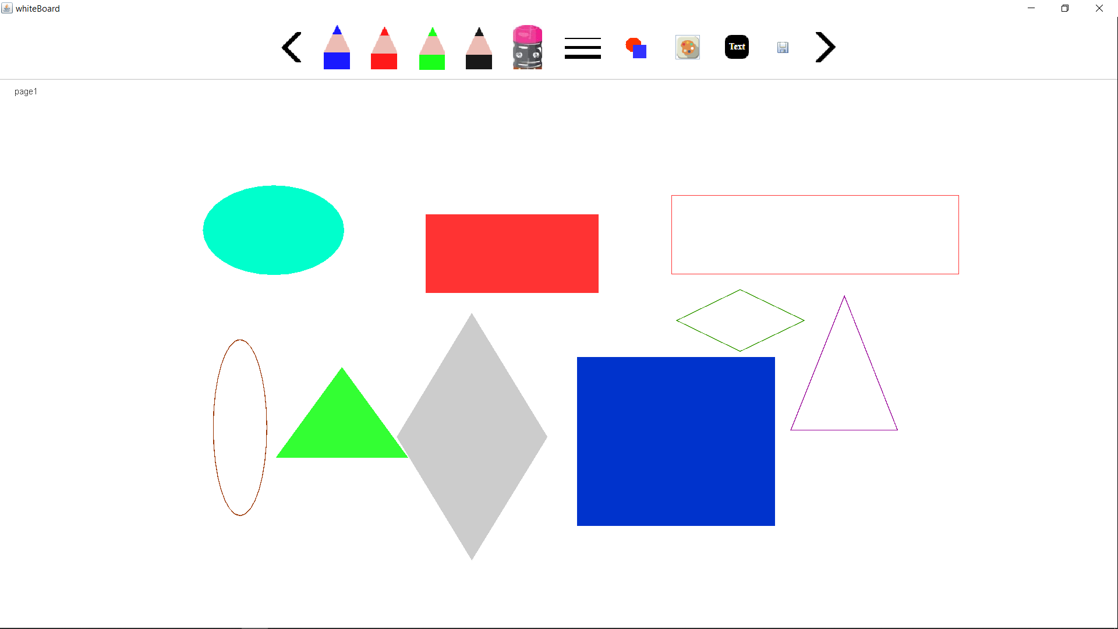

**Draw or Writing text on Whiteboard:-**

If you need to write text on whiteboard, then it is possible for you. You have select the text icon. After click on text icon it will show a text field and an add button as shown in next picture.

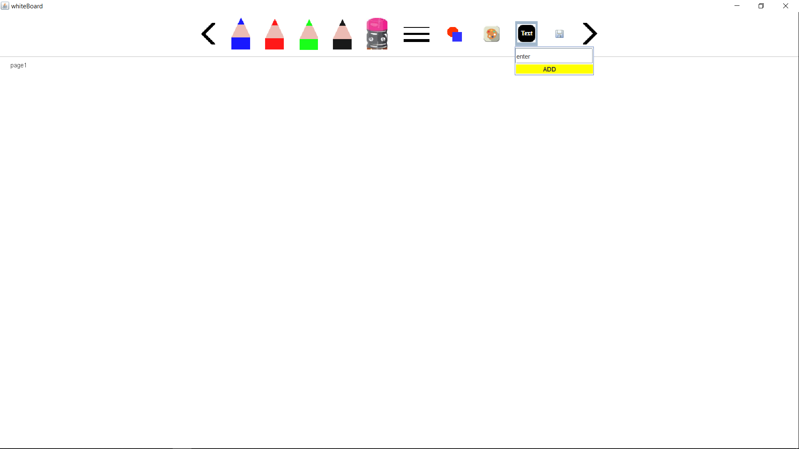

When the text field is showing to you. You just have to enter the text that you want to display. And then press add button. The add button will set your text. After set the text you have to press the mouse where you want to display and then drag the mouse. When you drag the mouse you will the text is inside a rectangle and the height of rectangle is the font size of text that you entered.

After displaying the text whiteboard will look like this as show in picture.

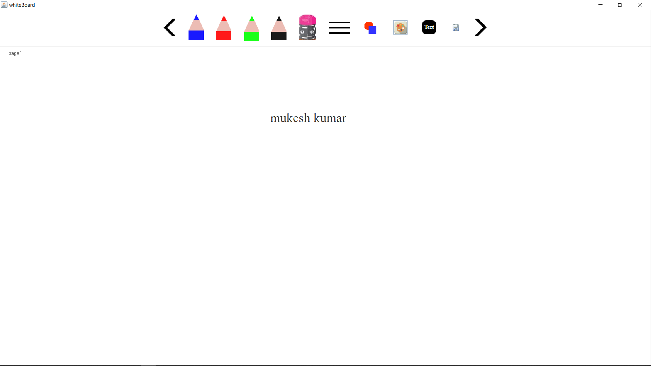

You can also adjust the font size and position of text. To adjust the text, you have click on it to select the text. After selection of text, you will see that the text is inside a rectangle and also there is two small rectangle. As show in picture.

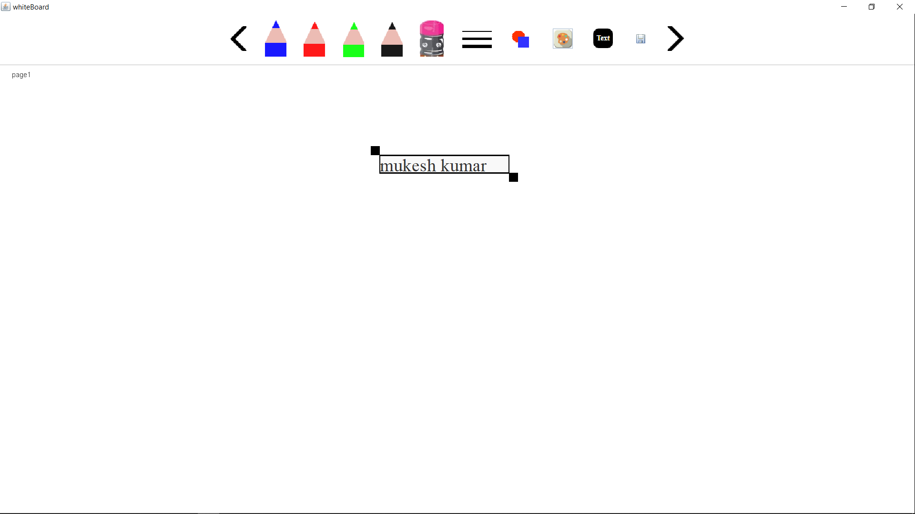

These two small rectangle is used to change the font size.as show in picture.

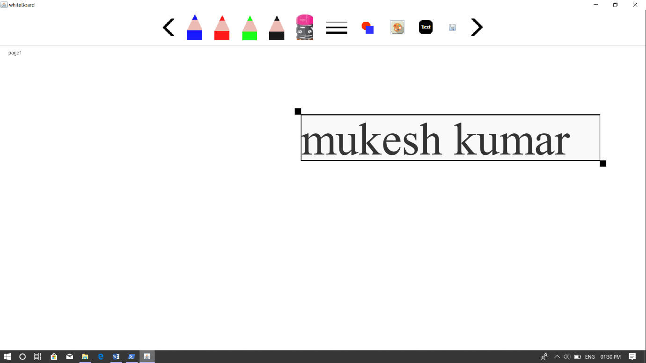

And after pressing mouse on selected text and drag mouse to change the position of text.as show in picture.

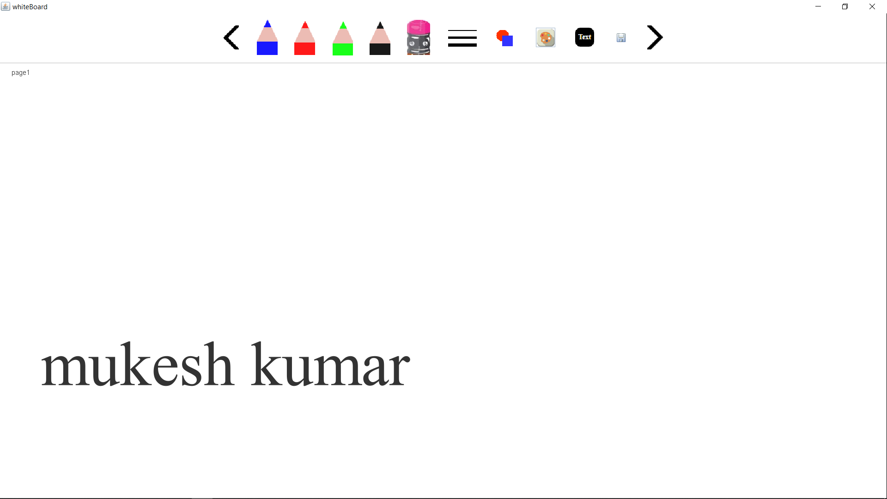

You can also remove the text by three time click on selected text. As show in picture

You can also change the color of text as your need. To change the color of text, you have select the color from color option and then set the text and the draw or write on display or whiteboard. The next picture shows texts with different colors.

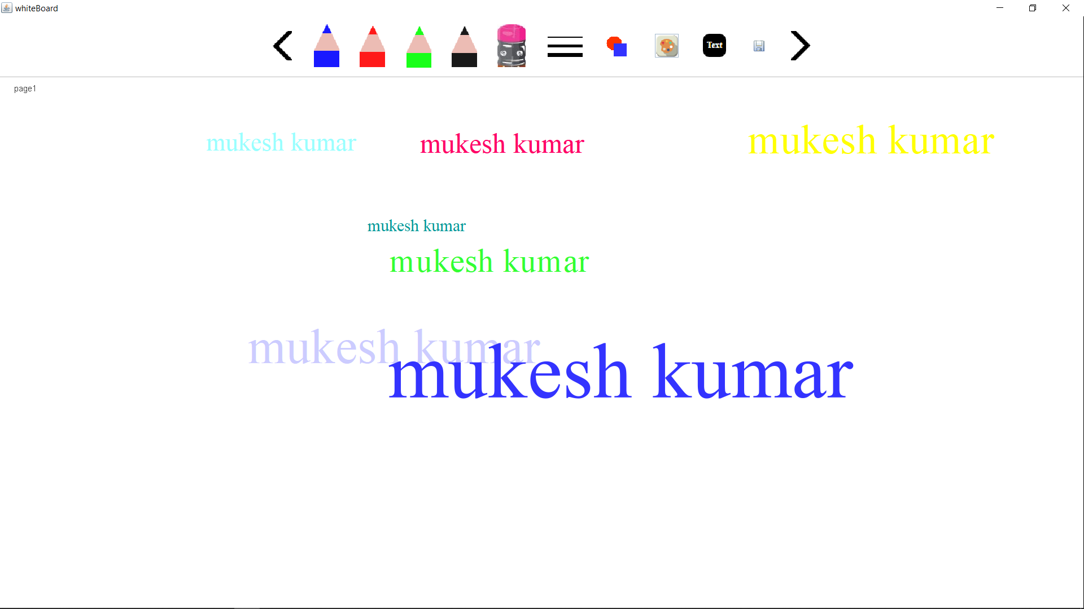

**Next and Previous page:-**

The first and last icon are for previous and next page respectively. If your current page is fully filled , you have not space to use then you can move toward next page by click on next icon i.e. the last icon. And can also edit or view previous page if it have.

The following picture show some pages , you can check the page number given top-right corner.

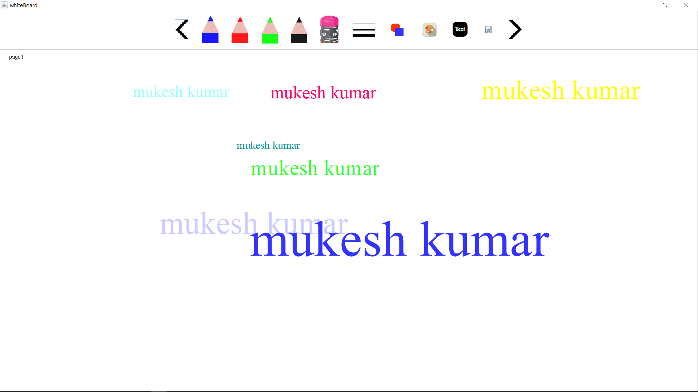

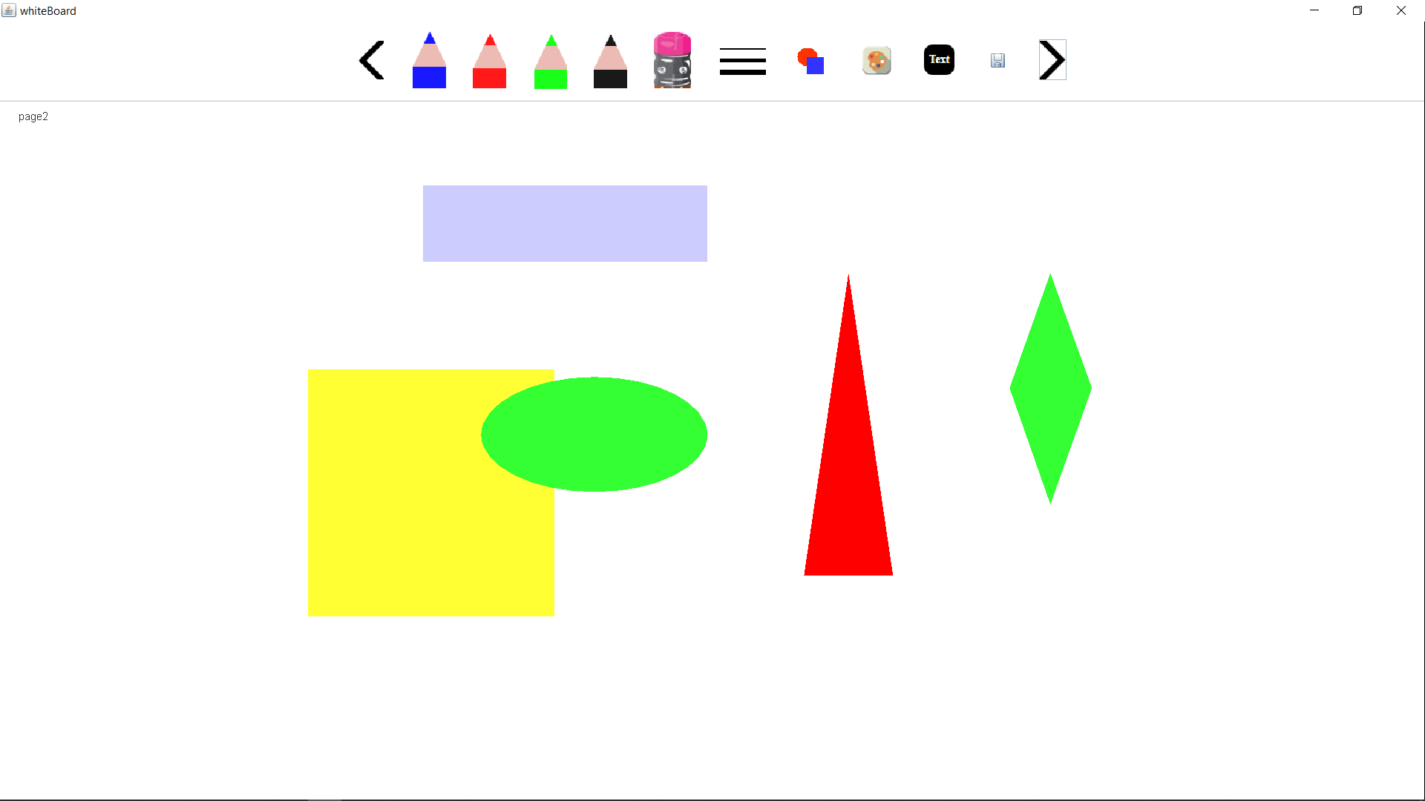

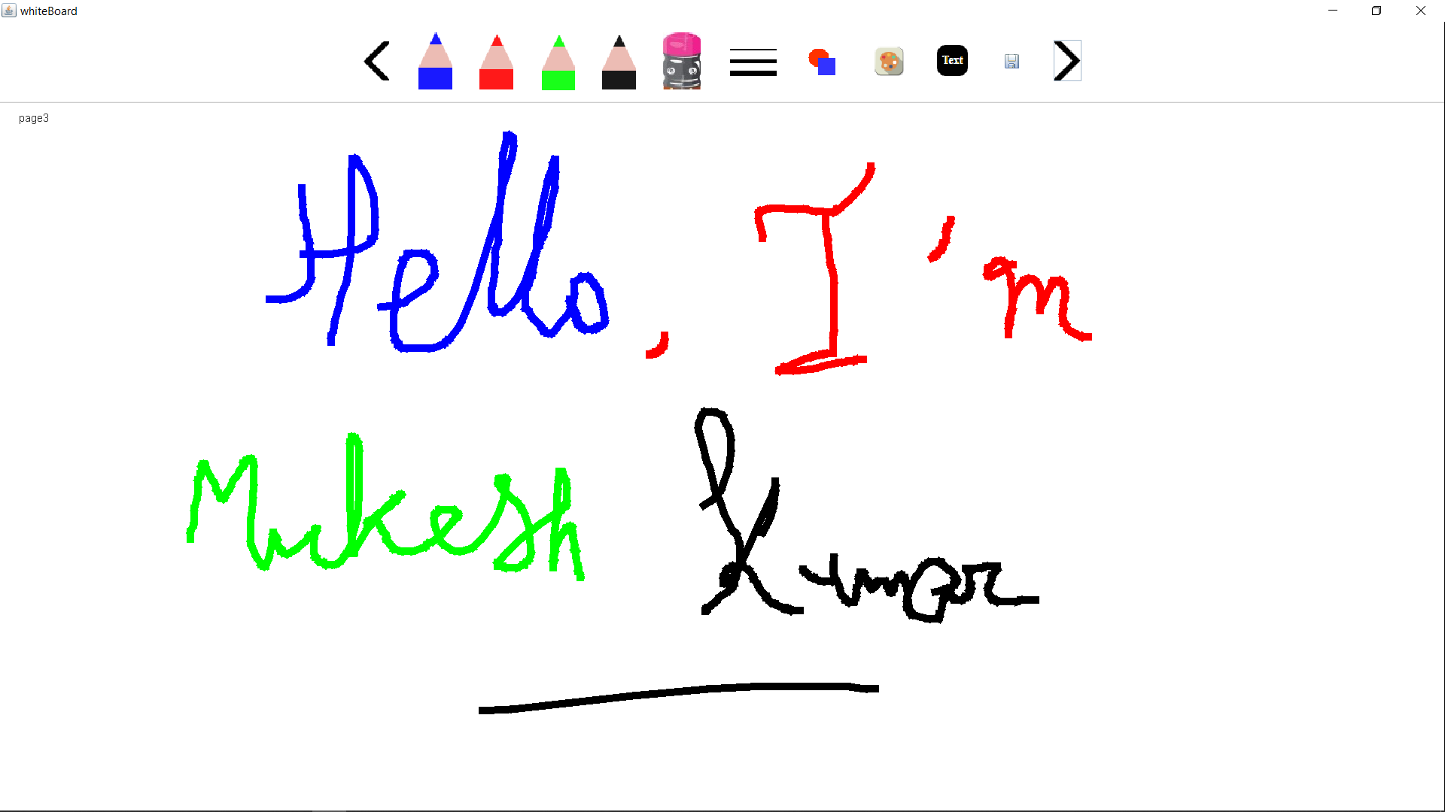

**Saving as images:-**

At the last if you have finish your work with whiteboard then you can save all the pages that are used.

To save the content you have to click on save option at the second last. When click on save option then a dialog box is open that have some locations as shown in next picture.

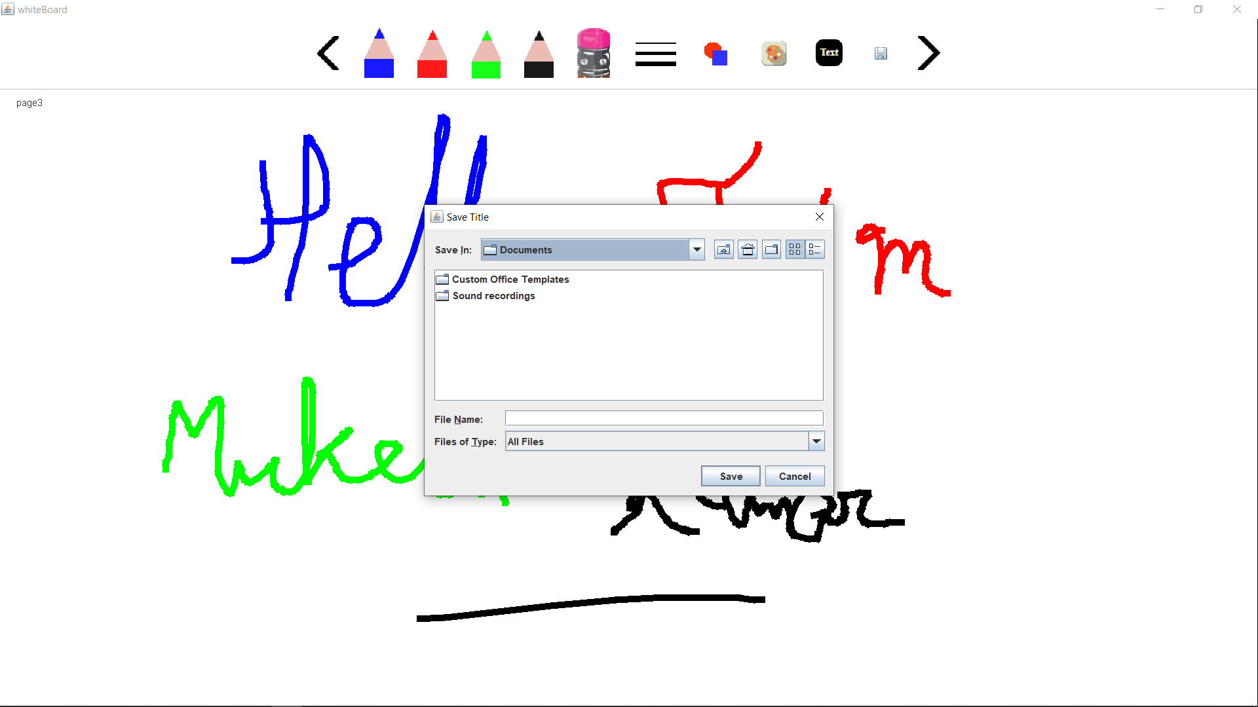

You can select a specific location and a specific to save the images.

**Chapter 5. Conclusion/Recommendation**

**5.1 Conclusion and Future Scope: -**

In the modern world, an interactive whiteboard or IWB is very popular among the new generation, especially for solving work problems. Interactive whiteboard works with the attachment of a computer and is projected by a projector. It is a phenomenal type of tool. It is used as a replacement for the white or black boards in schools. Students show a lot of interest in it as it works and displays information just like a desktop computer. Teachers now need and demand it so that they can store information, study plans and all the past work which they have done for the review of students and as the working routine for them.

It is the best technology for students for the repetition of their lesson and for seeing all the information again which they had learned at one time. Due to this feature, it has become ery popular among youngsters and students of every field. Students could save their lectures and make notes and they would not have to carry a lot of papers and books for their daily studies. All the doctors and workers of the other fields use these boards in their daily routine and work for the success of their employers.

It is very beneficial for students who are absent from class or for getting past papers and information on important issues. Students can store very detailed lectures and information in the form of points and headings for ease in their studies and carriers. There are a lot of uses for it in many fields. Its demand is increasing day by day due to its great features and extraordinary qual