**Question:1**

**Simple_String_methods:-**

**CaseFold()**

*This is inbuilt function which provided by the python  
Main functionality of this method  
This method more less a bruteforce one because it won't bother it will convert everything into lowercase*

***endswith()*** *it will checks last indices of the targetString is present in the source  
Here it will compares the characters from last  
If any character is not matched returns true or returns false*

***isalnum()****Its checks is there any digit is available in the  
just compare each character bitsize and checks bits is falling out of the captial and small cases of the alpbabets*

***istitle()*** *It checks each word in the sentence are starting with the Captial letter or not*

***join()***

*It is an inbuilt string function in Python used to join elements of the sequence separated by a string separator.*

*This function joins elements of a sequence and makes it a string.*

**Question:2**

**Simple Spilt function:**

**Rfind(userParam)**

Returns the right-most index of the substring if it is found in the given string; if not found, then it returns -1.

**Rindex(Userparam):**

Returns the highest index of the substring inside the string if substring is found. Otherwise it raises an exception.

**LStrip**

A set of characters to remove as leading characters. By default, it uses space as the character to remove.

**Question:3**

**find_and_split:-**

search = ","

pos = (a_name.find(search))

Find(Seperator):-

Find method will takes separator as parameter ,it will split the given string with given String and will return **List’s** zero Index length value

And return

**Using different splits :-!,&,\*** for different userInputs

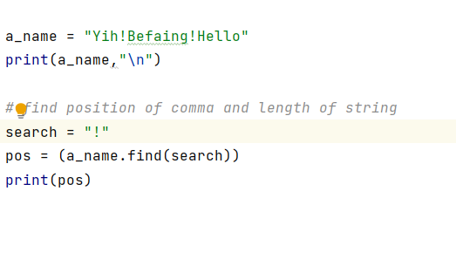

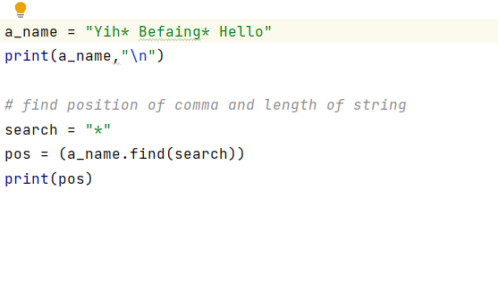

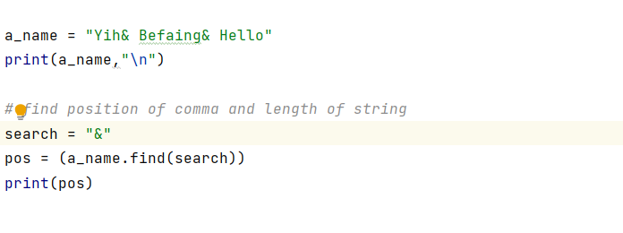

**How “:” works in array-index.**

Array[start:end]

It was internally designed iterate the digits from start point to end point-1 and incrementing

One step

It’s a simple for loop:**for(int i=0;i<10;i++)**

Here we mentioned I starts from zero and ends when I reaches to Zero

Start to End and incrementing one step

**Question:4**

**Sample_python_function**

Sample_python_function:-Mathematicals

It will make round the value

*#It will rounds the value to upper decimal*a=2.35  
print("Ceil",math.ceil(a))  
  
*#It will find the value the GCD of the two values*a=12  
b=24  
print("GCD",math.gcd(a,b))  
  
*#It find the values of the square root of the given value*a=16  
print("Sqrt of the value",math.sqrt(16))  
  
*#It will find the product of the given values  
#sequence(a,b,c) --> a*b*c*sequence = (3,5,10)  
print("multication ",math.prod(sequence))  
  
  
*#It will find the value of the*print ("Sin value of zero ",math.sin(0.00))  
print ("Sin value of 90 ",math.sin(math.pi/2))

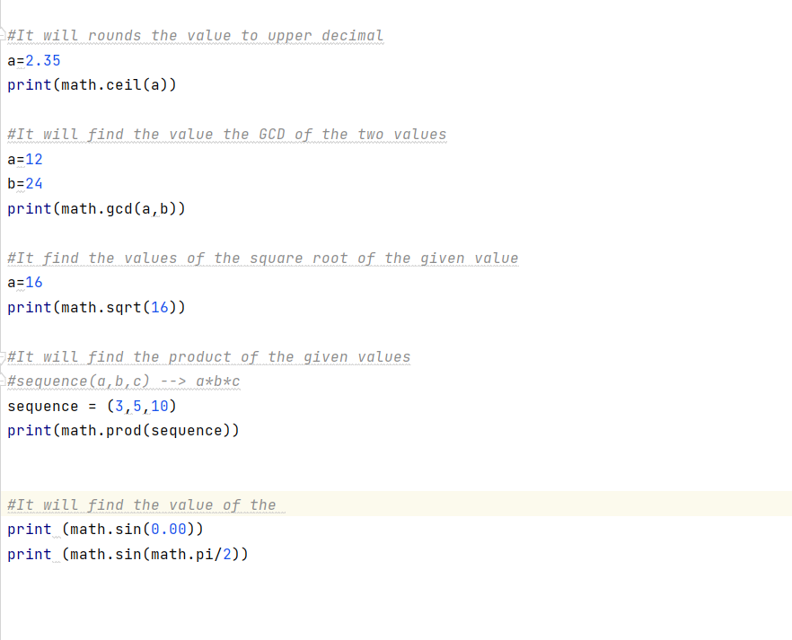

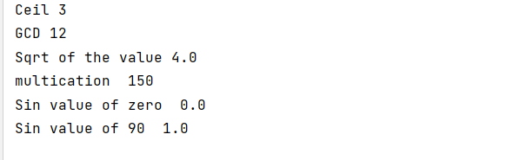

**Question:5**

**Armstrong**_**number**

Tried Armstrong number for different numbers

And code changed



