Executed different types of text by using default print function

**File Name:hello.py**

**FileName:-hello_version.py**

**Import Keyword:-**In every programming there are some in built functions are there .

Print is inbuilt functions it will takes some parameters are input those will be printed.

Some of the functions we need to imported, so that imported functions are available at runtime and code execution will be done.

**from decimal import Decimal is an example.**

We converted String to Decimal by passing value to Decimal()  
  
**Format keyword:-**It’s nothing but replacing a value at given place

The substitutions are identified by braces ('{' and '}').

Internal Implementation of the format Method

**FileName:Sample_variables**

Added some other variables and found their data types by using in-built **Type** function

**FileName:math.py**Changed I,**X** and **Y** values and performed some below operations ,Additions, Subtraction,Division,Modulus,Exponentiantion,Multiplication,Floor Division

Performed BODMAS operations.

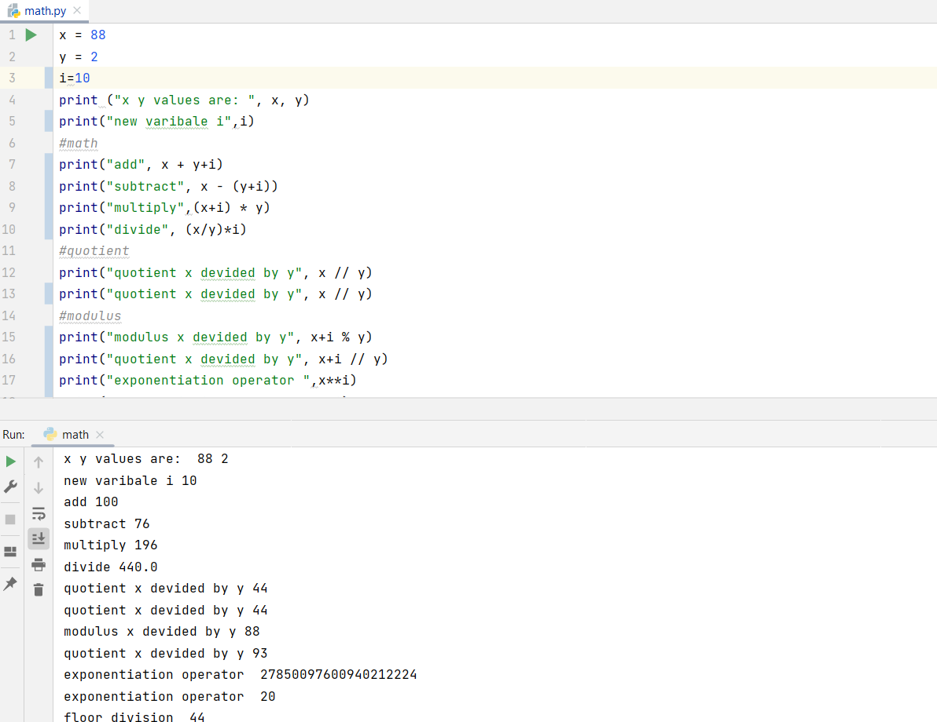

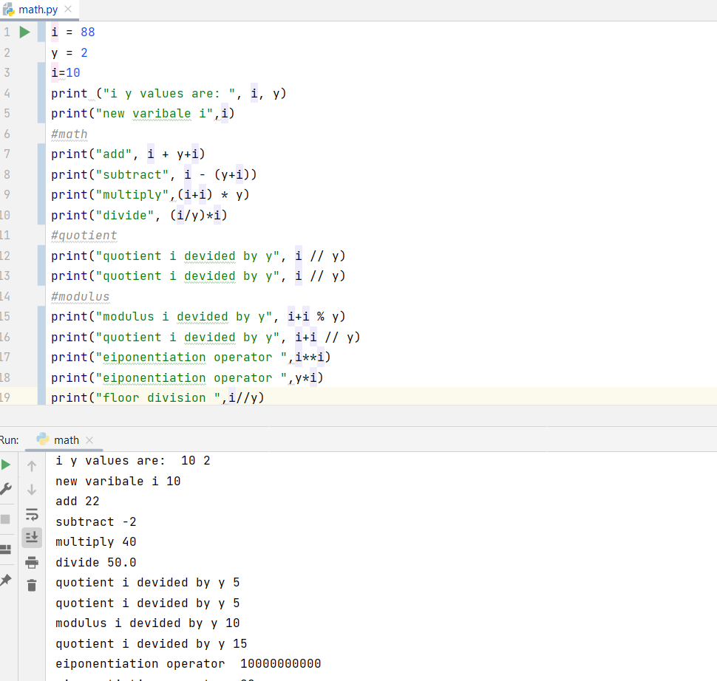

**FileName:-Test_input.py**

**Input() keyword:** takes input from user and initialize where it need

Comments about input(Python official Documentation)

a,b are new two variables and they are initialised at same line.  
added new Decimal DataType variable and taken user Input and printed them

"""

Read a string from standard input. The trailing newline is stripped

The prompt string, if given, is printed to standard output without a

trailing newline before reading input

If the user hits EOF (*nix: Ctrl-D, Windows: Ctrl-Z+Return), raise EOFError.

On *nix systems, readline is used if available.

"""

**Type() keyword:**

It will take initial variable and find it’s datatype :Int,Boolean,Decimal,String

**Int() keyword:**It’s data type in python it will stores Integer Type Numeric DataTypes

**Float() keyword:** It’s data type in python it will stores Float Type Numeric DataTypes

**Source:GeeksforGeeks**