**Boolean.py**

**If-else and if-else statement:**

When to use: If there **userInput** ,and need to do check multiple cases/Conditions.

Example:- Leap Year Check

Condition 1:Year %400 and year %100

Condition 2:Year%4 and Year%100!=0

We are checking conditions at same time

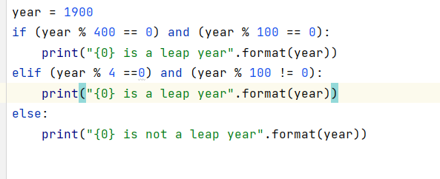

**Conditionals.py**

Reference:W3 Schools

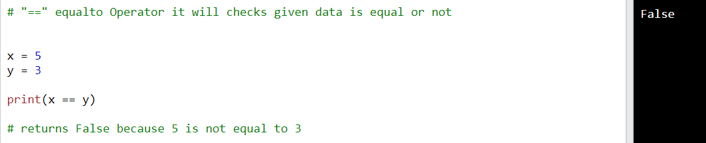

**LogicalOperators**

**logical_compares.py**

When to use:If there are multiple conditions and we need to them at once(statements are combined at once)

**Nested-If loops:-**

**When to Use:** If there are multiple conditions need to be checked for given usecase.

In below case we case checking if first condition is true and we moved further step and checked another condition

