**Lab2B01 :Test Cases**

**Question 1** Lab2B01.py

def convertInttoRomanNumberical(userInput):  
  
 dict={}  
 dict[1]="I"  
 dict[2]="II"  
 dict[3]="III"  
 dict[4]="IV"  
 dict[5]="V"  
 dict[6]="VI"  
 dict[7]="VII"  
 dict[8]="VIII"  
 dict[9]="IX"  
 dict[10]="X"  
  
 print("Roman Numberal",dict.get(userInput))  
  
if __name__ == '__main__':  
 userInput=input("Enter a number from one to 10:")  
 if(int(userInput)>10):  
 print("Number entered from one to 10:",userInput)  
 else:  
 convertInttoRomanNumberical(int(userInput))

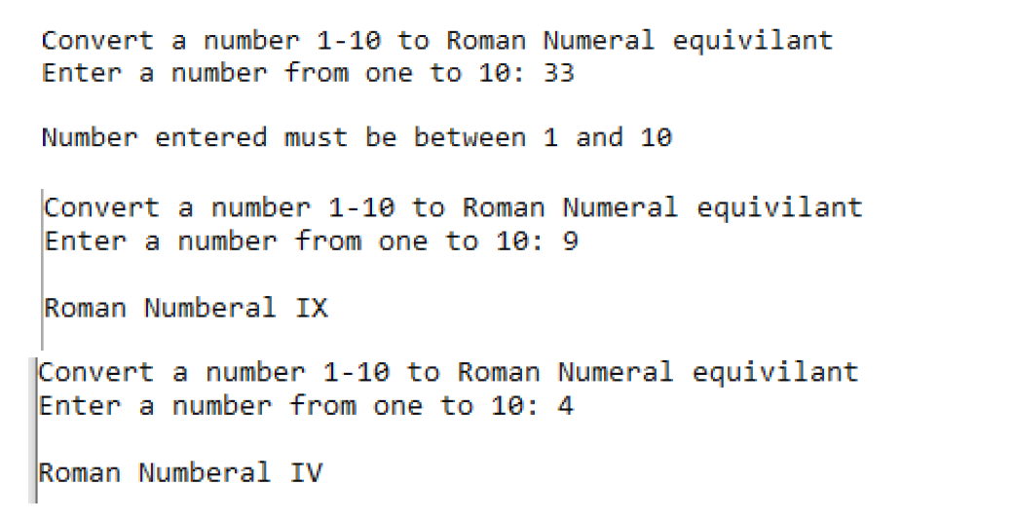

Case:1

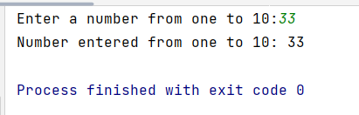

Case:2

Case:3

Question2: Lab2B02.py

def magicDateCheck(mm,dd,yy):  
 if(mm*dd==yy):  
 print(mm,dd,yy,"IS a magic date")  
 else:  
 print("The entered date is invalid")  
  
  
if __name__ == '__main__':  
 mm=int(input("Enter mm for month:"))  
 dd=int(input("Enter dd for day:"))  
 yy=int(input("Enter yy for year:"))  
 magicDateCheck(mm,dd,yy)

Case:1

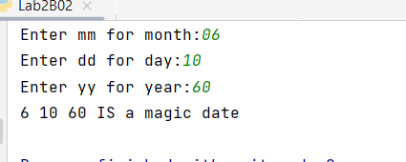

Case:2

Question3: **Lab2B03.py**

def rouleteeWheel(userInput):  
 if(int(userInput)==0):  
 print(userInput,"is green")  
 if(int(userInput) in range(1,11)):  
 if(int(userInput)%2==0):  
 print(userInput,"is red")  
 else:  
 print(userInput,"black")  
 elif(int(userInput)in range(11,19)):  
 if(int(userInput)%2==0):  
 print(userInput,"is red")  
 else:  
 print(userInput,"black")  
 elif(int(userInput)in range(19,29)):  
 if(int(userInput)%2==0):  
 print(userInput,"is black")  
 else:  
 print(userInput,"red")  
 elif(int(userInput)in range(29,37)):  
 if(int(userInput)%2==0):  
 print(userInput,"is red")  
 else:  
 print(userInput,"black")

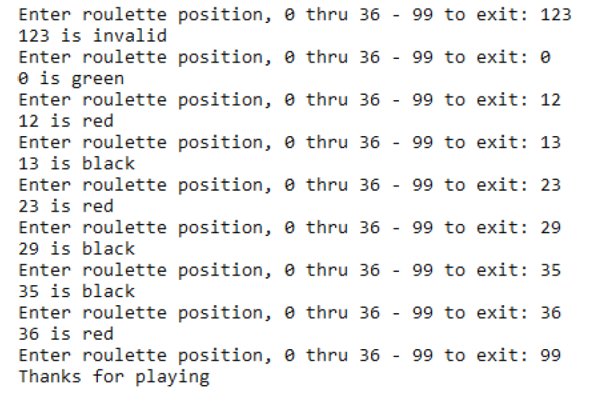

Case:1

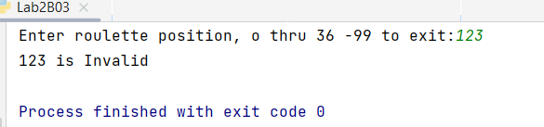

Case:2

Case3:

Case4:

Case5:

Case:6

Case:7

Case:8

