Note:Comments are included in python script files

Question:1

**Lab3B01.py**



if __name__ == '__main__':  
  
 userInput=input("Enter number of between 1.00 and 999.99 inclusive:")  
 userInput=float(userInput)  
 if( userInput>=float(1) and userInput<=float(999.99) and userInput!=float(555.55)):  
 print("Yes,","{0:.2f}".format(userInput),"is valid")  
 elif(userInput==555.55):  
 print("{0:.2f}".format(userInput),"to exit")  
 else:  
 print("no,","not valid")

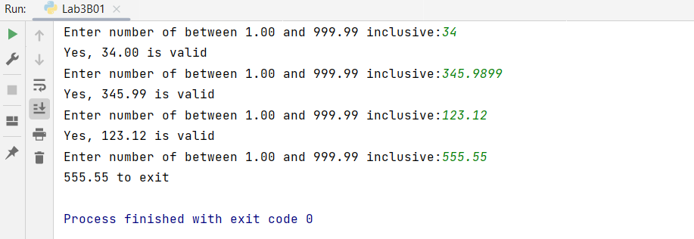

Question:2



if __name__ == '__main__':  
 a=[]  
 for i in range(5):  
 x=i+1  
 a.append(input("Enter a number - counter at {usrInput} :".format(usrInput=i+1)))  
 print("Now convert the list to a tuple")  
 print("Print the tuple in reversed order")  
 res=tuple(i for i in a[::-1])  
 for i in range(len(res)):  
 print("Reverse print - counter at {usrInput} :".format(usrInput=5-i),res[i])

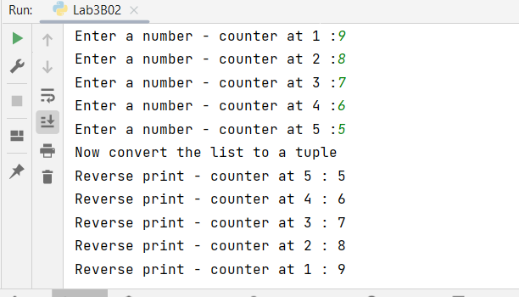

Question 3



if __name__ == '__main__':  
 a=[];  
 a=[]  
  
 a.append(float(input("Enter sales in dollars for Mon : ")))  
 a.append(float(input("Enter sales in dollars for Tue : ")))  
 a.append(float(input("Enter sales in dollars for Wed : ")))  
 a.append(float(input("Enter sales in dollars for Thu : ")))  
 a.append(float(input("Enter sales in dollars for Fri : ")))  
 a.append(float(input("Enter sales in dollars for Sat : ")))  
 a.append(float(input("Enter sales in dollars for Sun : ")))  
  
 dict={}  
 dict[a[0]]="Mon"  
 dict[a[1]]="Tue"  
 dict[a[2]]="Wed"  
 dict[a[3]]="Thu"  
 dict[a[4]]="Fri"  
 dict[a[5]]="Sat"  
 dict[a[6]]="Sun"  
  
 print("Total sales were ${0:.2f}".format(sum(a)))  
 print("Average sales were ${0:.2f}".format(sum(a)/len(a)))  
 print("Greatest sales were ${0:.2f}".format(max(a)),dict[max(a)],".")  
 print("Least sales were ${0:.2f}".format(min(a)),dict[min(a)],".")

