**Question:-1**

**List:**

List in python will stores the inserted order.

It will store heterogeneous data, it does not consider any data type we have given

Some of the inbuilt functions of list

**Source :Official Python documentation,**

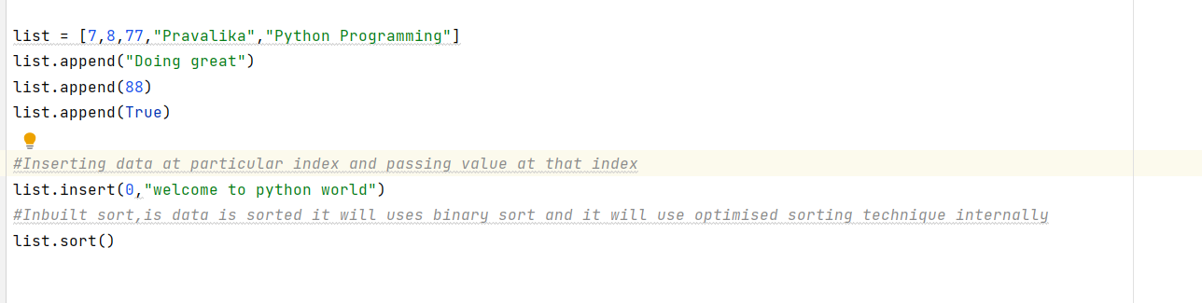

**Question:2**

**Tuple:-**

Tuple creation:-

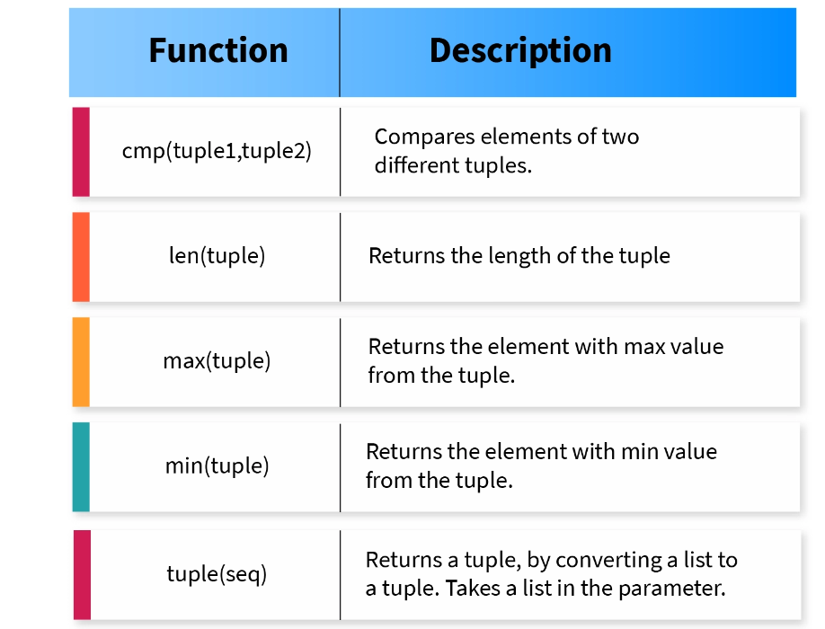

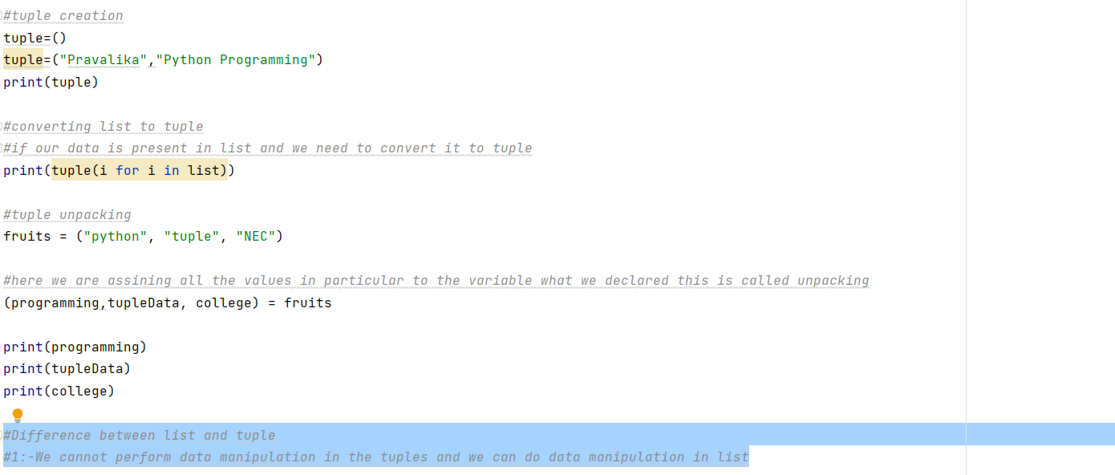

**Question:3**

**While loops:-**

**When to use:-**If we don’t know how many iteration we need to do to get required solution

**How to use:**-Here we know about the condition, so we will repeat the process until condition statement is failed

Below code snippet says, While condition will be exited will user statement is true and used break key word

**Question:4**



For data in list:

Print(data)

This will iterate the each data record in the list until it reaches the list

**Question:5**

**Dictionary/HashMap:-**

**What is dictonary:**

**Basic Operation on Dictionary:-**



**Iteration of dictionary**

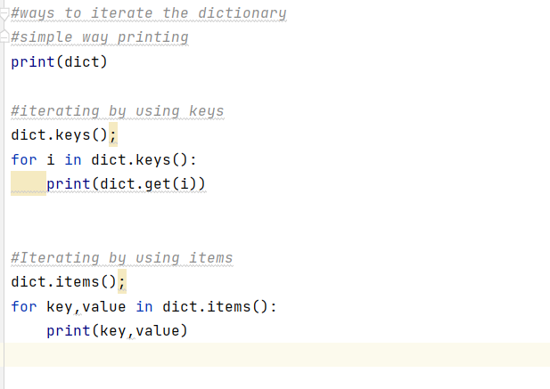

**Question:6**

**List/tuple Iterations:-**

**Explanation is given with comments .**

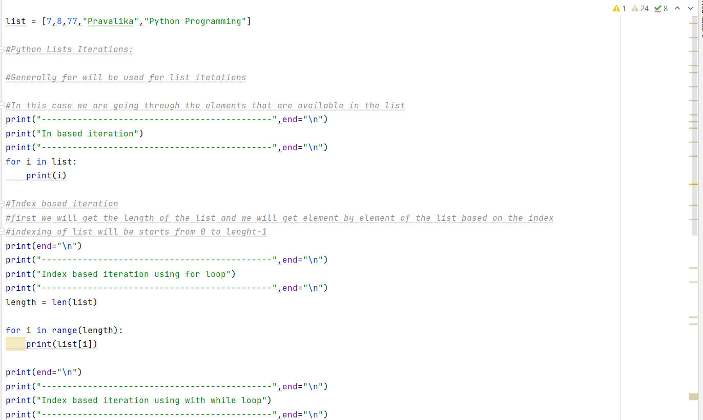

**Outputs for ListItreations**

**Backward Iteration of List:-**



