**Test_local.py**

**Global and Local Variables**

**Local Variables**:-Local Variables address will be stored in the heap and it will happens when the Object is formed.

Local variables are declared in the function and they will be utilized and manipulated inside of that function   
They cannot be accessed outside of the function,  
Once function execution is done that variable will be destroyed.

**Global Variables:-**Global variables are declared outside of the function and inside the class

Global Variables are accessed within class and also in the function

They will be access and manipulated throughout the program execution

They can be accessed by using the className directly using the class name instead of using the object creation

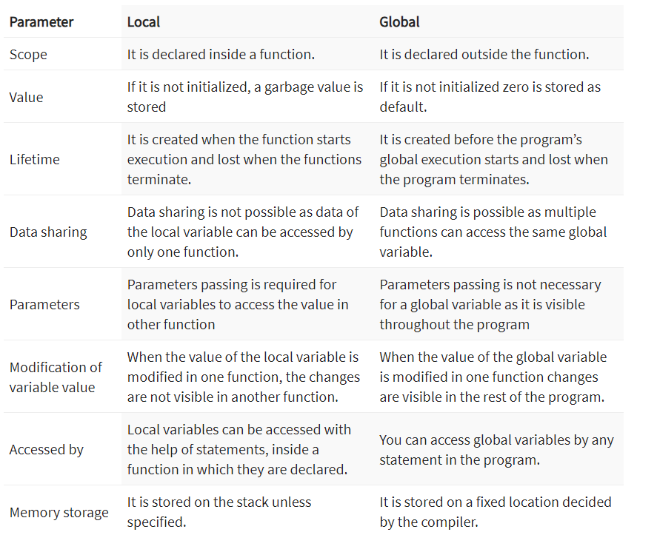

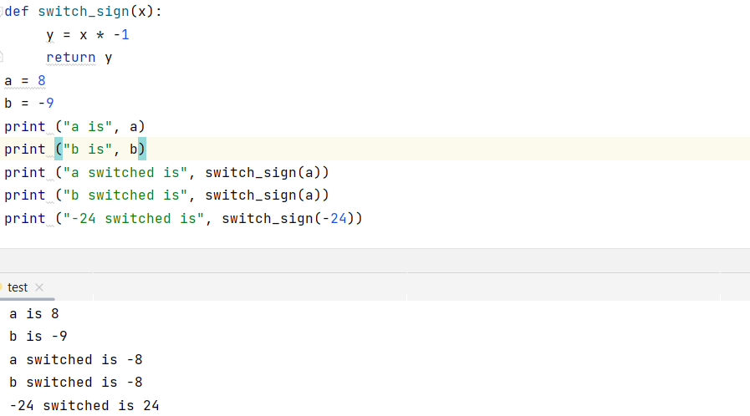

**Function Declaration:-**

Function is declared by the keyword(def) and followed by the functionName()

Once code is compiled and then address will be assigned to the function where the functionality is also called

**Why statements on lines 23 and 24 are commented out? If uncommented, what will happen when this program is run? You may need to test the code for clarification of your answers**

They are local variables and we cannot access them .

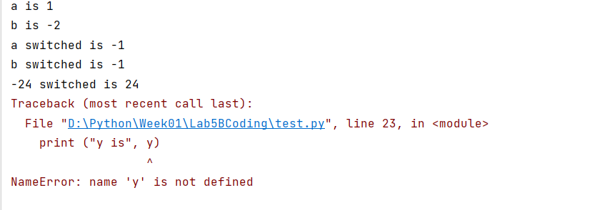

**2:-function_find_and_split.py**

In this function we are just finding the index of the special character and storing it into a variable,  
and then we are splitting the string based on the **pos** index.

If the search “character “ is not in the string it will returns -1 .

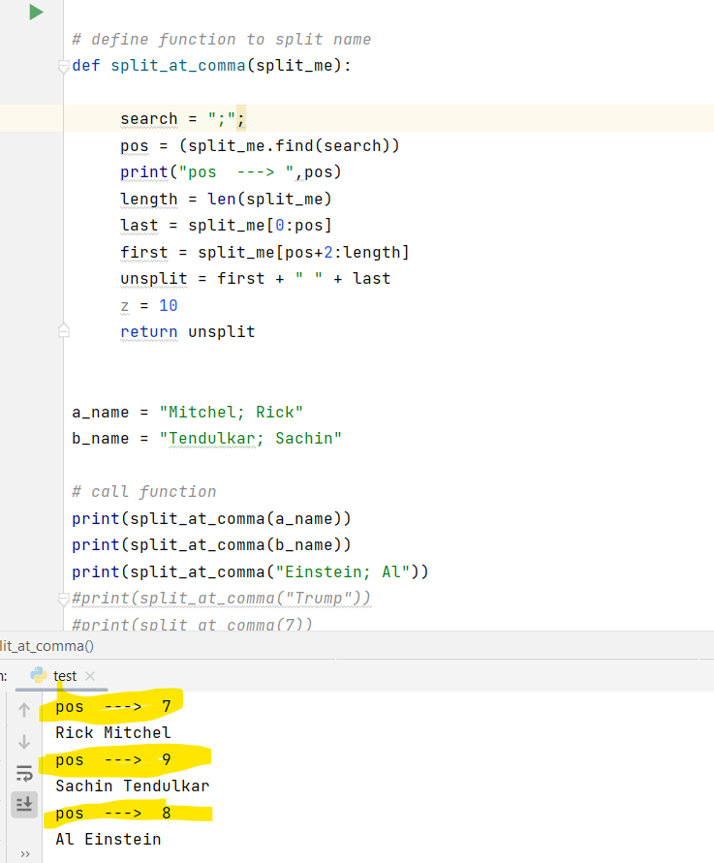

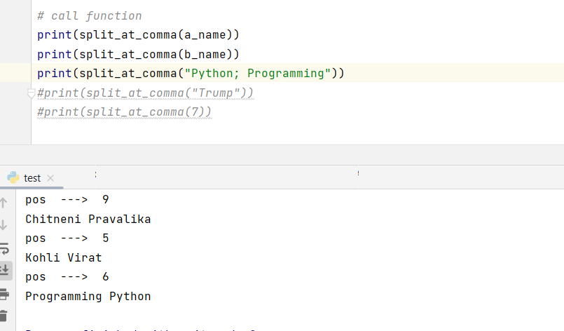

Why statements on lines 26 and 27 are commented out? If uncommented, what will happen when this program is run? You may need to test the code for clarification of your answers

Once we have uncommented the comment code it will gives following error,  
Search method will not works for integer and there are some local variables and they cannot initiated outside the function

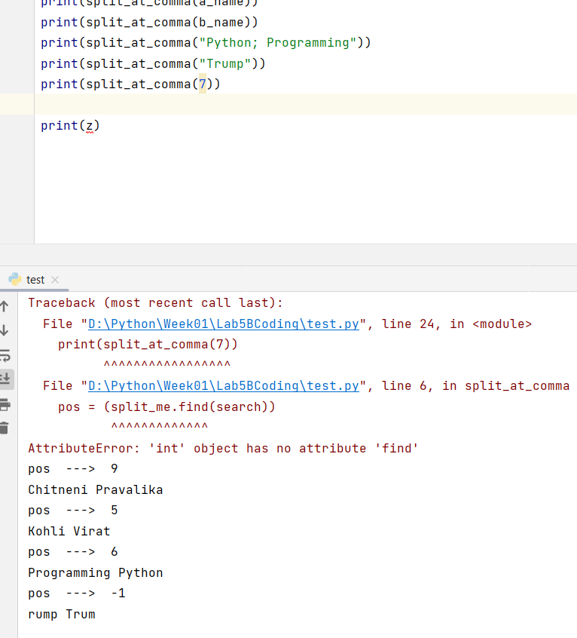

3:-“**function_temp_default.py**” and “**lamba_temp_convert.py**”

Convention function declaration will be starts with keyword(**def**) and in Lambda it’s starts with keyword

In normal function we will have good idea of the flow and how to tweak and manipulations and control over variables also

In lambda we cannot get that one

**lambda.**

Lambda function in Python are nonymous functions created using the `lambda` keyword. They are concese, single-line functions that don't require explicit declaritions in the namespace. Lambda functions take parameters directly after the `lambda` keyword, and the result of the expression after the colon is implicitly returned. Unlike reguler functions define with `def`, lambda functions are often used for short, temporary operations and do not use parenthesis for parameters. They are a convenient way to create small, inline functions in Python.

A few Difference between lambda and normal function

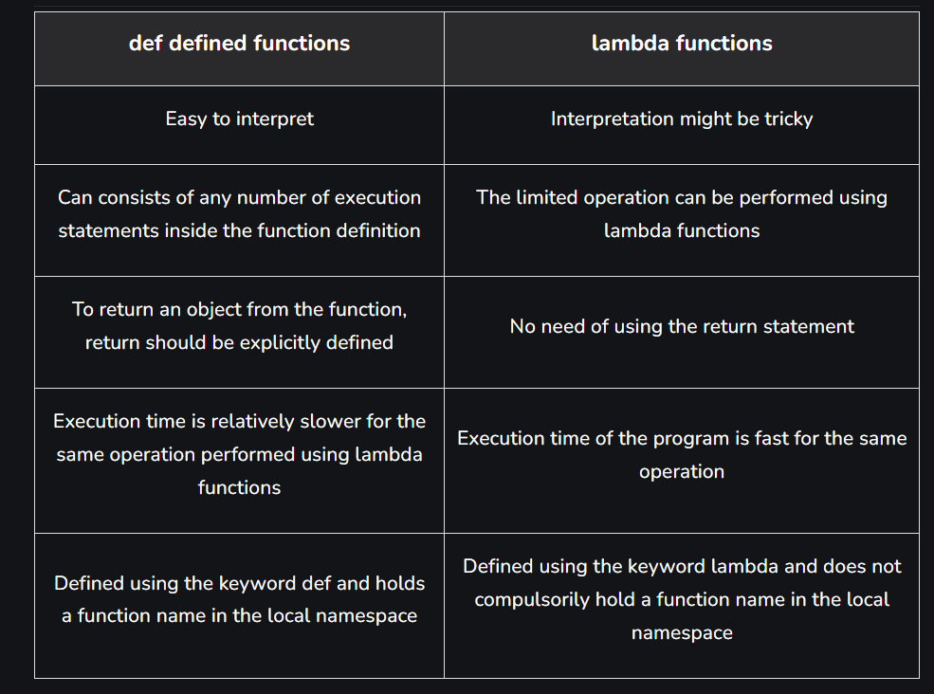

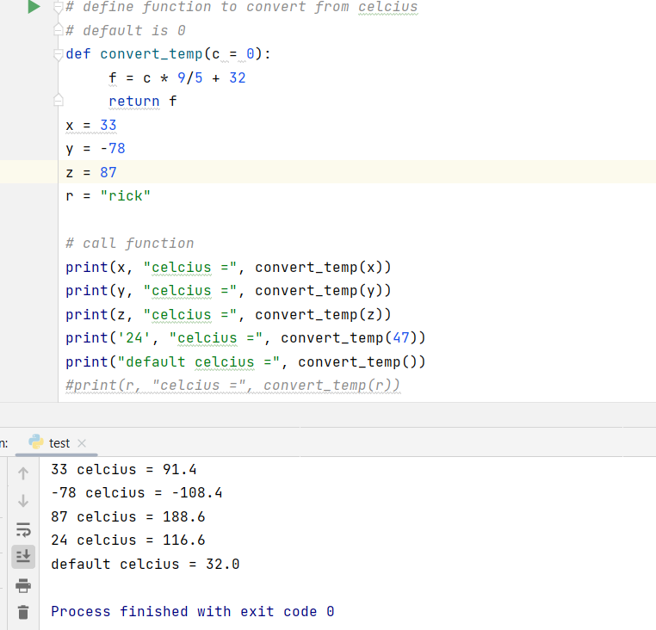

**Lamdba**

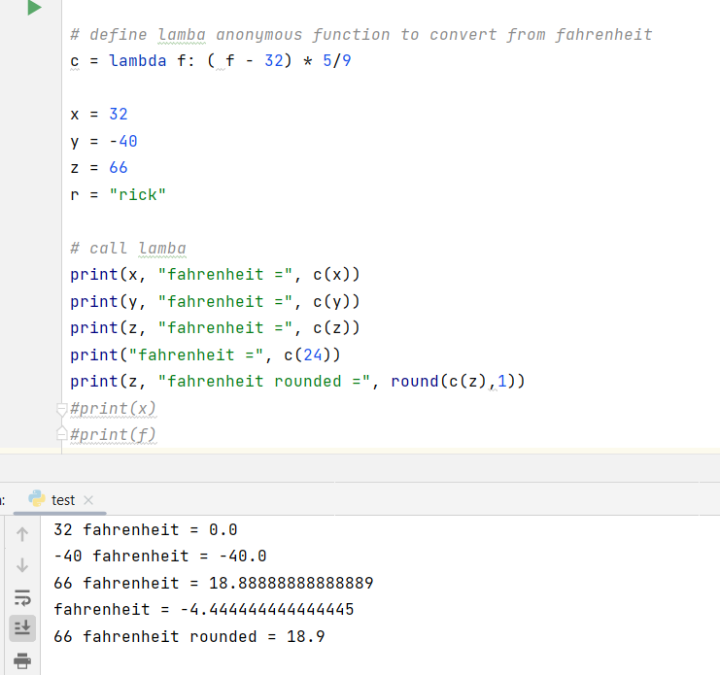

**On uncomment code:-**It will throws error to us because,we cannot perform arthimatic operations on the string datatype,and there is another local variable which we are trying to access from outside

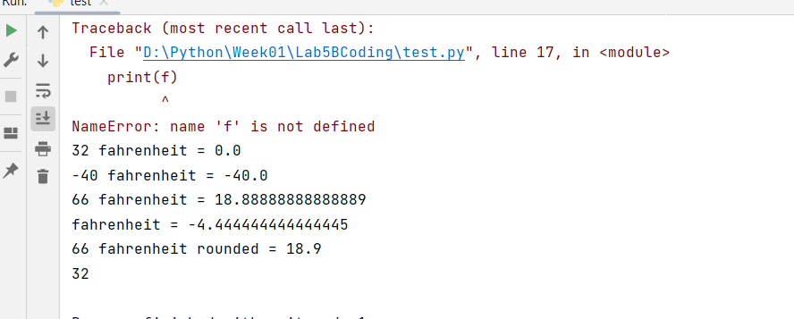

**4:-function_rec_defalut.py**

In below function we are passing the parameters with the values, they are keyword with arguments.

Default arguments are keyword arguments whose values are assigned at the time of function definition. Optional arguments are default arguments that, based on the values assigned to them (e.g., None or 0), can be disregarded.

