**start_up:-**

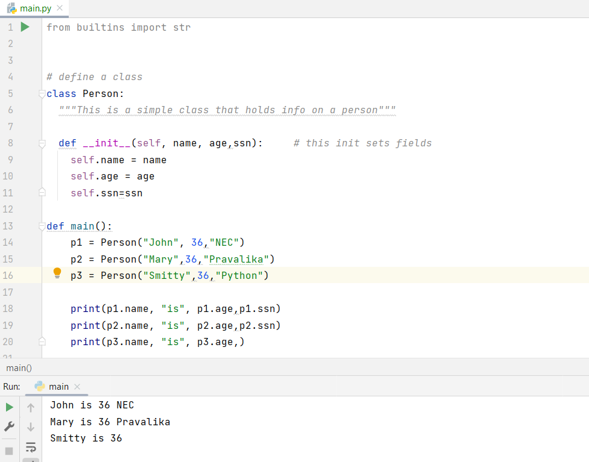

**Explanation:-**

Person class with attributes name, age, and ssn are declared and then created constructor and constructor is used to initialize the attributes of the class when an instance is created.

In the main function, you've created three instances of the Person class: p1, p2, and p3, each with different values for name, age, and ssn.

Once p1,p2,p3 objects are created and then all the attributes are called and then we have printed that data.

**dog_class**

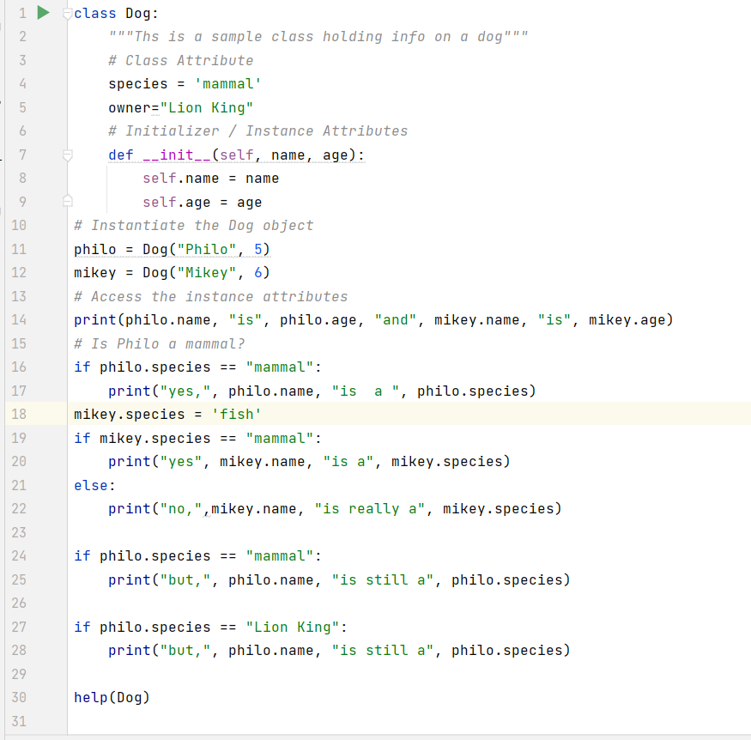

Explanation:

Created Class named Dog:

It has class level and InstanceLevel attributes

Name InstanceLevel:-Name,Age

Class LevelNames:-species,owner

Created two objects and named as philo and mikey

and we have printed all the data of the attributes.

Here,we have added some if-else conditional loops:

Conditions are added based on the Class level attributes

Class level attributes are Species,Owner

they can be accessed without using the objects,to access we need className,

Same thing is happened in here

Person_class

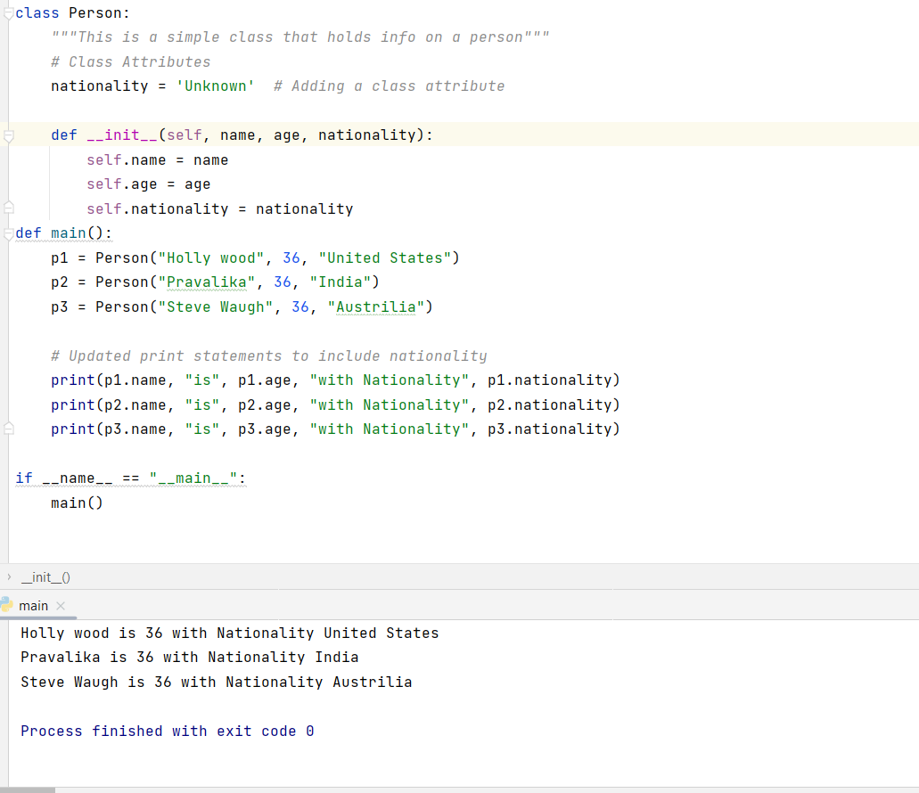

Explanation:-

Person class has been created to represent individuals with attributes such as name, age, and nationality.

The class includes a class attribute nationality set to 'Unknown' by default, and constructor method is updated to accept the nationality as a parameter.

Instances of the Person class are then created in the main function, each with a different name, age, and nationality.

The script prints out information about each person, including their name, age, and nationality.

This modification allows for greater flexibility in specifying the nationality of each person when creating instances of the Person class.

**Rectagle**

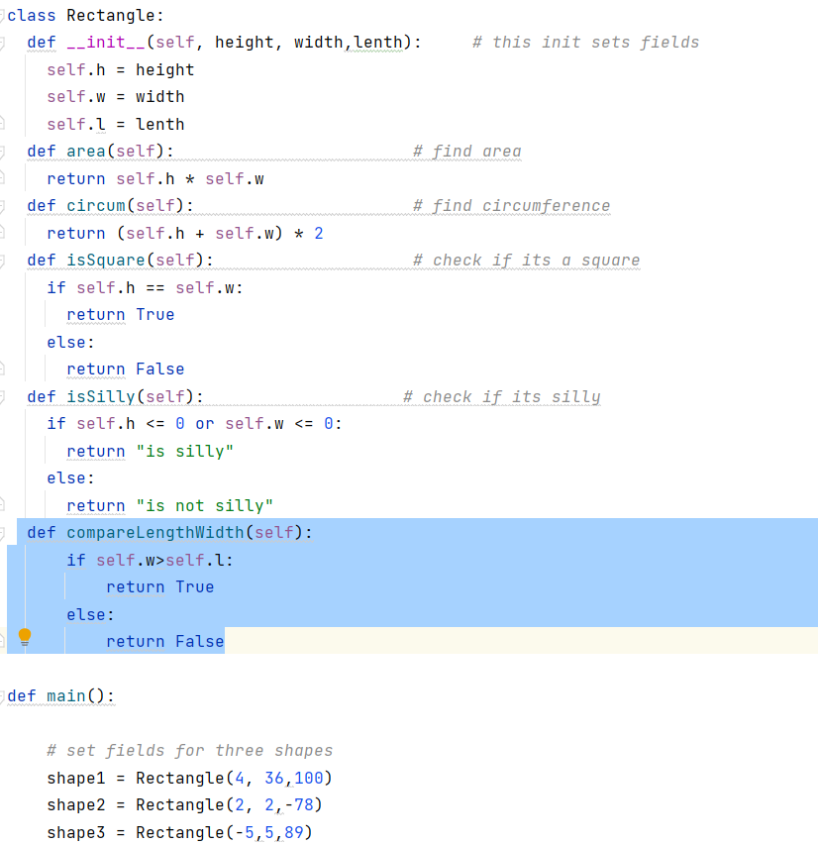

Explanation:-

Rectangle Class:

Class Rectangle has some attributes height, width, and length of the rectangle.

And we have added extra method **compareLengthWidth** to the existing methods

**isSilly**

**area**

**isSquare**

**circum**

and all methods will takes **instance level attributes and they are initiated at object level**

**super_subclass:-**

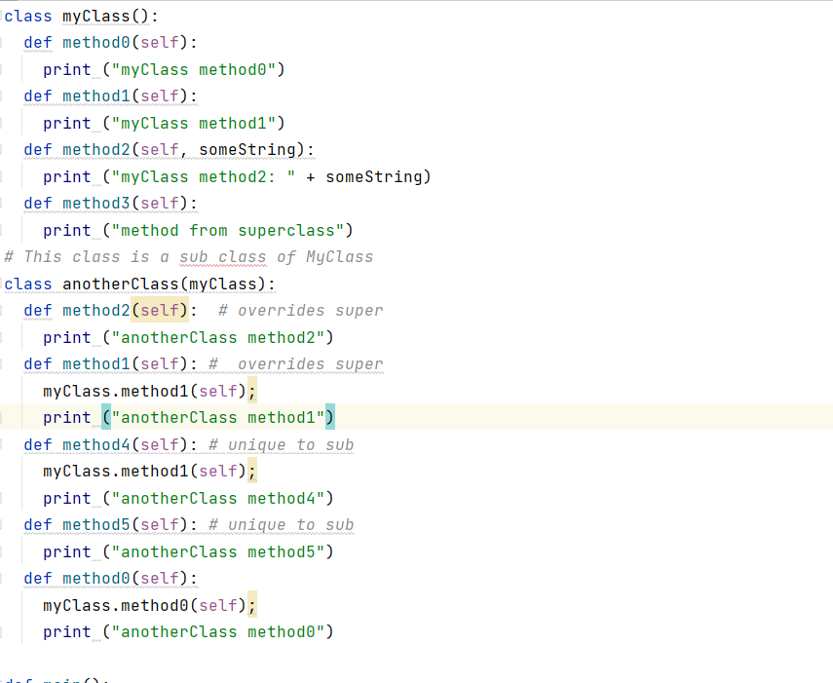

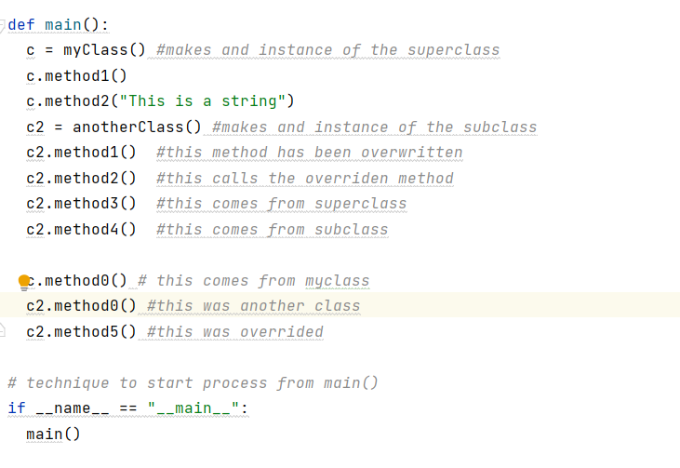

**Explanation:**

myClass:

method0,

method1,

and

method2

The anotherClass class inherits from myClass.

It overrides method

method2 :-from the superclass.

It has two unique methods

method4

method5

An instance of myClass is created, and its methods are called.

An instance of anotherClass is created, and its methods are called.

method1 in anotherClass calls the overridden method1 in the superclass.

method2 in anotherClass overrides the method2 in the superclass.

method3 in anotherClass calls the method from the superclass.

method4 and method5 are unique to anotherClass.

method0 in anotherClass explicitly calls the method0 in the superclass.