Question:1

|  |  |
| --- | --- |
| Value Error.py | Value Exception |
| In this code snippet,python will expects IntegerData type as the Input | In this code snippet,python will expects IntegerData type as the Input |
| If we gave the String as userInput and it won’t convert the data into Integer,and it will throws an error.  Code execution will be stopped | In there code snippet we error code moved to try block,If throws any error and we will catch that error and code execution will not stop and it will be continued. |

Value Error.py

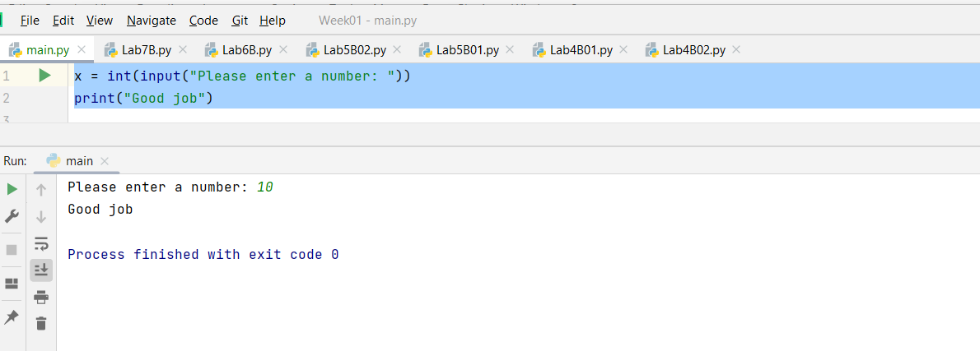

value_exception.py

Question:-2

|  |  |
| --- | --- |
| custom_exception.py | custom_excetion_caught.py |
| In this code snippet we are raising the Exception explicitly and passing the message,Here it won’t go the catch block | Here it, we are raising the exception without any Error message, and it will go to catch block |
|  |  |

Question 3:-

Here we are catching the Index Error message and we are printing it,and there is another exception is there where it will catches other exceptions apart from the

Question:-4

|  |  |
| --- | --- |
| Part A | PartB |
| Here we raised a general Exception | In the we raised explicit Arithmetic exception and also added finally block and this will executed after execution of try or catch block |

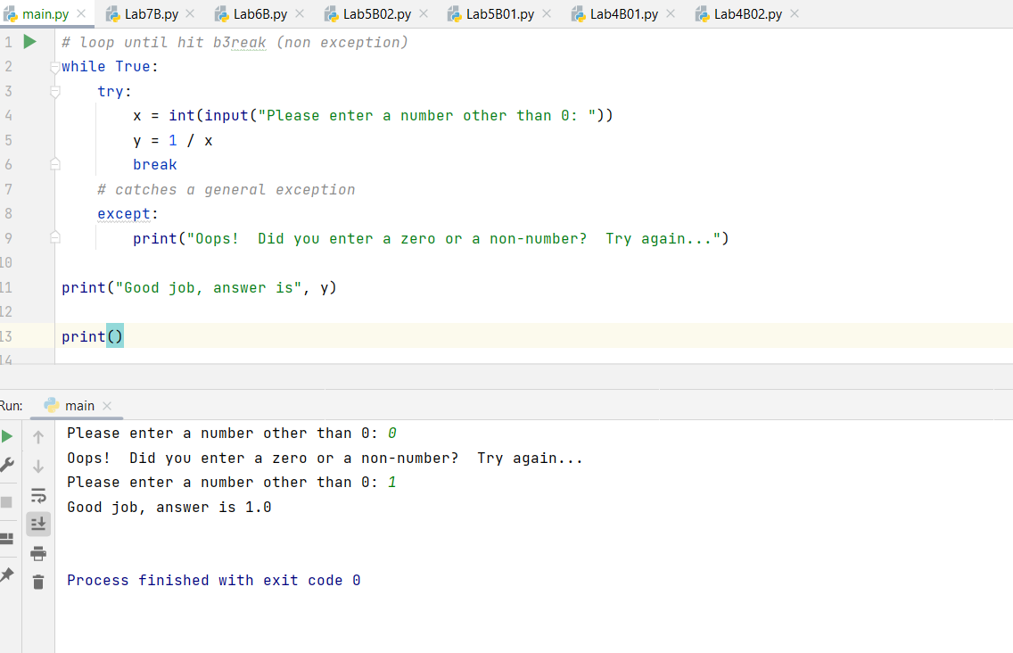

Question:-4

rectangle_with_exception

In this code we will see it will handles only all exceptions raised the by code and not limited to the type errors.

And you can see the results below cases with Error handling and normal

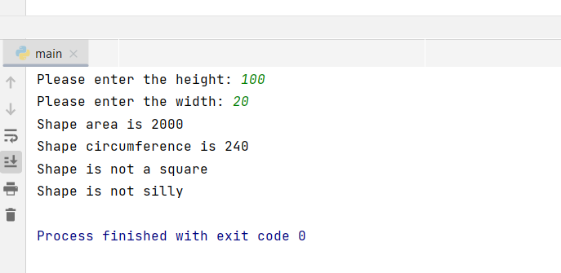

Question 5:

"x" – Create: this command will create a new file if and only if there is no file already in existence with that name or else it will return an error.

Here sampleNew2.txt was created

On rerun of the same code,I am facing the issue.

Read Only ('r’): This mode opens the text files for reading only. The start of the file is where the handle is located. It raises the I/O error if the file does not exist. This is the default mode for opening files as well.

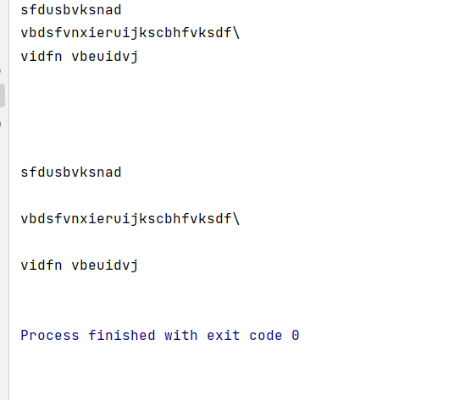

This is happened due to the file has readOnly Access and we are trying to write the data

Question:7

Here we are trying to access the file that is not available in directory and instead of throwing error by compiler we handled it and we are print the error

Question:8

This mode allows the file to be opened for writing. If the file doesn't yet exist, a new one gets created. The handle is set at the end of the file. The newly written data will be added at the end, following the previously written data.

We have created a file having the append access and then we write data to same file and closed that file,and then same file was opened with readOnly and we read the data and then closed that file

