Rules of chess

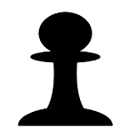Pieces

**Pawn**

8 pieces

1 point

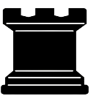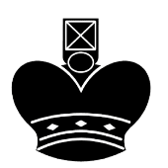

**Knight**

2 pieces

3 points

**Bishop**

2 pieces

3 points

**Rook**

2 pieces

5 points

**Queen**

1 piece

9 points

**King**

1 piece

* point

Starting position

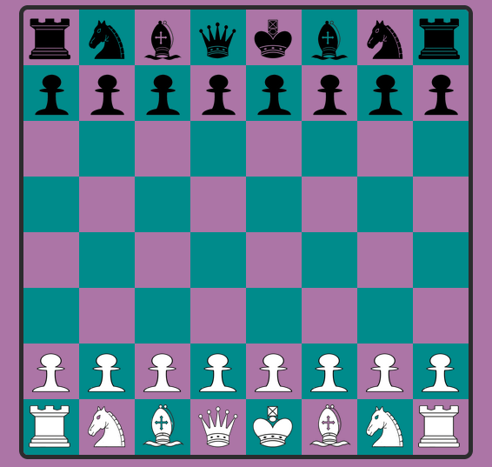Chess is a game between two players in a 8x8 board, 16 pieces to each player, each piece has its own movement and value. The goal is to checkmate the other king, Checkmate is when the other king is in a position that the king can't escape from capture called check.

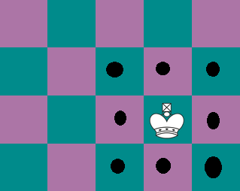Pieces moves

The King – Is the most important piece. The King only move one square in any direction, has to move when he is being targeted and can't move to a checked square.

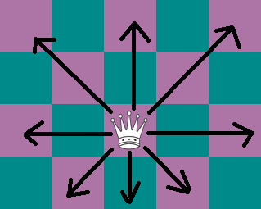

The Queen – The most powerful piece in the game, it can move any direction (forward, backward, sideways, diagonally) as far as possible.

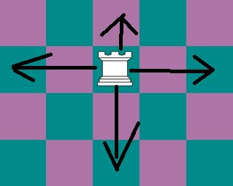

The Rook – can move forward, backward and to the two sides, as far as possible.

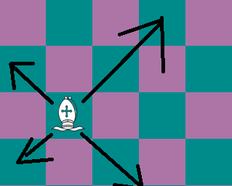

The Bishop – can move diagonally, as far as possible.

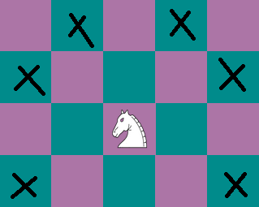

The Knight – can move like the shape of an "L", two squares in one direction and one square in another direction at a 90-degree angle.

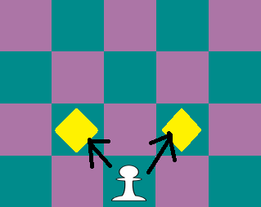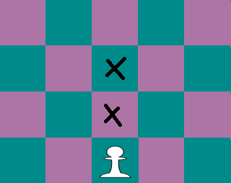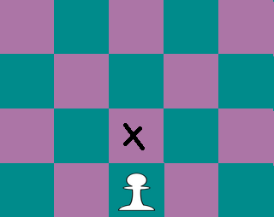The pawn – can move one square forward and only in the first move the pawn can move two squares forward, can only eat diagonally and when it's at the last square on the opposite side of the board the pawn can change to any piece of than the king.

Castling

Castling is when the rook and king move to the center of each other and go to the center of and replace places

* it must be that king’s first move
* it must be that rook’s first move
* there cannot be any pieces between the king and rook to move
* the king may not be in check or pass through check

