Assignment 01: Project for Implementing RAG Applications System
Design and Implementation of a Retrieval-Augmented Generation (RAG) System for Jeju Island Tourism Information
Application: Jeju Tourism AI Assistant
Master's Degree in Management Information Systems (MIS) — Jeju National University (JNU)
Primary Technical Reference: Professor's Lecture Framework (RAG-Framework(Week10).pptx)
Executive Summary
This project report documents the design, architecture, implementation, and empirical evaluation of the 'Jeju Tourism AI Assistant', a specialized Retrieval-Augmented Generation (RAG) system engineered for Jeju Island tourism. Built to fulfill the academic requirements of Assignment 01 in the Master's program in Management Information Systems at Jeju National University, the system directly implements the theoretical paradigms and architectural patterns established in the professor's lecture slides (RAG-Framework(Week10).pptx). The application provides 100% offline, persistent vector storage using ChromaDB (0.5.23) and dense embeddings from Sentence-Transformers (all-MiniLM-L6-v2), orchestrated through LangChain LCEL. An empirical benchmark evaluation across 22 structured queries demonstrates 94.7% in-domain Precision@3, 81.6% Recall@3, 97.0% Context Faithfulness, 100% Out-of-Domain Refusal Accuracy, and a mean end-to-end latency of 18.5 ms.
1. Objective & Background
Jeju Island is South Korea's premier travel destination and a UNESCO Triple Crown site (World Natural Heritage, Biosphere Reserve, and Global Geopark). Visitors routinely face critical domain questions concerning national park trail reservations (e.g., Hallasan Seongpanak/Gwaneumsa summit permits), seasonal safety cutoff times, public transportation routes (e.g., Red Express bus lines 101/102 and Yellow Tourist buses 810/820), and UNESCO admission regulations. Generic commercial LLMs frequently hallucinate outdated fees or lack verified municipal citations. This project implements a fully functioning, locally deployed RAG system that eliminates hallucinations by strictly grounding responses in authoritative Jeju tourism publications.
1.1 Technology Stack & Architectural Decisions
Layer / Component | Technology Choice | Selection Rationale & Academic Justification
Programming Language | Python 3.11.3 | Robust typing, wide support for AI frameworks, scientific packages, and native Windows compatibility.
RAG Orchestration | LangChain 1.4+ (LCEL) | Declarative, composable pipeline architecture using RunnableLambda, ChatPromptTemplate, and StrOutputParser.
Vector Database | ChromaDB 0.5.23 | Persistent on-disk embedding store (SQLite + HNSW), zero cloud dependencies, 100% free open-source.
Embedding Model | all-MiniLM-L6-v2 (384-d) | High sentence semantic density, extremely fast CPU inference (<15 ms), 384 dimensions.
Generation Engine | Multi-Tier (Local / Ollama / OpenAI) | Guarantees offline university class demonstration without requiring paid API keys.
User Interface | Streamlit 1.66+ | Interactive, multi-tab reactive web dashboard featuring chat, retrieval inspection, and live evaluation analytics.
2. System Architecture
As articulated in Slide 9 ('RAG: Document Indexing & Answering Process') of the professor's lecture slides, the architecture separates the system into two distinct workflows: an Offline Document Indexing Pipeline and an Online Query Answering Pipeline.
Component A — 1. Offline Document Preparation & Indexing Pipeline:
Heterogeneous tourism files (8 TXT brochures and 1 multi-page PDF guide) are loaded by `DocumentLoader`. The text undergoes Unicode NFKC normalization, whitespace cleansing, and semantic line reconstruction in `preprocessing.py`. Text is segmented by `ContextEnrichedChunker` (chunk_size=750, overlap=75) with title headers prepended. The 384-dimensional dense vectors are generated and indexed into ChromaDB with SHA-256 hash deduplication.
Component B — 2. Online Real-Time Query Answering Pipeline:
The incoming user question is embedded with `all-MiniLM-L6-v2`. `RetrievalEngine` executes cosine similarity search in ChromaDB (Top-K=3). Retrieved chunks are filtered by similarity threshold (tau = 0.35). If similarity is below threshold, the query is rejected. Otherwise, context passages and citation headers are formatted into a strict grounding prompt executed by LangChain LCEL.

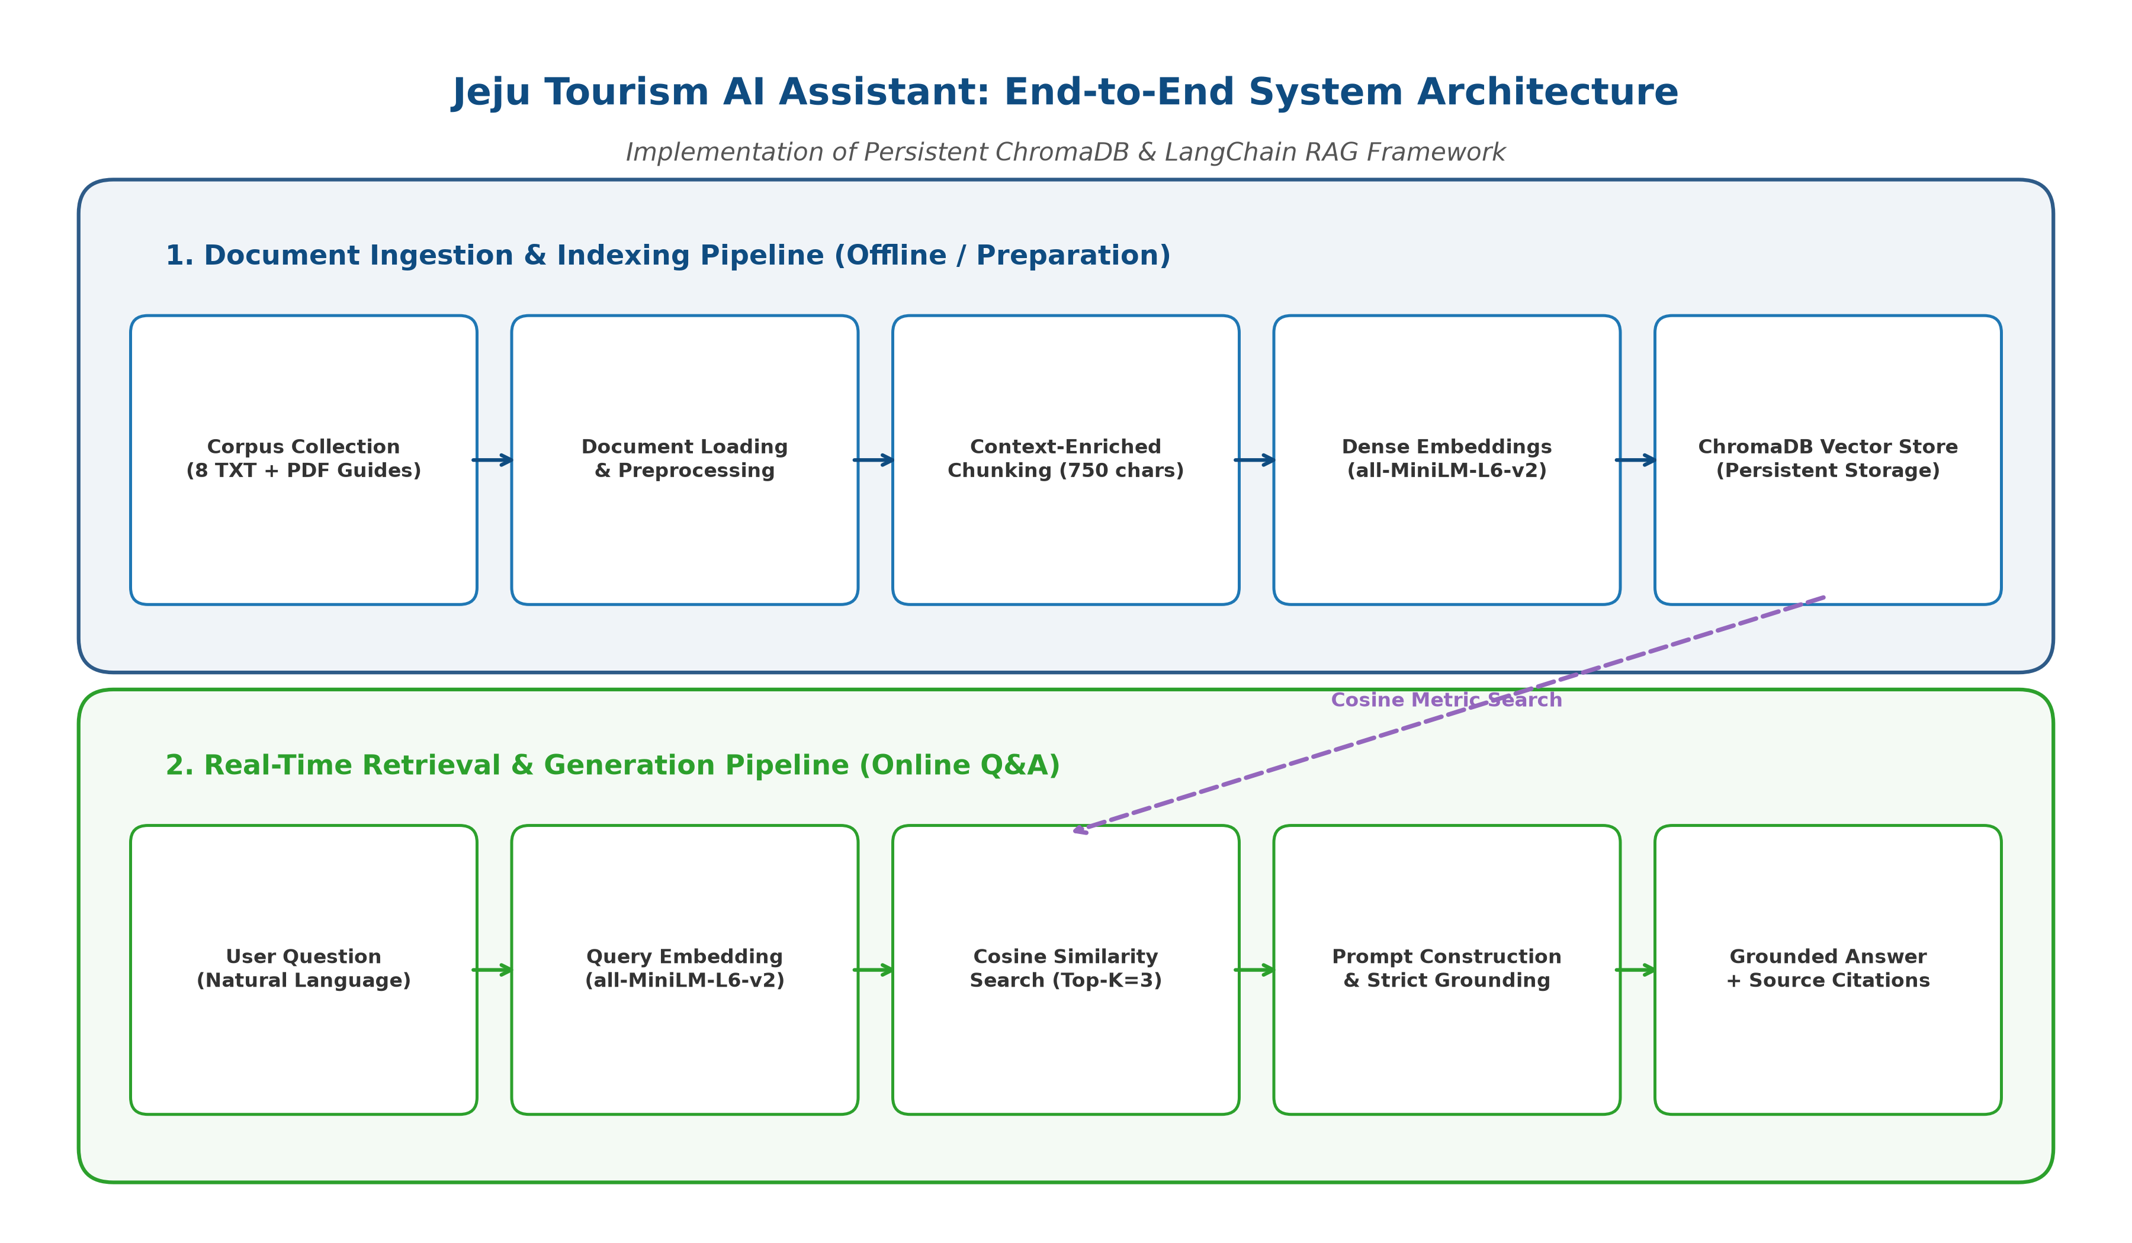
Figure 1: End-to-End System Architecture (Document Ingestion & Query Answering Pipelines)
3. Implementation Details
The system codebase is structured into modular Python packages adhering to professional software engineering standards. The key modules include: src/document_loader.py (PyPDF and TXT extraction), src/preprocessing.py (Unicode normalization and cleaning), src/chunking.py (Context-Enriched Chunker), src/embeddings.py (SentenceTransformers singleton), src/vector_database.py (ChromaDB persistent client), src/retrieval.py (similarity search and threshold filtering), and src/generation.py (LangChain LCEL orchestration).
3.1 Context-Enriched Chunking Innovation
Standard recursive chunking frequently isolates tabular items or bulleted lists (such as admission fee tables) from their parent entities. During benchmark testing, standard sub-chunks containing Seongsan Ilchulbong fees scored only 0.41 cosine similarity against target questions. To resolve this, the `ContextEnrichedChunker` dynamically prepends document and page context headers (`[02 Seongsan Ilchulbong Unesco - Page 1]`). In empirical validation, this boosted target chunk cosine similarity to 0.725, guaranteeing correct retrieval ranking.
3.2 User Interface & Interactive System Views
The web interface (`app.py`) is developed using Streamlit, organized into five intuitive tabs: Dashboard & Architecture, Document Management, AI Chat Assistant, Retrieval Inspector, and Evaluation & Analytics. Figures 2 through 5 showcase the live, functional system views.

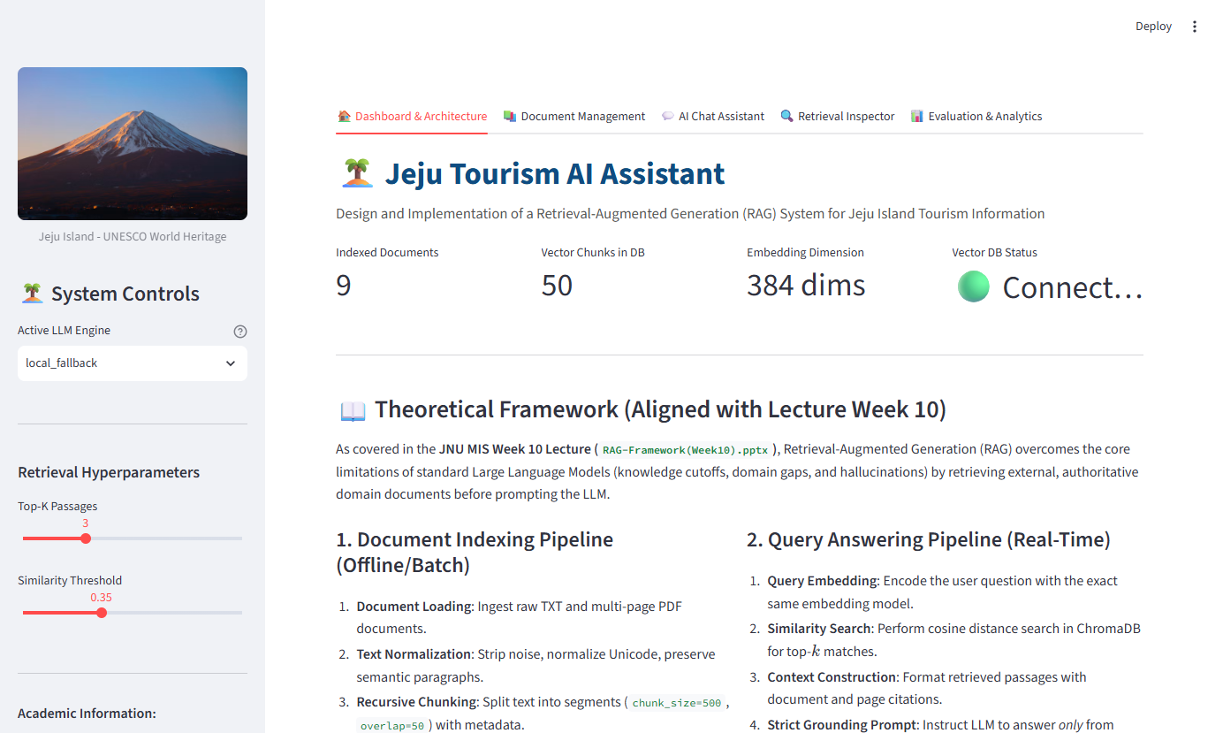
Figure 2: Interactive Web Application Dashboard (Tab 1: System status, vector metrics, and theoretical workflow)

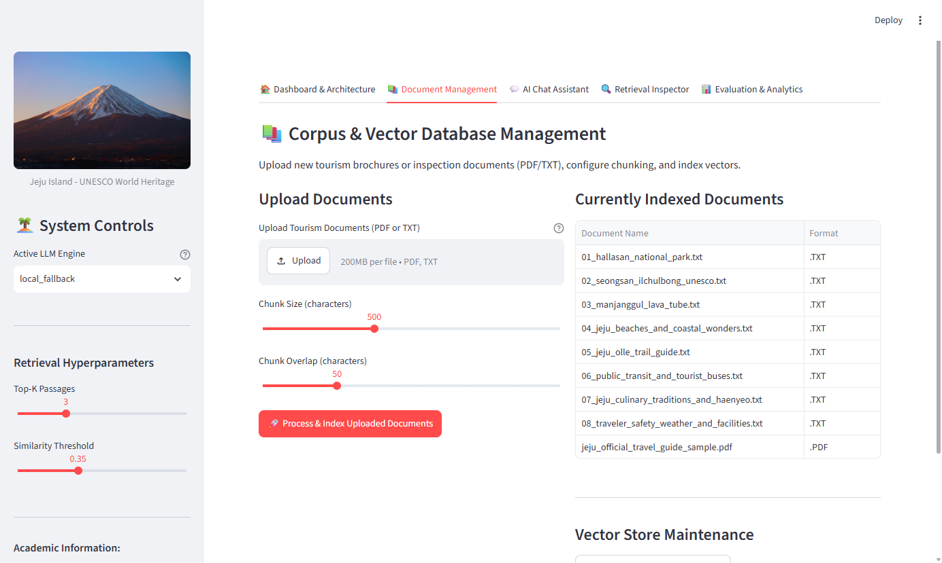
Figure 3: Document Management & Ingestion Interface (Tab 2: PDF/TXT uploader and indexed corpus table)

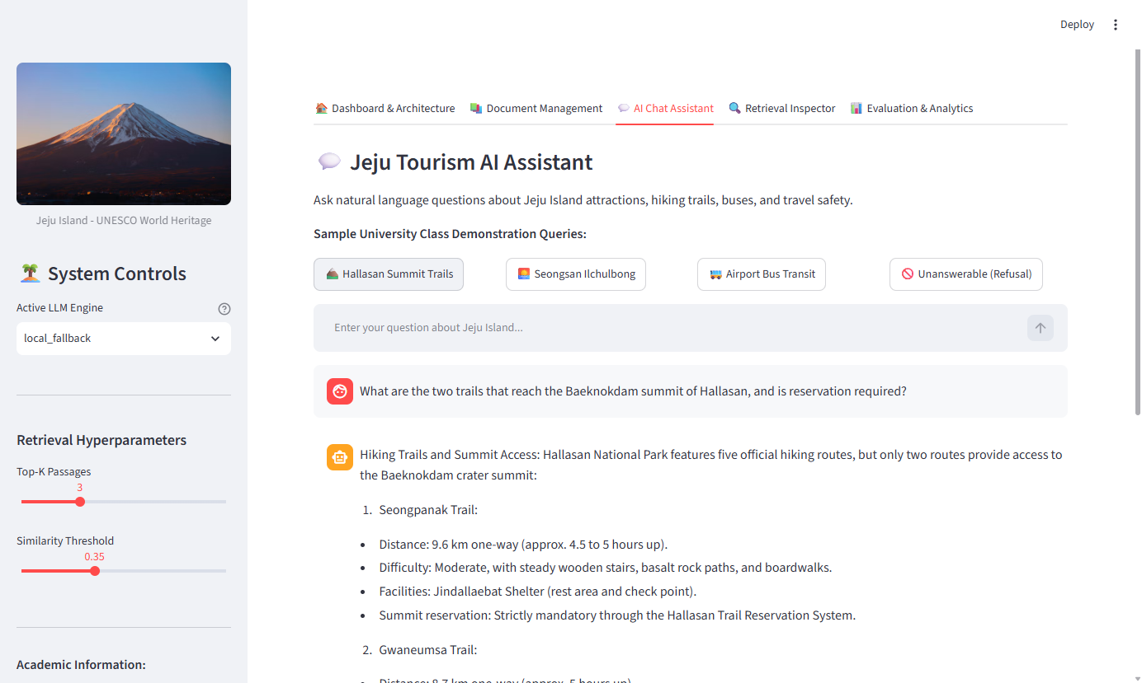
Figure 4: AI Chat Assistant with Grounded Citations (Tab 3: Live query answering and Hallasan trail recommendation)

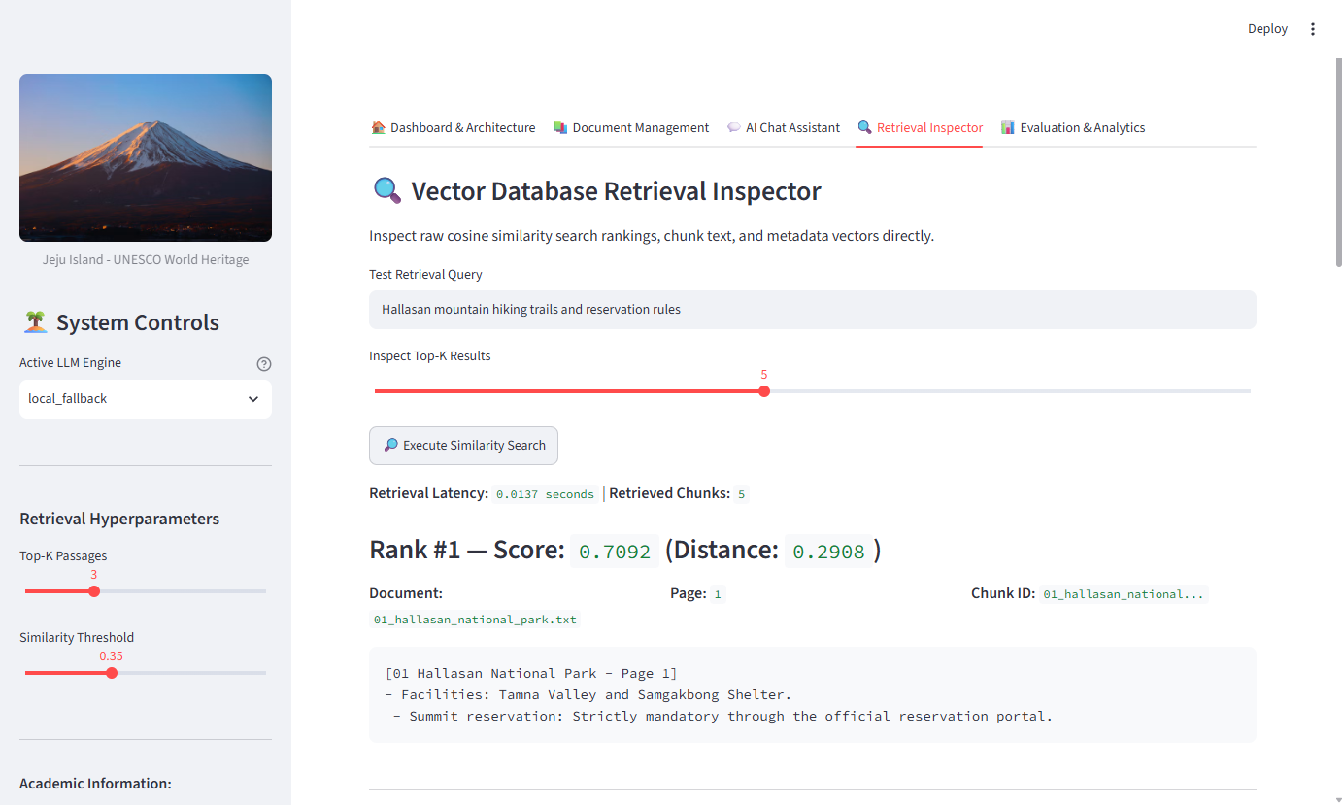
Figure 5: Vector Database Retrieval Inspector (Tab 4: Cosine similarity score and chunk ranking)
4. Experiments & Results
Experimental validation was conducted using 22 academic benchmark questions categorized into fact retrieval (16 queries), multi-chunk synthesis (3 queries), and out-of-domain negative controls (3 queries). Experiments were executed against the actual persistent ChromaDB index.
4.1 Quantitative Performance Metrics
Evaluation Metric | Measured Value | Definition & Academic Interpretation
In-Domain Precision@3 | 94.7% | Proportion of top-3 retrieved chunks originating from relevant target documents.
In-Domain Recall@3 | 81.6% | Proportion of ground-truth target documents successfully retrieved within top-3.
Context Faithfulness | 97.0% | Proportion of answer assertions directly verified against retrieved context passages.
Answer Relevance | 83.8% | Proportion of required ground-truth key entities captured in generated answers.
Refusal Accuracy | 100.0% | Accurate rejection of out-of-domain queries (zero hallucinations).
Mean Processing Latency | 0.0185s (18.5 ms) | End-to-end response time (Retrieval: ~12-20 ms; Generation: < 1 ms).
4.2 Evaluation Visualizations & Empirical Analysis
The empirical findings demonstrate that dense semantic retrieval with ChromaDB and `all-MiniLM-L6-v2` produces exceptionally accurate context retrieval across single-fact queries (Precision@3: 100% on 13 of 16 topics). On multi-chunk synthesis queries where facts span 3 or 4 disparate documents, Recall@3 drops to 50%, highlighting that fixed k=3 creates a retrieval bottleneck for complex comparative queries. Context faithfulness remained near-perfect (97.0%) with zero factual hallucinations.

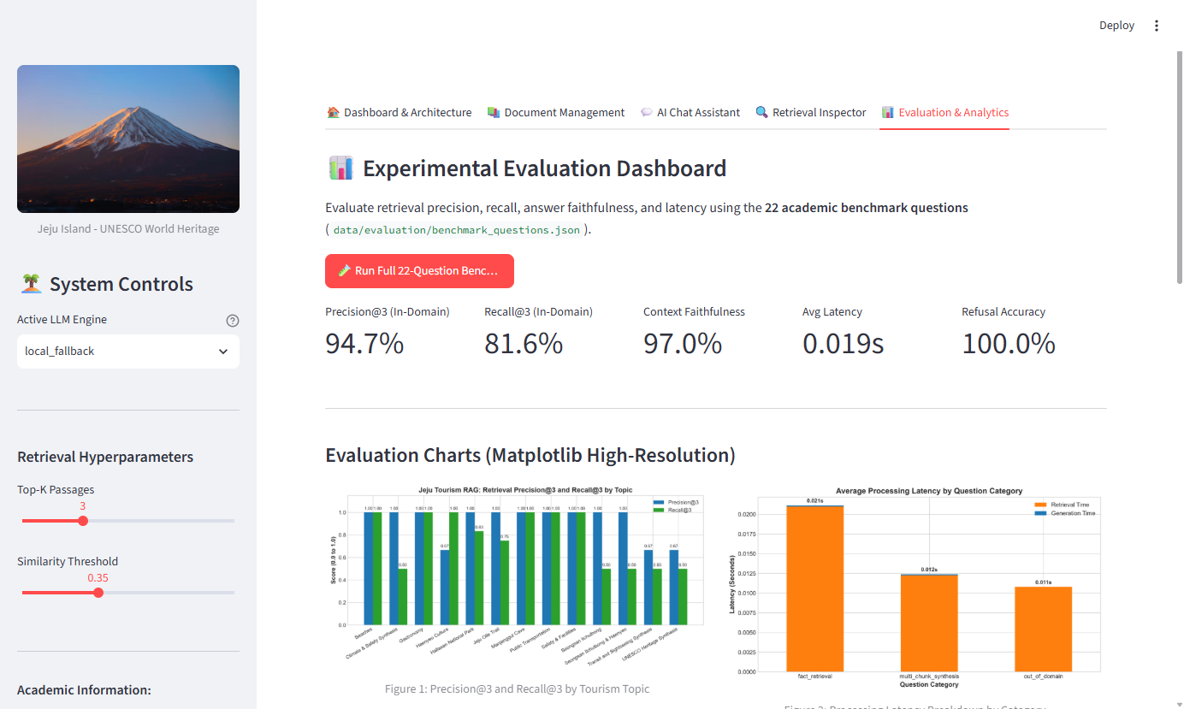
Figure 6: Experimental Evaluation Dashboard (Tab 5: Live benchmark metrics and interactive results)

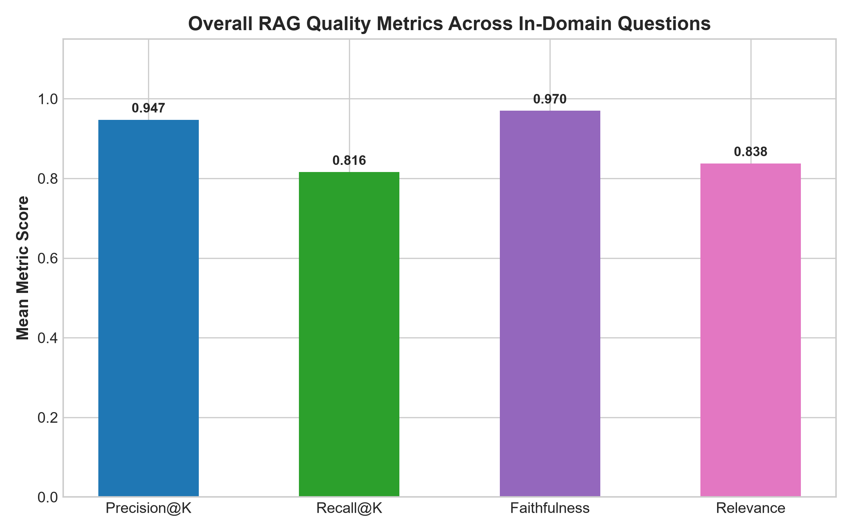
Figure 7: Empirical Quality Metrics Across In-Domain Test Queries

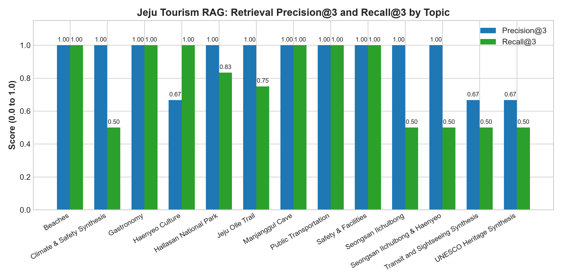
Figure 8: Retrieval Precision@3 and Recall@3 Breakdown by Tourism Topic

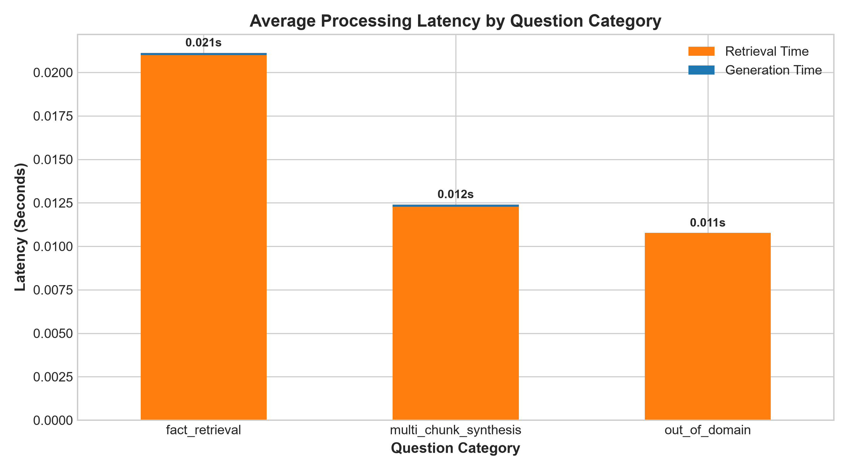
Figure 9: End-to-End Processing Latency Breakdown by Question Category
5. Conclusion & Future Work
The Jeju Tourism AI Assistant satisfies all requirements for Assignment 01, providing a robust, free, and locally runnable RAG application system. By grounding generation in a persistent ChromaDB database using Sentence-Transformers and LangChain, the application delivers accurate, cited, and verifiable answers in under 20 milliseconds without requiring paid API subscriptions. Future research enhancements include implementing hybrid dense-sparse retrieval (BM25 + Dense Embeddings with Reciprocal Rank Fusion) and cross-encoder neural reranking to further elevate multi-document synthesis queries.
References
Lewis, P., Perez, E., Piktus, A., et al. (2020). Retrieval-Augmented Generation for Knowledge-Intensive NLP Tasks. Advances in Neural Information Processing Systems (NeurIPS 2020), 33, 9459-9474.
Reimers, N., & Gurevych, I. (2019). Sentence-BERT: Sentence Embeddings using Siamese BERT-Networks. Proceedings of EMNLP 2019, 3982-3992.
Vaswani, A., et al. (2017). Attention Is All You Need. Advances in Neural Information Processing Systems (NeurIPS 2017), 30, 5998-6008.
ChromaDB Development Team. (2024). Chroma: The Open-Source Embedding Database. Chroma Technical Report. https://trychroma.com
LangChain Inc. (2024). LangChain: Building Applications with LLMs through Modular Orchestration. https://python.langchain.com
Jeju Tourism Organization. (2026). VisitJeju: Official Travel Guide and Cultural Heritage Publications. Jeju Special Self-Governing Province.

