* + 1. 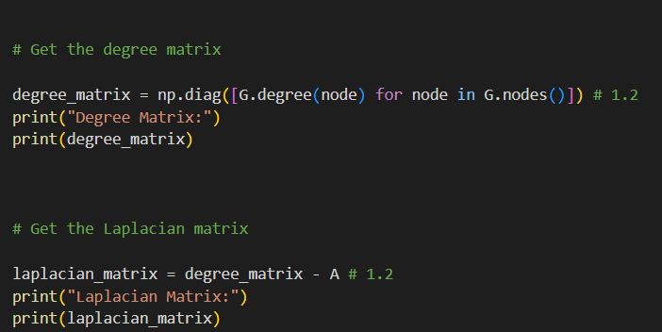
    2. 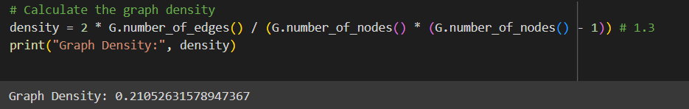
    3. 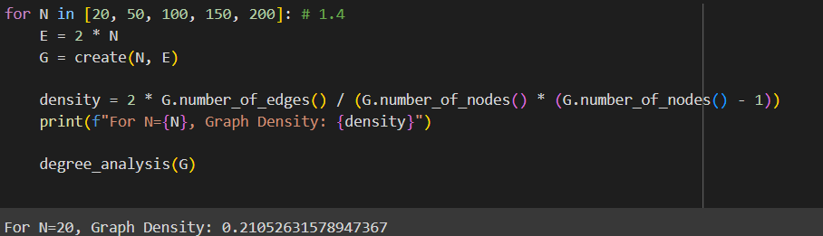
    4. Supervised Learning: Requires labeled data for training.
    5. Self-Supervised Learning: Uses data itself to generate labels.
    6. Semi-Supervised Learning: Uses a small amount of labeled data and a large amount of unlabeled data.
    7. Transductive Learning: Learns on a fixed dataset.
    8. Inductive Learning: Learns a model that generalizes to new, unseen data.

1. 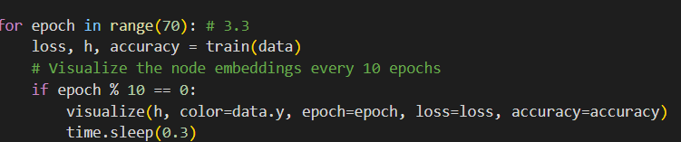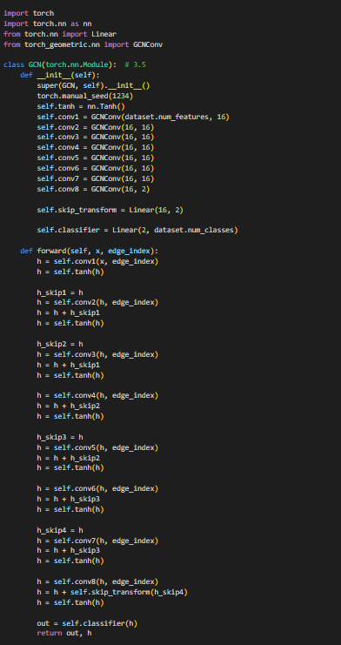
   1. Message Passing GNN:

Generic framework where nodes aggregate information from neighbors.

* 1. Graph Convolutional Network (GCN):

Uses convolutional layers to aggregate information from neighbors.

* 1. Graph Attention Network (GAT):

Uses attention mechanism to weight contributions of neighbors.

* 1. GraphSAGE:

Aggregates information using different strategies (mean, LSTM).

[**tharakabasuru/DL-LAB-06**](https://github.com/tharakabasuru/DL-LAB-06)