CIFAR-10 Image Classification Using VGG16

This part is going to classify the images in the CIFAR-10 dataset by the deep learning technique of the modified version of VGG16. CIFAR-10 consists of 60,000 32x32 color images in 10 classes, with 6,000 images in each class. It’s a transfer learning model whose base model is a pre-trained VGG16 model over ImageNet was developed.[1]

Extra custom layers are used to adapt the model to tasks of classification applied for images from the classes of CIFAR-10: airplane, automobile, bird, cat, and other classes.

**Dataset Preprocessing**

First, the CIFAR-10 dataset is loaded, and the pixel values are normalized by dividing them by 255 for values between 0 and 1. That is an important thing to do, because it considerably speeds up convergence of the model during training. Then, the dataset is divided into two parts: the test and the train data. In addition, class labels are transformed into a binary matrix using one-hot encoding; this is the required format when a neural network faces problems of categorical classification.

**Model Architecture**

The VGG16 model used here is inspired by performance in image classification challenges. For this project, we consider a pre-trained VGG16 model sans the top layers of the fully connected layers. For our purposes, we retain only convolutional layers since those work like feature extractors. It’ll be extended for CIFAR-10 by adding:

* **Flatten layer** to project output from convolutional layers into a 1D vector.
* **Dense layer** of 256 neurons followed by ReLU to introduce non-linearity.
* **Output layer**: With 10 neurons and Softmax, this layer will classify the images into one of the 10 classes in the CIFAR-10 dataset.

The weights of the convolutional layers are freezed so we don't retrain the VGG16 feature extractor but only the added layers, hence saving training time because we will not be overfitted.

**Data Augmentation**

The augmentation will be done through rotation, width and height shifts, zooms, and horizontal flips to improve the performance and generalization of the model. Data augmentation will make new variants of the images of the training set that the model must learn from. On a small dataset such as CIFAR-10, it will increase the size and variability of the training data artificially.

Training of Models It was then compiled with the Adam optimizer and categorical cross-entropy loss, which are the defaults for multi-class classification problems. This model has been trained over a total of 10 epochs; in each of them, the batch size was put to 64 with augmented training data and the same test data for validation. While training, through the process, the model learns to classify the images by readjusting the weights which were added as dense layers over the VGG16 architecture.[2]

**Model Evaluation**

Evaluate the trained model on the test set of the CIFAR-10, which provides an estimate of the performance in general. It would be noticed that the model was quite good, with some good skills in classifying images from the CIFAR-10 dataset. The model is saved on disk for later use to make the prediction in real time.

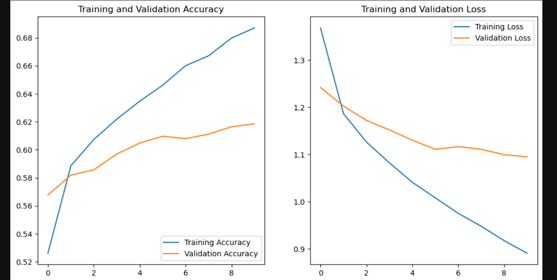

**Real-Time Image Classification**

The latter part would represent the functionality of real-time image classification using the VGG16 trained model: any image can be loaded inside an implemented function, preprocessed-scaled and normalized, and given as input to the trained model to predict its class and show it to the user along with the image itself. It makes the model quite useful for actual deployment.

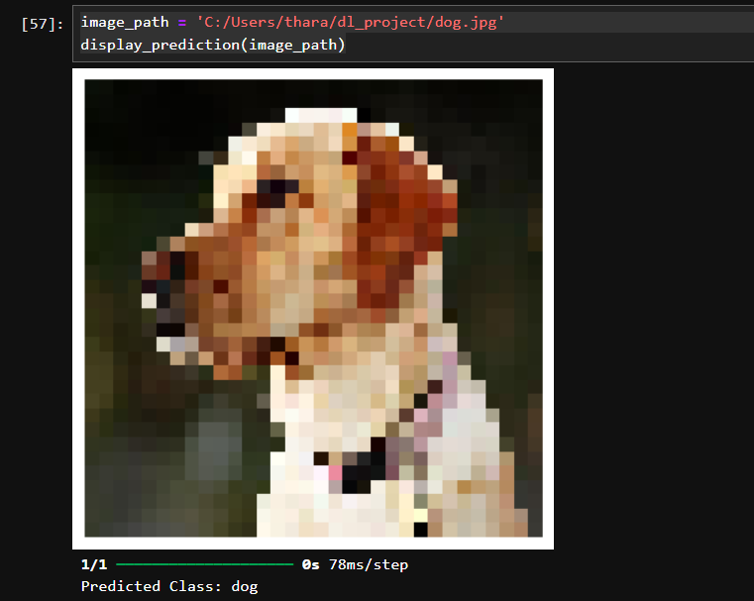

**Applications**

**1. Mobile Devices**

This then would find its way into mobile devices so that it can find itself in applications carrying out image classification that has been captured from the phone's camera, whether it's animals, objects, or anything at all. It will be optimized using libraries like TensorFlow Lite so that it can do well in the mobile environment where the computational resources are poor. For instance, as in the case of a fashion mobile application, the ability to shoot pictures of outfits should allow for auto-classification, show related items, or other fashion trends.

**2. Embedded Systems**

A model, once so trained, can then be deployed on hardware systems, such as drones or robots, where models identify objects in an environment and further act based on their classifications. Think, for instance, of a camera-enabled drone that will classify the terrain or whatever else may pop up in its view as it flies; it would, thus, be much more autonomous to greatly enrich its decision-making. On similar lines, it could classify merchandise on store shelves in the case of a fashion retail robot for inventory management.

**3. Clustering and Recommendation of Fashion Items**

The architecture followed for this project is based on the VGG16 architecture. This model could be modified for classifying different fashion items such as shirts, pants, and shoes among others. To identify those categories of clothes by exposure to a dataset of labeled fashion images-for instance, tops or trousers, or fashion accessories. This can further be integrated with a recommendation system that can propose similar or complementary fashion items to the users once the classification is done. This might also prove to be very useful in recommending fashion items to online retailers' customers. By combining classification with a recommendation engine, fashion apps or websites could enhance user experience, recommending items based on current trends or personal style preferences. The key benefit is a personalized shopping experience, which could drive engagement and sales.[3]

**Conclusion**

The methodology followed in this work utilizes deep learning approaches for classifying images, fine-tuning the pre-trained VGG16 model on the CIFAR-10 dataset. By enabling the model through transfer learning, augmentation of data, and custom architectures, it could classify images taken into ten categories. In other words, data augmentation only expanded the performance capability by enhancing generalized performance regarding new data.

These go beyond mere classification tasks but find their application in realistic cases, such as from real-time image classification within mobile applications to object recognition in dynamic environments of embedded systems. This is also useful in domain-specific ways, such as in the classification and recommendation of fashion items. It extends the service to offer users personalized suggestions through recognition of images. Hence, this would provide a very active methodology of image classification, with very high potentials for real applications such as in mobile technology, embedded systems, and e-commerce, considering personalized fashion recommendations.[4]

**References**

[1] E. Alam, “Enhancing Image Classification With Federated Learning: a Comparative Study of VGG16 and Mobilenet on CIFAR-10,” *SSRN Electronic Journal*, 2024, doi: <https://doi.org/10.2139/ssrn.4813254>.

[2] A. Mikołajczyk and M. Grochowski, "Data augmentation for improving deep learning in image classification problem," 2018 International Interdisciplinary PhD Workshop (IIPhDW), Świnouście, Poland, 2018, pp. 117-122, doi: 10.1109/IIPHDW.2018.8388338

[3] J. Jo, S. Lee, C. Lee, D. Lee, and H. Lim, “Development of Fashion Product Retrieval and Recommendations Model Based on Deep Learning,” *Electronics*, vol. 9, no. 3, p. 508, Mar. 2020, doi: <https://doi.org/10.3390/electronics9030508>.

[4] A. Singhal, P. Sinha, and R. Pant, “Use of Deep Learning in Modern Recommendation System: A Summary of Recent Works,” *International Journal of Computer Applications*, vol. 180, no. 7, pp. 17–22, Dec. 2017, doi: <https://doi.org/10.5120/ijca2017916055>.

‌

GitHub Link : [tharakabasuru/IT20391768_DLProject (github.com)](https://github.com/tharakabasuru/IT20391768_DLProject)

‌