[tharakabasuru/Lab-08---Submission (github.com)](https://github.com/tharakabasuru/Lab-08---Submission)

Question (01)

06.

Gridworld

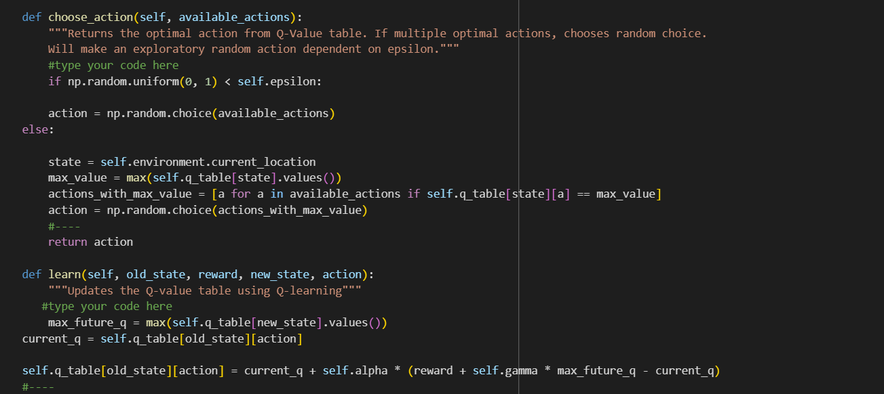

Markov

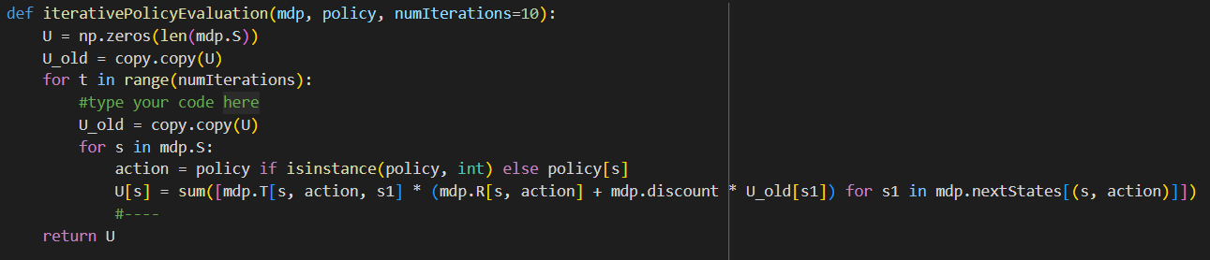

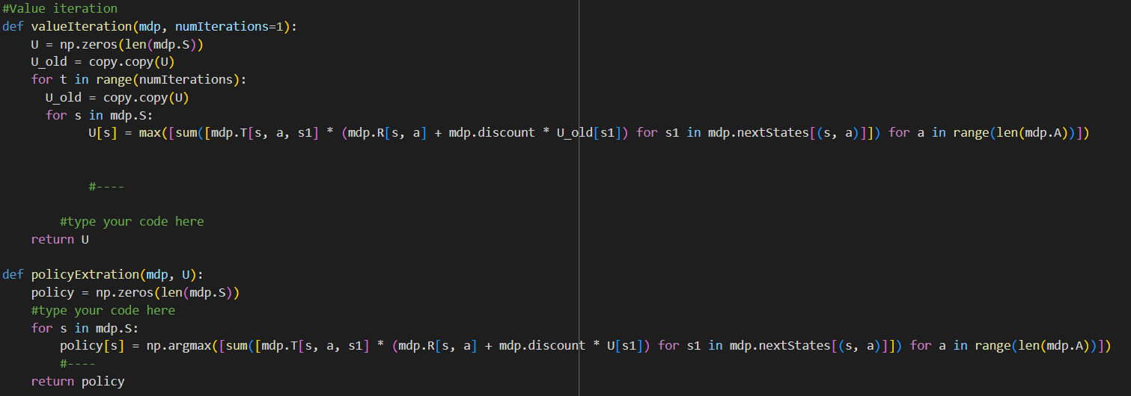

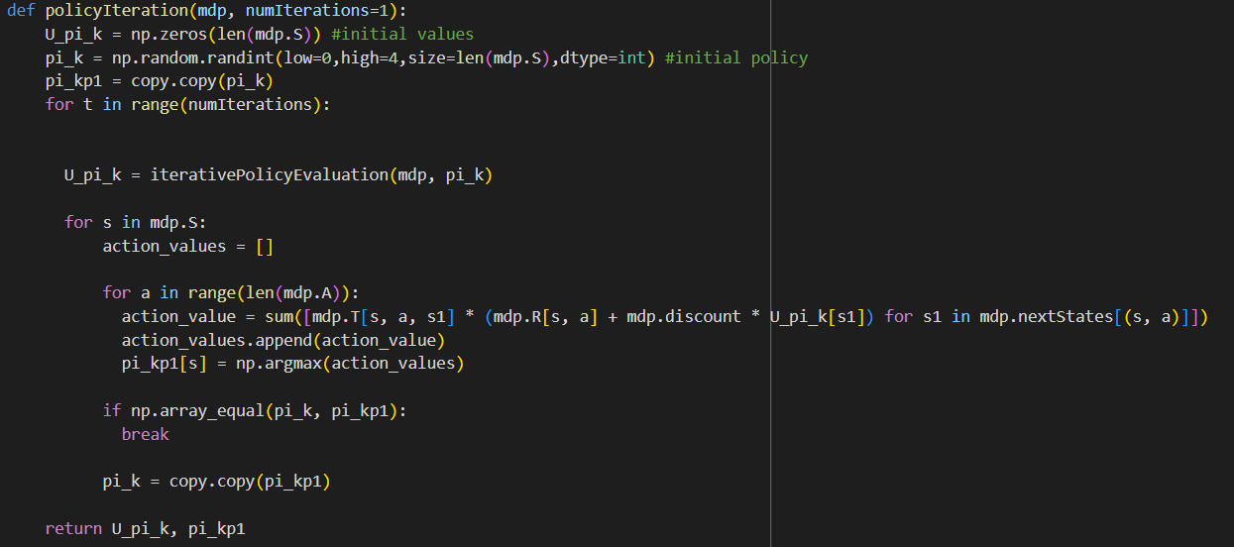

Question (02)

02. Model-Based approaches leverage a known environment to quickly compute an optimal policy

Model-Free approaches explore the environment to gradually learn the policy.

03. 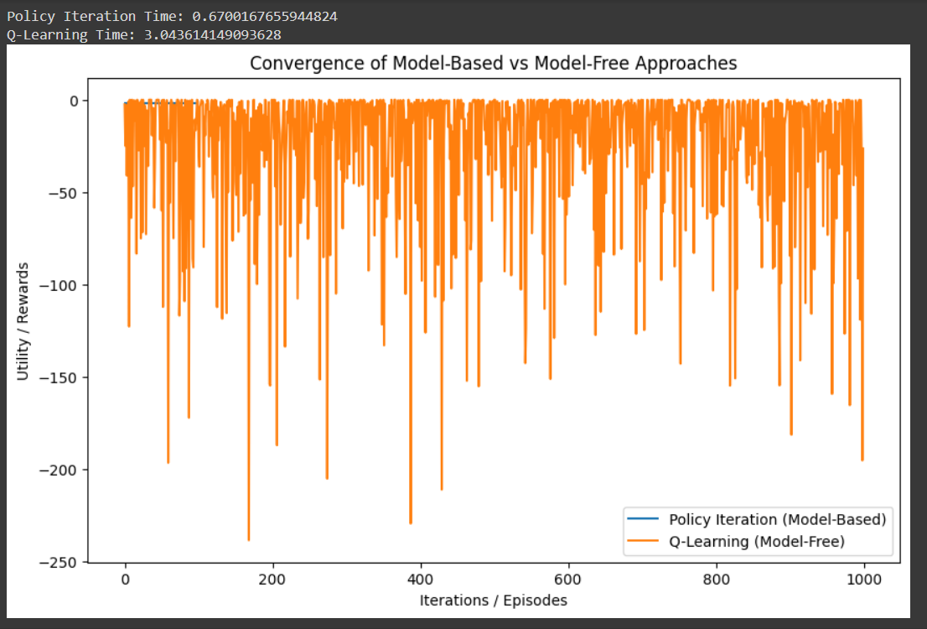

Question (03)

04. The results show how different epsilon values impact the agent's exploration vs. exploitation. Higher epsilon (e.g., 0.9) encourages more exploration, leading to varied performance, while lower epsilon (e.g., 0.1) focuses more on exploitation, which may improve performance but can limit discovery of better strategies.

