The effect of anodal transcranial direct current stimulation on human working memory

Srinivas Bangalore Seshadri¹, Uttara Khatri², Tharan Suresh²​
¹Dept of Electrical & Computer Engineering, UT Austin​; ²Dept of Kinesiology & Health Education, UT Austin​

Introduction.
Methods.

Results.
Figure 3. ERP potentials from Fz electrode pre and post stimulation for each subject across set-sizes.
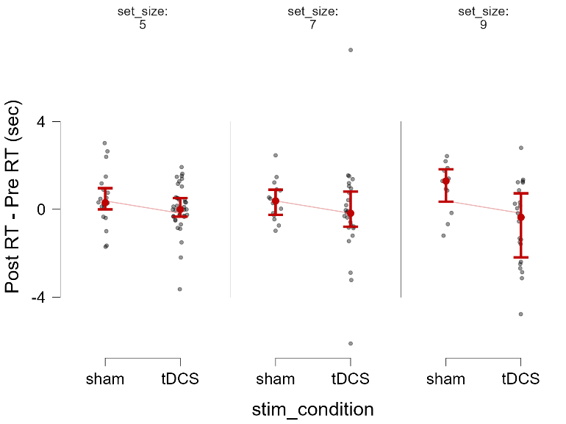
Behavior. A one-way ANOVA with set size(5,7,9) and stimulation type (tDCS vs sham) and difference in reaction times (Post _{stimulation} – Pre _{stimulation}) as the dependent variable revealed a significant main effect of stimulation type (F=9.23, p = 0.003) with no main effect of set size or set size x stimulation type interaction (see Table 1 in supplementary info). Post-hoc comparison using Tukey’s PSD showed a mean difference of 0.88s in RT between stimulation types (t=3.03, p=0.003). Similarly, a one-way ANOVA with set size x stimulation type with difference in accuracy (post _{accuracy} – pre _{accuracy}) as dependent variable revealed no significant main or interaction effect.
Figure 1. Mean differences in RT for stimulation type and set size.

Event related potentials.A one-way ANOVA with set size and stimulation type and difference in ERP amplitudes (Post _{stimulation} – Pre _{stimulation}) at Fz electrode as the dependent variable revealed a main effect of set size (F=4.32, p=0.015), no effect of stimulation type while set_size x stimulation type interaction approached significance (F=2.96, p=0.05). Tukey’s post-hoc comparison showed a significant mean difference in amplitude between set size 5 and 9 (t=2.88, p=0.01), while the mean difference between set size 7 and 9 approached significance (t=2.21, p=0.07) see Table 2. in supplementary info.
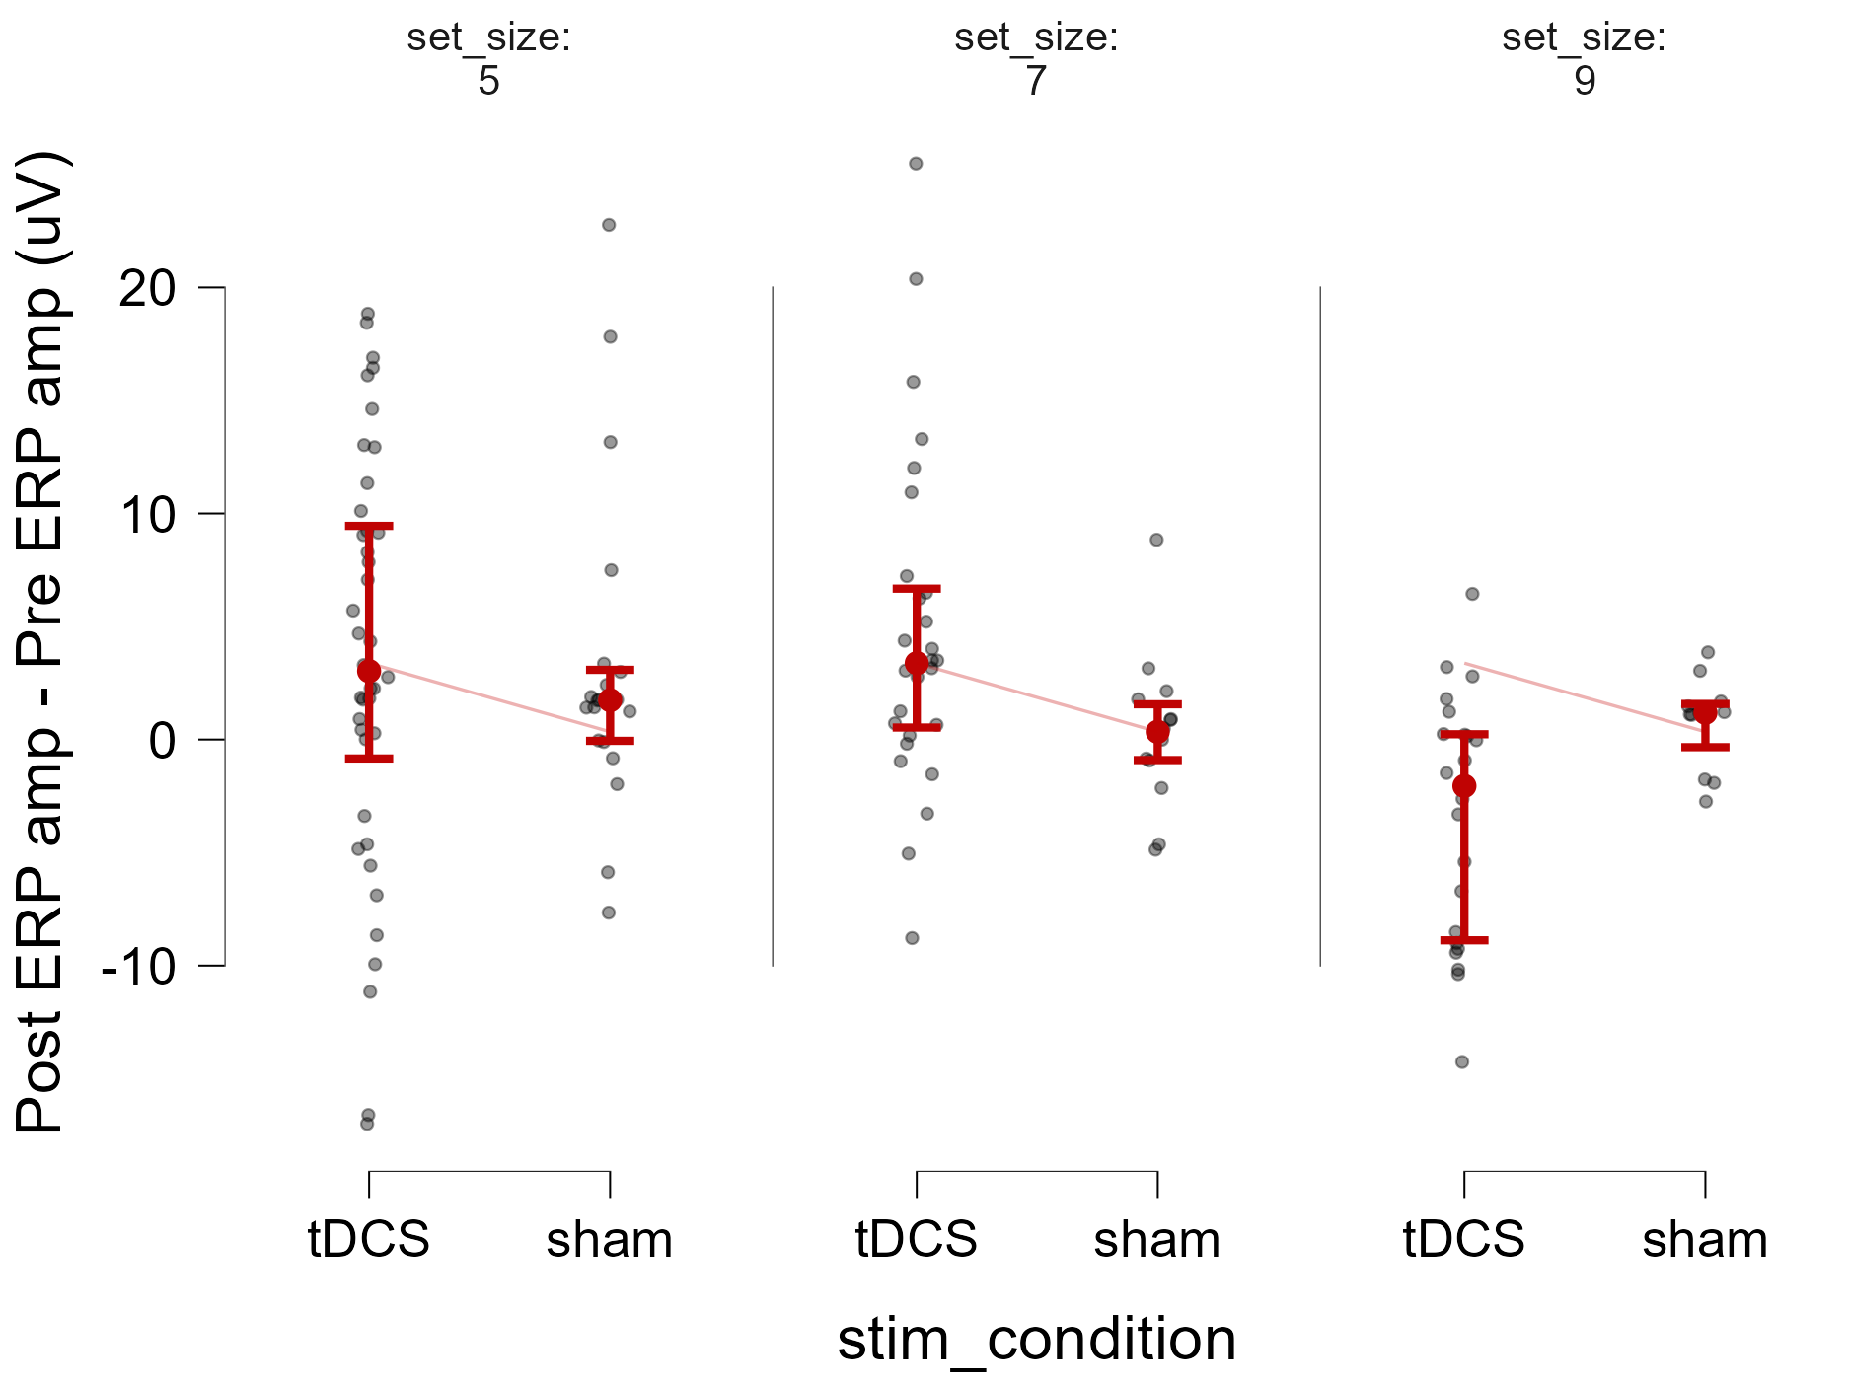
Figure 2. Mean differences in ERP amplitude for stimulation type and set size.

Power.

Supplementary information
Table1. One way analysis of variance – reaction time.
One way ANOVA - Post RT - Pre RT (sec)
Cases |  | Sum of Squares |  | df |  | Mean Square |  | F |  | p
set_size |  | 0.524 |  | 2 |  | 0.262 |  | 0.111 |  | 0.895
stim_condition |  | 21.715 |  | 1 |  | 21.715 |  | 9.225 |  | 0.003
set_size ✻ stim_condition |  | 7.961 |  | 2 |  | 3.980 |  | 1.691 |  | 0.188
Residuals |  | 296.589 |  | 126 |  | 2.354

Table2. One way analysis of variance – ERP amplitude.
One way ANOVA - Post ERP amplitude - Pre ERP amplitude (uV)
Cases |  | Sum of Squares |  | df |  | Mean Square |  | F |  | p
set_size |  | 444.868 |  | 2 |  | 222.434 |  | 4.316 |  | 0.015
stim_condition |  | 1.086 |  | 1 |  | 1.086 |  | 0.021 |  | 0.885
set_size ✻ stim_condition |  | 304.429 |  | 2 |  | 152.215 |  | 2.954 |  | 0.056
Residuals |  | 6647.662 |  | 129 |  | 51.532

Table3. Post-hoc pairwise comparison of stimulation type x set-size interaction.
Post Hoc Comparisons - set_size
 |  |  |  | Mean Difference |  | SE |  | t |  | p_{tukey}
5 |  | 7 |  | 0.843 |  | 1.532 |  | 0.550 |  | 0.847
 |  | 9 |  | 4.748 |  | 1.650 |  | 2.877 |  | 0.013
7 |  | 9 |  | 3.905 |  | 1.771 |  | 2.205 |  | 0.074
Note. P-value adjusted for comparing a family of 3
Note. Results are averaged over the levels of stimulation type

