Experiment: Addition of Two Numbers Using LEX Program
1. Aim
To write and execute a LEX program to read two numbers from the user and calculate their sum.
2. Algorithm
- Start the program.
- Include the required header files.
- Declare variables num1, num2, and count.
- Read the input using the LEX analyzer.
- Convert the first and second numbers from strings to integers using atoi().
- Add the two numbers and display the sum.
- Stop the program.
3. Pseudocode
BEGIN
Initialize num1 = 0, num2 = 0, count = 0
Display "Enter two numbers"
Read input using LEX

FOR each number matched
IF count == 0 THEN
num1 = convert to integer
ELSE
num2 = convert to integer
END IF

count = count + 1

IF count == 2 THEN
sum = num1 + num2
Display sum
STOP
END IF
END FOR
END
4. LEX Program
File name: addition.l
%{
#include <stdio.h>
#include <stdlib.h>

int num1, num2, count = 0;
%}

%%
[0-9]+ {
if (count == 0)
num1 = atoi(yytext);
else
num2 = atoi(yytext);

count++;

if (count == 2) {
printf("Sum = %d\n", num1 + num2);
count = 0;
return 0;
}
}

[ \t\n]+ ;
. { printf("Invalid input\n"); }
%%

int yywrap(void)
{
return 1;
}

int main(void)
{
printf("Enter two numbers: ");
yylex();
return 0;
}
5. Input
Enter two numbers: 10 20
6. Output
Sum = 30
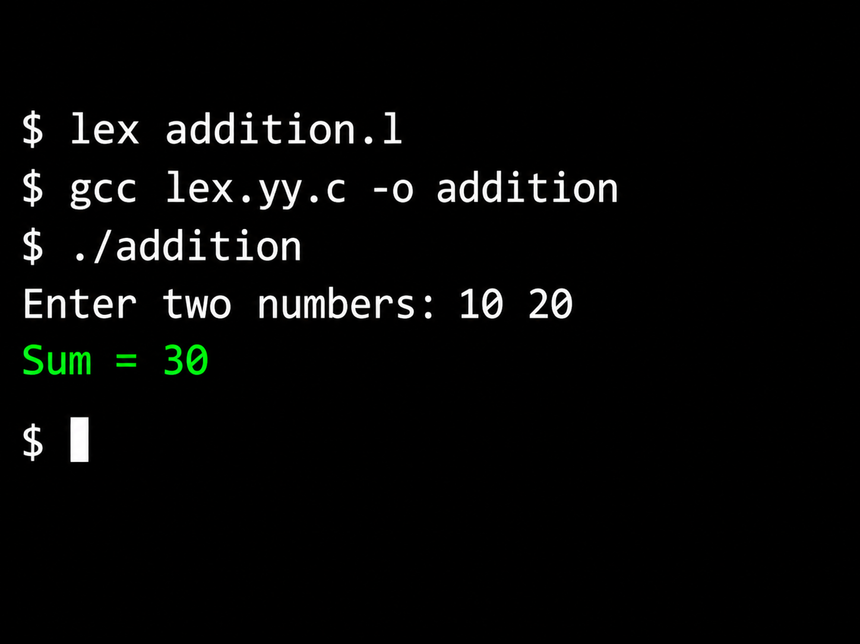
7. Result
Thus, the LEX program to read two numbers and calculate their sum was written and executed successfully.

