AIM
To write a C program to perform lexical analysis of a given C statement and identify the tokens as keywords, identifiers, constants, operators, and special symbols.
PSEUDOCODE
- Start the program.
- Declare an array containing all the C keywords.
- Read a C statement from the user.
- Scan the input statement character by character.
- Ignore white spaces.
- If the character is a letter or underscore, read the complete word.
- Check whether the word is a keyword.
  - If yes, identify it as a Keyword.
  - Otherwise, identify it as an Identifier.
- If the character is a digit, read the complete number and identify it as a Constant.
- Check for arithmetic operators such as +, -, *, /, %.
- Check for relational and assignment operators such as =, <, >, ==, <=, >=.
- Check for special symbols such as (, ), {, }, [, ], ;, and ,.
- If the character does not belong to any category, identify it as an Unknown Symbol.
- Display each token along with its corresponding category.
- Stop the program.
CODE:
#include <stdio.h>
#include <string.h>
#include <ctype.h>

int isKeyword(char str[])
{
char keywords[][20] = {
"auto", "break", "case", "char", "const",
"continue", "default", "do", "double",
"else", "enum", "extern", "float", "for",
"goto", "if", "int", "long", "register",
"return", "short", "signed", "sizeof",
"static", "struct", "switch", "typedef",
"union", "unsigned", "void", "volatile",
"while"
};
int i;
for (i = 0; i < 32; i++)
{
if (strcmp(str, keywords[i]) == 0)
return 1;
}
return 0;
}
int main()
{
char input[1000];
int i = 0;
printf("Enter a C statement:\n");
fgets(input, sizeof(input), stdin);
while (input[i] != '\0')
{
if (isspace(input[i]))
{
i++;
continue;
}
if (isalpha(input[i]) || input[i] == '_')
{
char word[50];
int j = 0;
while (isalnum(input[i]) || input[i] == '_')
{
word[j++] = input[i++];
}
word[j] = '\0';
if (isKeyword(word))
printf("%s\t\tKeyword\n", word);
else
printf("%s\t\tIdentifier\n", word);
}
else if (isdigit(input[i]))
{
char number[50];
int j = 0;
while (isdigit(input[i]) || input[i] == '.')
{
number[j++] = input[i++];
}
number[j] = '\0';
printf("%s\t\tConstant\n", number);
}
else if (input[i] == '+' || input[i] == '-' ||
input[i] == '*' || input[i] == '/' ||
input[i] == '%')
{
printf("%c\t\tArithmetic Operator\n", input[i]);
i++;
}
else if (input[i] == '=' || input[i] == '<' ||
input[i] == '>')
{
if (input[i + 1] == '=')
{
printf("%c%c\t\tRelational Operator\n",
input[i], input[i + 1]);
i += 2;
}
else
{
printf("%c\t\tOperator\n", input[i]);
i++;
}
}
else if (input[i] == '(' || input[i] == ')' ||
input[i] == '{' || input[i] == '}' ||
input[i] == '[' || input[i] == ']' ||
input[i] == ';' || input[i] == ',')
{
printf("%c\t\tSpecial Symbol\n", input[i]);
i++;
}
else
{
printf("%c\t\tUnknown Symbol\n", input[i]);
i++;
}
}
return 0;
}
OUTPUT
Input:
Enter a C statement:
int a = 10 + b;
Output:
int Keyword
a Identifier
= Operator
10 Constant
+ Arithmetic Operator
b Identifier
; Special Symbol
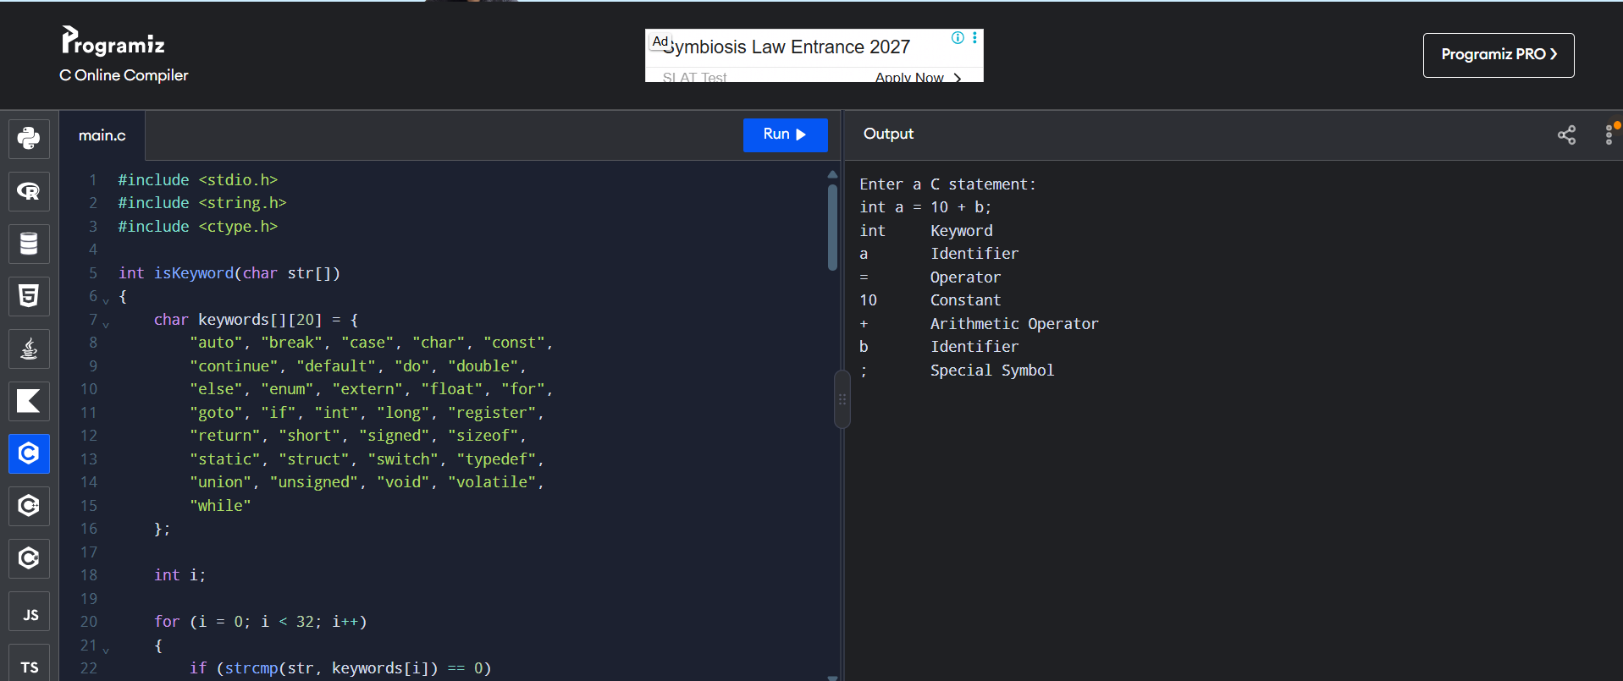
RESULT
Thus, the C program for lexical analysis was successfully executed, and the given C statement was analyzed to identify keywords, identifiers, constants, operators, and special symbols.

