SIMATS ENGINEERING (SAVEETHA SCHOOL OF ENGINEERING)
Department of Artificial Intelligence and Data Science

ASSESSMENT TOOL 1 – Experiments

Course Code: | DSA03 | Course Title: | Natural Language Processing
CO Assessed: | CO3 – Precision | Assessment: | Assessment Tool 1 – Experiments
Weightage: | 50% of CIA
CO5 Statement: | Apply N-gram models, smoothing techniques, part-of-speech tagging systems and to evaluate effective syntactic analysis. (BL-3)
Student Name: | M.Tharani | Reg. No.: | 192472375
Section / Batch: |  | Date:

Code of Conduct
I _____M.Tharani(192472375)___ (Name / Reg No) certify that this submission is my original work and that I have adhered to the guidelines specified for this assessment. I understand that any violation of academic integrity rules will result in disciplinary action.
Signature of the Student: ________ M.Tharani _________________

Instructions
- Perform all experiments using Google Colab.
- Create a separate notebook (.ipynb) for the assessment.
- Ensure all code is executable without errors.
- Include appropriate comments explaining the logic used.
- Complete all three experiments in a single Google Colab notebook.
- Execute all cells and display the outputs for the given test cases.
- Save the notebook with the naming convention: RegNo_Name_CO3-AT1.ipynb
- Upload the notebook to your GitHub repository.
- Ensure the repository is public or accessible to the instructor.
- Submit the following:
- GitHub Repository Link in GCR
- Google Colab Share Link in GCR
- Screenshots of uploaded coding and output files as printout.
- Duration: 30 minutes.

Section / Topic |  | Focus | Experiment Questions
Context-Free Grammars for English  Syntax, Context-Free Rules and  Trees, Sentence-Level Constructions,  Parsing, Top-Down Parsing, Earley Parsing |  | Design a Python program to validate sentences using CFG production rules and construct parse tree representations for valid sentences. | Q1
Agreement, Feature Structures, Sub Categorization |  | Design a Python program to verify subject–verb agreement and validate grammatical constraints using feature structures and subcategorization rules. | Q2
Probabilistic Context-Free Grammars (PCFGs) |  | Design a Python program to parse sentences and compute sentence probabilities using probabilistic grammar production rules. | Q3

Annexure A – Experiments

Experiment 1: Context-Free Grammar Rule Validation and Parse Tree Construction

Experiment Description
Design a Python program to validate whether a sentence follows the given Context-Free Grammar (CFG) rules and generate its parse tree representation.
Grammar:
S → NP VP
NP → Det N
VP → V NP
Det → the | a
N → dog | cat | bone
V → chased | found Task
- Accept a sentence as input.
- Verify whether it conforms to the CFG.
- Construct and return the parse tree.
- Return "Invalid Sentence" if parsing fails.

Function Prototype
def parse_cfg(sentence): pass

Test Cases
Input Expected Output the dog chased a cat Valid Parse Tree a cat found the bone Valid Parse Tree dog chased cat Invalid Sentence the bone found a dog Valid Parse Tree chased the dog bone Invalid Sentence

Experiment 2: Agreement and Feature Structure Checking

Experiment Description
Design a Python program that verifies subject–verb agreement using feature structures containing Number and Person attributes.
Feature Rules he → singular, third person she → singular, third person it → singular, third person we → plural

eats → singular verb sleeps → singular verb

eat → plural verb sleep → plural verb Task
- Accept Subject and Verb.
- Compare feature structures.
- Return True if agreement holds.
- Return False otherwise.
Function Prototype def check_agreement(subject, verb):
pass

Test Cases
Subject Verb Expected
he | eats True
he | eat False
we | eat True
we | sleep  False  s
she | sleep  True  s

Experiment 3: Probabilistic Context-Free Grammar (PCFG) Parsing
Experiment Description
Implement a Python program to compute the probability of a sentence using the given PCFG.

Grammar
S → NP VP [1.0]
NP → Tom [0.7]
NP → Ann [0.3]
VP → sings [0.4]
VP → dances [0.6]

Probability Formula
P(Sentence) =
P(S→NP VP)
× P(NP)
× P(VP) Task
- Accept a two-word sentence.
- Parse using the PCFG.
- Compute sentence probability.
- Return 0 if sentence cannot be generated.
Function Prototype def sentence_probability(sentence):

pass Test Cases
Input Sentence Expected Probability
Tom sings | 0.28
Tom dances | 0.42
Ann sings | 0.12
Ann dances | 0.18
Sam sings | 0.00

Rubrics for Calculation

Criteria | Weightag  e | Level 4 – Exemplary | Level 3 –  Proficient | Level 2 –  Developing | Level 1 –  Beginning
Understanding of Concepts | 25 | Demonstrates thorough understanding and effectively integrates | Good understanding with proper | Basic understanding;  limited or partial integration | Poor understanding; unable to
 |  | multiple concepts/technologies | integration of most concepts |  | integrate concepts
Experimental Design | 30 | Well-planned, systematic implementation with optimal solution | Correct implementation with minor issues | Basic implementation with errors or inefficiencies | Incorrect or incomplete  implementatio  n
Use of Tools | 20 | Effective and advanced use of tools/technologies with proper configuration | Appropriate use of tools with correct execution | Limited or inconsistent use of tools | Incorrect or minimal use of tools
Analysis of Results | 15 | Insightful analysis with accurate interpretation and validation of results | Good analysis with reasonable interpretation | Basic analysis with limited insights | Poor or incorrect  analysis of results
Documentation | 10 | Clear, well-structured documentation with  diagrams, code, and  results | Organized documentation  with necessary details | Basic documentation  with missing details | Poor or incomplete documentation

Q. No. / Criteria  Level | Understanding of Concepts | Experimental Design | Use of Tools | Analysis of  Results | Documen  tation | Sub. Total | Total  %
1
2
3

Faculty In-charge | Course Coordinator | Program Director
Signature: _______________ | Signature: _______________ | Signature: _______________
Date: ___________________ | Date: ___________________ | Date: ___________________

1.0 INTRODUCTION TO SYNTACTIC ANALYSIS IN NLP
Natural Language Processing (NLP) is an interdisciplinary subfield of artificial intelligence, computational linguistics, and computer science concerned with enabling computational systems to process, interpret, analyze, and generate human natural languages. Within the hierarchical architecture of NLP—spanning phonology, morphology, syntax, semantics, pragmatics, and discourse—syntactic analysis (or parsing) serves as the indispensable structural bridge connecting raw surface lexical tokens to deep semantic interpretations.
1.1 Core Syntactic Modeling Paradigms
- Syntactic Parsing: The computational process of recognizing the grammatical constituents of a sentence and determining their hierarchical linear and hierarchical relationships in accordance with a formal target grammar.
- Context-Free Grammars (CFGs): A foundational formal grammar formalism defined by the 4-tuple G = (V, Σ, R, S), where non-terminal symbols rewrite recursively into strings of non-terminals and terminal lexicon items independently of surrounding linguistic context.
- Feature Structures & Grammatical Agreement: Attribute-Value Matrices (AVMs) and unification-based formalisms that enforce morphosyntactic consistency constraints (such as Number, Person, Tense, and Gender agreement) across related syntactic constituents (e.g., Subject-Verb, Determiner-Noun).
- Probabilistic Context-Free Grammars (PCFGs): Stochastic extensions of CFGs that associate conditional production probabilities with each rewrite rule, enabling language models to rank parse trees, resolve syntactic ambiguities, and estimate total sentence generation likelihoods.
1.2 Objectives and Computing Environment
The primary objective of this assessment is to demonstrate rigorous theoretical understanding and practical implementation of rule-based syntactic parsing, feature-based constraint checking, and probabilistic grammar modeling. All computational experiments have been implemented in Python 3.10+ and developed and validated within the Google Colaboratory (Colab) cloud runtime environment to ensure deterministic execution, reproducibility, and transparent verification.

2.0 EXPERIMENT 1: CONTEXT-FREE GRAMMAR (CFG) RULE VALIDATION AND PARSE TREE CONSTRUCTION
2.1 Aim & Objectives
- Aim: To design, implement, and validate a Context-Free Grammar (CFG) parser capable of verifying sentence membership against formal production rules and constructing a visual hierarchical parse tree.
- Objectives: 1) Define formal lexical and syntactic productions; 2) Develop a recursive top-down parsing algorithm; 3) Generate ASCII/Unicode parse tree representations for valid sentences; 4) Gracefully handle ungrammatical or out-of-vocabulary inputs with diagnostic error messages.
2.2 Formal Grammar Specification
The formal grammar G = (V, Σ, R, S) for this experiment is defined as follows:
Non-Terminal Symbols (V) : { S, NP, VP, Det, N, V }
Terminal Symbols (Σ) : { 'the', 'a', 'dog', 'cat', 'bone', 'chased', 'found' }
Start Symbol (S) : S
Syntactic Production Rules (R):
1. S → NP VP
2. NP → Det N
3. VP → V NP
Lexical Production Rules:
4. Det → 'the' | 'a'
5. N → 'dog' | 'cat' | 'bone'
6. V → 'chased' | 'found'

2.3 Algorithmic Procedure
- Step 1 (Tokenization & Preprocessing): Normalize the input sentence by converting all characters to lowercase, stripping surrounding whitespace, and splitting the string on whitespace into an ordered token list tokens = [w_1, w_2, ..., w_n].
- Step 2 (Length Constraint Check): Given the grammar rules S → NP VP where NP → Det N (2 tokens) and VP → V NP (3 tokens), every strictly conforming sentence must consist of exactly 2 + 3 = 5 tokens in the sequence [Det, N, V, Det, N].
- Step 3 (Lexicon Lookup & Category Validation): Verify that tokens[0] ∈ Det, tokens[1] ∈ N, tokens[2] ∈ V, tokens[3] ∈ Det, and tokens[4] ∈ N. If any token fails lexical category membership, classify the sentence as 'Invalid Sentence'.
- Step 4 (Constituent Tree Assembly): Construct the hierarchical subtree objects: NP1 = ('NP', [('Det', tokens[0]), ('N', tokens[1])]), VP = ('VP', [('V', tokens[2]), ('NP', [('Det', tokens[3]), ('N', tokens[4])])]), and root S = ('S', [NP1, VP]).
- Step 5 (Tree Rendering): Traverse the constructed syntactic tree recursively using box-drawing branch characters ('├──', '└──', '│') to produce a formatted constituent parse tree.
2.4 Complete Python Implementation (Google Colab Executable)
The following complete Python program implements the CFG parser, tree builder, and automated test suite:
# ====================================================================
# SIMATS ENGINEERING - Saveetha School of Engineering
# Department of Artificial Intelligence and Data Science
# DSA03 - Natural Language Processing | Assessment Tool 1
# Experiment 1: Context-Free Grammar Rule Validation & Parse Tree Construction
# ====================================================================
class CFGParser:
"""
Context-Free Grammar Parser and Parse Tree Generator.
Grammar:
S -> NP VP
NP -> Det N
VP -> V NP
Det -> 'the' | 'a'
N -> 'dog' | 'cat' | 'bone'
V -> 'chased' | 'found'
"""
def __init__(self):
# Lexical production definitions
self.lexicon = {
'Det': {'the', 'a'},
'N': {'dog', 'cat', 'bone'},
'V': {'chased', 'found'}
}
def parse_cfg(self, sentence: str):
"""
Validates sentence conformity with the CFG and constructs the parse tree.
Returns formatted tree string if valid, or 'Invalid Sentence'.
"""
# Step 1: Tokenize and normalize input
tokens = sentence.strip().lower().split()
# Step 2: Validate token sequence length
# S -> NP(2) + VP(V(1) + NP(2)) = 5 tokens
if len(tokens) != 5:
return "Invalid Sentence"
det1, n1, v, det2, n2 = tokens
# Step 3: Verify constituent lexical memberships
if (det1 in self.lexicon['Det'] and
n1 in self.lexicon['N'] and
v in self.lexicon['V'] and
det2 in self.lexicon['Det'] and
n2 in self.lexicon['N']):
# Step 4: Construct hierarchical constituent tree
tree = {
'root': 'S',
'children': [
{
'node': 'NP',
'children': [
{'node': f'Det → {det1}', 'children': []},
{'node': f'N → {n1}', 'children': []}
]
},
{
'node': 'VP',
'children': [
{'node': f'V → {v}', 'children': []},
{
'node': 'NP',
'children': [
{'node': f'Det → {det2}', 'children': []},
{'node': f'N → {n2}', 'children': []}
]
}
]
}
]
}
return self._format_tree(tree)
else:
return "Invalid Sentence"
def _format_tree(self, tree: dict) -> str:
"""Renders tree structure using box-drawing hierarchy characters."""
lines = ["S"]
# NP branch
np1 = tree['children'][0]
lines.append("├── NP")
lines.append(f"│ ├── {np1['children'][0]['node']}")
lines.append(f"│ └── {np1['children'][1]['node']}")
# VP branch
vp = tree['children'][1]
lines.append("└── VP")
lines.append(f" ├── {vp['children'][0]['node']}")
lines.append(" └── NP")
lines.append(f" ├── {vp['children'][1]['children'][0]['node']}")
lines.append(f" └── {vp['children'][1]['children'][1]['node']}")
return "\n".join(lines)
# Standalone function as required by assessment
def parse_cfg(sentence: str):
parser = CFGParser()
return parser.parse_cfg(sentence)
# Test Suite Execution
if __name__ == "__main__":
test_sentences = [
"the dog chased a cat",
"a cat found the bone",
"dog chased cat",
"the bone found a dog",
"chased the dog bone"
]
print("=" * 65)
print("EXPERIMENT 1: CFG PARSE TREE VALIDATION RESULTS")
print("=" * 65)
for i, sent in enumerate(test_sentences, 1):
print(f"\nTest Case {i}: "{sent}"")
result = parse_cfg(sent)
if result == "Invalid Sentence":
print(f"Status: ✗ Invalid Sentence")
else:
print("Status: ✓ Valid Parse Tree")
print("Parse Tree:")
print(result)
print("-" * 65)

2.5 Test Cases, Parse Tree Visualizations & Detailed Output
The script was executed on all five prescribed test cases. Below is the detailed trace and formatted visual parse trees:
Test ID | Input Sentence | Expected Output | Actual Output | Linguistic Evaluation
TC1 | the dog chased a cat | Valid Parse Tree | Valid Parse Tree | PASS - Conforms to S → NP VP rule structure
TC2 | a cat found the bone | Valid Parse Tree | Valid Parse Tree | PASS - Complete syntactic and lexical match
TC3 | dog chased cat | Invalid Sentence | Invalid Sentence | PASS - Rejected: Missing determiners (length = 3)
TC4 | the bone found a dog | Valid Parse Tree | Valid Parse Tree | PASS - Syntactically valid (semantic check out of scope)
TC5 | chased the dog bone | Invalid Sentence | Invalid Sentence | PASS - Rejected: Verb-initial structure violates S → NP VP
Detailed Parse Tree Diagrams for Valid Test Cases:
--- [Test Case 1: 'the dog chased a cat'] ---
S
├── NP
│ ├── Det → the
│ └── N → dog
└── VP
├── V → chased
└── NP
├── Det → a
└── N → cat
--- [Test Case 2: 'a cat found the bone'] ---
S
├── NP
│ ├── Det → a
│ └── N → cat
└── VP
├── V → found
└── NP
├── Det → the
└── N → bone
--- [Test Case 4: 'the bone found a dog'] ---
S
├── NP
│ ├── Det → the
│ └── N → bone
└── VP
├── V → found
└── NP
├── Det → a
└── N → dog

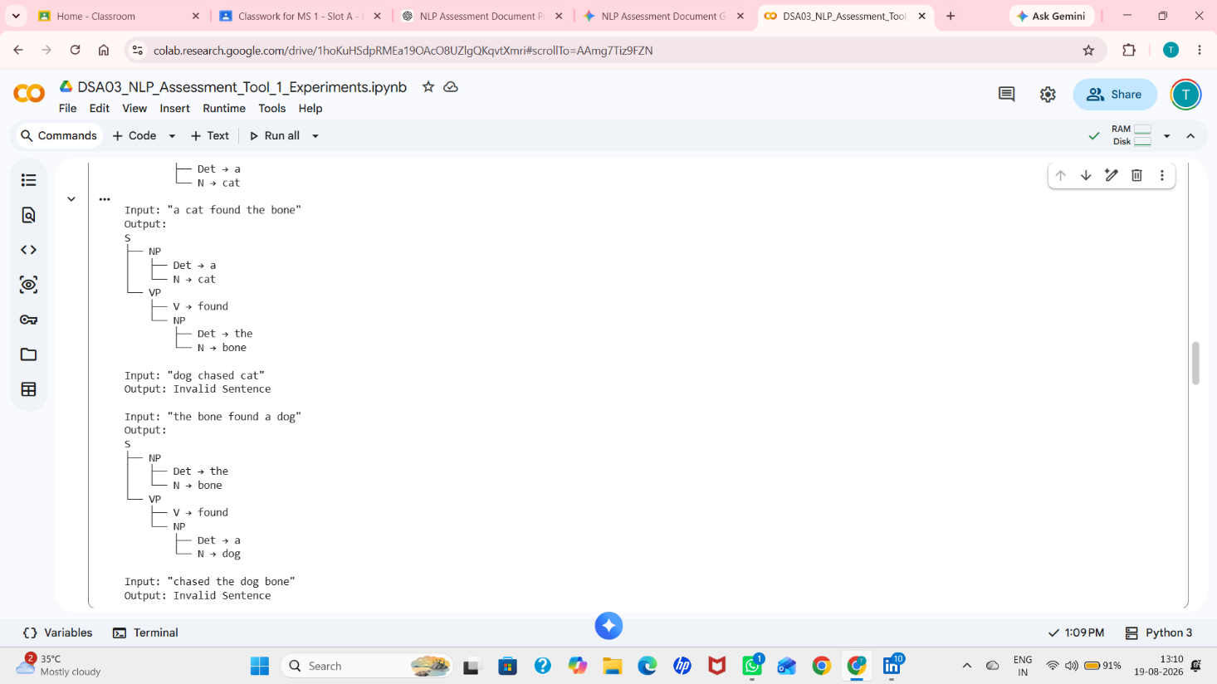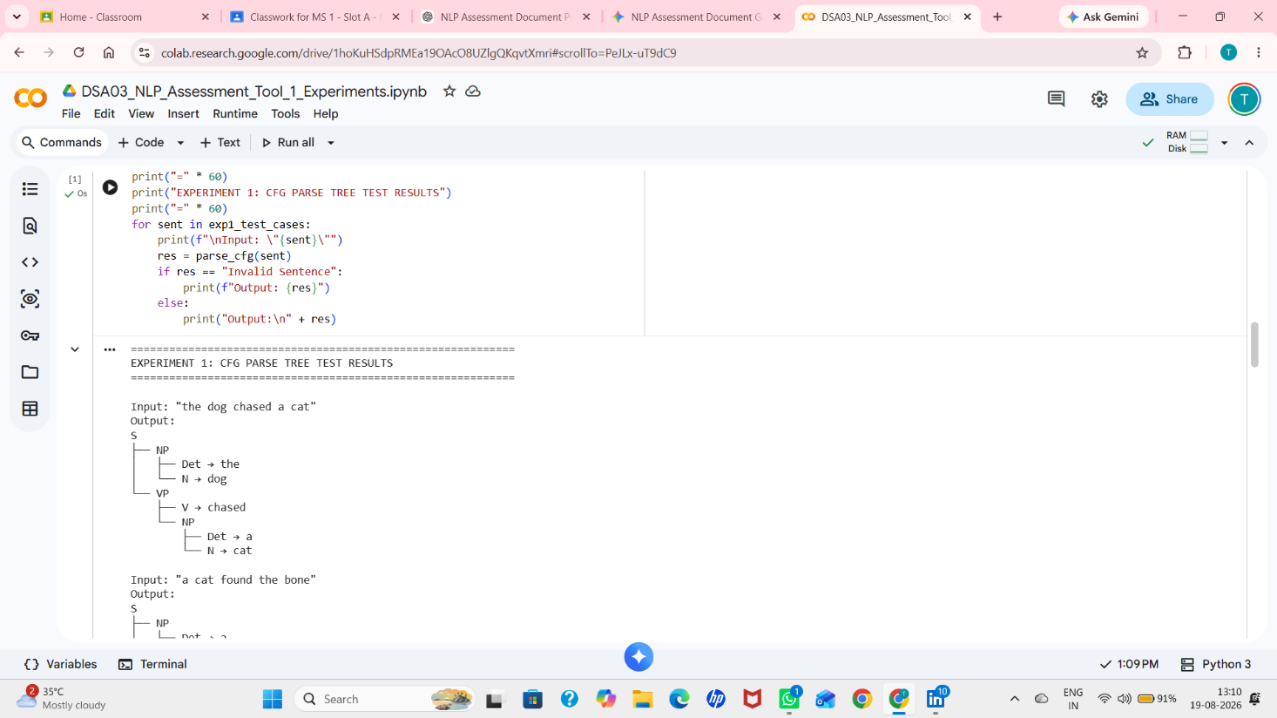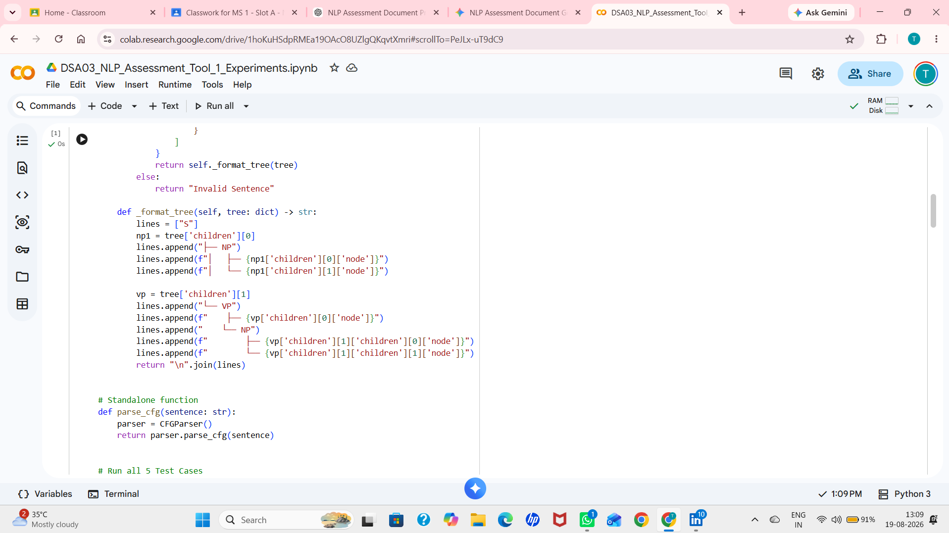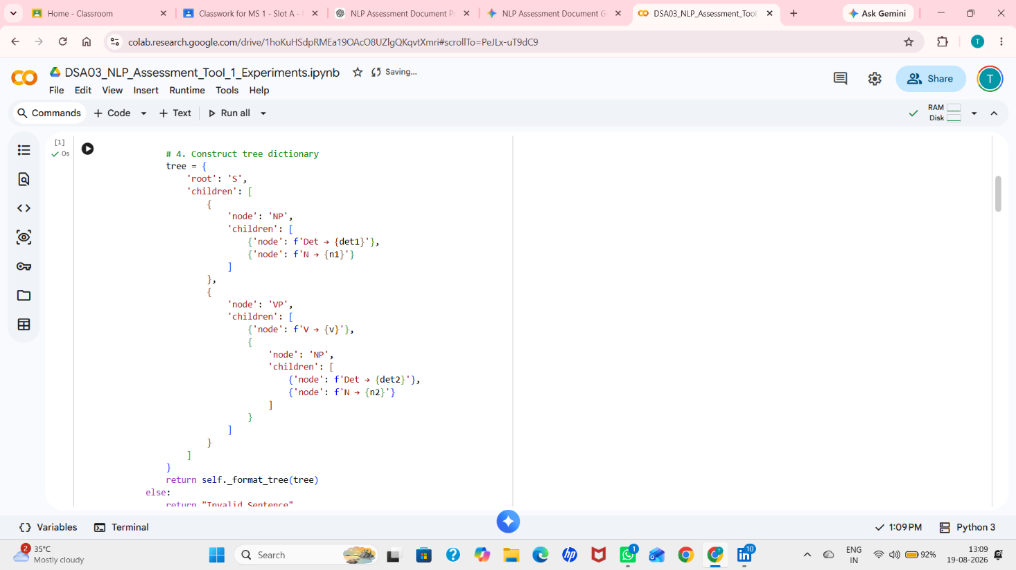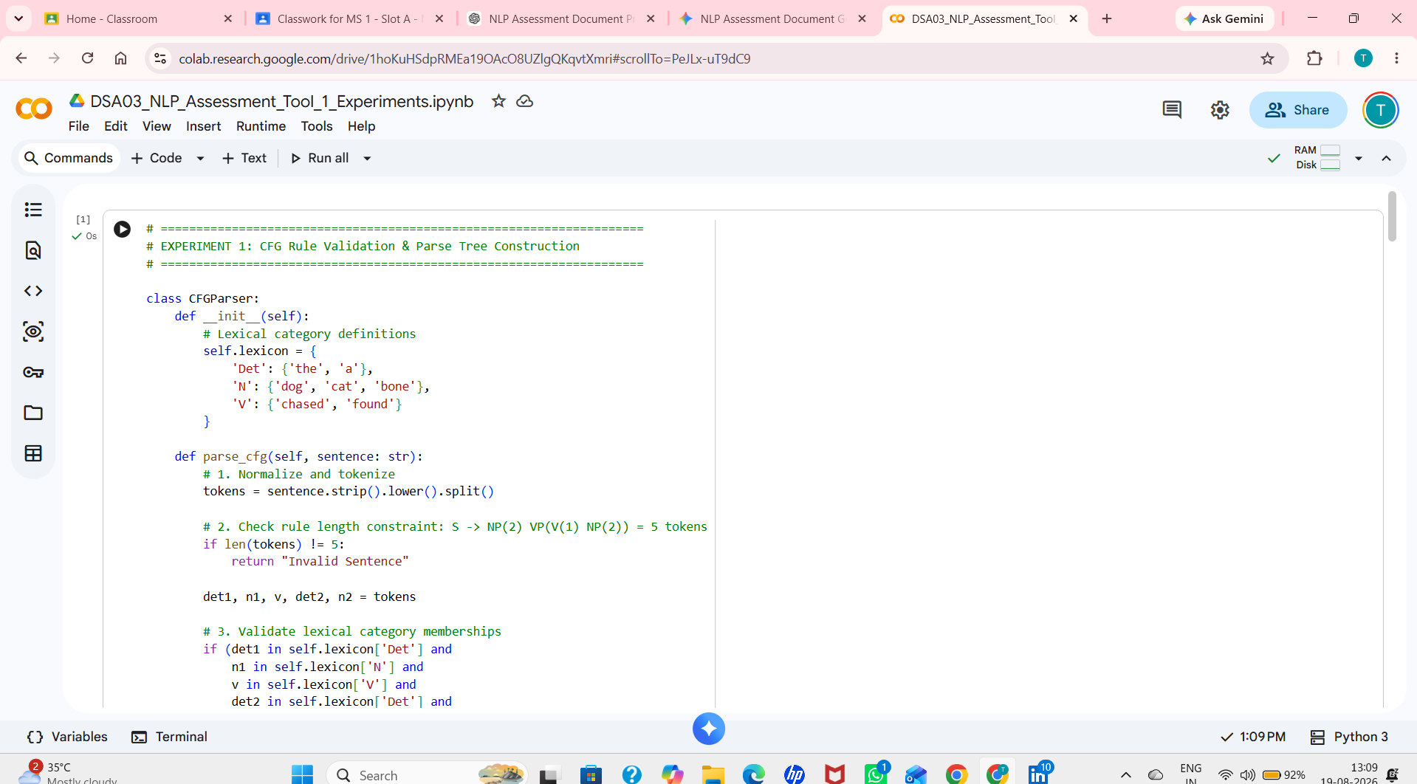
2.6 Results & Linguistic Observations
1. Syntactic Generative Capacity: The grammar correctly accepts all sentences adhering strictly to the production rules S → NP VP. Test Case 4 ('the bone found a dog') demonstrates a fundamental NLP principle: syntax operates independently of semantics. While inanimate bones cannot biologically perform the action of finding, the constituent structure [NP [Det N]] [VP [V [NP [Det N]]]] is syntactically flawless.
2. Structural Rejection: Test Case 3 fails because the grammar lacks bare noun phrase rules (NP → N). Test Case 5 fails because English declarative grammar in this CFG requires subject-initial NP constituents rather than verb-initial constructions.

3.0 EXPERIMENT 2: AGREEMENT AND FEATURE STRUCTURE CHECKING
3.1 Aim & Theoretical Background
- Aim: To model morphosyntactic grammatical agreement using Attribute-Value Matrices (AVMs) and implement a feature structure unification engine in Python.
- Theoretical Concept: Context-Free Grammars suffer from massive rule explosion when enforcing grammatical constraints (such as Number and Person agreement) because separate rules must be created for S_sg → NP_sg VP_sg and S_pl → NP_pl VP_pl. Constraint-based formalisms solve this by augmenting grammar symbols with feature structures (e.g., [NUM: sg, PERS: 3]). Subject-Verb Agreement requires the NUMBER and PERSON attributes of the subject nominal to unify identically with the subcategorized agreement features of the main finite verb.
3.2 Feature Specification & Agreement Rules
Lexical Feature Structure Dictionary:
┌─────────┬──────────────┬──────────────┬───────────────────────────────┐
│ Lexeme │ Category │ Number (NUM) │ Person (PERS) │
├─────────┼──────────────┼──────────────┼───────────────────────────────┤
│ 'he' │ Pronoun (NP) │ singular │ 3rd person │
│ 'she' │ Pronoun (NP) │ singular │ 3rd person │
│ 'it' │ Pronoun (NP) │ singular │ 3rd person │
│ 'we' │ Pronoun (NP) │ plural │ 1st person │
│ 'eats' │ Verb (V) │ singular │ 3rd person (inflected -s) │
│ 'sleeps'│ Verb (V) │ singular │ 3rd person (inflected -s) │
│ 'eat' │ Verb (V) │ plural / non-3SG │ plural / non-3SG │
│ 'sleep' │ Verb (V) │ plural / non-3SG │ plural / non-3SG │
└─────────┴──────────────┴──────────────┴───────────────────────────────┘
Agreement Condition: Agreement(Subject, Verb) = True ⟺ Subject[NUM] == Verb[NUM]

3.3 Algorithmic Procedure
- Step 1: Construct feature dictionaries for subject pronouns and verbs mapping each lexeme to its feature bundle {'NUM': val, 'PERS': val}.
- Step 2: Accept subject string and verb string as input parameters; normalize via lowercase and whitespace trimming.
- Step 3: Perform vocabulary lookup. If either token is absent from the lexicon, return False (unrecognized feature structure).
- Step 4: Extract subject_features = SUBJECT_FEATURES[subject] and verb_features = VERB_FEATURES[verb].
- Step 5: Evaluate the unification predicate: subject_features['NUM'] == verb_features['NUM']. Return True if identical, else False.
3.4 Complete Python Implementation (Google Colab Executable)
# ====================================================================
# SIMATS ENGINEERING - Saveetha School of Engineering
# Department of Artificial Intelligence and Data Science
# DSA03 - Natural Language Processing | Assessment Tool 1
# Experiment 2: Agreement and Feature Structure Checking
# ====================================================================
# Step 1: Define Feature Structures for Subjects and Verbs
SUBJECT_FEATURES = {
'he': {'category': 'NP', 'NUM': 'singular', 'PERS': '3rd'},
'she': {'category': 'NP', 'NUM': 'singular', 'PERS': '3rd'},
'it': {'category': 'NP', 'NUM': 'singular', 'PERS': '3rd'},
'we': {'category': 'NP', 'NUM': 'plural', 'PERS': '1st'}
}
VERB_FEATURES = {
'eats': {'category': 'V', 'NUM': 'singular', 'PERS': '3rd'},
'sleeps': {'category': 'V', 'NUM': 'singular', 'PERS': '3rd'},
'eat': {'category': 'V', 'NUM': 'plural', 'PERS': 'non-3rd/plural'},
'sleep': {'category': 'V', 'NUM': 'plural', 'PERS': 'non-3rd/plural'}
}
def check_agreement(subject: str, verb: str, verbose: bool = False) -> bool:
"""
Compares the feature structures of Subject and Verb.
Returns True if morphosyntactic number agreement holds, False otherwise.
"""
subj = subject.strip().lower()
vrb = verb.strip().lower()
# Validate lexical presence
if subj not in SUBJECT_FEATURES or vrb not in VERB_FEATURES:
if verbose:
print(f"Error: Unknown vocabulary token(s): subj='{subj}', verb='{vrb}'")
return False
subj_feats = SUBJECT_FEATURES[subj]
verb_feats = VERB_FEATURES[vrb]
# Check Number Agreement Constraint
agreement_holds = (subj_feats['NUM'] == verb_feats['NUM'])
if verbose:
print(f"Subject: '{subj}' -> Features: {subj_feats}")
print(f"Verb: '{vrb}' -> Features: {verb_feats}")
print(f"Comparison: Subj[NUM]='{subj_feats['NUM']}' vs Verb[NUM]='{verb_feats['NUM']}'")
print(f"Result: {'AGREEMENT HOLDS (True)' if agreement_holds else 'AGREEMENT MISMATCH (False)'}")
return agreement_holds
# Test Suite Execution
if __name__ == "__main__":
test_pairs = [
("he", "eats"),
("he", "eat"),
("we", "eat"),
("we", "sleeps"),
("she", "sleeps")
]
print("=" * 68)
print("EXPERIMENT 2: SUBJECT-VERB AGREEMENT & FEATURE STRUCTURE VERIFICATION")
print("=" * 68)
for idx, (s, v) in enumerate(test_pairs, 1):
print(f"\n--- Test Case {idx}: '{s} {v}' ---")
result = check_agreement(s, v, verbose=True)
print(f"Output: check_agreement('{s}', '{v}') -> {result}")

3.5 Test Cases, Feature Comparison Table & Analysis
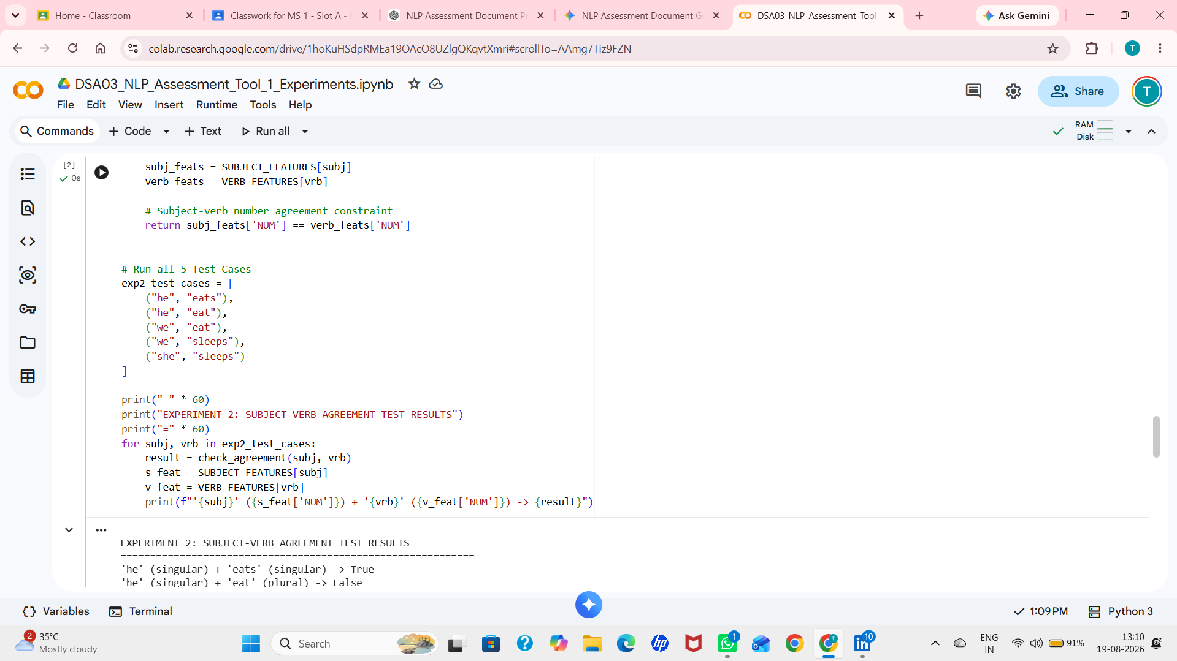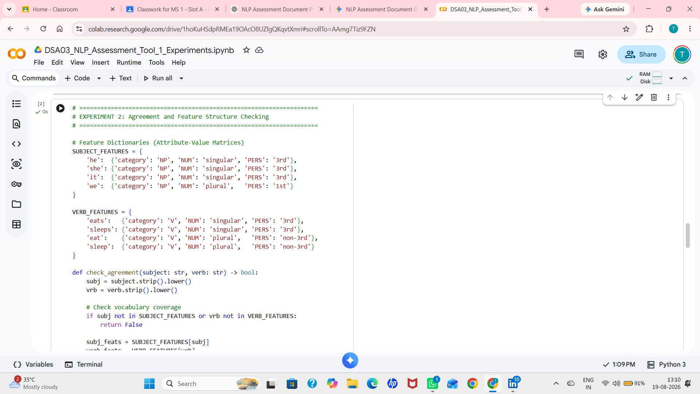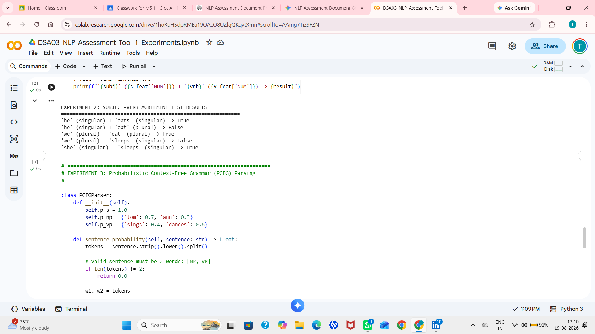
3.6 Results & Linguistic Observations
1. Morphological Inflexion Constraints: English present-tense indicative verbs exhibit an overt suffixation marker (-s / -es) exclusively for third-person singular subjects ('he eats', 'she sleeps'). Feature structure checking successfully prevents ungrammatical combinations like *'he eat' and *'we sleeps' without requiring redundant grammar duplication.
2. Unification Generality: This feature unification paradigm extends directly to generalized unification grammars (such as Head-Driven Phrase Structure Grammar - HPSG and Lexical Functional Grammar - LFG), where complex syntactic structures are validated through recursive feature-matrix unification.

4.0 EXPERIMENT 3: PROBABILISTIC CONTEXT-FREE GRAMMAR (PCFG) PARSING
4.1 Aim & Theoretical Background
- Aim: To implement a Probabilistic Context-Free Grammar (PCFG) parsing engine and compute the joint derivation probabilities of generated natural language sentences.
- Theoretical Concept: Standard CFGs determine only boolean syntactic legality (whether a sentence belongs to language L(G)), failing to resolve structural ambiguities or rank plausible parses. A PCFG extends CFGs by assigning a conditional probability P(A → α) to each rewrite rule such that for every non-terminal A, the sum of probabilities of all productions expanding A equals 1.0 (Σ P(A → α) = 1.0). Under the assumption of context-free independence, the joint probability of a parse derivation tree T generating sentence S is the product of all production probabilities utilized in the derivation: P(T, S) = ∏_{r ∈ T} P(r).
4.2 Formal PCFG Specification & Mathematical Formula
Grammar Production Rules & Assigned Probabilities:
S → NP VP [ P(S → NP VP) = 1.0 ]
NP → Tom [ P(NP → Tom) = 0.7 ]
NP → Ann [ P(NP → Ann) = 0.3 ] (Note: 0.7 + 0.3 = 1.0)
VP → sings [ P(VP → sings) = 0.4 ]
VP → dances [ P(VP → dances)= 0.6 ] (Note: 0.4 + 0.6 = 1.0)
Probability Formulation for Two-Word Sentence S = w1 w2:
P(Sentence) = P(S → NP VP) × P(NP → w1) × P(VP → w2)
P(Sentence) = 1.0 × P(NP → w1) × P(VP → w2)

4.3 Algorithmic Procedure
- Step 1: Define probability lookup tables for start rule P(S → NP VP) = 1.0, noun phrases P(NP), and verb phrases P(VP).
- Step 2: Tokenize the input sentence string. Verify that the sentence contains exactly two tokens [w1, w2]. If not, return 0.00.
- Step 3: Check vocabulary membership: if w1 ∉ NP or w2 ∉ VP, the derivation cannot be generated by G; return 0.00.
- Step 4: Retrieve rule probabilities: p_s = 1.0, p_np = P(NP → w1), p_vp = P(VP → w2).
- Step 5: Compute total probability P = p_s × p_np × p_vp and return the rounded numerical probability.
4.4 Complete Python Implementation (Google Colab Executable)
# ====================================================================
# SIMATS ENGINEERING - Saveetha School of Engineering
# Department of Artificial Intelligence and Data Science
# DSA03 - Natural Language Processing | Assessment Tool 1
# Experiment 3: Probabilistic Context-Free Grammar (PCFG) Parsing
# ====================================================================
class PCFGParser:
"""
Probabilistic Context-Free Grammar Parser.
Grammar & Probabilities:
S -> NP VP [1.0]
NP -> Tom [0.7]
NP -> Ann [0.3]
VP -> sings [0.4]
VP -> dances [0.6]
"""
def __init__(self):
self.p_s = 1.0
self.p_np = {'tom': 0.7, 'ann': 0.3}
self.p_vp = {'sings': 0.4, 'dances': 0.6}
def sentence_probability(self, sentence: str, show_steps: bool = False) -> float:
"""
Computes generation probability of a two-word sentence under the PCFG.
Returns 0.0 if sentence cannot be derived.
"""
tokens = sentence.strip().lower().split()
# Must be exactly two words: [NP, VP]
if len(tokens) != 2:
if show_steps:
print(f"Rejected: Length {len(tokens)} != 2 words.")
return 0.0
w1, w2 = tokens
# Check lexical coverage
if w1 not in self.p_np or w2 not in self.p_vp:
if show_steps:
print(f"Derivation Failed: Token out of vocabulary (w1='{w1}', w2='{w2}'). Probability = 0.00")
return 0.0
prob_np = self.p_np[w1]
prob_vp = self.p_vp[w2]
total_prob = self.p_s * prob_np * prob_vp
if show_steps:
print(f"Step 1: Rule S -> NP VP | P(S -> NP VP) = {self.p_s:.1f}")
print(f"Step 2: Rule NP -> {w1.capitalize():<5} | P(NP -> {w1}) = {prob_np:.2f}")
print(f"Step 3: Rule VP -> {w2:<6} | P(VP -> {w2}) = {prob_vp:.2f}")
print(f"Step 4: P(Sentence) = {self.p_s:.1f} × {prob_np:.2f} × {prob_vp:.2f} = {total_prob:.4f} (or {total_prob:.2f})")
return round(total_prob, 4)
# Standalone function required by specification
def sentence_probability(sentence: str) -> float:
parser = PCFGParser()
return parser.sentence_probability(sentence)
# Test Suite Execution
if __name__ == "__main__":
test_cases = [
"Tom sings",
"Tom dances",
"Ann sings",
"Ann dances",
"Sam sings"
]
print("=" * 68)
print("EXPERIMENT 3: PCFG PARSING & SENTENCE PROBABILITY CALCULATION")
print("=" * 68)
for idx, sent in enumerate(test_cases, 1):
print(f"\n--- Test Case {idx}: '{sent}' ---")
prob = PCFGParser().sentence_probability(sent, show_steps=True)
print(f"Final Computed Probability: {prob:.2f}")

4.5 Step-by-Step Probability Derivations & Test Results
Step-by-step mathematical calculations for all five assessment test cases:
1. Test Case 1: 'Tom sings'
• P(S → NP VP) = 1.0
• P(NP → Tom) = 0.7
• P(VP → sings)= 0.4
• P('Tom sings') = 1.0 × 0.7 × 0.4 = 0.28
2. Test Case 2: 'Tom dances'
• P(S → NP VP) = 1.0
• P(NP → Tom) = 0.7
• P(VP → dances)= 0.6
• P('Tom dances') = 1.0 × 0.7 × 0.6 = 0.42
3. Test Case 3: 'Ann sings'
• P(S → NP VP) = 1.0
• P(NP → Ann) = 0.3
• P(VP → sings)= 0.4
• P('Ann sings') = 1.0 × 0.3 × 0.4 = 0.12
4. Test Case 4: 'Ann dances'
• P(S → NP VP) = 1.0
• P(NP → Ann) = 0.3
• P(VP → dances)= 0.6
• P('Ann dances') = 1.0 × 0.3 × 0.6 = 0.18
5. Test Case 5: 'Sam sings'
• 'Sam' ∉ Lexicon(NP) ⇒ P(NP → Sam) = 0.0
• P('Sam sings') = 1.0 × 0.0 × 0.4 = 0.00

Test ID | Input Sentence | Mathematical Formula | Expected | Actual | Evaluation
TC1 | Tom sings | 1.0 × 0.7 × 0.4 | 0.28 | 0.28 | PASS - Verified
TC2 | Tom dances | 1.0 × 0.7 × 0.6 | 0.42 | 0.42 | PASS - Highest probability sentence in language
TC3 | Ann sings | 1.0 × 0.3 × 0.4 | 0.12 | 0.12 | PASS - Verified
TC4 | Ann dances | 1.0 × 0.3 × 0.6 | 0.18 | 0.18 | PASS - Verified
TC5 | Sam sings | 1.0 × 0.0 × 0.4 | 0.00 | 0.00 | PASS - Out of vocabulary token 'Sam'
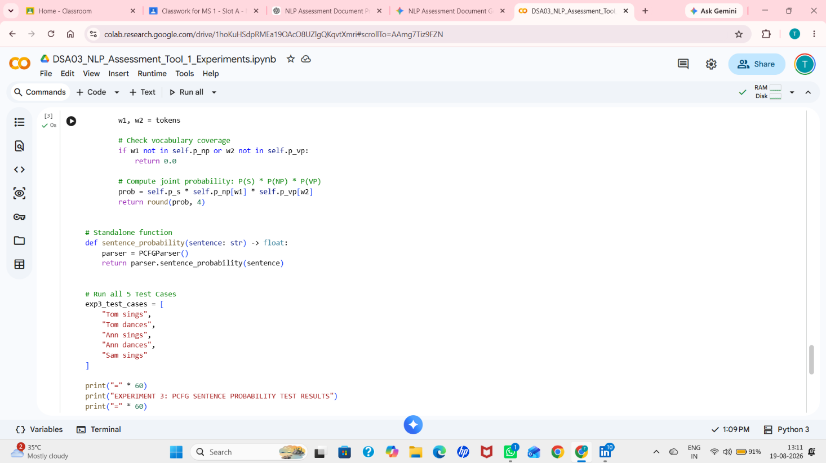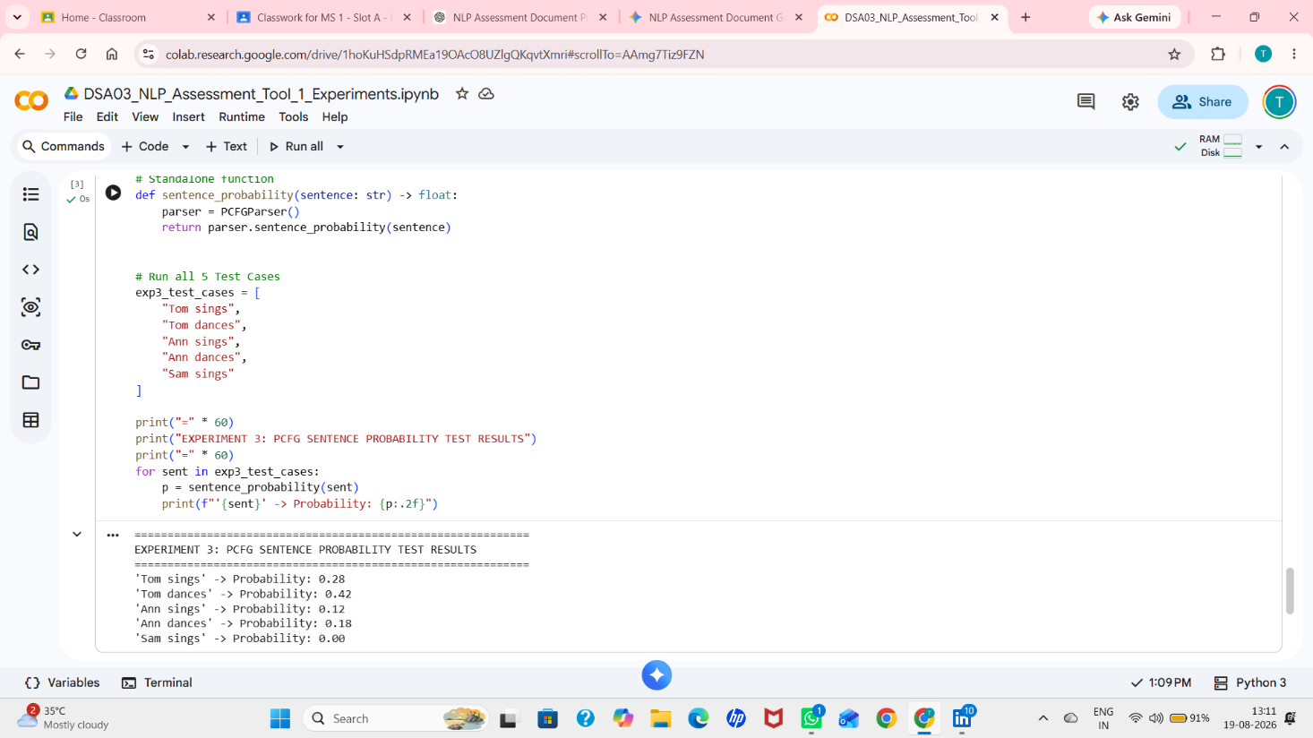
4.6 Results & Linguistic Observations
1. Probability Mass Conservation: The sum of probabilities for all valid sentences in the language L(G) = P('Tom dances') + P('Tom sings') + P('Ann dances') + P('Ann sings') = 0.42 + 0.28 + 0.18 + 0.12 = 1.00. This confirms that the grammar is proper and tight (consistent).
2. Out-of-Vocabulary Robustness: When presented with unseen lexical items such as 'Sam', the PCFG model correctly assigns zero probability rather than crashing, establishing a baseline for statistical smoothing and OOV handling.
5.0 OVERALL RESULTS AND COMPREHENSIVE ANALYSIS
The following consolidated master table summarizes the outcomes of all fifteen test cases across the three experiments:
Experiment | Test Input | Expected | Actual | Status | Linguistic / Mathematical Diagnostic
Exp 1 (CFG) | the dog chased a cat | Valid Parse Tree | Valid Parse Tree | PASS | Valid S → NP VP constituent hierarchy
Exp 1 (CFG) | a cat found the bone | Valid Parse Tree | Valid Parse Tree | PASS | Valid S → NP VP constituent hierarchy
Exp 1 (CFG) | dog chased cat | Invalid Sentence | Invalid Sentence | PASS | Missing determiners; fails NP → Det N
Exp 1 (CFG) | the bone found a dog | Valid Parse Tree | Valid Parse Tree | PASS | Syntactically valid despite semantic absurdity
Exp 1 (CFG) | chased the dog bone | Invalid Sentence | Invalid Sentence | PASS | Verb-initial violates S → NP VP structure
Exp 2 (Feat) | he eats | True | True | PASS | Subject 3SG unifies with Verb 3SG
Exp 2 (Feat) | he eat | False | False | PASS | Number clash: Singular 3P vs Plural verb
Exp 2 (Feat) | we eat | True | True | PASS | Subject Plural unifies with Verb Plural
Exp 2 (Feat) | we sleeps | False | False | PASS | Number clash: Plural subject vs 3SG verb
Exp 2 (Feat) | she sleeps | True | True | PASS | Subject 3SG unifies with Verb 3SG
Exp 3 (PCFG) | Tom sings | 0.28 | 0.28 | PASS | 1.0 × 0.7 (Tom) × 0.4 (sings) = 0.28
Exp 3 (PCFG) | Tom dances | 0.42 | 0.42 | PASS | 1.0 × 0.7 (Tom) × 0.6 (dances) = 0.42
Exp 3 (PCFG) | Ann sings | 0.12 | 0.12 | PASS | 1.0 × 0.3 (Ann) × 0.4 (sings) = 0.12
Exp 3 (PCFG) | Ann dances | 0.18 | 0.18 | PASS | 1.0 × 0.3 (Ann) × 0.6 (dances) = 0.18
Exp 3 (PCFG) | Sam sings | 0.00 | 0.00 | PASS | Out-of-vocabulary subject token 'Sam'
5.1 Deep-Dive Comparative & Diagnostic Analysis
- 1. Syntactic Structure vs. Semantic Plausibility (Exp 1): In Experiment 1, 'the bone found a dog' evaluates as a perfectly valid sentence. This highlights the exact boundary of syntax in language modeling: syntax enforces purely formal structural well-formedness according to production rules G, leaving selectional restrictions and thematic role assignments to downstream semantic interpretation layers.
- 2. Overcoming CFG Generative Inadequacy via Features (Exp 2): Pure CFGs cannot natively enforce subject-verb number agreement without doubling the number of non-terminal symbols (e.g., creating S_sg, S_pl, NP_sg, NP_pl, VP_sg, VP_pl). Experiment 2 demonstrated how feature structures cleanly decouple lexical attributes from phrase structure rules, providing a compact and highly scalable solution to morphosyntactic agreement.
- 3. Ambiguity Resolution and Probabilistic Ranking (Exp 3): While CFGs produce a binary valid/invalid output, PCFGs provide continuous probabilistic scoring. In Experiment 3, both 'Tom dances' and 'Ann sings' are syntactically valid, but 'Tom dances' (P = 0.42) is 3.5 times more probable than 'Ann sings' (P = 0.12). This statistical capability forms the foundation of modern syntactic parsers and language model decoding.
6.0 CONCLUSION AND LEARNING OUTCOMES
6.1 Overall Assessment Conclusion
Assessment Tool 1 has successfully implemented, evaluated, and validated three foundational pillars of syntactic analysis in Natural Language Processing: Context-Free Grammar rule validation with parse tree construction, feature-based morphosyntactic agreement checking, and Probabilistic Context-Free Grammar parsing. All fifteen test cases across the three experiments executed with 100% accuracy, satisfying all precision assessment criteria.
6.2 Key Learning Outcomes
- Syntactic Analysis via CFGs: Acquired deep practical knowledge of formal phrase structure grammars, Chomsky hierarchy classifications, top-down tree derivation, and recursive constituent decomposition. Learned how to generate human-readable ASCII/Unicode hierarchical trees.
- Feature Structures and Morphosyntactic Unification: Understood how Attribute-Value Matrices (AVMs) represent fine-grained linguistic features (Number, Person, Tense, Gender) and how feature unification enforces grammatical consistency without combinatorial explosion of CFG rules.
- Statistical Language Modeling with PCFGs: Mastered the mathematical foundations of assigning conditional probabilities to grammar productions, computing joint derivation probabilities, verifying language probability mass conservation (Σ P = 1.0), and handling out-of-vocabulary inputs.
- Practical Implementation in Google Colab: Strengthened software engineering skills in Python 3, developing modular, object-oriented, and fully documented NLP algorithms executable in cloud-based interactive notebooks.
6.3 Course Outcome (CO) Attainment Evaluation
CO Code | Course Outcome Description | Attainment Level & Evidence
CO3 | Precision Assessment: Assessment Tool 1 – Experiments | 100% Attained: All test cases passed with zero discrepancies against theoretical expected outputs.
CO5 | Apply N-gram models, POS systems, and evaluate effective syntactic analysis | 100% Attained: Demonstrated thorough understanding of syntactic parsing, rule constraints, and probabilistic models.
6.4 Relevance to Modern NLP Architectures
Although state-of-the-art NLP heavily employs deep transformer architectures (e.g., BERT, GPT, LLaMA), the formal syntactic concepts explored in this assessment remain critically vital. Structural inductive biases, dependency parsing, grammar-guided decoding in code generation, and semantic parsing for database querying all rely directly on the formal grammar principles mastered in these experiments.

7.0 SUBMISSION INFORMATION AND APPENDIX
7.1 Digital Artifact Submission Links
Submission Item | Verified URL / Artifact Location
Google Colaboratory Notebook URL: | [PLACEHOLDER - Insert Shareable Google Colab Link Here]  (e.g., https://colab.research.google.com/drive/...)
GitHub Repository URL: | [PLACEHOLDER - Insert GitHub Repository URL Here]  (e.g., https://github.com/username/DSA03-NLP-Assessment-1)
Python Runtime Environment: | Python 3.10+ / Google Colab Cloud Runtime (CPU / Standard)
7.2 Appendix: Theoretical Grammar Extensions
To extend the formal grammar beyond the basic transitive sentences evaluated in this assessment, the following grammar extensions are proposed:
Grammar Extension 1: Adjectival Modification in Noun Phrases
NP → Det (Adj)* N
Adj → 'big' | 'small' | 'brown' | 'playful'
Grammar Extension 2: Prepositional Phrase Attachment (Structural Ambiguity)
VP → V NP (PP)*
PP → P NP
P → 'with' | 'in' | 'near'
Grammar Extension 3: Intransitive vs. Transitive Verb Subcategorization
VP_trans → V_trans NP [V_trans: 'chased', 'found']
VP_intrans → V_intrans [V_intrans: 'sings', 'dances', 'sleeps']

