Education Regulation Impact Analyzer (ERIA)

Project Report
Prepared by

Tharaniya VM

Abstract
Education Regulation Impact Analyzer (ERIA) is an AI-powered analytics dashboard developed using Streamlit and Google Gemini AI. The system helps educational institutions analyze policy documents, regulations, and government circulars efficiently. The application converts complex educational regulations into structured insights, risk indicators, and stakeholder impact summaries. The platform improves decision-making and reduces the manual effort required to interpret large policy documents.

Introduction
Educational institutions regularly receive government circulars and policy updates. Understanding these documents manually is time-consuming and difficult. ERIA was developed to simplify the process of analyzing educational regulations using Artificial Intelligence and Natural Language Processing techniques.

Problem Statement
Educational regulations are usually lengthy and written in complex legal language. Institutions face difficulties identifying important changes, risks, and stakeholder impacts quickly. There is a need for an automated system that can summarize and analyze such documents effectively.

Objectives
- To develop an AI-based regulation analysis dashboard.
- To upload and process educational policy documents in PDF format.
- To generate structured summaries and insights automatically.
- To identify stakeholder impacts and risk indicators.
- To provide a user-friendly dashboard for educational institutions.

Technology Stack
Technology | Purpose
Python | Core programming language
Streamlit | Dashboard development
Google Gemini AI | Document analysis and AI insights
PDF Processing | Handling uploaded circulars
HTML/CSS | UI styling and customization

System Architecture
1. User uploads an educational regulation PDF.
2. The document is processed by the Streamlit application.
3. Google Gemini AI analyzes the content.
4. The system generates summaries, impact analysis, and risk indicators.
5. Results are displayed in the analytics dashboard.

Features
- AI-powered regulation analysis
- Interactive Streamlit dashboard
- PDF document upload support
- Risk indicator generation
- Stakeholder impact summaries
- Clean and modern UI design

Modules Description
Home Module: Displays the project overview and dashboard interface.
Impact Analyzer Module: Uploads and analyzes educational regulation documents.
AI Analysis Module: Uses Gemini AI to generate summaries and insights.
Visualization Module: Displays analytics and impact results.

Methodology
The ERIA system follows a document analysis workflow. Users upload educational regulation PDFs into the dashboard. The application extracts the document content and sends it to the Gemini AI model. The AI processes the document and returns structured insights such as summaries, risks, and impacts. The results are then displayed in an easy-to-understand dashboard format.

Advantages
- Reduces manual analysis effort
- Provides faster policy interpretation
- Improves decision-making accuracy
- Simple and user-friendly interface
- Supports AI-driven insights

Limitations
- Requires internet access for Gemini AI integration
- Currently supports mainly PDF documents
- Analysis quality depends on AI model responses

Future Enhancements
- Support for multiple document formats
- Advanced analytics and visualization charts
- Multi-language document analysis
- Cloud deployment support
- Real-time collaboration features

Screenshots

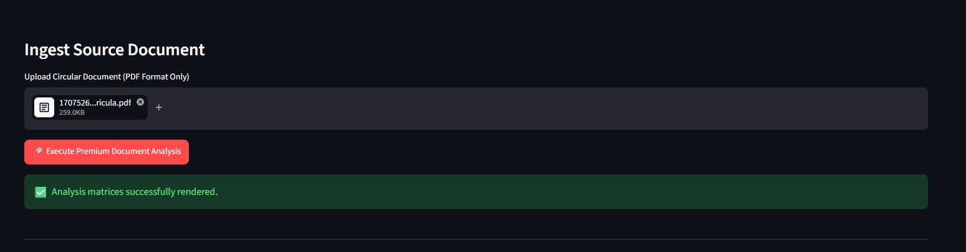

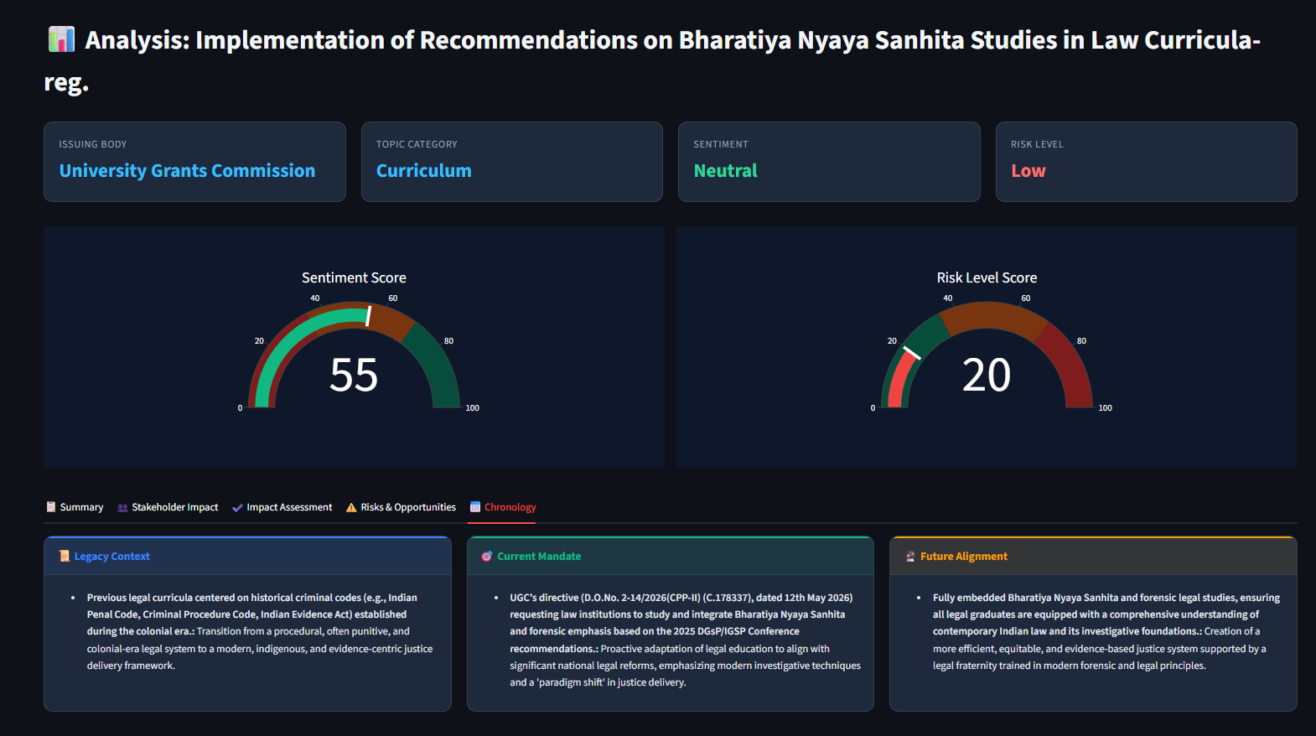

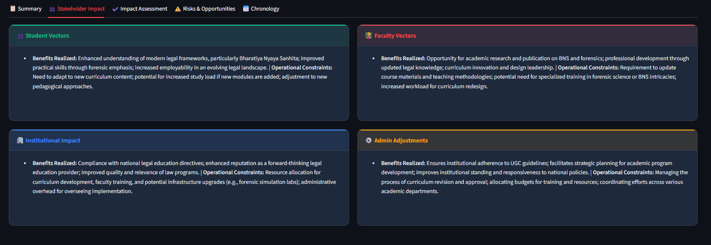

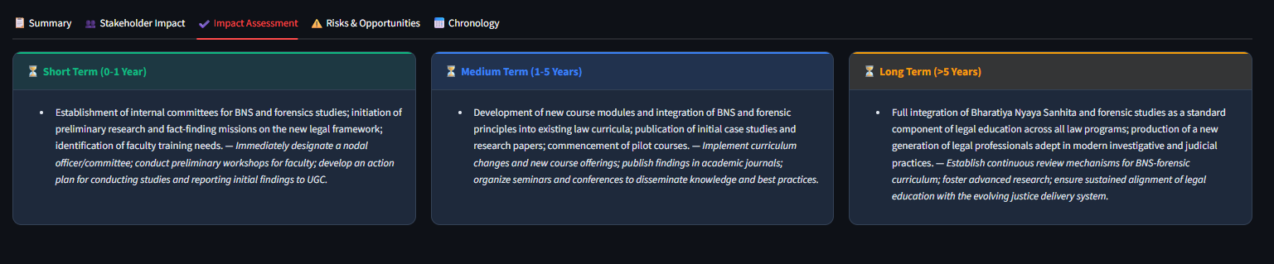

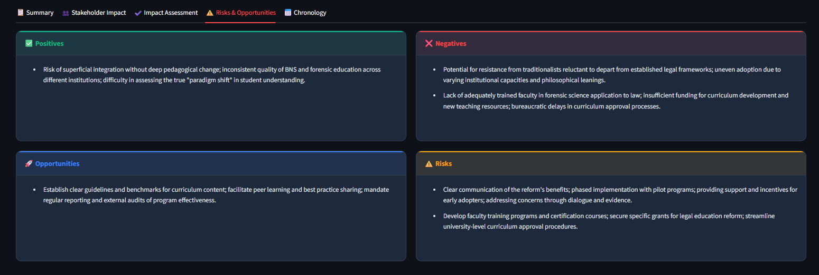

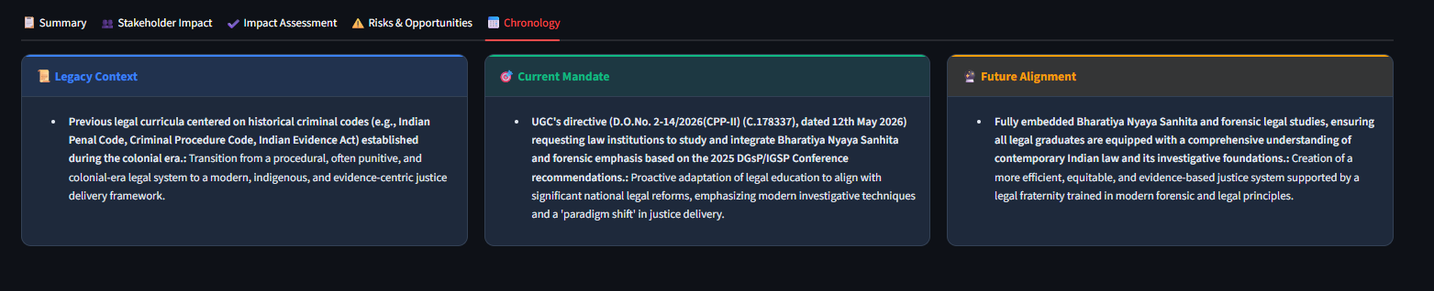

Conclusion
The Education Regulation Impact Analyzer (ERIA) is an innovative AI-powered solution for analyzing educational policies and regulations. The project demonstrates how Artificial Intelligence can simplify complex document analysis and help institutions make better decisions efficiently.

References
- Python Official Documentation - https://www.python.org/
- Streamlit Documentation - https://streamlit.io/
- Google Gemini AI Documentation - https://ai.google.dev/
- GitHub Repository Source Code

Appendix
README Extract from Repository:
# Education Regulation Impact Analyzer (ERIA)
ERIA is a Streamlit-based analytics dashboard for educational regulations, circulars, and policy documents.
It is designed to help institutions translate dense legislative text into actionable insights, risk indicators, and stakeholder impact summaries.
## Project Structure
- `Home.py` - Main Streamlit landing page with project overview and feature description.
- `pages/ImpactAnalyzer.py` - Secondary Streamlit page for premium document analysis using Google Gemini.
- `Education Regulation Impact Analyzer (ERIA).docx` - Project documentation or proposal.
## Features
- Clean dashboard layout using Streamlit and custom UI styling.
- Document ingestion for PDF circulars.
- Integration with Google Gemini AI for structured document analysis.
- Extraction of policy metrics, stakeholder impacts, risk assessment, and timeline insights.
## Requirements
- Python 3.10+ or compatible Python environment.
- `streamlit`
- `pandas`
- `google-genai` (Google Gemini client library)
You can install all dependencies from `requirements.txt`:
```bash
pip install -r requirements.txt
```
## Setup
1. Create and activate a virtual environment:
```bash
python3 -m venv .venv
source .venv/bin/activate
```
2. Install dependencies:
```bash
pip install streamlit pandas google-genai
```
3. Set your Google Gemini API key in the environment or enter it in the app sidebar:
```bash
export GEMINI_API_KEY="your_api_key_here"
```
## Running the App
From the project root, run:
```bash
streamlit run Home.py
```
Then open the local Streamlit URL shown in the terminal.
## Usage
- `Home.py` provides an overview of ERIA and its analytics capabilities.
- `pages/ImpactAnalyzer.py` lets you upload a PDF circular and analyze it with Gemini.
- If the API key is not set, the sidebar will prompt you to enter it.
## Notes
- The current app expects uploaded documents in PDF format.
- Gemini integration is required for the premium analysis workflow.
- Yo

