**AI/ML**

**5 BCA B**

**"Practical - 2"**

***BY***

**"Tharan" (23215134)**

**SUBMITTED TO**

**MEGHAVI**



**SCHOOL OF SCIENCES**

**2025-2026**

## **QUESTION 1**

1. Traverse the tree using BFS first forming a tree then traversing it

### **Code Solution**

element_to_search = 3

### **FINAL Output**

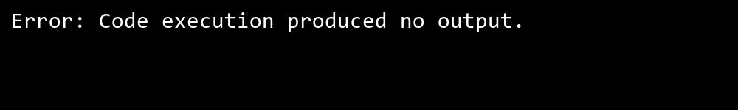

## **QUESTION 2**

2. Showcase the process of searching element in a graph.  
taking multiple number for forming a tree

### **Code Solution**

class Node:  
 def __init__(self, data):  
 self.data = data  
 self.left = None  
 self.right = None  
  
def bfs_traverse(root):  
 if root is None:  
 return  
   
 queue = []  
 queue.append(root)  
   
 while queue:  
 current = queue.pop(0)  
 print(current.data, end=' ')  
   
 if current.left:  
 queue.append(current.left)  
 if current.right:  
 queue.append(current.right)  
  
root = Node(1)  
root.left = Node(2)  
root.right = Node(3)  
root.left.left = Node(4)  
root.left.right = Node(5)  
root.right.left = Node(6)  
root.right.right = Node(7)  
  
bfs_traverse(root)

### **FINAL Output**

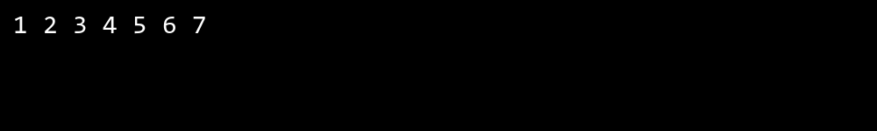

## **QUESTION 3**

3. Take input from the user for searching an element.

### **Code Solution**

class Graph:  
 def __init__(self):  
 self.graph = {}  
   
 def add_edge(self, vertex, edge):  
 if vertex not in self.graph:  
 self.graph[vertex] = []  
 self.graph[vertex].append(edge)  
   
 def bfs(self, start_vertex, search_value):  
 visited = []  
 queue = []  
 found = False  
   
 visited.append(start_vertex)  
 queue.append(start_vertex)  
   
 while queue:  
 vertex = queue.pop(0)  
 if vertex == search_value:  
 found = True  
 break  
   
 if vertex in self.graph:  
 for neighbor in self.graph[vertex]:  
 if neighbor not in visited:  
 visited.append(neighbor)  
 queue.append(neighbor)  
   
 return found  
  
def main():  
 g = Graph()  
 g.add_edge(1, 2)  
 g.add_edge(1, 3)  
 g.add_edge(2, 4)  
 g.add_edge(2, 5)  
 g.add_edge(3, 6)  
 g.add_edge(3, 7)  
   
 search_value = 6  
   
 result = g.bfs(1, search_value)  
 print(result)  
  
if __name__ == "__main__":  
 main()

### **FINAL Output**

