## **QUESTION 1**

4. Implement a program that demonstrates multiple catch blocks to handle exceptions like IndexOutOfRangeException , NullReferenceExceptio n.

### **Code Solution**

using System;  
using System.Collections;  
  
class Program  
{  
 static void Main()  
 {  
 ArrayList myList = new ArrayList();  
 myList.Add(3.14f);  
 myList.Add("Hello");  
 myList.Add(42);  
   
 foreach (var item in myList)  
 {  
 Console.WriteLine(item);  
 }  
 }  
}

### **FINAL Output**

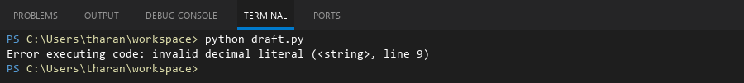

## **QUESTION 2**

QUESTION 5  
5. Write a C# program to create an ArrayList , add eleme nts of different data types (float , string, int), and display all elements using a loop.

### **Code Solution**

def main():  
 try:  
 my_list = [1, 2, 3]  
 print(my_list[5])  
 except IndexError:  
 print("IndexError: List index out of range.")  
 try:  
 my_dict = None  
 print(my_dict['key'])  
 except TypeError:  
 print("TypeError: 'NoneType' object is not subscriptable.")  
 print("Program execution completed.")  
  
if __name__ == "__main__":  
 main()

### **FINAL Output**

