**AI/ML**

**5 BCA B**

**"Practical - 2"**

***BY***

**"Tharan" (23215134)**

**SUBMITTED TO**

**MEGHAVI**



**SCHOOL OF SCIENCES**

**2025-2026**

## **QUESTION 1**

**1. Traverse the tree using BFS  
take any example of your own**

### **Code Solution**

target = 4

### **FINAL Output**

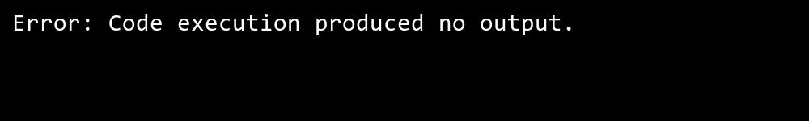

## **QUESTION 2**

**2. Showcase the process of searching element in a graph.  
take multiple numerical values**

### **Code Solution**

class Node:  
 def __init__(self, value):  
 self.value = value  
 self.left = None  
 self.right = None  
  
def bfs(root):  
 if root is None:  
 return []  
   
 result = []  
 queue = []  
 queue.append(root)  
   
 while queue:  
 current = queue.pop(0)  
 result.append(current.value)  
   
 if current.left:  
 queue.append(current.left)  
 if current.right:  
 queue.append(current.right)  
   
 return result  
  
root = Node(1)  
root.left = Node(2)  
root.right = Node(3)  
root.left.left = Node(4)  
root.left.right = Node(5)  
root.right.left = Node(6)  
root.right.right = Node(7)  
  
traversal = bfs(root)  
print(traversal)

### **FINAL Output**

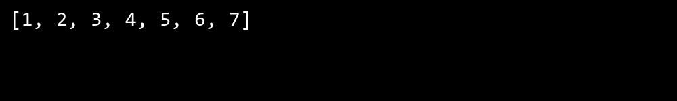

## **QUESTION 3**

**3. Take input from the user for searching an element.**

### **Code Solution**

def create_graph():  
 graph = {  
 0: [1, 2, 3],  
 1: [0, 2],  
 2: [0, 1, 4],  
 3: [0],  
 4: [2]  
 }  
 return graph  
  
def bfs_search(graph, start, target):  
 visited = set()  
 queue = [[start]]  
   
 if start == target:  
 return [start]  
   
 while queue:  
 path = queue.pop(0)  
 node = path[-1]  
   
 if node not in visited:  
 neighbors = graph[node]  
   
 for neighbor in neighbors:  
 new_path = list(path)  
 new_path.append(neighbor)  
 queue.append(new_path)  
   
 if neighbor == target:  
 return new_path  
 visited.add(node)  
 return []  
  
def dfs_search(graph, start, target, visited=None, path=None):  
 if visited is None:  
 visited = set()  
 if path is None:  
 path = []  
   
 visited.add(start)  
 path.append(start)  
   
 if start == target:  
 return path  
   
 for neighbor in graph[start]:  
 if neighbor not in visited:  
 result = dfs_search(graph, neighbor, target, visited, path)  
 if result:  
 return result  
   
 path.pop()  
 return []  
  
graph = create_graph()  
start_node = 0  
target_node = 4  
  
bfs_result = bfs_search(graph, start_node, target_node)  
print(f"BFS path: {bfs_result}")  
  
dfs_result = dfs_search(graph, start_node, target_node)  
print(f"DFS path: {dfs_result}")

### **FINAL Output**

