**#COURSE NAME**

**#Class name**

**"#PRACTICAL_NUMBER"**

***BY***

**"tharan" (#Registration Number)**

**SUBMITTED TO**

**#teacher name**



**SCHOOL OF SCIENCES**

**2025-2026**

## **QUESTION 1**

factorial of 5

### **Code Solution**

def factorial(n):  
 if n == 0:  
 return 1  
 else:  
 return n * factorial(n-1)  
  
number = 5  
result = factorial(number)  
print(result)

### **FINAL Output**

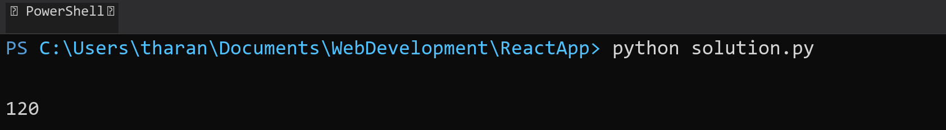

## **QUESTION 2**

fibbonachi series till 10

### **Code Solution**

def fibonacci(n):  
 if n <= 0:  
 return []  
 elif n == 1:  
 return [0]  
 sequence = [0, 1]  
 for i in range(2, n):  
 sequence.append(sequence[i-1] + sequence[i-2])  
 return sequence  
  
result = fibonacci(10)  
print(result)

### **FINAL Output**

