**#COURSE NAME**

**#Class name**

**"#PRACTICAL_NUMBER"**

***BY***

**"sarthak" (#Registration Number)**

**SUBMITTED TO**

**#teacher name**



**SCHOOL OF SCIENCES**

**2025-2026**

## **QUESTION 1**

factorial of 5

### **Code Solution**

def fibonacci(n):  
 a = 0  
 b = 1  
 fib_series = []  
 for i in range(n):  
 fib_series.append(a)  
 c = a + b  
 a = b  
 b = c  
 return fib_series  
  
n = 10  
result = fibonacci(n)  
print(result)

### **FINAL Output**

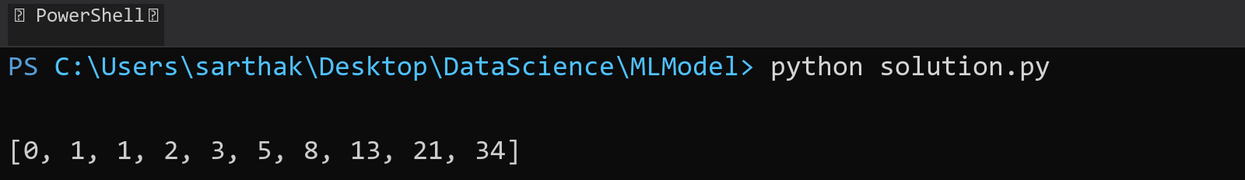

## **QUESTION 2**

fibbonachi series till 10

### **Code Solution**

def factorial(n):  
 if n == 0:  
 return 1  
 else:  
 return n * factorial(n - 1)  
  
number = 5  
result = factorial(number)  
print(result)

### **FINAL Output**

