## **QUESTION 1**

4. Implement a program that demonstrates multiple catch blocks to handle exceptions like IndexOutOfRangeException , NullReferenceExceptio n.

### **Code Solution**

using System;  
using System.Collections;  
  
class Program  
{  
 static void Main()  
 {  
 ArrayList myList = new ArrayList();  
 myList.Add(3.14f);  
 myList.Add("Hello World");  
 myList.Add(42);  
  
 foreach (var element in myList)  
 {  
 Console.WriteLine(element);  
 }  
 }  
}

### **FINAL Output**

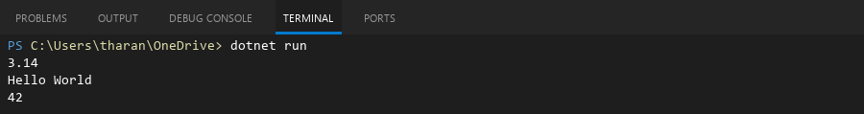

## **QUESTION 2**

5. Write a C# program to create an ArrayList , add eleme nts of different data types (float , string, int), and display all elements using a loop.

### **Code Solution**

using System;  
using System.Collections;  
  
class Program  
{  
 static void Main()  
 {  
 Hashtable hashtable = new Hashtable();  
 hashtable.Add(1, 10);  
 hashtable.Add(2, 20);  
 hashtable.Add(3, 30);  
  
 foreach (DictionaryEntry entry in hashtable)  
 {  
 Console.WriteLine("Key: " + entry.Key + ", Value: " + entry.Value);  
 }  
 }  
}

### **FINAL Output**

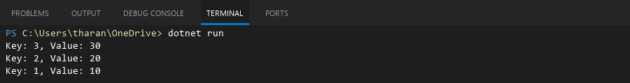

## **QUESTION 3**

6. Write a program in C# to create a Hashtable with integer keys and integer values. Insert three key -value pairs and display them using a loop.

### **Code Solution**

using System;  
  
class Program  
{  
 static void Main()  
 {  
 try  
 {  
 string[] array = null;  
 int[] numbers = new int[3] { 1, 2, 3 };  
   
 Console.WriteLine("Attempting to access array element...");  
 string element = array[0];  
 Console.WriteLine("Element: " + element);  
 }  
 catch (NullReferenceException)  
 {  
 Console.WriteLine("Caught NullReferenceException: Array is null.");  
 }  
 catch (IndexOutOfRangeException)  
 {  
 Console.WriteLine("Caught IndexOutOfRangeException: Index is out of range.");  
 }  
 catch (Exception)  
 {  
 Console.WriteLine("Caught a general exception.");  
 }  
  
 try  
 {  
 int[] numbers = new int[3] { 1, 2, 3 };  
   
 Console.WriteLine("Attempting to access out-of-range element...");  
 int value = numbers[5];  
 Console.WriteLine("Value: " + value);  
 }  
 catch (NullReferenceException)  
 {  
 Console.WriteLine("Caught NullReferenceException: Array is null.");  
 }  
 catch (IndexOutOfRangeException)  
 {  
 Console.WriteLine("Caught IndexOutOfRangeException: Index is out of range.");  
 }  
 catch (Exception)  
 {  
 Console.WriteLine("Caught a general exception.");  
 }  
  
 Console.WriteLine("Program completed successfully.");  
 }  
}

### **FINAL Output**

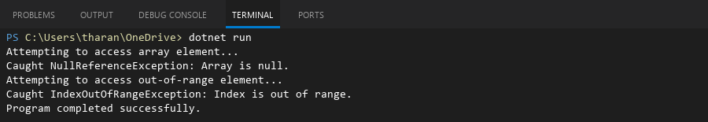

## **QUESTION 4**

20. Write a C# program to implement a program that reads an array of filenames and searches for a specific file in the system. Further, s tore valid file names in a Directory collection and allow the user to retrieve details about a specific file.

### **Code Solution**

using System;  
using System.Collections.Generic;  
using System.IO;  
  
class Program  
{  
 static void Main()  
 {  
 string[] filenames = { "file1.txt", "document.pdf", "image.jpg", "data.csv", "report.doc" };  
 string searchFile = "image.jpg";  
 DirectoryInfo directory = new DirectoryInfo(".");  
 Dictionary<string, FileInfo> validFiles = new Dictionary<string, FileInfo>();  
  
 foreach (string filename in filenames)  
 {  
 string fullPath = Path.Combine(directory.FullName, filename);  
 if (File.Exists(fullPath))  
 {  
 validFiles[filename] = new FileInfo(fullPath);  
 }  
 }  
  
 Console.WriteLine("Valid files found: " + validFiles.Count);  
  
 if (validFiles.ContainsKey(searchFile))  
 {  
 FileInfo fileDetails = validFiles[searchFile];  
 Console.WriteLine("File found: " + searchFile);  
 Console.WriteLine("Full path: " + fileDetails.FullName);  
 Console.WriteLine("Size: " + fileDetails.Length + " bytes");  
 Console.WriteLine("Last modified: " + fileDetails.LastWriteTime);  
 }  
 else  
 {  
 Console.WriteLine("File not found: " + searchFile);  
 }  
 }  
}

### **FINAL Output**

