**AI/ML**

**5 BCA B**

**"Practical - 2"**

***BY***

**"Tharan" (23215134)**

**SUBMITTED TO**

**MEGHAVI**



**SCHOOL OF SCIENCES**

**2025-2026**

## **QUESTION 1**

**1. Traverse the tree using BFS  
take any example of your own take multiple numerical values**

### **Code Solution**

search_element = 8

### **FINAL Output**

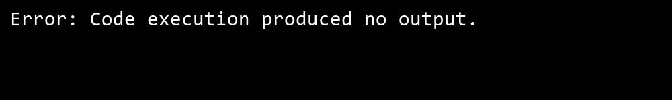

## **QUESTION 2**

**2. Showcase the process of searching element in a graph.**

### **Code Solution**

class Node:  
 def __init__(self, value):  
 self.value = value  
 self.left = None  
 self.right = None  
  
def breadth_first_search(root):  
 if root is None:  
 return []  
   
 result = []  
 queue = []  
 queue.append(root)  
   
 while queue:  
 current = queue.pop(0)  
 result.append(current.value)  
   
 if current.left:  
 queue.append(current.left)  
 if current.right:  
 queue.append(current.right)  
   
 return result  
  
root = Node(1)  
root.left = Node(2)  
root.right = Node(3)  
root.left.left = Node(4)  
root.left.right = Node(5)  
root.right.left = Node(6)  
root.right.right = Node(7)  
  
bfs_result = breadth_first_search(root)  
print(bfs_result)

### **FINAL Output**

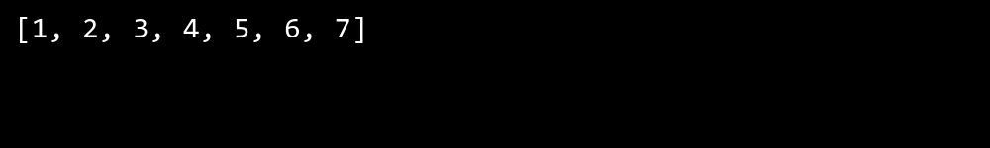

## **QUESTION 3**

**3. Take input from the user for searching an element.**

### **Code Solution**

class Graph:  
 def __init__(self):  
 self.graph = {}  
   
 def add_edge(self, vertex, edge):  
 if vertex not in self.graph:  
 self.graph[vertex] = []  
 self.graph[vertex].append(edge)  
   
 def bfs(self, start_vertex, search_value):  
 visited = set()  
 queue = []  
 queue.append(start_vertex)  
 visited.add(start_vertex)  
   
 while queue:  
 vertex = queue.pop(0)  
 if vertex == search_value:  
 return True  
   
 for neighbor in self.graph[vertex]:  
 if neighbor not in visited:  
 visited.add(neighbor)  
 queue.append(neighbor)  
 return False  
   
 def dfs(self, start_vertex, search_value, visited=None):  
 if visited is None:  
 visited = set()  
   
 if start_vertex == search_value:  
 return True  
   
 visited.add(start_vertex)  
   
 for neighbor in self.graph[start_vertex]:  
 if neighbor not in visited:  
 if self.dfs(neighbor, search_value, visited):  
 return True  
 return False  
  
g = Graph()  
g.add_edge(0, 1)  
g.add_edge(0, 2)  
g.add_edge(1, 2)  
g.add_edge(2, 0)  
g.add_edge(2, 3)  
g.add_edge(3, 3)  
  
search_value = 3  
print(f"BFS found {search_value}: {g.bfs(2, search_value)}")  
print(f"DFS found {search_value}: {g.dfs(2, search_value)}")

### **FINAL Output**

