**#COURSE NAME**

**#Class name**

**“#practicle number”**

***BY***

**<#Student Name> (#Registration Number)**

**SUBMITTED TO**

**#teacher name**



**SCHOOL OF SCIENCES**

**2025-2026**

## QUESTION 1

***factoiral of 5***

### Code Solution

def factorial(n):  
 if n == 0:  
 return 1  
 return n * factorial(n-1)  
  
n = 5  
result = factorial(n)  
print(result)

### FINAL Output

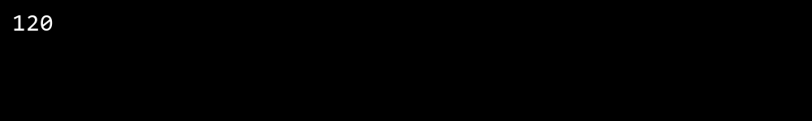

## QUESTION 2

***fibbonachi series till 10***

### Code Solution

a = 0  
b = 1  
i = 0  
while i < 10:  
 print(a)  
 c = a + b  
 a = b  
 b = c  
 i += 1

### FINAL Output

