Assignment

**Name: tharan  
Register Number: 23215134**

________________________________________

## QUESTION 1

1.Write a program to print the numbers from 1 to 50 using a for loop.

### Code Solution

Error: Unable to fetch solution from DeepSeek API.

### FINAL Output

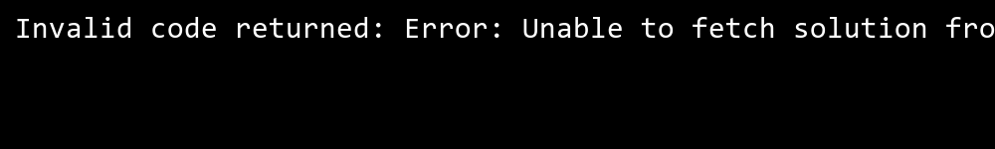

## QUESTION 2

2.Write a program that takes an integer as input and checks if it is even or odd.

### Code Solution

Error: Unable to fetch solution from DeepSeek API.

### FINAL Output



## QUESTION 3

3.Create a program that prints a right -angled triangle pattern of * with a height of 5.

### Code Solution

Error: Unable to fetch solution from DeepSeek API.

### FINAL Output



## QUESTION 4

4.Write a program that takes a number (1 -7) as input and prints the corresponding day of the week using a switch statement.

### Code Solution

Error: Unable to fetch solution from DeepSeek API.

### FINAL Output



## QUESTION 5

5.Write a program to calculate the sum of all numbers from 1 to n using a while loop.

### Code Solution

Error: Unable to fetch solution from DeepSeek API.

### FINAL Output



## QUESTION 6

6.Write a program to check if a given number is prime or not using a for loop and if conditions.

### Code Solution

Error: Unable to fetch solution from DeepSeek API.

### FINAL Output

