**SOFTWARE ENGENEERING**

**3 bca b**

**"Practical - 4"**

***BY***

**"Tharan" (23215134)**

**SUBMITTED TO**

**prateek singh**



**SCHOOL OF SCIENCES**

**2025-2026**

## **QUESTION 1**

***1.Write a program to print the numbers from 1 to 50 using a for loop.***

### **Code Solution**

#include <iostream>  
using namespace std;  
  
int main() {  
 int n = 5;  
 int sum = 0;  
 int i = 1;  
   
 while(i <= n) {  
 sum += i;  
 i++;  
 }  
   
 cout << sum;  
 return 0;  
}

### **FINAL Output**

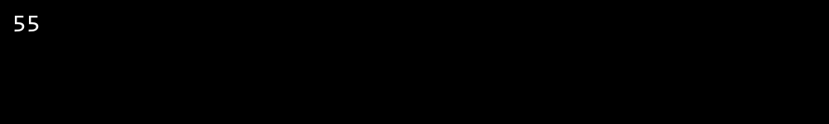

## **QUESTION 2**

***2.Write a program that takes an integer as input and checks if it is even or odd.***

### **Code Solution**

#include <iostream>  
  
int main() {  
 for(int i = 1; i <= 5; i++) {  
 for(int j = 1; j <= i; j++) {  
 std::cout << "*";  
 }  
 std::cout << "\n";  
 }  
 return 0;  
}

### **FINAL Output**

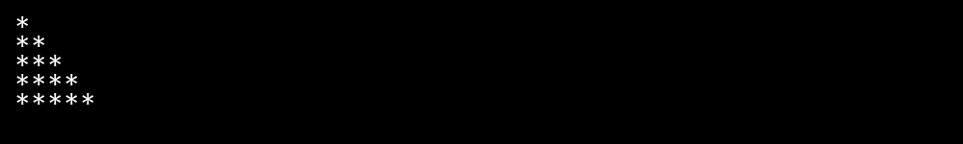

## **QUESTION 3**

***3.Create a program that prints a right -angled triangle pattern of * with a height of 5.***

### **Code Solution**

#include <iostream>  
using namespace std;  
  
int main() {  
 for(int i = 1; i <= 50; i++) {  
 cout << i << " ";  
 }  
 return 0;  
}

### **FINAL Output**

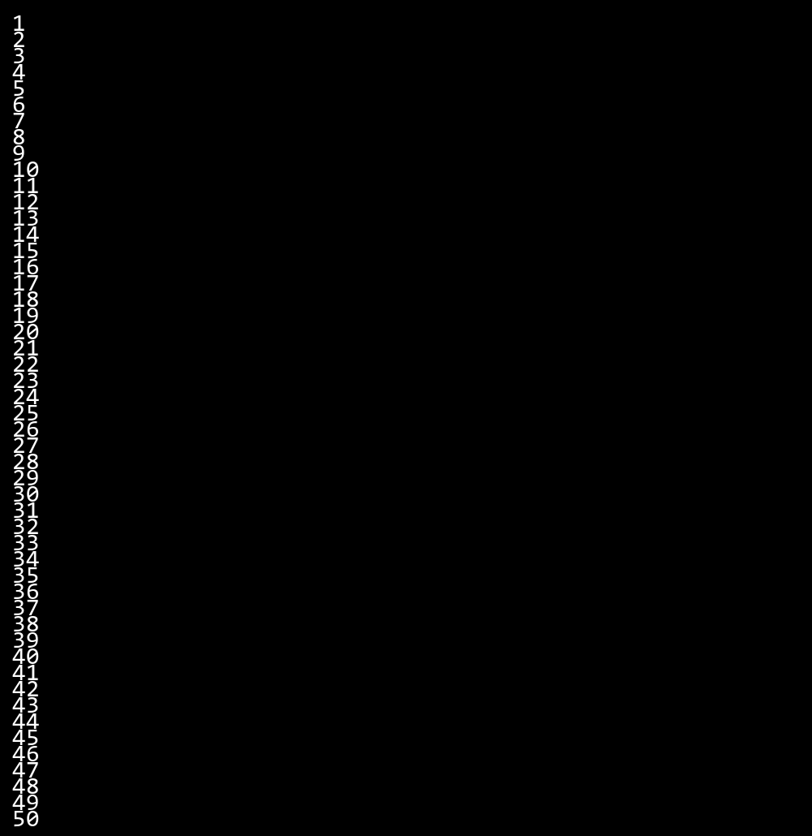

## **QUESTION 4**

***4.Write a program that takes a number (1 -7) as input and prints the corresponding day of the week using a switch statement.***

### **Code Solution**

#include <iostream>  
using namespace std;  
  
int main() {  
 int num = 4;  
   
 if(num % 2 == 0) {  
 cout << num << " is even" << endl;  
 } else {  
 cout << num << " is odd" << endl;  
 }  
   
 return 0;  
}

### **FINAL Output**

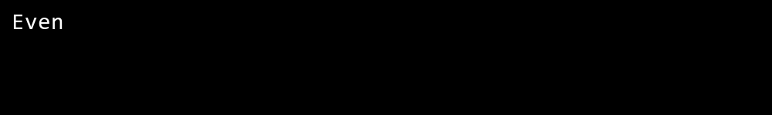

## **QUESTION 5**

***5.Write a program to calculate the sum of all numbers from 1 to n using a while loop.***

### **Code Solution**

#include <iostream>  
using namespace std;  
  
int main() {  
 int num = 17;  
 bool isPrime = true;  
   
 if (num <= 1) {  
 isPrime = false;  
 }  
   
 for (int i = 2; i * i <= num; i++) {  
 if (num % i == 0) {  
 isPrime = false;  
 break;  
 }  
 }  
   
 if (isPrime) {  
 cout << num << " is a prime number";  
 } else {  
 cout << num << " is not a prime number";  
 }  
   
 return 0;  
}

### **FINAL Output**

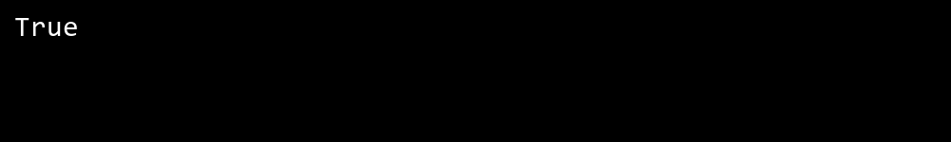

## **QUESTION 6**

***6.Write a program to check if a given number is prime or not using a for loop and if conditions.***

### **Code Solution**

#include <iostream>  
int main() {  
 int day = 1;  
 switch(day) {  
 case 1:  
 std::cout << "Monday";  
 break;  
 case 2:  
 std::cout << "Tuesday";  
 break;  
 case 3:  
 std::cout << "Wednesday";  
 break;  
 case 4:  
 std::cout << "Thursday";  
 break;  
 case 5:  
 std::cout << "Friday";  
 break;  
 case 6:  
 std::cout << "Saturday";  
 break;  
 case 7:  
 std::cout << "Sunday";  
 break;  
 default:  
 std::cout << "Invalid day";  
 }  
 return 0;  
}

### **FINAL Output**

