Assignment

**Name: geetha  
Register Number: 00000786**

________________________________________

## QUESTION 1

1.Write a program to print the numbers from 1 to 50 using a for loop.

### Code Solution

#include <iostream>  
using namespace std;  
  
int main() {  
 for (int i = 1; i <= 50; i++) {  
 cout << i << endl;  
 }  
 return 0;  
}

### FINAL Output

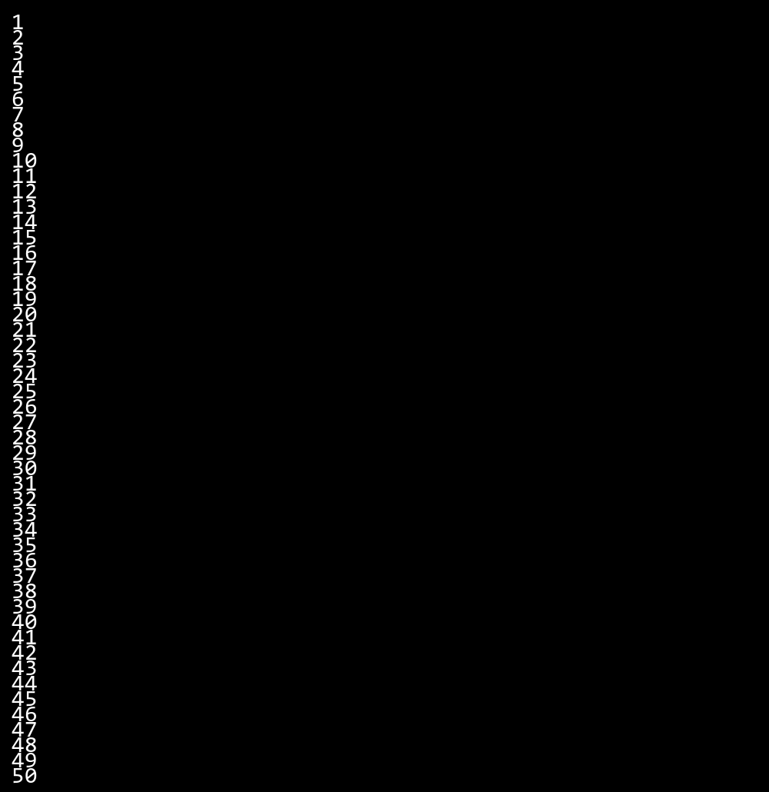

## QUESTION 2

2.Write a program that takes an integer as input and checks if it is even or odd.

### Code Solution

#include <iostream>  
  
int main() {  
 int num = 9;  
 if (num % 2 == 0) {  
 std::cout << "Even";  
 } else {  
 std::cout << "Odd";  
 }  
 return 0;  
}

### FINAL Output

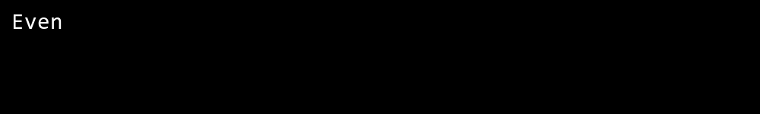

## QUESTION 3

3.Create a program that prints a right -angled triangle pattern of * with a height of 5.

### Code Solution

#include <iostream>  
  
int main() {  
 int height = 5;  
 for (int i = 1; i <= height; ++i) {  
 for (int j = 1; j <= i; ++j) {  
 std::cout << "*";  
 }  
 std::cout << std::endl;  
 }  
 return 0;  
}

### FINAL Output

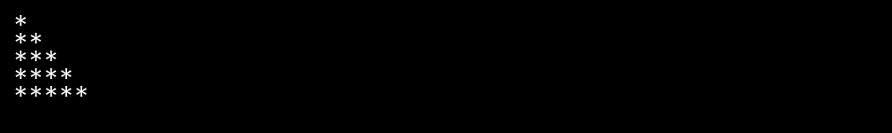

## QUESTION 4

4.Write a program that takes a number (1 -7) as input and prints the corresponding day of the week using a switch statement.

### Code Solution

#include <iostream>  
  
int main() {  
 int n = 10;  
 int sum = 0;  
 int i = 1;  
 while (i <= n) {  
 sum += i;  
 i++;  
 }  
 std::cout << sum;  
 return 0;  
}

### FINAL Output

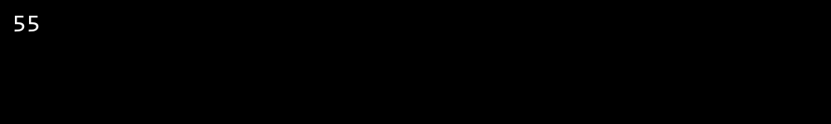

## QUESTION 5

5.Write a program to calculate the sum of all numbers from 1 to n using a while loop.

### Code Solution

#include <iostream>  
  
bool isPrime(int num) {  
 if (num <= 1) {  
 return false;  
 }  
 for (int i = 2; i * i <= num; ++i) {  
 if (num % i == 0) {  
 return false;  
 }  
 }  
 return true;  
}  
  
int main() {  
 int number = 17;  
 if (isPrime(number)) {  
 std::cout << number << " is a prime number." << std::endl;  
 } else {  
 std::cout << number << " is not a prime number." << std::endl;  
 }  
 return 0;  
}

### FINAL Output

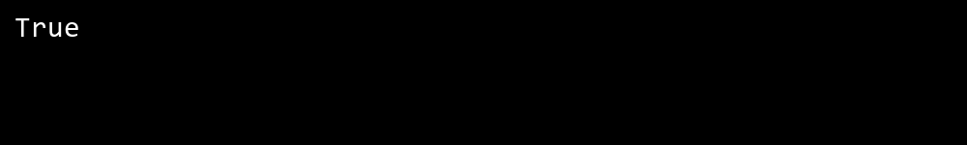

## QUESTION 6

6.Write a program to check if a given number is prime or not using a for loop and if conditions.

### Code Solution

#include <iostream>  
using namespace std;  
  
int main() {  
 int day = 6;  
 switch(day) {  
 case 1:  
 cout << "Monday";  
 break;  
 case 2:  
 cout << "Tuesday";  
 break;  
 case 3:  
 cout << "Wednesday";  
 break;  
 case 4:  
 cout << "Thursday";  
 break;  
 case 5:  
 cout << "Friday";  
 break;  
 case 6:  
 cout << "Saturday";  
 break;  
 case 7:  
 cout << "Sunday";  
 break;  
 }  
 return 0;  
}

### FINAL Output

