*Assignment*

***Name: Tharan  
Register Number: 23215134***

***________________________________________***

## *QUESTION 1*

***1.Write a program to print the numbers from 1 to 50 using a for loop.***

### *Code Solution*

def is_prime(n):  
 if n < 2:  
 return False  
 for i in range(2, int(n ** 0.5) + 1):  
 if n % i == 0:  
 return False  
 return True  
  
number = 17  
result = is_prime(number)  
print(result)

### *FINAL Output*

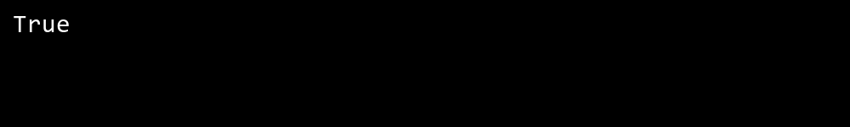

## *QUESTION 2*

***2.Write a program that takes an integer as input and checks if it is even or odd.***

### *Code Solution*

for i in range(1, 51):  
 print(i)

### *FINAL Output*

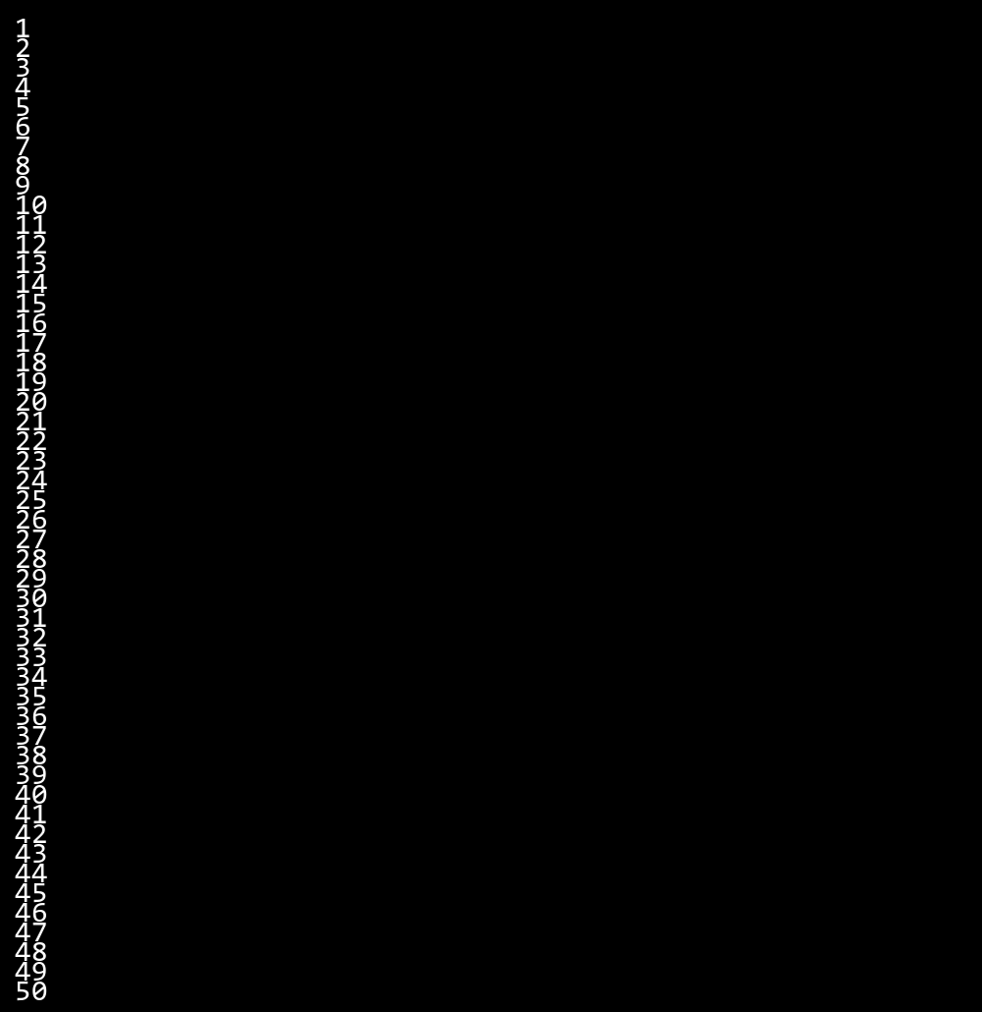

## *QUESTION 3*

***3.Create a program that prints a right -angled triangle pattern of * with a height of 5.***

### *Code Solution*

n = 10  
total = 0  
i = 1  
while i <= n:  
 total += i  
 i += 1  
print(total)

### *FINAL Output*



## *QUESTION 4*

***4.Write a program that takes a number (1 -7) as input and prints the corresponding day of the week using a switch statement.***

### *Code Solution*

for i in range(1, 6):  
 for j in range(i):  
 print("*", end="")  
 print()

### *FINAL Output*

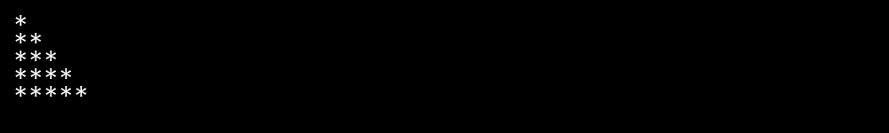

## *QUESTION 5*

***5.Write a program to calculate the sum of all numbers from 1 to n using a while loop.***

### *Code Solution*

def get_day_of_week(number):  
 match number:  
 case 1:  
 return "Monday"  
 case 2:  
 return "Tuesday"  
 case 3:  
 return "Wednesday"  
 case 4:  
 return "Thursday"  
 case 5:  
 return "Friday"  
 case 6:  
 return "Saturday"  
 case 7:  
 return "Sunday"  
 case _:  
 return "Invalid day number"  
  
number = 5  
print(get_day_of_week(number))

### *FINAL Output*

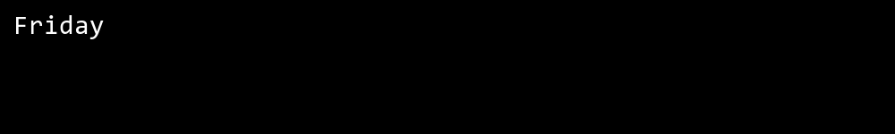

## *QUESTION 6*

***6.Write a program to check if a given number is prime or not using a for loop and if conditions.***

### *Code Solution*

num = 8  
if num % 2 == 0:  
 print("Even")  
else:  
 print("Odd")

### *FINAL Output*

