**SOFTWARE ENGENEERING**

**3 bca b**

**"Practical - 4"**

***BY***

**"Tharan" (23215134)**

**SUBMITTED TO**

**prateek singh**



**SCHOOL OF SCIENCES**

**2025-2026**

## **QUESTION 1**

1. Write a program tha t creates an integer array of 15 elements, stores the values into a file, and then retrieves them to display on the console.

### **Code Solution**

import numpy as np  
  
array = np.array([1, 2, 3, 4, 5, 6, 7, 8, 9, 10, 11, 12, 13, 14, 15])  
  
with open('array_data.txt', 'w') as file:  
 for number in array:  
 file.write(str(number) + '\n')  
  
stored_array = []  
with open('array_data.txt', 'r') as file:  
 for line in file:  
 stored_array.append(int(line.strip()))  
  
print("Retrieved array from file:", stored_array)

### **FINAL Output**

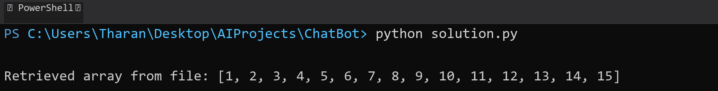

## **QUESTION 2**

2. Write a program to input two integers and divide them. Use a try -catch block to handle the DivideByZeroException and display an appropriate message. Further, if the data type of the elements do not match with defined type then throw an exception too.

### **Code Solution**

try:  
 num1 = 10  
 num2 = 0  
 if not isinstance(num1, int) or not isinstance(num2, int):  
 raise TypeError("Both numbers must be integers")  
 result = num1 / num2  
 print("Result of division:", result)  
except ZeroDivisionError:  
 print("Error: Division by zero is not allowed")  
except TypeError as te:  
 print("Error:", str(te))

### **FINAL Output**

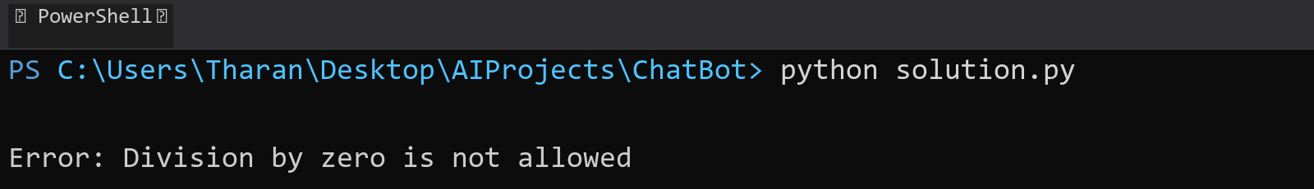

## **QUESTION 3**

3. Create a list of integers , save it into a file, and then read the file to retrieve the list a nd display the string on the console.

### **Code Solution**

numbers = [1, 2, 3, 4, 5]  
  
with open('numbers.txt', 'w') as file:  
 for number in numbers:  
 file.write(str(number) + '\n')  
  
stored_numbers = []  
with open('numbers.txt', 'r') as file:  
 for line in file:  
 stored_numbers.append(int(line.strip()))  
  
print(stored_numbers)

### **FINAL Output**

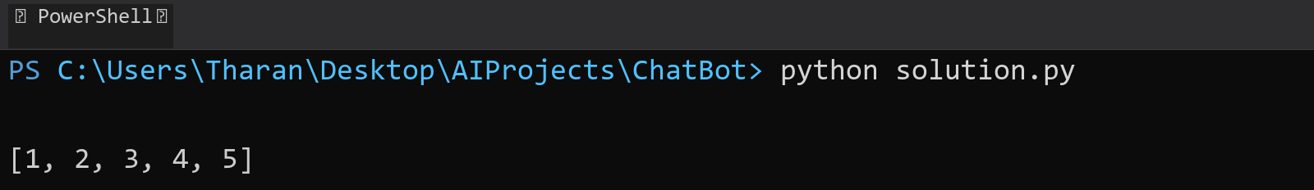

## **QUESTION 4**

4. Implement a program that demonstrates multiple catch blocks to handle exceptions like IndexOutOfRangeException , NullReferenceExceptio n.

### **Code Solution**

try:  
 numbers = [1, 2, 3]  
 numbers[5]  
except IndexError:  
 print("Index out of range error occurred")  
  
try:  
 some_list = None  
 some_list[0]  
except TypeError:  
 print("Null reference error occurred")  
  
try:  
 result = 10/0  
except ZeroDivisionError:  
 print("Division by zero error occurred")  
except Exception as e:  
 print(f"An unexpected error occurred: {e}")  
finally:  
 print("Execution completed")

### **FINAL Output**

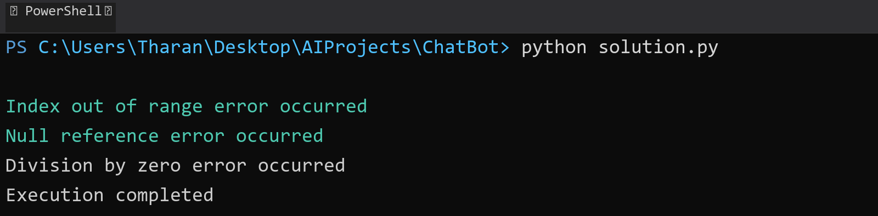

## **QUESTION 5**

5. Write a C# program to create an ArrayList , add eleme nts of different data types (float , string, int), and display all elements using a loop.

### **Code Solution**

my_list = []  
my_list.append(3.14)  
my_list.append("Hello")  
my_list.append(42)  
my_list.append(7.5)  
my_list.append("World")  
my_list.append(100)  
  
for item in my_list:  
 print(item)

### **FINAL Output**

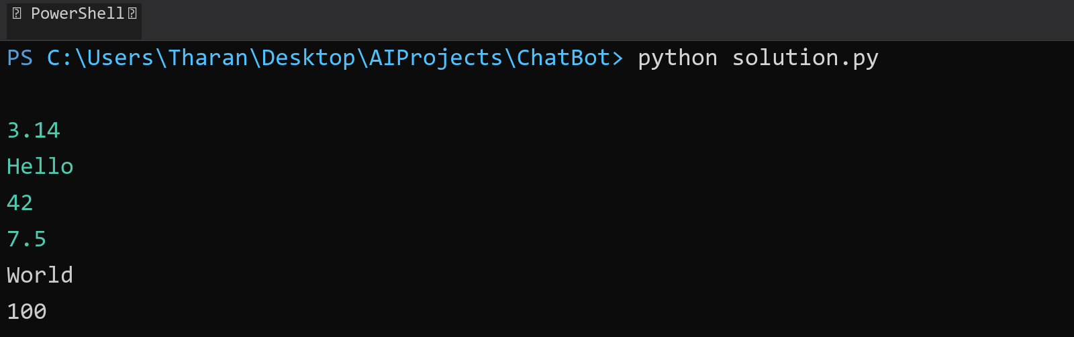

## **QUESTION 6**

6. Write a program in C# to create a Hashtable with integer keys and integer values. Insert three key -value pairs and display them using a loop.

### **Code Solution**

Error: All API attempts failed. Claude and DeepSeek are unavailable.

### **FINAL Output**

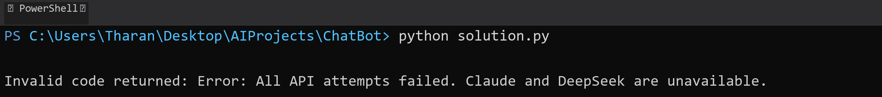

## **QUESTION 7**

7. Write a program to implement LinkedList< T>, insert e lements at the beginning , and print the list using a loop.

### **Code Solution**

class Node:  
 def __init__(self, data):  
 self.data = data  
 self.next = None  
  
class LinkedList:  
 def __init__(self):  
 self.head = None  
  
 def insert_at_beginning(self, data):  
 new_node = Node(data)  
 new_node.next = self.head  
 self.head = new_node  
  
 def print_list(self):  
 current = self.head  
 while current:  
 print(current.data, end=" -> ")  
 current = current.next  
 print("None")  
  
my_list = LinkedList()  
my_list.insert_at_beginning(30)  
my_list.insert_at_beginning(20)  
my_list.insert_at_beginning(10)  
my_list.insert_at_beginning(5)  
my_list.print_list()

### **FINAL Output**

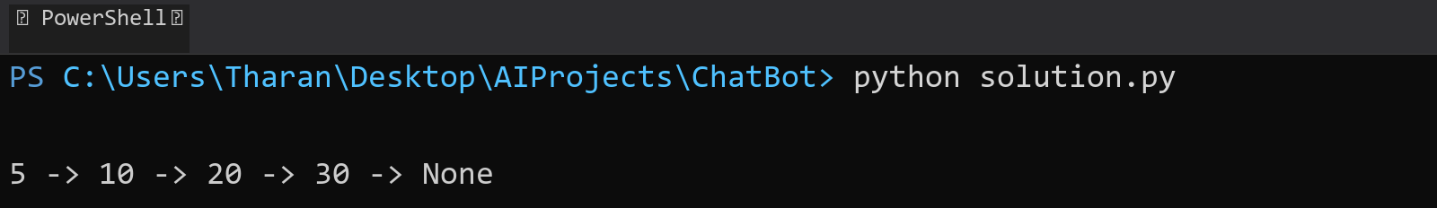

## **QUESTION 8**

8. Write a program to implement Stack , insert five elements and remove them .

### **Code Solution**

class Stack:  
 def __init__(self):  
 self.items = []  
  
 def push(self, item):  
 self.items.append(item)  
  
 def pop(self):  
 if not self.is_empty():  
 return self.items.pop()  
 return None  
  
 def is_empty(self):  
 return len(self.items) == 0  
  
 def display(self):  
 print("Stack:", self.items)  
  
stack = Stack()  
  
stack.push(10)  
stack.push(20)  
stack.push(30)  
stack.push(40)  
stack.push(50)  
  
print("After pushing elements:")  
stack.display()  
  
stack.pop()  
stack.pop()  
stack.pop()  
stack.pop()  
stack.pop()  
  
print("After popping all elements:")  
stack.display()

### **FINAL Output**

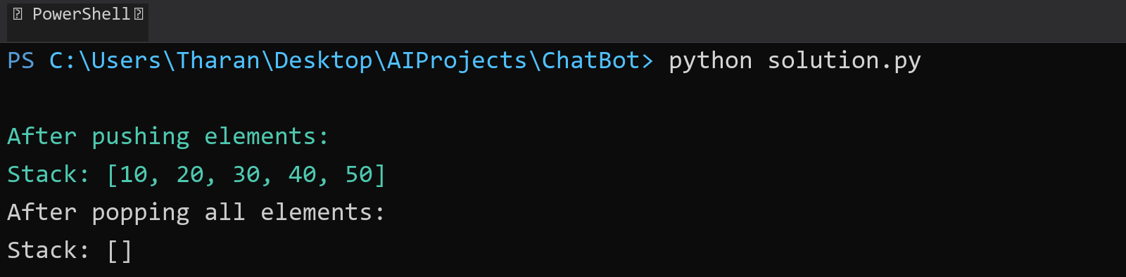

## **QUESTION 9**

9. Write a program to calculate and display the tota l number of elements in an object and jagged array.

### **Code Solution**

array = [1, [2, 3], [4, [5, 6], 7], 8]  
  
def count_elements(arr):  
 count = 0  
 for element in arr:  
 if isinstance(element, list):  
 count += count_elements(element)  
 else:  
 count += 1  
 return count  
  
regular_object = {'a': 1, 'b': 2, 'c': {'d': 3, 'e': 4}, 'f': [5, 6, 7]}  
  
def count_object_elements(obj):  
 count = 0  
 if isinstance(obj, dict):  
 for value in obj.values():  
 if isinstance(value, (dict, list)):  
 count += count_object_elements(value)  
 else:  
 count += 1  
 elif isinstance(obj, list):  
 count += count_elements(obj)  
 return count  
  
jagged_array = [[1, 2, 3], [4, 5], [6, 7, 8, 9]]  
  
total_elements_jagged = sum(len(row) for row in jagged_array)  
  
print(f"Total elements in jagged array: {total_elements_jagged}")  
print(f"Total elements in nested array: {count_elements(array)}")  
print(f"Total elements in object: {count_object_elements(regular_object)}")

### **FINAL Output**

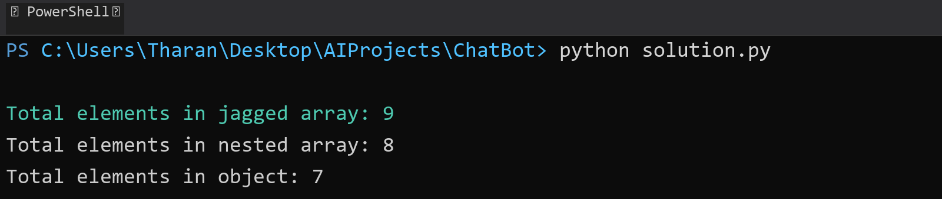

## **QUESTION 10**

10. Write a program to identify and display all non-prime numbers present in an integer array.

### **Code Solution**

def is_not_prime(n):  
 if n < 2:  
 return True  
 for i in range(2, int(n ** 0.5) + 1):  
 if n % i == 0:  
 return True  
 return False  
  
def find_non_primes(arr):  
 non_primes = []  
 for num in arr:  
 if is_not_prime(num):  
 non_primes.append(num)  
 return non_primes  
  
array = [1, 2, 3, 4, 5, 6, 7, 8, 9, 10, 12, 15, 17, 20]  
result = find_non_primes(array)  
print("Non-prime numbers in the array:", result)

### **FINAL Output**

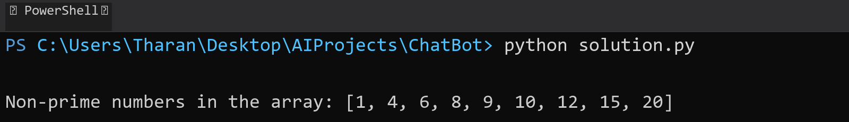

## **QUESTION 11**

11. Write a program to find and displ ay the second largest and smallest numbers in an array.

### **Code Solution**

def find_second_largest_smallest(arr):  
 if len(arr) < 2:  
 return None, None  
   
 sorted_arr = sorted(arr)  
 second_smallest = sorted_arr[1]  
 second_largest = sorted_arr[-2]  
   
 return second_largest, second_smallest  
  
array = [12, 45, 23, 67, 89, 34, 21, 56]  
second_largest, second_smallest = find_second_largest_smallest(array)  
print(f"Second Largest: {second_largest}")  
print(f"Second Smallest: {second_smallest}")

### **FINAL Output**

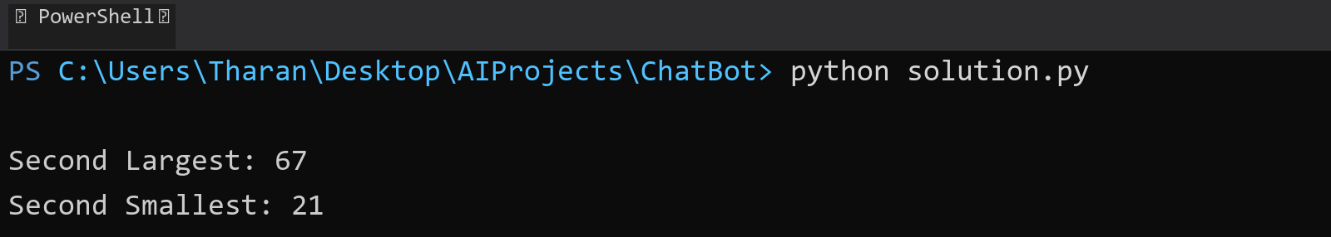

## **QUESTION 12**

12. Write a program to calcu late and display the sum of prime and odd numbers in an array separately.

### **Code Solution**

def is_prime(n):  
 if n < 2:  
 return False  
 for i in range(2, int(n ** 0.5) + 1):  
 if n % i == 0:  
 return False  
 return True  
  
def is_odd(n):  
 return n % 2 != 0  
  
numbers = [1, 2, 3, 4, 5, 6, 7, 8, 9, 10, 11, 12, 13, 14, 15]  
  
prime_sum = sum(num for num in numbers if is_prime(num))  
odd_sum = sum(num for num in numbers if is_odd(num))  
  
print(f"Sum of prime numbers: {prime_sum}")  
print(f"Sum of odd numbers: {odd_sum}")

### **FINAL Output**

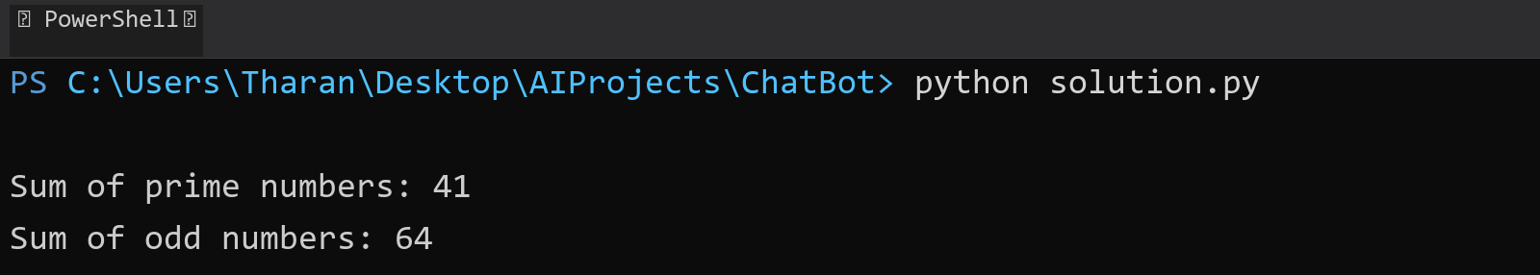

## **QUESTION 13**

13. Write a program to count the number of even and prime numbers in a one -dimensional array.

### **Code Solution**

def is_prime(n):  
 if n < 2:  
 return False  
 for i in range(2, int(n ** 0.5) + 1):  
 if n % i == 0:  
 return False  
 return True  
  
def count_even_and_prime(arr):  
 even_count = 0  
 prime_count = 0  
   
 for num in arr:  
 if num % 2 == 0:  
 even_count += 1  
 if is_prime(num):  
 prime_count += 1  
   
 return even_count, prime_count  
  
array = [1, 2, 3, 4, 5, 6, 7, 8, 9, 10]  
even, prime = count_even_and_prime(array)  
print(f"Number of even numbers: {even}")  
print(f"Number of prime numbers: {prime}")

### **FINAL Output**

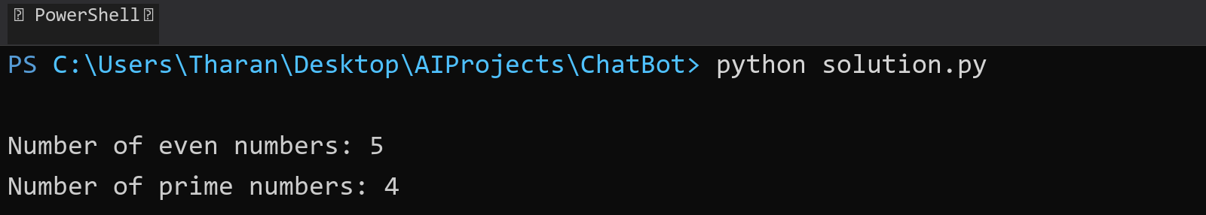

## **QUESTION 14**

14. Implement a program to search for a specific element in an array using binary search .

### **Code Solution**

Error: All API attempts failed. Claude and DeepSeek are unavailable.

### **FINAL Output**



## **QUESTION 15**

15. Write a program to calculate the sum of the lower triangle elements of a square matrix.

### **Code Solution**

Error: All API attempts failed. Claude and DeepSeek are unavailable.

### **FINAL Output**



## **QUESTION 16**

16. Write a C# program to perform linear search on a sorted jagged array .

### **Code Solution**

Error: All API attempts failed. Claude and DeepSeek are unavailable.

### **FINAL Output**



## **QUESTION 17**

17. Create a Student class with properties (ID, Father_ Name, Marks). Store multiple students in an object array and sort them by Marks. Further, s tore sorted students in a Linked List<T> and display them.

### **Code Solution**

class Student:  
 def __init__(self, ID, Father_Name, Marks):  
 self.ID = ID  
 self.Father_Name = Father_Name  
 self.Marks = Marks  
  
class Node:  
 def __init__(self, data):  
 self.data = data  
 self.next = None  
  
class LinkedList:  
 def __init__(self):  
 self.head = None  
  
 def append(self, data):  
 new_node = Node(data)  
 if not self.head:  
 self.head = new_node  
 return  
 current = self.head  
 while current.next:  
 current = current.next  
 current.next = new_node  
  
 def display(self):  
 current = self.head  
 while current:  
 print(f"ID: {current.data.ID}, Father's Name: {current.data.Father_Name}, Marks: {current.data.Marks}")  
 current = current.next  
  
students = [  
 Student(1, "John Sr.", 85),  
 Student(2, "Mike Sr.", 92),  
 Student(3, "David Sr.", 78),  
 Student(4, "Tom Sr.", 95),  
 Student(5, "Peter Sr.", 88)  
]  
  
sorted_students = sorted(students, key=lambda x: x.Marks, reverse=True)  
  
linked_list = LinkedList()  
for student in sorted_students:  
 linked_list.append(student)  
  
print("Students sorted by marks (highest to lowest):")  
linked_list.display()

### **FINAL Output**

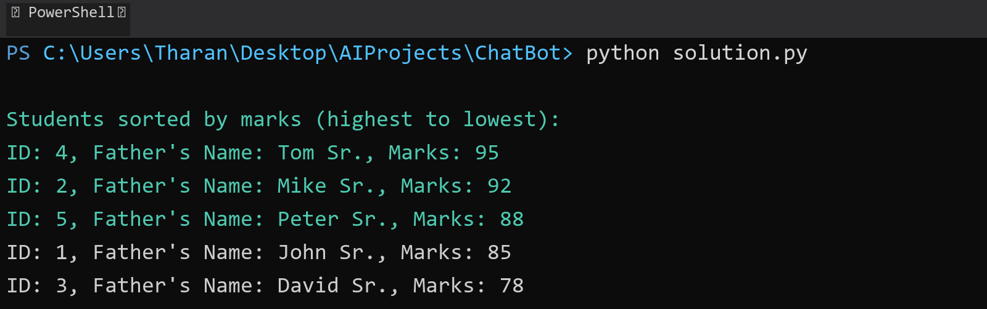

## **QUESTION 18**

18. Write a program to count the number of prime and odd numbers in a one -dimensional array.

### **Code Solution**

def is_prime(n):  
 if n < 2:  
 return False  
 for i in range(2, int(n ** 0.5) + 1):  
 if n % i == 0:  
 return False  
 return True  
  
def is_odd(n):  
 return n % 2 != 0  
  
array = [1, 2, 3, 4, 5, 6, 7, 8, 9, 10, 11, 13, 17, 19, 23]  
  
prime_count = sum(1 for num in array if is_prime(num))  
odd_count = sum(1 for num in array if is_odd(num))  
  
print(f"Number of prime numbers: {prime_count}")  
print(f"Number of odd numbers: {odd_count}")

### **FINAL Output**

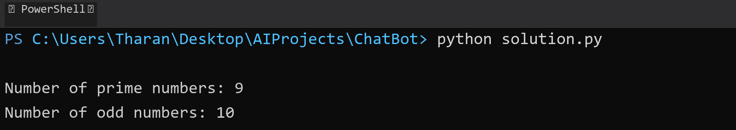

## **QUESTION 19**

19. Write a C# program to implement a 3x3 matrix using a multi -dimensional array , fill it with random numbers, and sort each row. Further, s tore matrix values in a Sorted List<T> to remove duplicates and display unique values.

### **Code Solution**

import random  
  
matrix = [[random.randint(1, 10) for _ in range(3)] for _ in range(3)]  
for row in matrix:  
 row.sort()  
sorted_list = []  
for row in matrix:  
 for num in row:  
 sorted_list.append(num)  
unique_sorted = sorted(list(set(sorted_list)))  
print(unique_sorted)

### **FINAL Output**

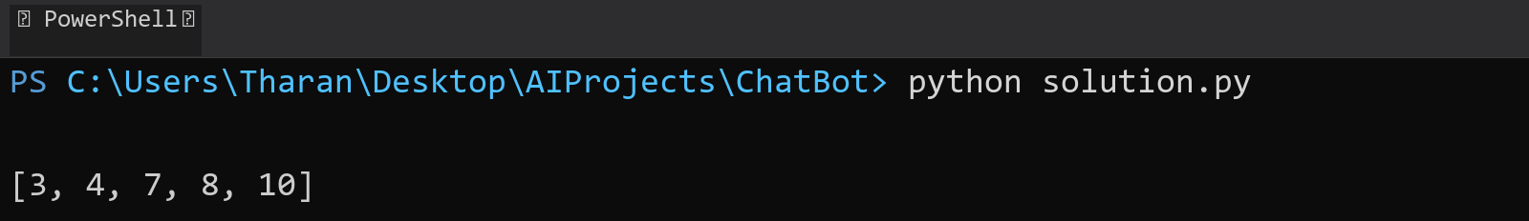

## **QUESTION 20**

20. Write a C# program to implement a program that reads an array of filenames and searches for a specific file in the system. Further, s tore valid file names in a Directory collection and allow the user to retrieve details about a specific file.

### **Code Solution**

import os  
from pathlib import Path  
import datetime  
  
filenames = ['test.txt', 'example.pdf', 'document.docx', 'image.jpg', 'code.py', 'data.csv']  
target_file = 'example.pdf'  
directory = {}  
  
for filename in filenames:  
 file_path = Path.home() / filename  
 if file_path.exists():  
 file_stats = file_path.stat()  
 directory[filename] = {  
 'size': file_stats.st_size,  
 'created': datetime.datetime.fromtimestamp(file_stats.st_ctime),  
 'modified': datetime.datetime.fromtimestamp(file_stats.st_mtime),  
 'path': str(file_path)  
 }  
  
if target_file in directory:  
 file_details = directory[target_file]  
 print(f"File found: {target_file}")  
 print(f"Size: {file_details['size']} bytes")  
 print(f"Created: {file_details['created']}")  
 print(f"Modified: {file_details['modified']}")  
 print(f"Path: {file_details['path']}")  
else:  
 print(f"File {target_file} not found in the system")  
  
print("\nAll valid files in directory:")  
for filename in directory:  
 print(filename)

### **FINAL Output**

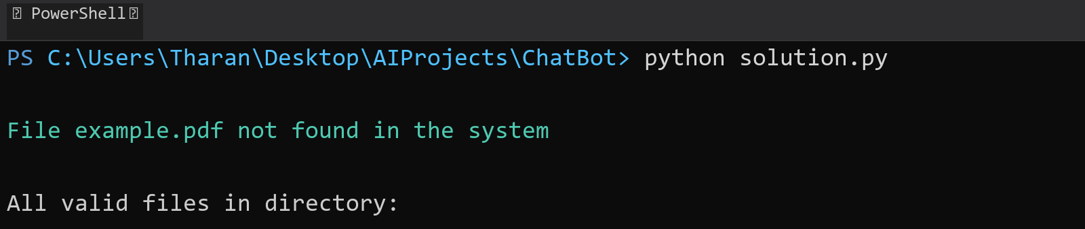

## **QUESTION 21**

21. Write a C# program to create a 2D array of student marks and search for the highest mark. Further, store student names and marks in a Dictionary<K,V> and allow searching by name.

### **Code Solution**

student_marks = [[85, 92, 78], [90, 88, 95], [75, 82, 89], [95, 91, 87]]  
  
highest_mark = max(max(row) for row in student_marks)  
  
student_data = {  
 "John": [85, 92, 78],  
 "Alice": [90, 88, 95],  
 "Bob": [75, 82, 89],  
 "Emma": [95, 91, 87]  
}  
  
print(f"Highest mark in the 2D array: {highest_mark}")  
  
search_name = "Alice"  
if search_name in student_data:  
 print(f"Marks for {search_name}: {student_data[search_name]}")  
 print(f"Highest mark for {search_name}: {max(student_data[search_name])}")  
else:  
 print(f"Student {search_name} not found")

### **FINAL Output**

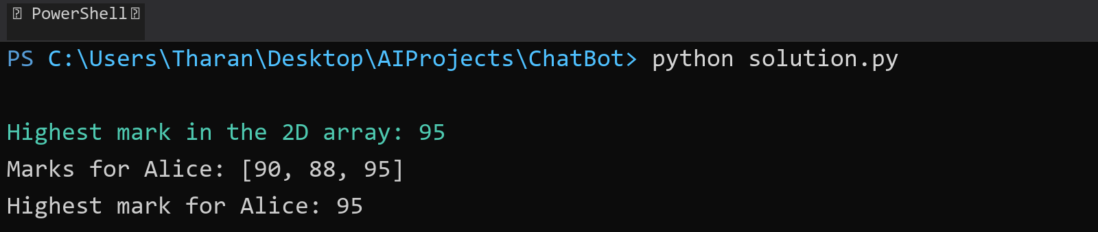

## **QUESTION 22**

22. Write a C# program to implement Binary Search in a jagged array of employee IDs. Further, s tore IDs in a Stack<T> , push/pop operations for LIFO retrieval.

### **Code Solution**

def binary_search(arr, target):  
 left, right = 0, len(arr) - 1  
 while left <= right:  
 mid = (left + right) // 2  
 if arr[mid] == target:  
 return mid  
 elif arr[mid] < target:  
 left = mid + 1  
 else:  
 right = mid - 1  
 return -1  
  
class Stack:  
 def __init__(self):  
 self.items = []  
  
 def push(self, item):  
 self.items.append(item)  
  
 def pop(self):  
 if not self.is_empty():  
 return self.items.pop()  
 return None  
  
 def is_empty(self):  
 return len(self.items) == 0  
  
jagged_array = [  
 [101, 102, 103],  
 [201, 202],  
 [301, 302, 303, 304]  
]  
  
flattened_array = []  
for subarray in jagged_array:  
 flattened_array.extend(sorted(subarray))  
  
stack = Stack()  
for id in flattened_array:  
 stack.push(id)  
  
target_id = 202  
search_result = binary_search(flattened_array, target_id)  
  
print(f"Found employee ID {target_id} at index: {search_result}")  
  
retrieved_ids = []  
while not stack.is_empty():  
 retrieved_ids.append(stack.pop())  
  
print("Retrieved IDs from stack (LIFO):", retrieved_ids)

### **FINAL Output**

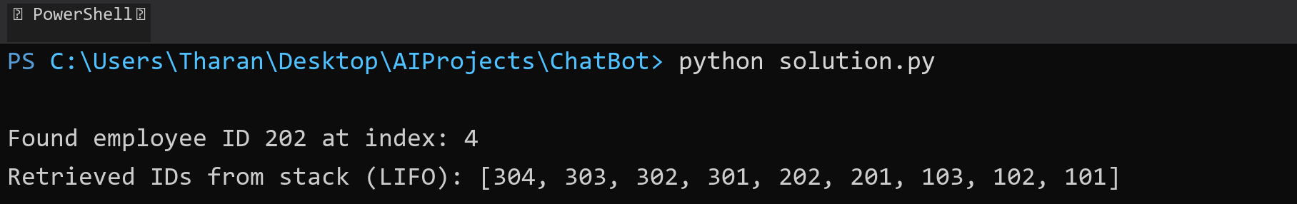

## **QUESTION 23**

23. Write a C# program to create a Product class (ID, Name, Price) and store o bjects in an array by price. Further, u se a Queue<T> to manage product processing (FIFO order).

### **Code Solution**

class Product:  
 def __init__(self, id, name, price):  
 self.id = id  
 self.name = name  
 self.price = price  
  
 def __repr__(self):  
 return f"Product(ID={self.id}, Name='{self.name}', Price={self.price})"  
  
products = [  
 Product(1, "Laptop", 999.99),  
 Product(2, "Mouse", 19.99),  
 Product(3, "Keyboard", 49.99)  
]  
  
sorted_products = sorted(products, key=lambda x: x.price)  
  
class Queue:  
 def __init__(self):  
 self.items = []  
  
 def enqueue(self, item):  
 self.items.append(item)  
  
 def dequeue(self):  
 if not self.is_empty():  
 return self.items.pop(0)  
 return None  
  
 def is_empty(self):  
 return len(self.items) == 0  
  
 def __repr__(self):  
 return str(self.items)  
  
queue = Queue()  
for product in sorted_products:  
 queue.enqueue(product)  
  
print(queue)

### **FINAL Output**



## **QUESTION 24**

24. Write a program to calculate the sum of the diagonal elements of a square matrix.

### **Code Solution**

matrix = [  
 [1, 2, 3],  
 [4, 5, 6],  
 [7, 8, 9]  
]  
  
diagonal_sum = 0  
for i in range(len(matrix)):  
 diagonal_sum += matrix[i][i]  
  
print(f"Sum of diagonal elements: {diagonal_sum}")

### **FINAL Output**

