**SOFTWARE ENGENEERING**

**5 BCA B**

**"Practical - 4"**

***BY***

**"geetha" (23215134)**

**SUBMITTED TO**

**prateek singh**



**SCHOOL OF SCIENCES**

**2025-2026**

## **QUESTION 1**

1.Write a program to print the numbers from 1 to 50 using a for loop.

### **Code Solution**

for i in range(1, 51):  
 print(i)

### **FINAL Output**

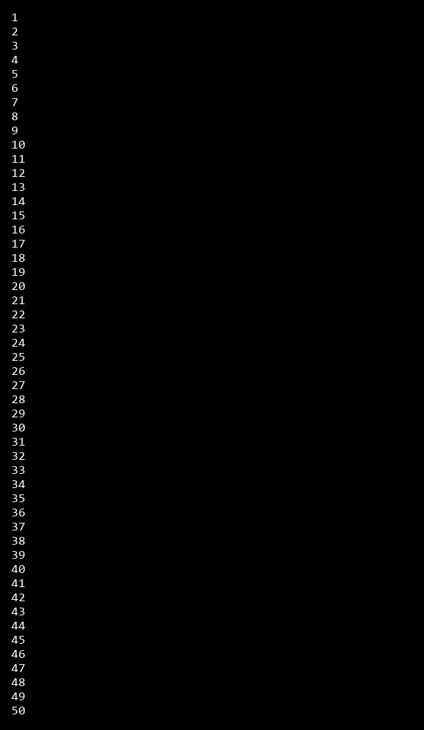

## **QUESTION 2**

2.Write a program that takes an integer as input and checks if it is even or odd.

### **Code Solution**

n = 6  
if n % 2 == 0:  
 print("Even")  
else:  
 print("Odd")

### **FINAL Output**



## **QUESTION 3**

3.Create a program that prints a right -angled triangle pattern of * with a height of 5.

### **Code Solution**

for i in range(5):  
 for j in range(i + 1):  
 print("*", end="")  
 print()

### **FINAL Output**

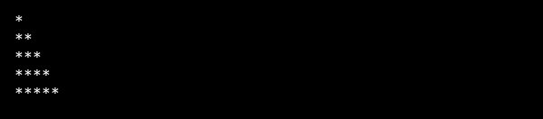

## **QUESTION 4**

4.Write a program that takes a number (1 -7) as input and prints the corresponding day of the week using a switch statement.

### **Code Solution**

def get_day(day_num):  
 match day_num:  
 case 1:  
 return "Monday"  
 case 2:  
 return "Tuesday"  
 case 3:  
 return "Wednesday"  
 case 4:  
 return "Thursday"  
 case 5:  
 return "Friday"  
 case 6:  
 return "Saturday"  
 case 7:  
 return "Sunday"  
 case _:  
 return "Invalid day number"  
  
day = 8  
print(get_day(day))

### **FINAL Output**



## **QUESTION 5**

5.Write a program to calculate the sum of all numbers from 1 to n using a while loop.

### **Code Solution**

n = 10  
sum = 0  
i = 1  
while i <= n:  
 sum += i  
 i += 1  
print(f"Sum of numbers from 1 to {n} is: {sum}")

### **FINAL Output**



## **QUESTION 6**

6.Write a program to check if a given number is prime or not using a for loop and if conditions.

### **Code Solution**

num = 17  
is_prime = True  
if num > 1:  
 for i in range(2, num):  
 if num % i == 0:  
 is_prime = False  
 break  
 print(f"{num} is prime") if is_prime else print(f"{num} is not prime")  
else:  
 print(f"{num} is not prime")

### **FINAL Output**

