**#COURSE NAME**

**#Class name**

**"#PRACTICAL_NUMBER"**

***BY***

**"Tharan" (#Registration Number)**

**SUBMITTED TO**

**#teacher name**



**SCHOOL OF SCIENCES**

**2025-2026**

## **QUESTION 1**

1.Write a program to print the numbers from 1 to 50 using a for loop.

### **Code Solution**

for i in range(1, 51):  
 print(i)

### **FINAL Output**

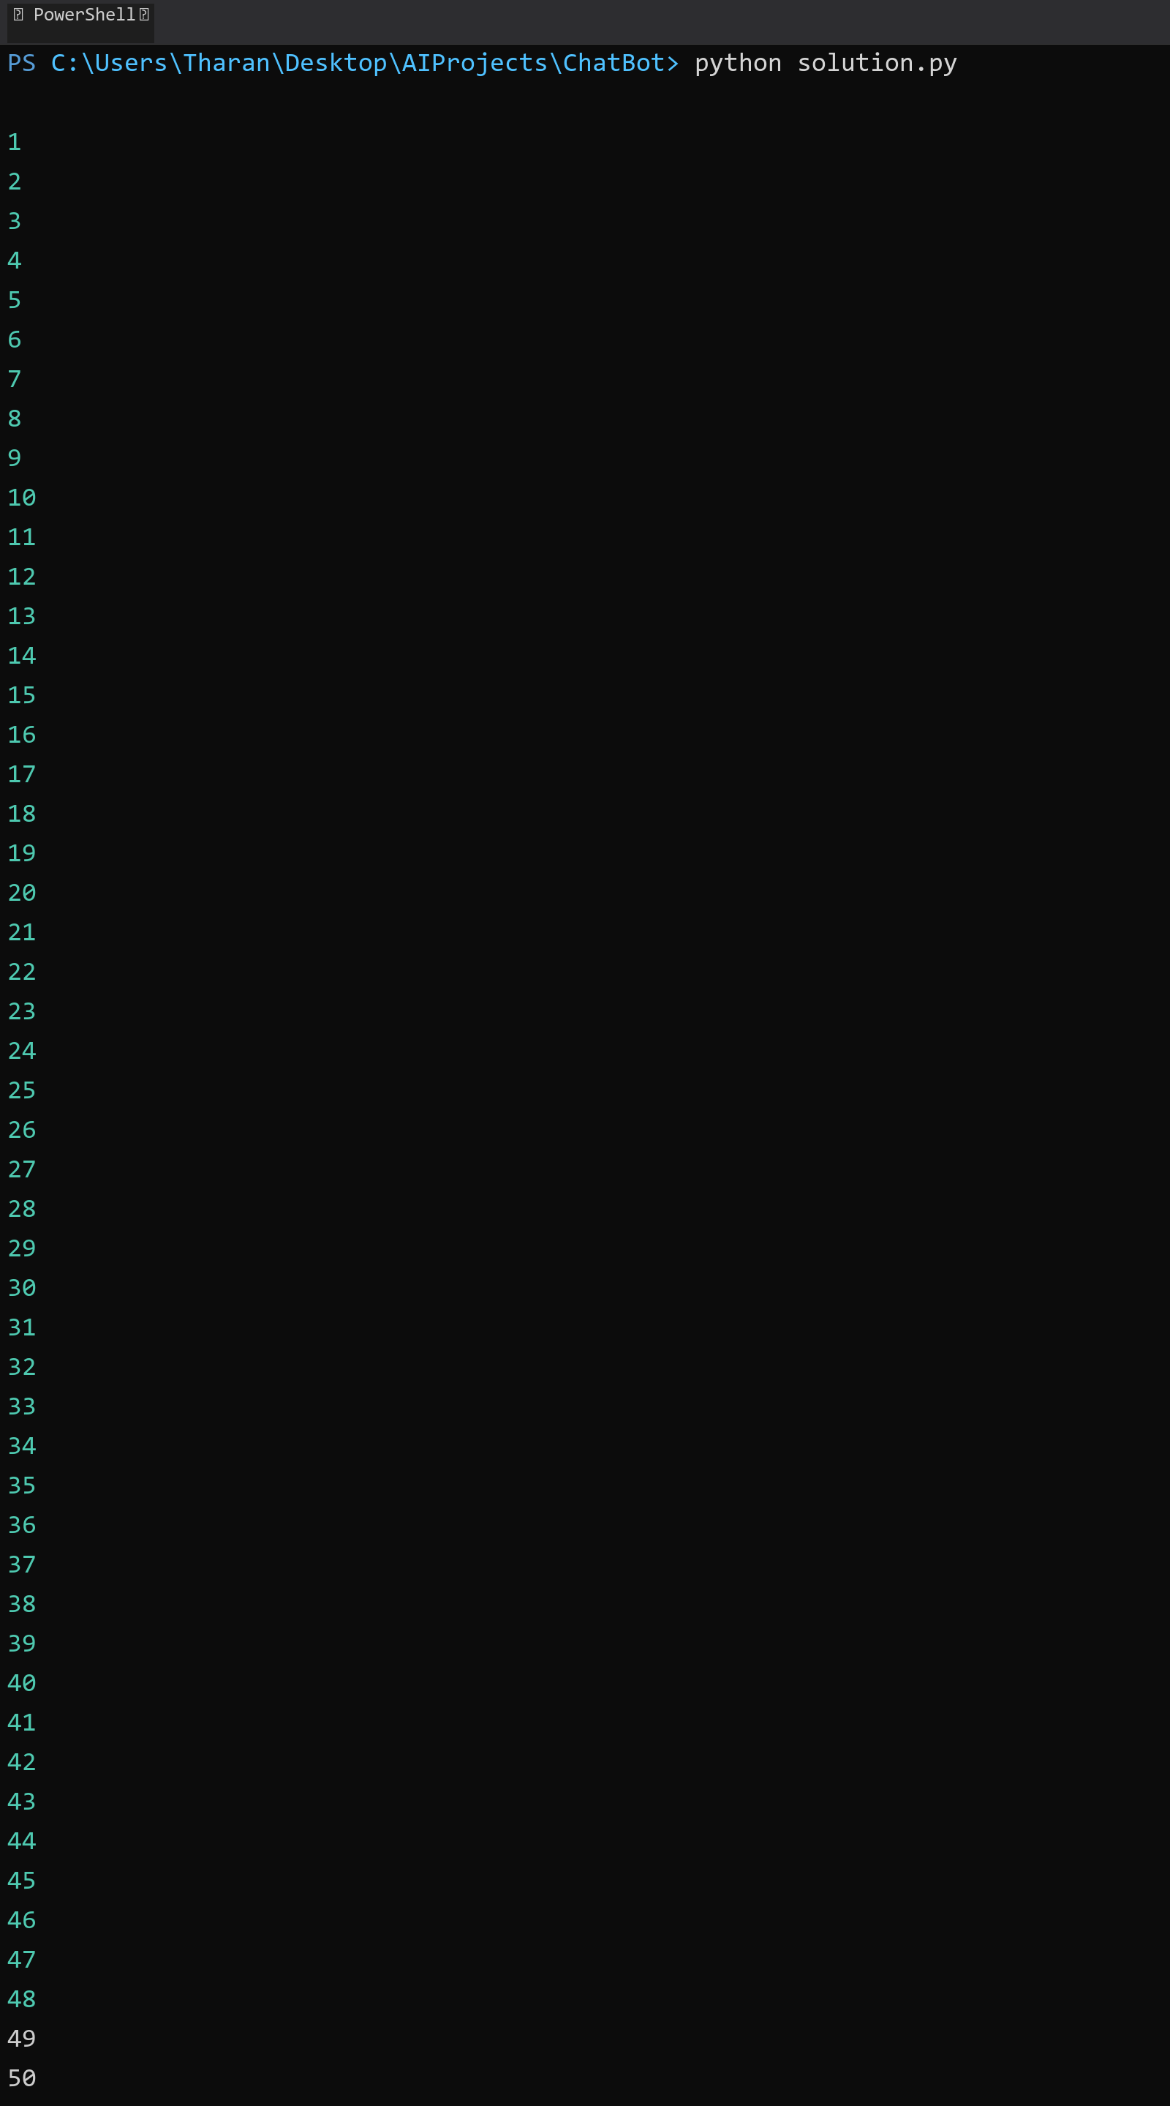

## **QUESTION 2**

2.Write a program that takes an integer as input and checks if it is even or odd.

### **Code Solution**

n = 6  
if n % 2 == 0:  
 print("Even")  
else:  
 print("Odd")

### **FINAL Output**

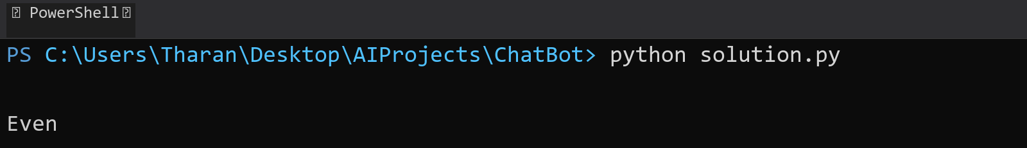

## **QUESTION 3**

3.Create a program that prints a right -angled triangle pattern of * with a height of 5.

### **Code Solution**

for i in range(1, 6):  
 print('*' * i)

### **FINAL Output**

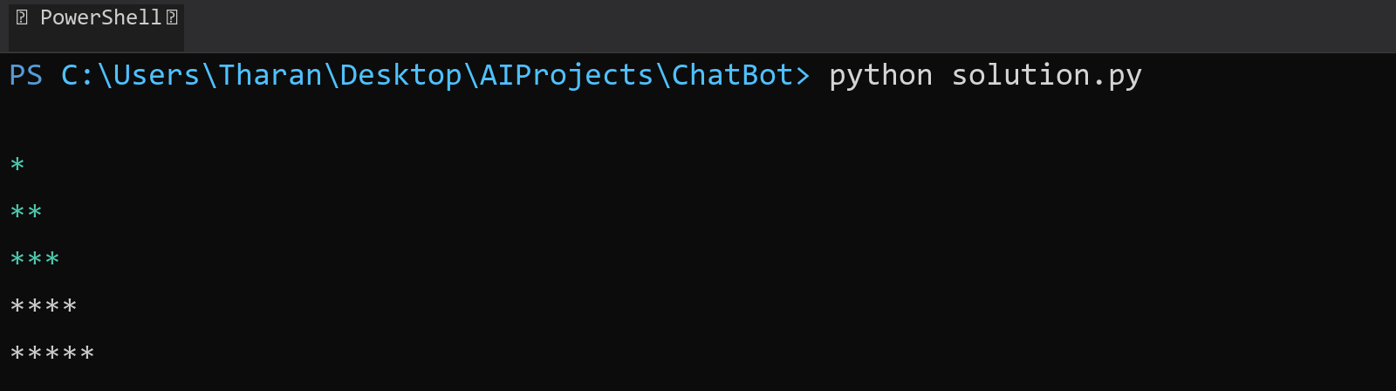

## **QUESTION 4**

4.Write a program that takes a number (1 -7) as input and prints the corresponding day of the week using a switch statement.

### **Code Solution**

def get_day(day_number):  
 days = {  
 1: "Monday",  
 2: "Tuesday",  
 3: "Wednesday",  
 4: "Thursday",  
 5: "Friday",  
 6: "Saturday",  
 7: "Sunday"  
 }  
 return days.get(day_number, "Invalid day number")  
  
day = 3  
print(get_day(day))

### **FINAL Output**

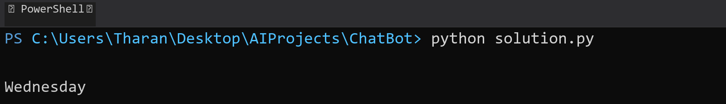

## **QUESTION 5**

5.Write a program to calculate the sum of all numbers from 1 to n using a while loop.

### **Code Solution**

n = 10  
sum = 0  
i = 1  
while i <= n:  
 sum += i  
 i += 1  
print(sum)

### **FINAL Output**

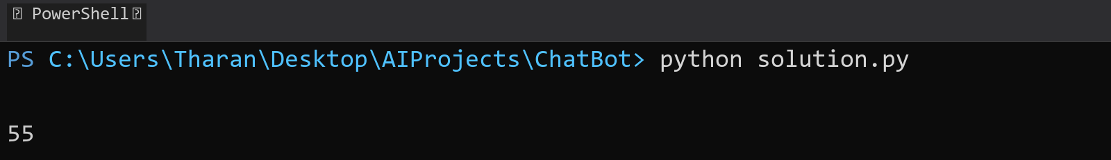

## **QUESTION 6**

6.Write a program to check if a given number is prime or not using a for loop and if conditions.

### **Code Solution**

def is_prime(n):  
 if n < 2:  
 return False  
 for i in range(2, int(n ** 0.5) + 1):  
 if n % i == 0:  
 return False  
 return True  
  
number = 17  
if is_prime(number):  
 print(f"{number} is a prime number")  
else:  
 print(f"{number} is not a prime number")

### **FINAL Output**

