Assignment

**Name: Tharan  
Register Number: 23215134**

________________________________________

## QUESTION 1

1.Write a program to print the numbers from 1 to 50 using a for loop.

### Code Solution

#include <iostream>  
using namespace std;  
  
int main() {  
 int n = 10;  
 int sum = 0;  
 int i = 1;  
   
 while(i <= n) {  
 sum += i;  
 i++;  
 }  
   
 cout << sum;  
 return 0;  
}

### FINAL Output

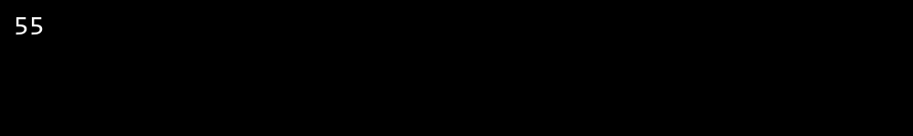

## QUESTION 2

2.Write a program that takes an integer as input and checks if it is even or odd.

### Code Solution

#include <iostream>  
  
int main() {  
 for(int i = 1; i <= 5; i++) {  
 for(int j = 1; j <= i; j++) {  
 std::cout << "*";  
 }  
 std::cout << "\n";  
 }  
 return 0;  
}

### FINAL Output

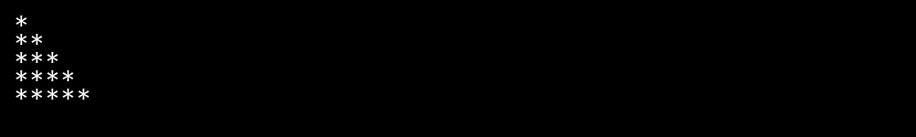

## QUESTION 3

3.Create a program that prints a right -angled triangle pattern of * with a height of 5.

### Code Solution

#include <iostream>  
  
int main() {  
 int number = 7;  
   
 if(number % 2 == 0) {  
 std::cout << number << " is even";  
 } else {  
 std::cout << number << " is odd";  
 }  
   
 return 0;  
}

### FINAL Output

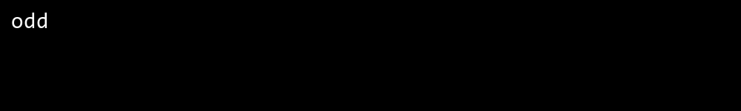

## QUESTION 4

4.Write a program that takes a number (1 -7) as input and prints the corresponding day of the week using a switch statement.

### Code Solution

#include <iostream>  
  
int main() {  
 for(int i = 1; i <= 50; i++) {  
 std::cout << i << " ";  
 }  
 return 0;  
}

### FINAL Output

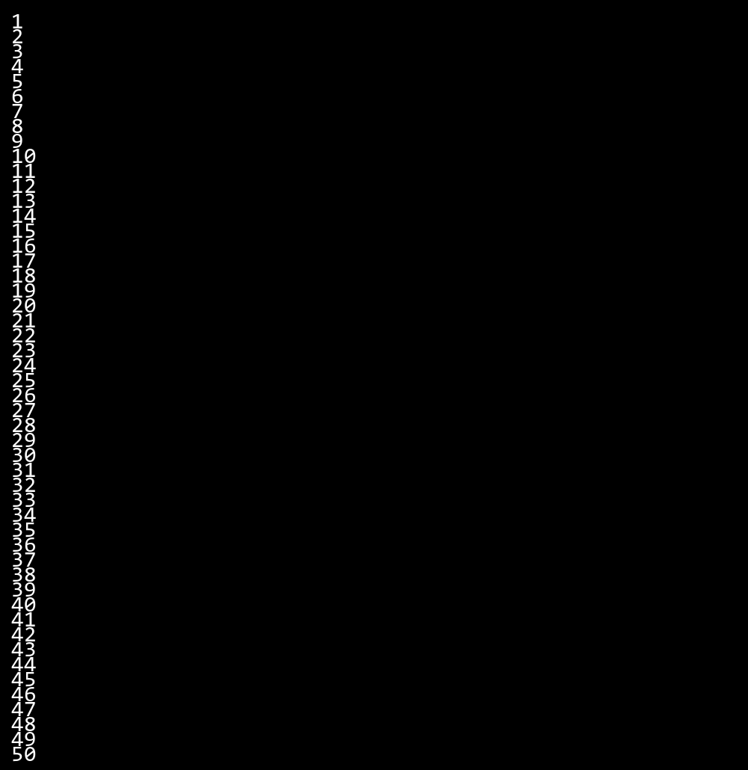

## QUESTION 5

5.Write a program to calculate the sum of all numbers from 1 to n using a while loop.

### Code Solution

#include <iostream>  
  
int main() {  
 int dayNumber = 6;  
   
 switch(dayNumber) {  
 case 1:  
 std::cout << "Monday";  
 break;  
 case 2:  
 std::cout << "Tuesday";  
 break;  
 case 3:  
 std::cout << "Wednesday";  
 break;  
 case 4:  
 std::cout << "Thursday";  
 break;  
 case 5:  
 std::cout << "Friday";  
 break;  
 case 6:  
 std::cout << "Saturday";  
 break;  
 case 7:  
 std::cout << "Sunday";  
 break;  
 default:  
 std::cout << "Invalid day number";  
 }  
 return 0;  
}

### FINAL Output

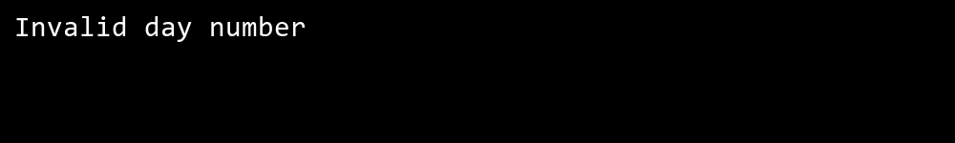

## QUESTION 6

6.Write a program to check if a given number is prime or not using a for loop and if conditions.

### Code Solution

#include <iostream>  
using namespace std;  
int main() {  
 int n = 17;  
 bool isPrime = true;  
 if (n <= 1) {  
 isPrime = false;  
 }  
 for (int i = 2; i * i <= n; i++) {  
 if (n % i == 0) {  
 isPrime = false;  
 break;  
 }  
 }  
 if (isPrime) {  
 cout << n << " is a prime number";  
 } else {  
 cout << n << " is not a prime number";  
 }  
 return 0;  
}

### FINAL Output

