**#COURSE NAME**

**#Class name**

**“#practicle number”**

***BY***

**<#Student Name> (#Registration Number)**

**SUBMITTED TO**

**#teacher name**



**SCHOOL OF SCIENCES**

**2025-2026**

## QUESTION 1

***1.Write a program to print the numbers from 1 to 50 using a for loop.***

### Code Solution

for i in range(1, 51):  
 print(i)

### FINAL Output

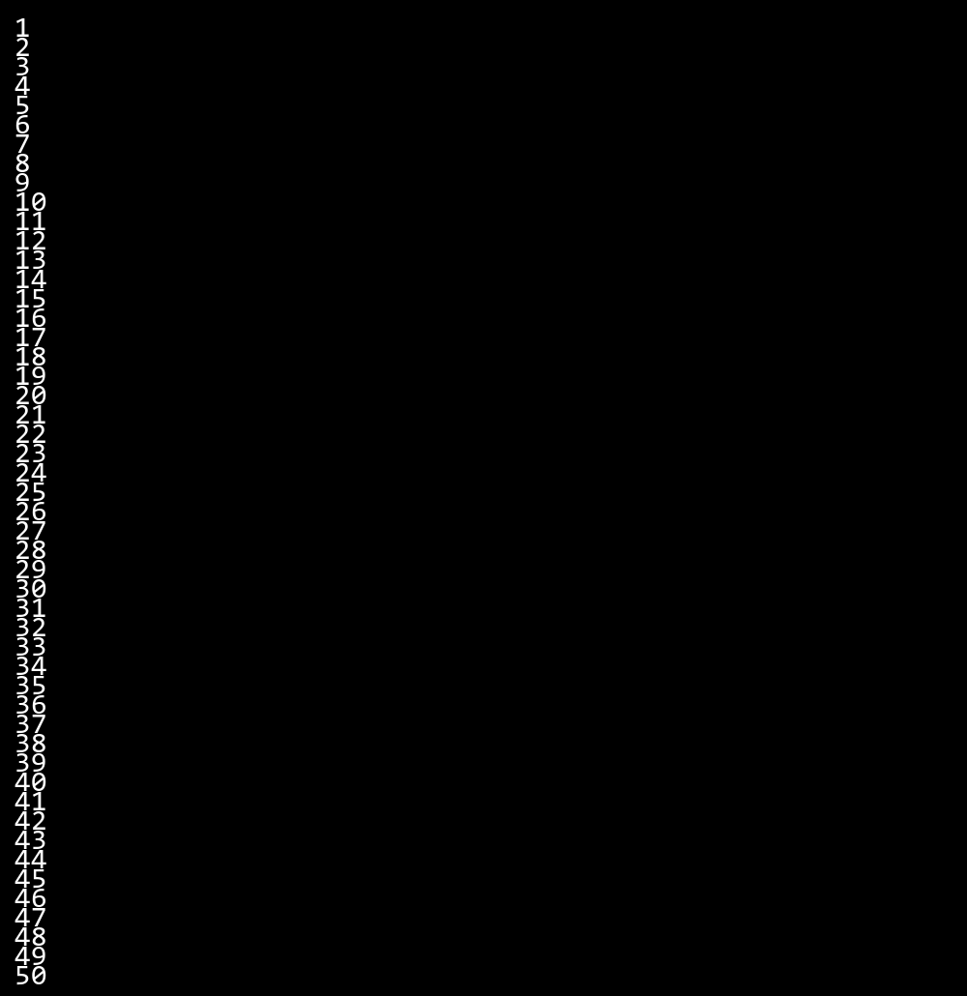

## QUESTION 2

***2.Write a program that takes an integer as input and checks if it is even or odd.***

### Code Solution

day = 2  
  
def get_day_name(day_number):  
 days = {  
 1: "Monday",  
 2: "Tuesday",  
 3: "Wednesday",  
 4: "Thursday",  
 5: "Friday",  
 6: "Saturday",  
 7: "Sunday"  
 }  
 return days.get(day_number, "Invalid day number")  
  
result = get_day_name(day)  
print(result)

### FINAL Output

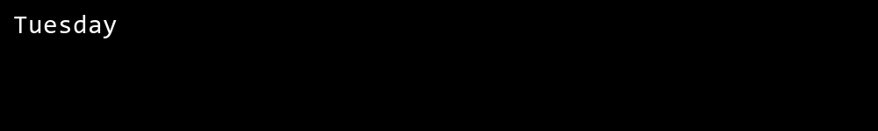

## QUESTION 3

***3.Create a program that prints a right -angled triangle pattern of * with a height of 5.***

### Code Solution

n = 10  
sum = 0  
i = 1  
while i <= n:  
 sum += i  
 i += 1  
print(sum)

### FINAL Output

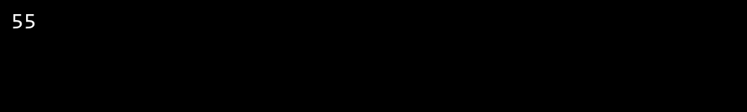

## QUESTION 4

***4.Write a program that takes a number (1 -7) as input and prints the corresponding day of the week using a switch statement.***

### Code Solution

def is_prime(number):  
 if number < 2:  
 return False  
 for i in range(2, int(number ** 0.5) + 1):  
 if number % i == 0:  
 return False  
 return True  
  
number = 17  
result = is_prime(number)  
print(result)

### FINAL Output

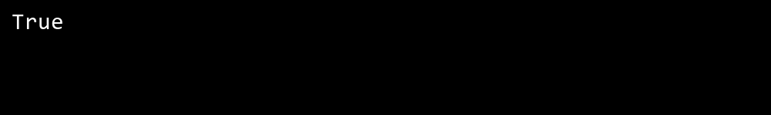

## QUESTION 5

***5.Write a program to calculate the sum of all numbers from 1 to n using a while loop.***

### Code Solution

num = 7  
if num % 2 == 0:  
 print(str(num) + " is even")  
else:  
 print(str(num) + " is odd")

### FINAL Output

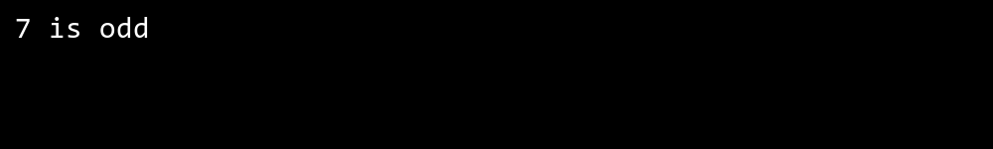

## QUESTION 6

***6.Write a program to check if a given number is prime or not using a for loop and if conditions.***

### Code Solution

for i in range(1, 6):  
 for j in range(i):  
 print("*", end="")  
 print()

### FINAL Output

