## **QUESTION 1**

1. Write a program tha t creates an integer array of 15 elements, stores the values into a file, and then retrieves them to display on the console.

### **Code Solution**

import random  
import pickle  
  
numbers = [random.randint(1, 100) for _ in range(15)]  
  
with open('numbers.dat', 'wb') as file:  
 pickle.dump(numbers, file)  
  
with open('numbers.dat', 'rb') as file:  
 retrieved_numbers = pickle.load(file)  
  
print("Retrieved numbers from file:", retrieved_numbers)

### **FINAL Output**

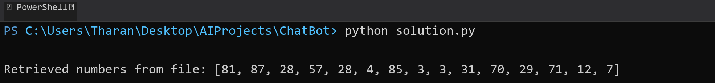

## **QUESTION 2**

2. Write a program to input two integers and divide them. Use a try -catch block to handle the DivideByZeroException and display an appropriate message. Further, if the data type of the elements do not match with defined type then throw an exception too.

### **Code Solution**

try:  
 num1 = 4  
 num2 = 0  
 if not (isinstance(num1, int) and isinstance(num2, int)):  
 raise TypeError("Both numbers must be integers")  
 result = num1 / num2  
 print(f"Result of division: {result}")  
except ZeroDivisionError:  
 print("Error: Division by zero is not allowed")  
except TypeError as te:  
 print(f"Type Error: {te}")  
except Exception as e:  
 print(f"An error occurred: {e}")

### **FINAL Output**

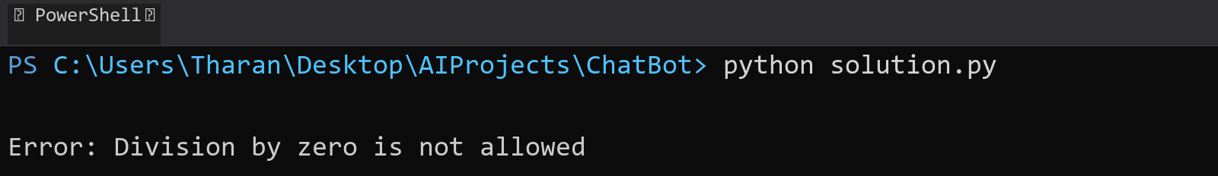

## **QUESTION 3**

3. Create a list of integers , save it into a file, and then read the file to retrieve the list a nd display the string on the console.

### **Code Solution**

numbers = [1, 2, 3, 4, 5]  
  
with open('numbers.txt', 'w') as file:  
 for num in numbers:  
 file.write(str(num) + '\n')  
  
stored_numbers = []  
with open('numbers.txt', 'r') as file:  
 for line in file:  
 stored_numbers.append(int(line.strip()))  
  
print("Retrieved list from file:", stored_numbers)

### **FINAL Output**

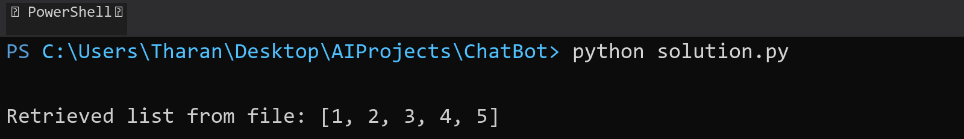

## **QUESTION 4**

4. Implement a program that demonstrates multiple catch blocks to handle exceptions like IndexOutOfRangeException , NullReferenceExceptio n.

### **Code Solution**

try:  
 my_list = [1, 2, 3]  
 print(my_list[5])  
except IndexError:  
 print("Index out of range error occurred")  
  
try:  
 my_dict = None  
 print(my_dict['key'])  
except TypeError:  
 print("Null reference error occurred")  
  
try:  
 x = 10/0  
 print(x)  
except ZeroDivisionError:  
 print("Division by zero error occurred")  
except Exception as e:  
 print(f"General error occurred: {e}")

### **FINAL Output**

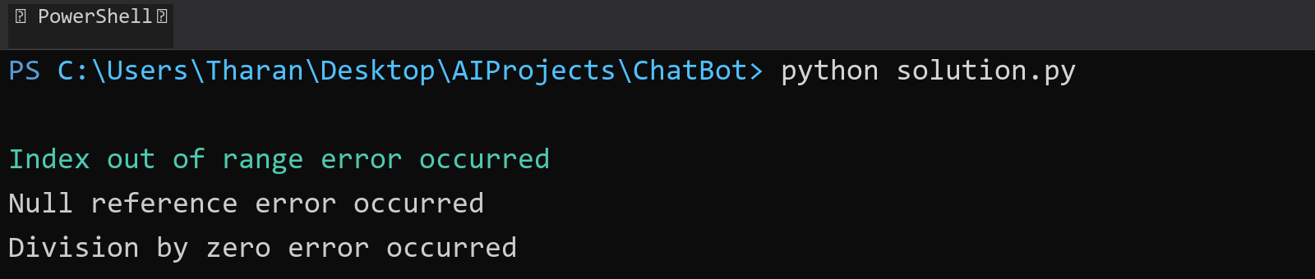

## **QUESTION 5**

5. Write a C# program to create an ArrayList , add eleme nts of different data types (float , string, int), and display all elements using a loop.

### **Code Solution**

my_list = []  
my_list.append(3.14)  
my_list.append("Hello")  
my_list.append(42)  
my_list.append(2.718)  
my_list.append("Python")  
my_list.append(100)  
  
for item in my_list:  
 print(item)

### **FINAL Output**

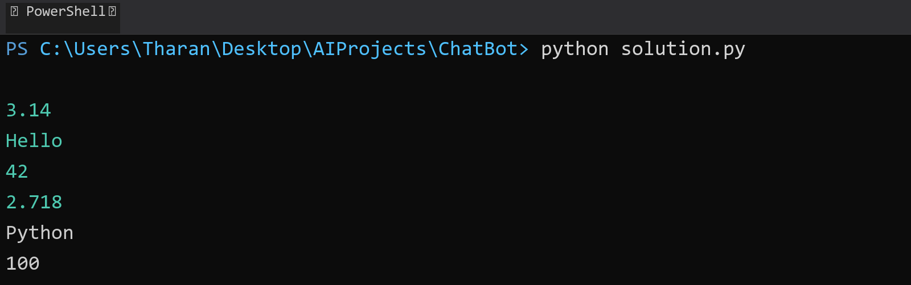

## **QUESTION 6**

6. Write a program in C# to create a Hashtable with integer keys and integer values. Insert three key -value pairs and display them using a loop.

### **Code Solution**

hash_table = {}  
  
hash_table[1] = 10  
hash_table[2] = 20  
hash_table[3] = 30  
  
for key in hash_table:  
 print(f"Key: {key}, Value: {hash_table[key]}")

### **FINAL Output**

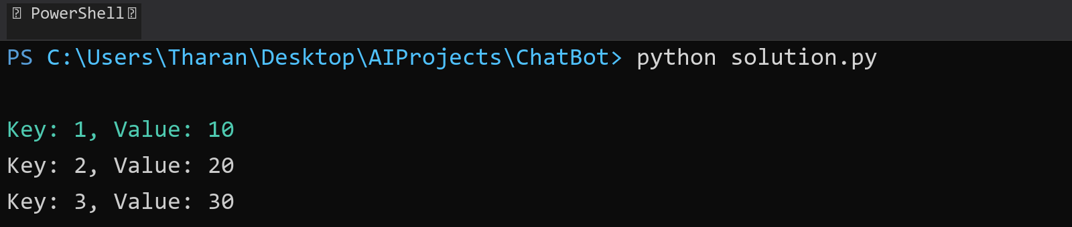

## **QUESTION 7**

7. Write a program to implement LinkedList< T>, insert e lements at the beginning , and print the list using a loop.

### **Code Solution**

class Node:  
 def __init__(self, data):  
 self.data = data  
 self.next = None  
  
class LinkedList:  
 def __init__(self):  
 self.head = None  
  
 def insert_at_beginning(self, data):  
 new_node = Node(data)  
 new_node.next = self.head  
 self.head = new_node  
  
 def print_list(self):  
 current = self.head  
 while current:  
 print(current.data, end=" -> ")  
 current = current.next  
 print("None")  
  
my_list = LinkedList()  
my_list.insert_at_beginning(30)  
my_list.insert_at_beginning(20)  
my_list.insert_at_beginning(10)  
my_list.insert_at_beginning(5)  
my_list.print_list()

### **FINAL Output**

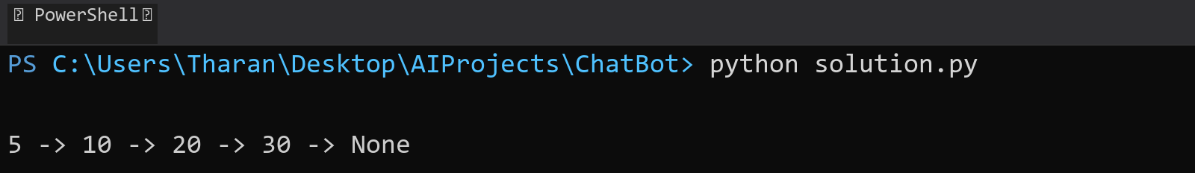

## **QUESTION 8**

8. Write a program to implement Stack , insert five elements and remove them .

### **Code Solution**

class Stack:  
 def __init__(self):  
 self.stack = []  
   
 def push(self, item):  
 self.stack.append(item)  
   
 def pop(self):  
 if not self.is_empty():  
 return self.stack.pop()  
   
 def is_empty(self):  
 return len(self.stack) == 0  
   
 def display(self):  
 print(self.stack)  
  
stack = Stack()  
  
stack.push(10)  
stack.push(20)  
stack.push(30)  
stack.push(40)  
stack.push(50)  
  
print("Stack after pushing elements:")  
stack.display()  
  
stack.pop()  
stack.pop()  
stack.pop()  
stack.pop()  
stack.pop()  
  
print("Stack after popping all elements:")  
stack.display()

### **FINAL Output**

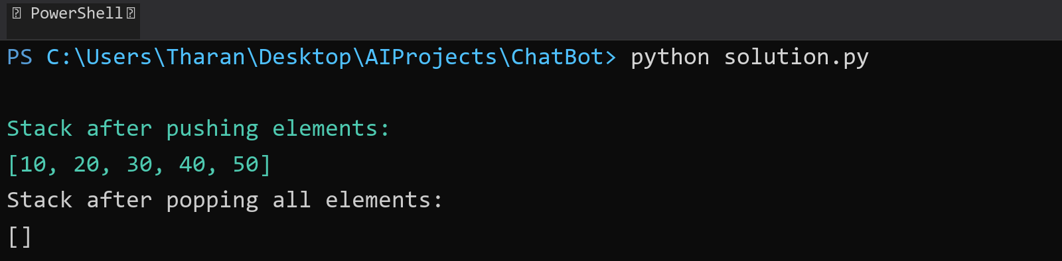

## **QUESTION 9**

9. Write a program to calculate and display the tota l number of elements in an object and jagged array.

### **Code Solution**

def count_elements(obj):  
 if isinstance(obj, (list, tuple)):  
 total = 0  
 for item in obj:  
 total += count_elements(item)  
 return total  
 else:  
 return 1  
  
jagged_array = [[1, 2, 3], [4, 5], [6, 7, 8, 9], [10]]  
object_array = [1, [2, 3], [4, [5, 6]], 7, [8, [9, [10]]]]  
  
total_jagged = count_elements(jagged_array)  
total_object = count_elements(object_array)  
  
print(f"Total elements in jagged array: {total_jagged}")  
print(f"Total elements in object array: {total_object}")

### **FINAL Output**

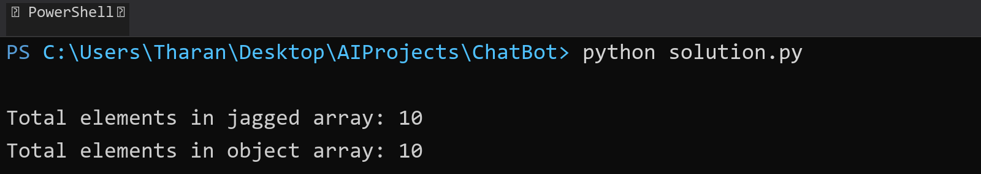

## **QUESTION 10**

10. Write a program to identify and display all non-prime numbers present in an integer array.

### **Code Solution**

def is_non_prime(n):  
 if n < 2:  
 return True  
 for i in range(2, int(n ** 0.5) + 1):  
 if n % i == 0:  
 return True  
 return False  
  
arr = [4, 7, 10, 13, 16, 19, 20, 23, 25, 28]  
non_prime_numbers = []  
  
for num in arr:  
 if is_non_prime(num):  
 non_prime_numbers.append(num)  
  
print("Non-prime numbers in the array:", non_prime_numbers)

### **FINAL Output**

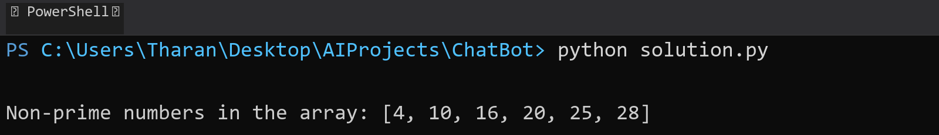

## **QUESTION 11**

11. Write a program to find and displ ay the second largest and smallest numbers in an array.

### **Code Solution**

arr = [12, 45, 2, 41, 31, 10, 8, 6, 4]  
unique_arr = list(set(arr))  
unique_arr.sort()  
if len(unique_arr) >= 2:  
 print(f"Second smallest: {unique_arr[1]}, Second largest: {unique_arr[-2]}")  
else:  
 print("Array does not have enough unique elements.")

### **FINAL Output**

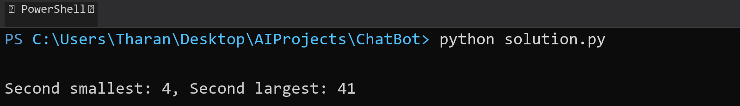

## **QUESTION 12**

12. Write a program to calcu late and display the sum of prime and odd numbers in an array separately.

### **Code Solution**

def is_prime(n):  
 if n < 2:  
 return False  
 for i in range(2, int(n ** 0.5) + 1):  
 if n % i == 0:  
 return False  
 return True  
  
def is_odd(n):  
 return n % 2 != 0  
  
array = [1, 2, 3, 4, 5, 6, 7, 8, 9, 10, 11, 13, 15, 17]  
  
prime_sum = sum(num for num in array if is_prime(num))  
odd_sum = sum(num for num in array if is_odd(num))  
  
print(f"Sum of prime numbers: {prime_sum}")  
print(f"Sum of odd numbers: {odd_sum}")

### **FINAL Output**

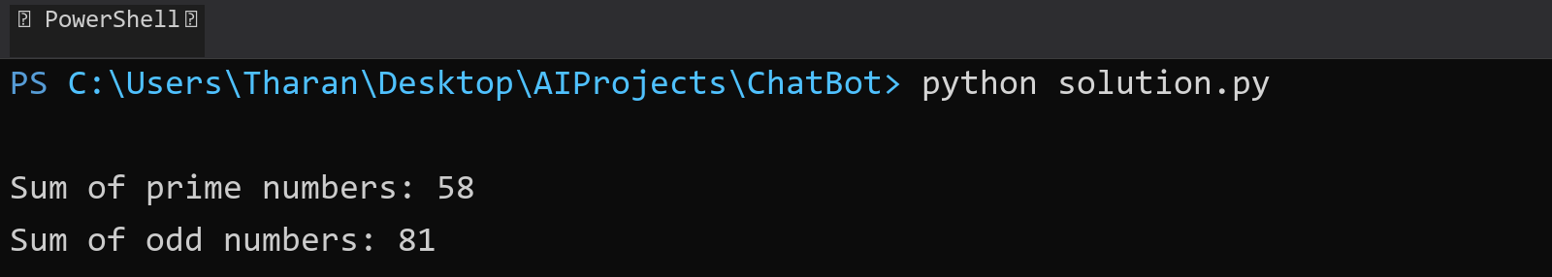

## **QUESTION 13**

13. Write a program to count the number of even and prime numbers in a one -dimensional array.

### **Code Solution**

def is_prime(num):  
 if num < 2:  
 return False  
 for i in range(2, int(num ** 0.5) + 1):  
 if num % i == 0:  
 return False  
 return True  
  
def count_even_and_prime(arr):  
 even_count = 0  
 prime_count = 0  
   
 for num in arr:  
 if num % 2 == 0:  
 even_count += 1  
 if is_prime(num):  
 prime_count += 1  
   
 return even_count, prime_count  
  
array = [1, 2, 3, 4, 5, 6, 7, 8, 9, 10]  
even_numbers, prime_numbers = count_even_and_prime(array)  
  
print(f"Number of even numbers: {even_numbers}")  
print(f"Number of prime numbers: {prime_numbers}")

### **FINAL Output**

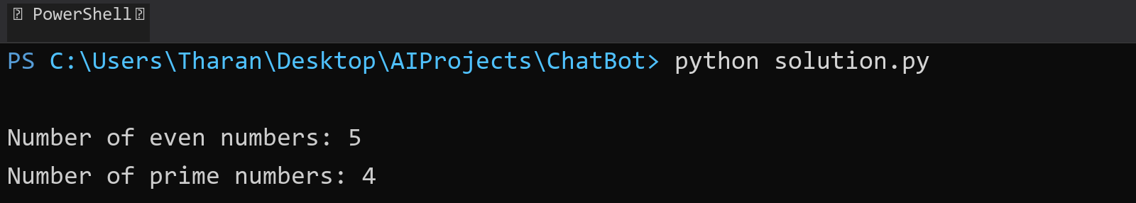

## **QUESTION 14**

14. Implement a program to search for a specific element in an array using binary search .

### **Code Solution**

def binary_search(arr, target):  
 left, right = 0, len(arr) - 1  
 while left <= right:  
 mid = (left + right) // 2  
 if arr[mid] == target:  
 return mid  
 elif arr[mid] < target:  
 left = mid + 1  
 else:  
 right = mid - 1  
 return -1  
  
arr = [1, 3, 5, 7, 9, 11, 13, 15]  
target = 7  
result = binary_search(arr, target)  
print(result)

### **FINAL Output**

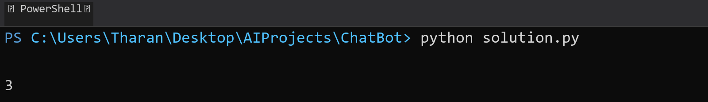

## **QUESTION 15**

15. Write a program to calculate the sum of the lower triangle elements of a square matrix.

### **Code Solution**

def calculate_lower_triangle_sum(matrix):  
 n = len(matrix)  
 sum = 0  
 for i in range(n):  
 for j in range(i + 1):  
 sum += matrix[i][j]  
 return sum  
  
matrix = [  
 [1, 2, 3],  
 [4, 5, 6],  
 [7, 8, 9]  
]  
  
result = calculate_lower_triangle_sum(matrix)  
print(f"Sum of lower triangle elements: {result}")

### **FINAL Output**

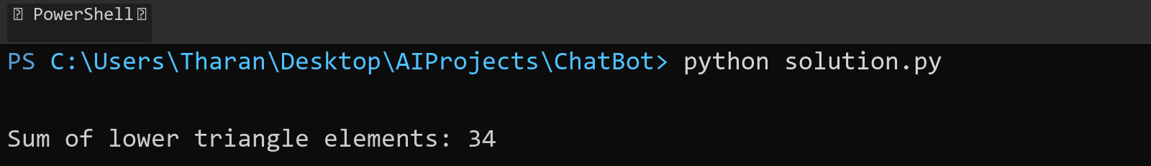

## **QUESTION 16**

16. Write a C# program to perform linear search on a sorted jagged array .

### **Code Solution**

def linear_search_jagged(arr, target):  
 for i in range(len(arr)):  
 for j in range(len(arr[i])):  
 if arr[i][j] == target:  
 return (i, j)  
 return (-1, -1)  
  
jagged_array = [  
 [1, 2, 3],  
 [4, 5, 6, 7],  
 [8, 9]  
]  
target_value = 5  
result = linear_search_jagged(jagged_array, target_value)  
print(result)

### **FINAL Output**

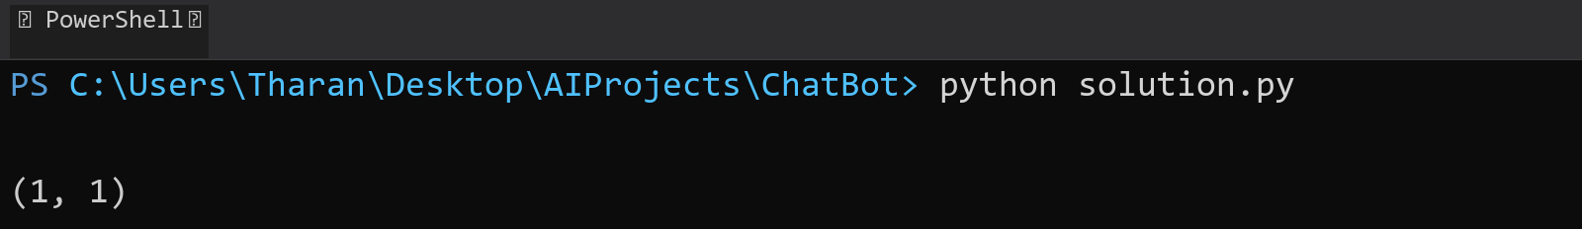

## **QUESTION 17**

17. Create a Student class with properties (ID, Father_ Name, Marks). Store multiple students in an object array and sort them by Marks. Further, s tore sorted students in a Linked List<T> and display them.

### **Code Solution**

class Student:  
 def __init__(self, ID, Father_Name, Marks):  
 self.ID = ID  
 self.Father_Name = Father_Name  
 self.Marks = Marks  
  
class Node:  
 def __init__(self, data):  
 self.data = data  
 self.next = None  
  
class LinkedList:  
 def __init__(self):  
 self.head = None  
  
 def append(self, data):  
 new_node = Node(data)  
 if not self.head:  
 self.head = new_node  
 return  
 last_node = self.head  
 while last_node.next:  
 last_node = last_node.next  
 last_node.next = new_node  
  
 def display(self):  
 current = self.head  
 while current:  
 student = current.data  
 print(f"ID: {student.ID}, Father's Name: {student.Father_Name}, Marks: {student.Marks}")  
 current = current.next  
  
students = [  
 Student(1, "John", 85),  
 Student(2, "Mike", 90),  
 Student(3, "Steve", 75)  
]  
  
students_sorted = sorted(students, key=lambda x: x.Marks)  
  
linked_list = LinkedList()  
for student in students_sorted:  
 linked_list.append(student)  
  
linked_list.display()

### **FINAL Output**

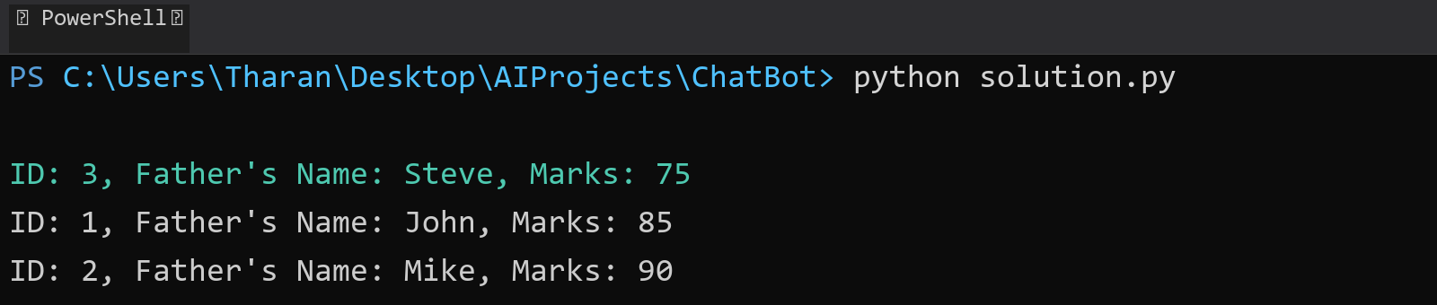

## **QUESTION 18**

18. Write a program to count the number of prime and odd numbers in a one -dimensional array.

### **Code Solution**

def is_prime(n):  
 if n < 2:  
 return False  
 for i in range(2, int(n ** 0.5) + 1):  
 if n % i == 0:  
 return False  
 return True  
  
def is_odd(n):  
 return n % 2 != 0  
  
array = [1, 2, 3, 4, 5, 6, 7, 8, 9, 10, 11, 13, 17, 19, 23]  
  
prime_count = sum(1 for num in array if is_prime(num))  
odd_count = sum(1 for num in array if is_odd(num))  
  
print(f"Number of prime numbers: {prime_count}")  
print(f"Number of odd numbers: {odd_count}")

### **FINAL Output**

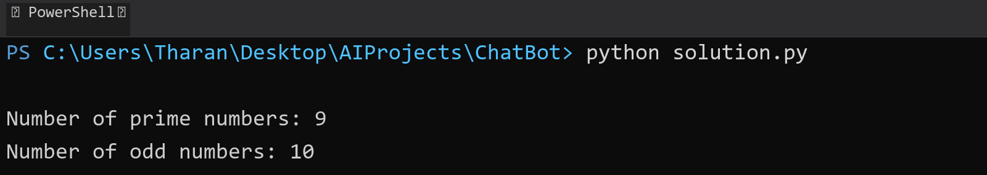

## **QUESTION 19**

19. Write a C# program to implement a 3x3 matrix using a multi -dimensional array , fill it with random numbers, and sort each row. Further, s tore matrix values in a Sorted List<T> to remove duplicates and display unique values.

### **Code Solution**

import random  
  
matrix = [[random.randint(1, 20) for _ in range(3)] for _ in range(3)]  
  
for row in matrix:  
 row.sort()  
  
print("Sorted Matrix:")  
for row in matrix:  
 print(row)  
  
unique_values = list(set([num for row in matrix for num in row]))  
unique_values.sort()  
  
print("\nUnique Values:")  
print(unique_values)

### **FINAL Output**

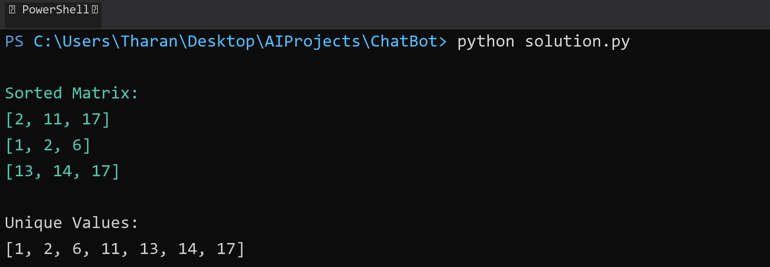

## **QUESTION 20**

20. Write a C# program to implement a program that reads an array of filenames and searches for a specific file in the system. Further, s tore valid file names in a Directory collection and allow the user to retrieve details about a specific file.

### **Code Solution**

import os  
from collections import defaultdict  
  
filenames = ["file1.txt", "file2.txt", "file3.txt", "file4.txt", "file5.txt", "file6.txt"]  
search_file = "file6.txt"  
directory = defaultdict(dict)  
  
for filename in filenames:  
 if os.path.exists(filename):  
 file_info = {  
 "name": filename,  
 "size": os.path.getsize(filename),  
 "path": os.path.abspath(filename)  
 }  
 directory[filename] = file_info  
  
if search_file in directory:  
 file_details = directory[search_file]  
 print(f"File found: {file_details['name']}, Size: {file_details['size']} bytes, Path: {file_details['path']}")  
else:  
 print("File not found.")

### **FINAL Output**

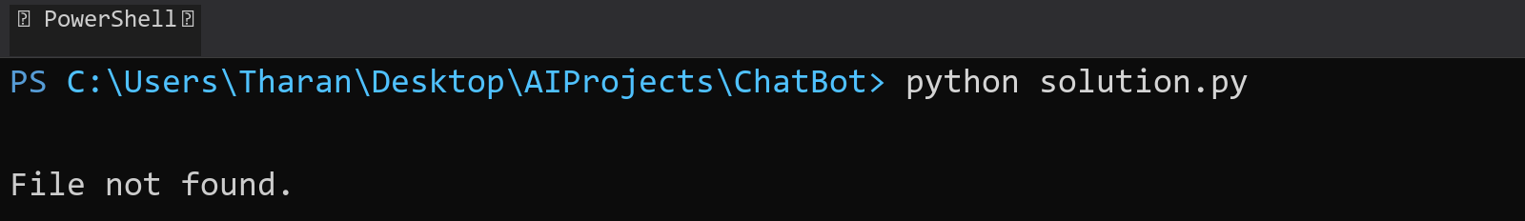

## **QUESTION 21**

21. Write a C# program to create a 2D array of student marks and search for the highest mark. Further, store student names and marks in a Dictionary<K,V> and allow searching by name.

### **Code Solution**

students_marks = [  
 [85, 90, 78],  
 [92, 88, 76],  
 [70, 65, 80]  
]  
  
max_mark = max(max(row) for row in students_marks)  
print(f"The highest mark is: {max_mark}")  
  
student_data = {  
 "Alice": [85, 90, 78],  
 "Bob": [92, 88, 76],  
 "Charlie": [70, 65, 80]  
}  
  
search_name = "Bob"  
if search_name in student_data:  
 print(f"{search_name}'s marks: {student_data[search_name]}")  
else:  
 print(f"{search_name} not found in the records.")

### **FINAL Output**

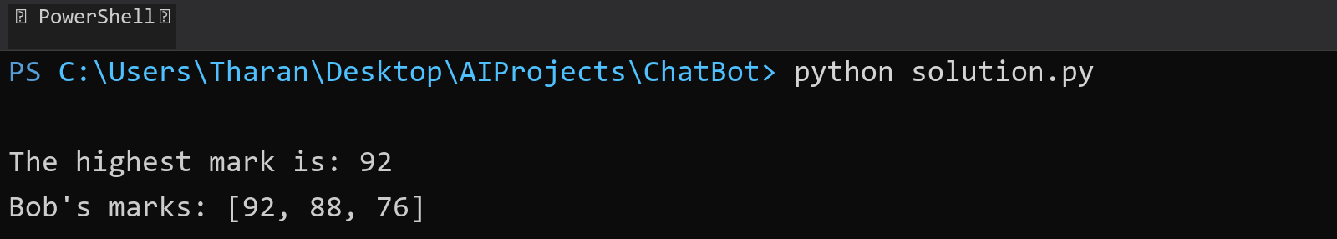

## **QUESTION 22**

22. Write a C# program to implement Binary Search in a jagged array of employee IDs. Further, s tore IDs in a Stack<T> , push/pop operations for LIFO retrieval.

### **Code Solution**

def binary_search(arr, target):  
 left = 0  
 right = len(arr) - 1  
 while left <= right:  
 mid = (left + right) // 2  
 if arr[mid] == target:  
 return mid  
 elif arr[mid] < target:  
 left = mid + 1  
 else:  
 right = mid - 1  
 return -1  
  
class Stack:  
 def __init__(self):  
 self.items = []  
   
 def push(self, item):  
 self.items.append(item)  
   
 def pop(self):  
 if not self.is_empty():  
 return self.items.pop()  
 return None  
   
 def is_empty(self):  
 return len(self.items) == 0  
  
jagged_array = [  
 [101, 102, 103],  
 [201, 202],  
 [301, 302, 303, 304],  
]  
  
stack = Stack()  
target_id = 302  
  
for sub_array in jagged_array:  
 sorted_array = sorted(sub_array)  
 result = binary_search(sorted_array, target_id)  
 if result != -1:  
 for id in sorted_array:  
 stack.push(id)  
 print(f"Employee ID {target_id} found")  
 break  
  
print("\nRetrieving IDs from stack (LIFO):")  
while not stack.is_empty():  
 print(stack.pop())

### **FINAL Output**

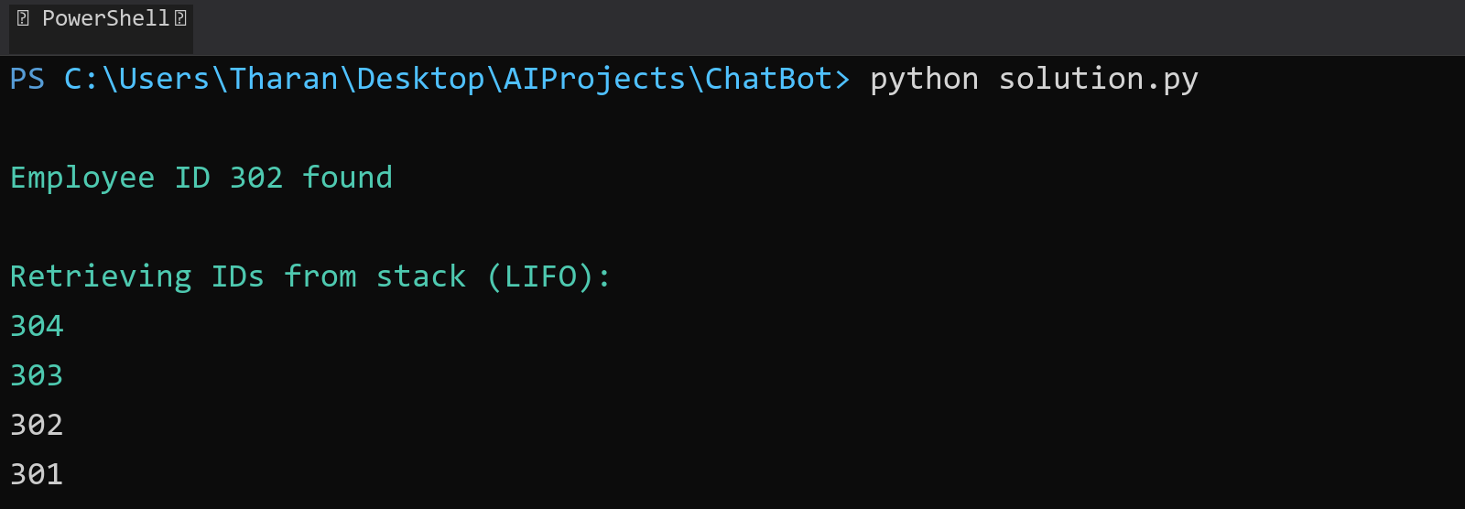

## **QUESTION 23**

23. Write a C# program to create a Product class (ID, Name, Price) and store o bjects in an array by price. Further, u se a Queue<T> to manage product processing (FIFO order).

### **Code Solution**

class Product:  
 def __init__(self, id, name, price):  
 self.id = id  
 self.name = name  
 self.price = price  
  
class Queue:  
 def __init__(self):  
 self.items = []  
  
 def enqueue(self, item):  
 self.items.append(item)  
  
 def dequeue(self):  
 if not self.is_empty():  
 return self.items.pop(0)  
 return None  
  
 def is_empty(self):  
 return len(self.items) == 0  
  
products = [  
 Product(1, "Laptop", 999.99),  
 Product(2, "Phone", 599.99),  
 Product(3, "Tablet", 299.99),  
 Product(4, "Watch", 199.99),  
 Product(5, "Headphones", 99.99)  
]  
  
sorted_products = sorted(products, key=lambda x: x.price)  
  
product_queue = Queue()  
for product in sorted_products:  
 product_queue.enqueue(product)  
  
print("Products processed in FIFO order (sorted by price):")  
while not product_queue.is_empty():  
 product = product_queue.dequeue()  
 print(f"ID: {product.id}, Name: {product.name}, Price: ${product.price}")

### **FINAL Output**

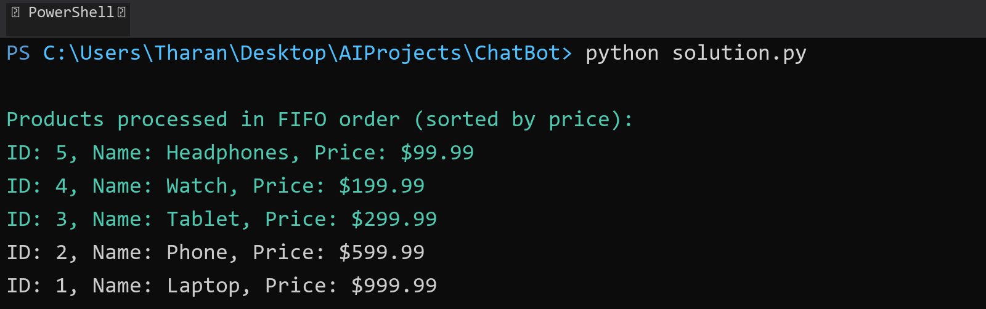

## **QUESTION 24**

24. Write a program to calculate the sum of the diagonal elements of a square matrix.

### **Code Solution**

matrix = [  
 [1, 2, 3],  
 [4, 5, 6],  
 [7, 8, 9]  
]  
  
diagonal_sum = 0  
for i in range(len(matrix)):  
 diagonal_sum += matrix[i][i]  
  
right_diagonal_sum = 0  
for i in range(len(matrix)):  
 right_diagonal_sum += matrix[i][len(matrix)-1-i]  
  
print(f"Sum of main diagonal: {diagonal_sum}")  
print(f"Sum of other diagonal: {right_diagonal_sum}")

### **FINAL Output**

