**#COURSE NAME**

**#Class name**

**"#PRACTICAL_NUMBER"**

***BY***

**"Tharan" (#Registration Number)**

**SUBMITTED TO**

**#teacher name**



**SCHOOL OF SCIENCES**

**2025-2026**

## **QUESTION 1**

1.Write a program to print the numbers from 1 to 50 using a for loop.

### **Code Solution**

for i in range(1, 51):  
 print(i)

### **FINAL Output**

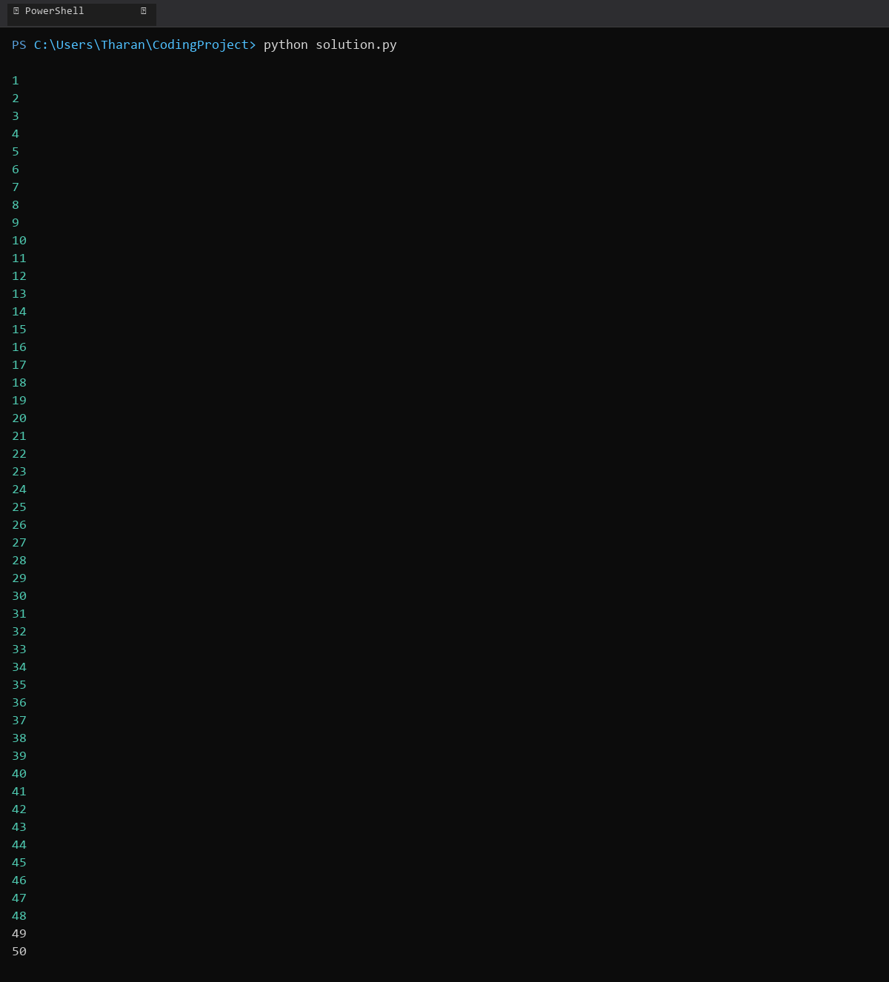

## **QUESTION 2**

2.Write a program that takes an integer as input and checks if it is even or odd.

### **Code Solution**

number = 7  
if number % 2 == 0:  
 print(number, "is even")  
else:  
 print(number, "is odd")

### **FINAL Output**

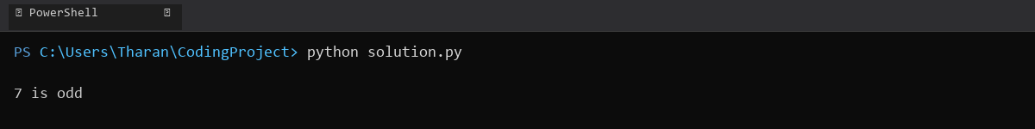

## **QUESTION 3**

3.Create a program that prints a right -angled triangle pattern of * with a height of 5.

### **Code Solution**

for i in range(1, 6):  
 print('*' * i)

### **FINAL Output**

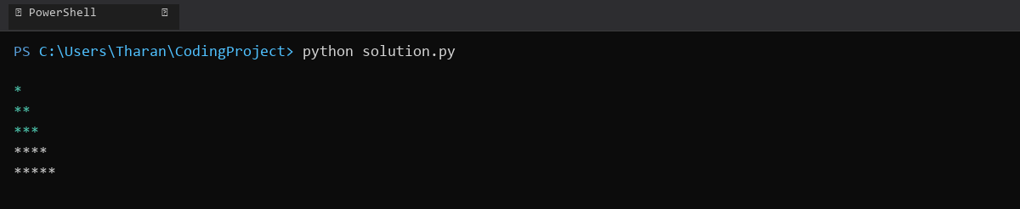

## **QUESTION 4**

4.Write a program that takes a number (1 -7) as input and prints the corresponding day of the week using a switch statement.

### **Code Solution**

day = 3  
  
match day:  
 case 1:  
 print("Monday")  
 case 2:  
 print("Tuesday")  
 case 3:  
 print("Wednesday")  
 case 4:  
 print("Thursday")  
 case 5:  
 print("Friday")  
 case 6:  
 print("Saturday")  
 case 7:  
 print("Sunday")  
 case _:  
 print("Invalid day number")

### **FINAL Output**

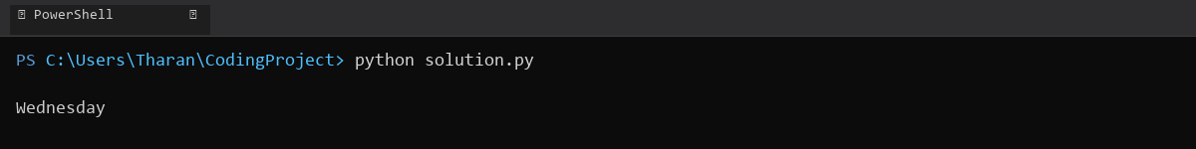

## **QUESTION 5**

5.Write a program to calculate the sum of all numbers from 1 to n using a while loop.

### **Code Solution**

n = 10  
sum = 0  
i = 1  
while i <= n:  
 sum += i  
 i += 1  
print(sum)

### **FINAL Output**

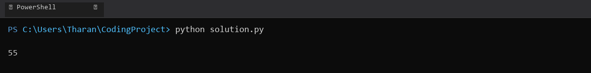

## **QUESTION 6**

6.Write a program to check if a given number is prime or not using a for loop and if conditions.

### **Code Solution**

num = 17  
is_prime = True  
  
if num > 1:  
 for i in range(2, num):  
 if num % i == 0:  
 is_prime = False  
 break  
else:  
 is_prime = False  
  
if is_prime:  
 print(num, "is a prime number")  
else:  
 print(num, "is not a prime number")

### **FINAL Output**

