**SOFTWARE ENGENEERING**

**3 bca b**

**"Practical - 4"**

***BY***

**"Tharan" (23215134)**

**SUBMITTED TO**

**prateek singh**



**SCHOOL OF SCIENCES**

**2025-2026**

## **QUESTION 1**

1.Write a program to print the numbers from 1 to 50 using a for loop.

### **Code Solution**

for i in range(1, 51):  
 print(i)

### **FINAL Output**

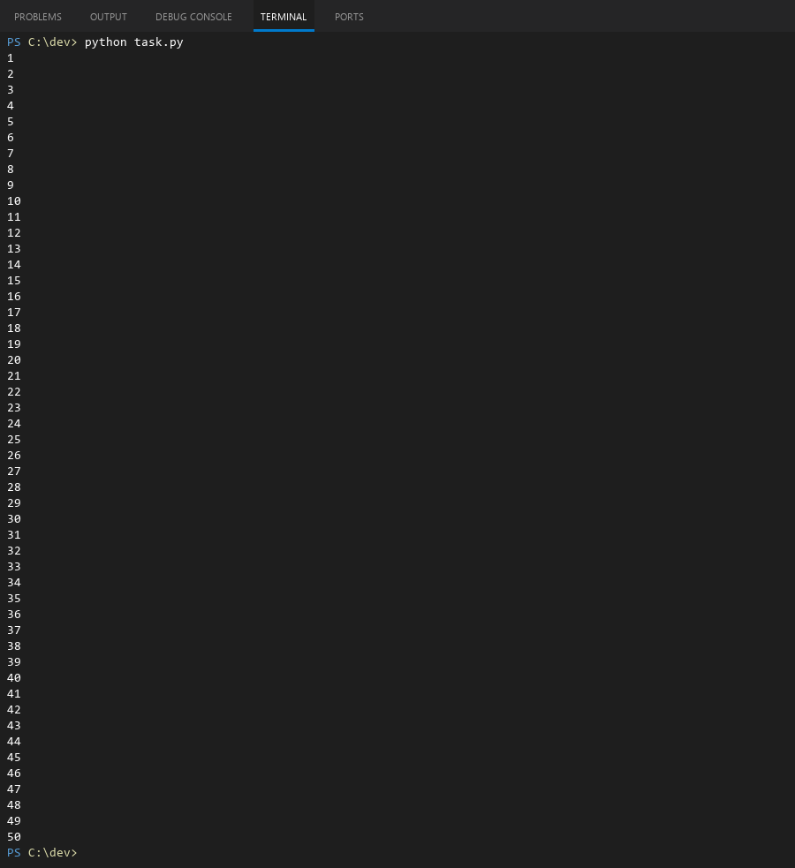

## **QUESTION 2**

2.Write a program that takes an integer as input and checks if it is even or odd.

### **Code Solution**

number = 6  
if number % 2 == 0:  
 print("even")  
else:  
 print("odd")

### **FINAL Output**

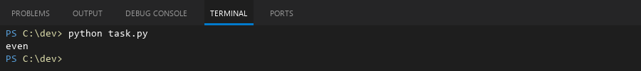

## **QUESTION 3**

3.Create a program that prints a right -angled triangle pattern of * with a height of 5.

### **Code Solution**

for i in range(1, 6):  
 print('*' * i)

### **FINAL Output**

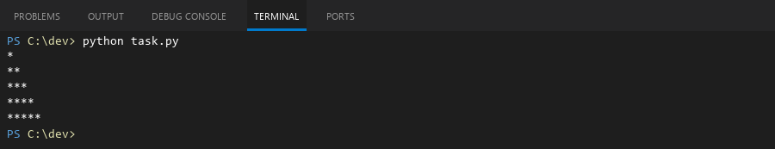

## **QUESTION 4**

4.Write a program that takes a number (1 -7) as input and prints the corresponding day of the week using a switch statement.

### **Code Solution**

day_number = 7  
if day_number == 1:  
 print("Monday")  
elif day_number == 2:  
 print("Tuesday")  
elif day_number == 3:  
 print("Wednesday")  
elif day_number == 4:  
 print("Thursday")  
elif day_number == 5:  
 print("Friday")  
elif day_number == 6:  
 print("Saturday")  
elif day_number == 7:  
 print("Sunday")  
else:  
 print("Invalid day")

### **FINAL Output**

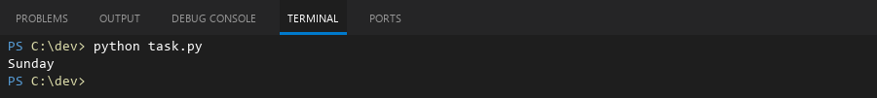

## **QUESTION 5**

5.Write a program to calculate the sum of all numbers from 1 to n using a while loop.

### **Code Solution**

n = 10  
total = 0  
i = 1  
while i <= n:  
 total += i  
 i += 1  
print(total)

### **FINAL Output**

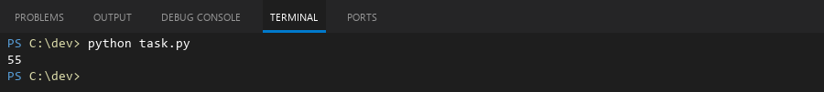

## **QUESTION 6**

6.Write a program to check if a given number is prime or not using a for loop and if conditions.

### **Code Solution**

number = 29  
is_prime = True  
if number > 1:  
 for i in range(2, number):  
 if number % i == 0:  
 is_prime = False  
 break  
else:  
 is_prime = False  
if is_prime:  
 print(number, "is a prime number")  
else:  
 print(number, "is not a prime number")

### **FINAL Output**

