## **QUESTION 1**

1. Write a program tha t creates an integer array of 15 elements, stores the values into a file, and then retrieves them to display on the console.

### **Code Solution**

import array  
import pickle  
  
my_array = array.array('i', [10, 20, 30, 40, 50, 60, 70, 80, 90, 100, 110, 120, 130, 140, 150])  
  
with open('array_data.bin', 'wb') as file:  
 pickle.dump(my_array, file)  
  
with open('array_data.bin', 'rb') as file:  
 retrieved_array = pickle.load(file)  
  
print("Retrieved array elements:", list(retrieved_array))

### **FINAL Output**

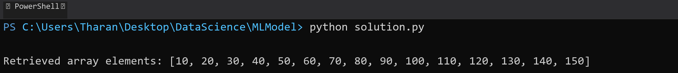

## **QUESTION 2**

2. Write a program to input two integers and divide them. Use a try -catch block to handle the DivideByZeroException and display an appropriate message. Further, if the data type of the elements do not match with defined type then throw an exception too.

### **Code Solution**

try:  
 num1 = 10  
 num2 = 0  
 if not isinstance(num1, int) or not isinstance(num2, int):  
 raise TypeError("Both numbers must be integers")  
 result = num1 / num2  
 print(f"Result of division: {result}")  
except ZeroDivisionError:  
 print("Error: Division by zero is not allowed")  
except TypeError as te:  
 print(f"Error: {te}")  
except Exception as e:  
 print(f"An unexpected error occurred: {e}")

### **FINAL Output**

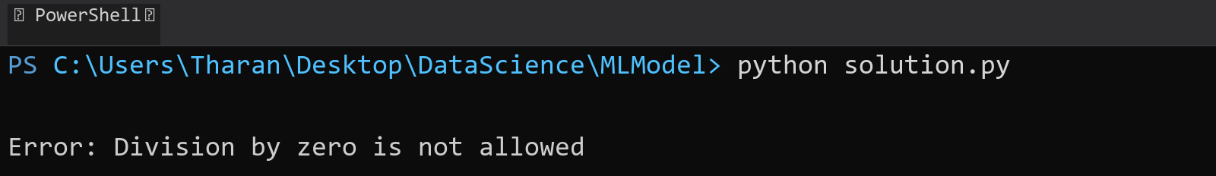

## **QUESTION 3**

3. Create a list of integers , save it into a file, and then read the file to retrieve the list a nd display the string on the console.

### **Code Solution**

numbers = [1, 2, 3, 4, 5]  
  
with open('numbers.txt', 'w') as file:  
 for num in numbers:  
 file.write(str(num) + '\n')  
  
stored_numbers = []  
with open('numbers.txt', 'r') as file:  
 for line in file:  
 stored_numbers.append(int(line.strip()))  
  
print(stored_numbers)

### **FINAL Output**

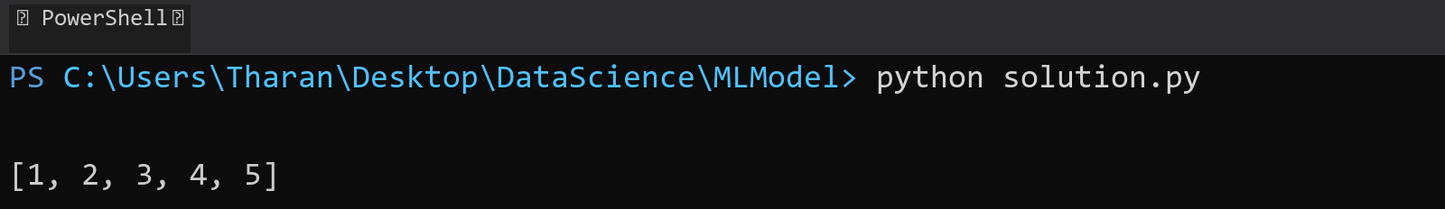

## **QUESTION 4**

4. Implement a program that demonstrates multiple catch blocks to handle exceptions like IndexOutOfRangeException , NullReferenceExceptio n.

### **Code Solution**

try:  
 numbers = [1, 2, 3]  
 index = 5  
 result = numbers[index]  
 print(result)  
except IndexError:  
 print("Index out of range error occurred")  
   
try:  
 my_list = None  
 value = my_list[0]  
 print(value)  
except TypeError:  
 print("Null reference error occurred")  
   
try:  
 x = 10/0  
 print(x)  
except ZeroDivisionError:  
 print("Division by zero error occurred")  
finally:  
 print("Exception handling completed")

### **FINAL Output**

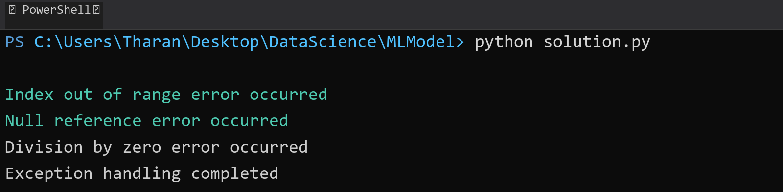

## **QUESTION 5**

5. Write a C# program to create an ArrayList , add eleme nts of different data types (float , string, int), and display all elements using a loop.

### **Code Solution**

array_list = []  
array_list.append(3.14)  
array_list.append("Hello")  
array_list.append(42)  
array_list.append(7.5)  
array_list.append("Python")  
array_list.append(100)  
  
for item in array_list:  
 print(item)

### **FINAL Output**

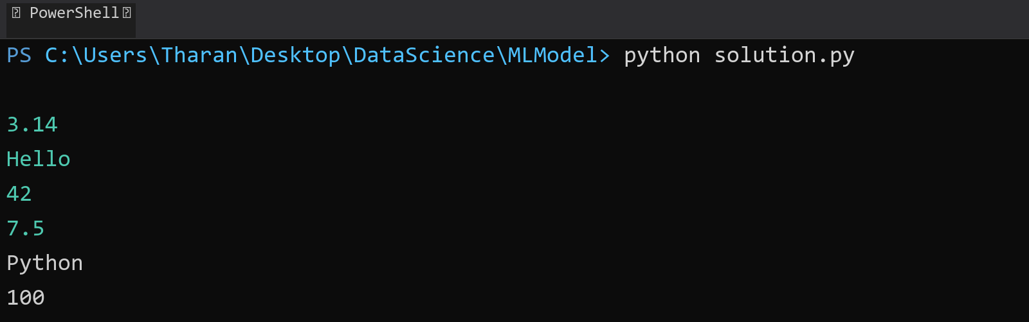

## **QUESTION 6**

6. Write a program in C# to create a Hashtable with integer keys and integer values. Insert three key -value pairs and display them using a loop.

### **Code Solution**

my_dict = {1: 10, 2: 20, 3: 30}  
  
for key, value in my_dict.items():  
 print(f"Key: {key}, Value: {value}")

### **FINAL Output**

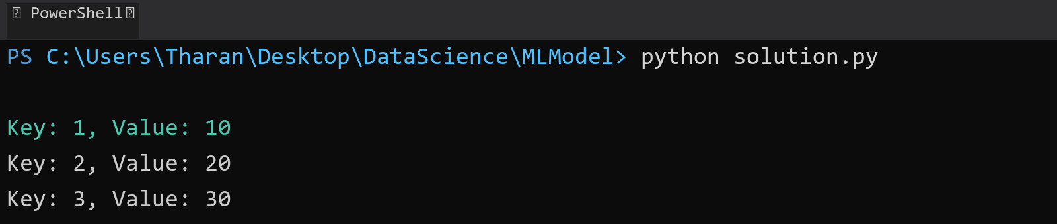

## **QUESTION 7**

7. Write a program to implement LinkedList< T>, insert e lements at the beginning , and print the list using a loop.

### **Code Solution**

class Node:  
 def __init__(self, data):  
 self.data = data  
 self.next = None  
  
class LinkedList:  
 def __init__(self):  
 self.head = None  
  
 def insert_at_beginning(self, data):  
 new_node = Node(data)  
 new_node.next = self.head  
 self.head = new_node  
  
 def print_list(self):  
 current = self.head  
 while current:  
 print(current.data, end=" -> ")  
 current = current.next  
 print("None")  
  
linked_list = LinkedList()  
linked_list.insert_at_beginning(30)  
linked_list.insert_at_beginning(20)  
linked_list.insert_at_beginning(10)  
linked_list.print_list()

### **FINAL Output**

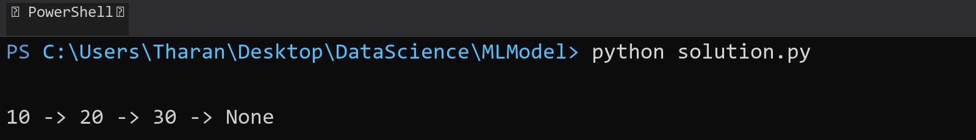

## **QUESTION 8**

8. Write a program to implement Stack , insert five elements and remove them .

### **Code Solution**

class Stack:  
 def __init__(self):  
 self.items = []  
  
 def push(self, item):  
 self.items.append(item)  
  
 def pop(self):  
 if not self.is_empty():  
 return self.items.pop()  
 return None  
  
 def is_empty(self):  
 return len(self.items) == 0  
  
 def peek(self):  
 if not self.is_empty():  
 return self.items[-1]  
 return None  
  
 def size(self):  
 return len(self.items)  
  
stack = Stack()  
  
print("Stack operations:")  
stack.push(10)  
stack.push(20)  
stack.push(30)  
stack.push(40)  
stack.push(50)  
print("Stack after pushing:", stack.items)  
  
print("Popped element:", stack.pop())  
print("Popped element:", stack.pop())  
print("Popped element:", stack.pop())  
print("Popped element:", stack.pop())  
print("Popped element:", stack.pop())  
print("Final stack:", stack.items)

### **FINAL Output**

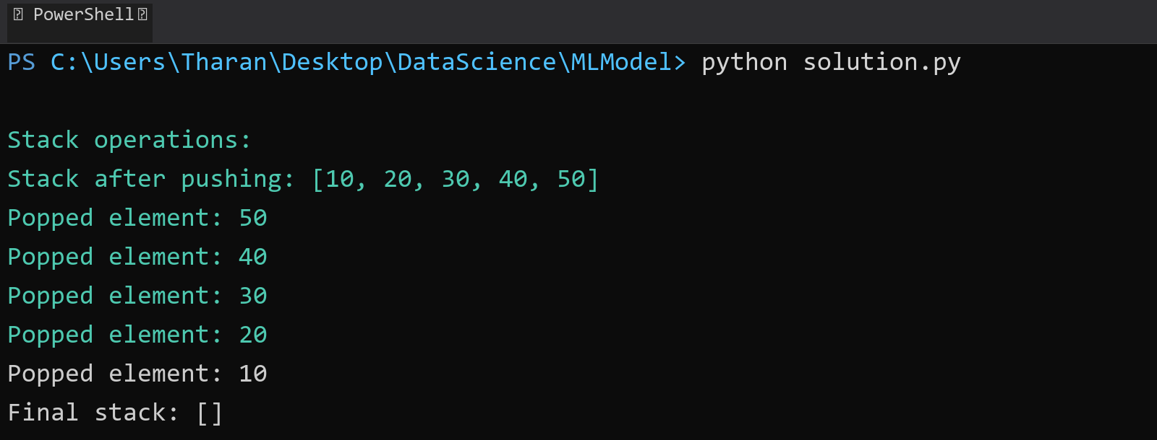

## **QUESTION 9**

9. Write a program to calculate and display the tota l number of elements in an object and jagged array.

### **Code Solution**

obj = {  
 'name': 'John',  
 'age': 30,  
 'city': 'New York',  
 'hobbies': ['reading', 'gaming']  
}  
  
jagged_array = [  
 [1, 2, 3],  
 [4, 5],  
 [6, 7, 8, 9],  
 [10]  
]  
  
obj_count = len(obj)  
for value in obj.values():  
 if isinstance(value, list):  
 obj_count += len(value) - 1  
  
array_count = 0  
for row in jagged_array:  
 array_count += len(row)  
  
print(f"Total elements in object: {obj_count}")  
print(f"Total elements in jagged array: {array_count}")

### **FINAL Output**

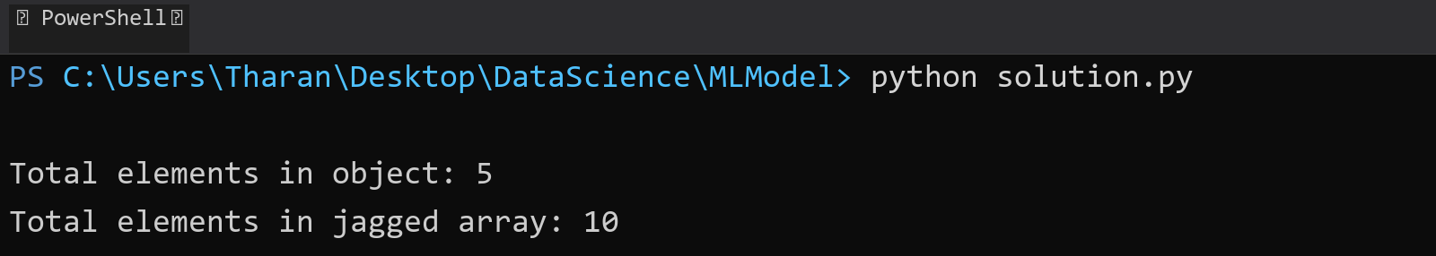

## **QUESTION 10**

10. Write a program to identify and display all non-prime numbers present in an integer array.

### **Code Solution**

def is_not_prime(n):  
 if n < 2:  
 return True  
 for i in range(2, int(n ** 0.5) + 1):  
 if n % i == 0:  
 return True  
 return False  
  
array = [4, 7, 10, 13, 16, 19, 20, 23, 25, 28, 31]  
  
non_prime_numbers = []  
for num in array:  
 if is_not_prime(num):  
 non_prime_numbers.append(num)  
  
print("Non-prime numbers in the array:", non_prime_numbers)

### **FINAL Output**

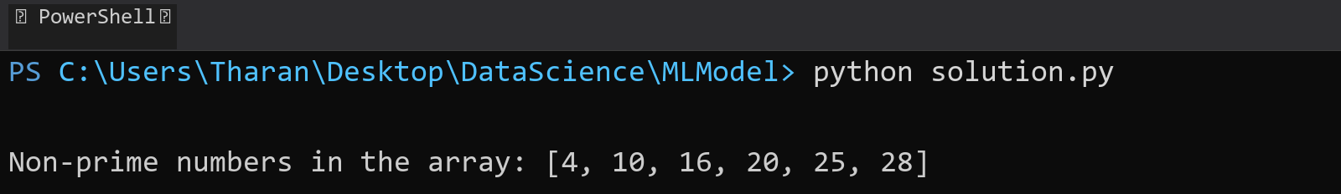

## **QUESTION 11**

11. Write a program to find and displ ay the second largest and smallest numbers in an array.

### **Code Solution**

numbers = [23, 45, 12, 67, 89, 34, 21, 56, 78, 90]  
  
if len(numbers) < 2:  
 print("Array should have at least 2 elements")  
else:  
 numbers.sort()  
 print(f"Second smallest number: {numbers[1]}")  
 print(f"Second largest number: {numbers[-2]}")

### **FINAL Output**

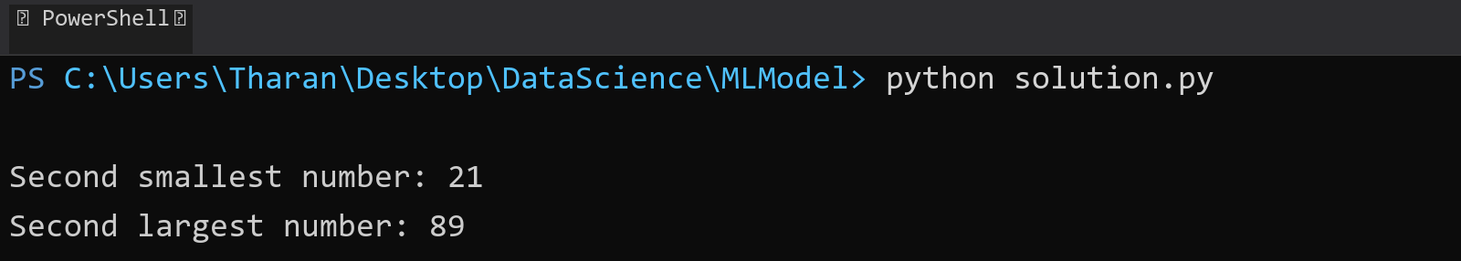

## **QUESTION 12**

12. Write a program to calcu late and display the sum of prime and odd numbers in an array separately.

### **Code Solution**

def is_prime(n):  
 if n < 2:  
 return False  
 for i in range(2, int(n ** 0.5) + 1):  
 if n % i == 0:  
 return False  
 return True  
  
def is_odd(n):  
 return n % 2 != 0  
  
array = [1, 2, 3, 4, 5, 6, 7, 8, 9, 10, 11, 13, 17]  
  
prime_sum = sum(num for num in array if is_prime(num))  
odd_sum = sum(num for num in array if is_odd(num))  
  
print(f"Sum of prime numbers: {prime_sum}")  
print(f"Sum of odd numbers: {odd_sum}")

### **FINAL Output**

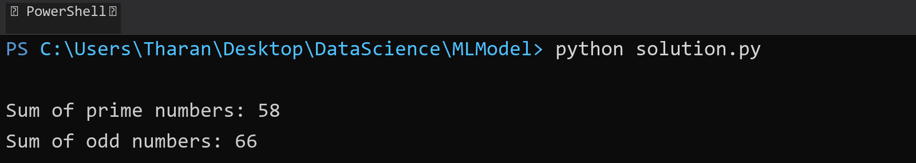

## **QUESTION 13**

13. Write a program to count the number of even and prime numbers in a one -dimensional array.

### **Code Solution**

def is_prime(n):  
 if n < 2:  
 return False  
 for i in range(2, int(n ** 0.5) + 1):  
 if n % i == 0:  
 return False  
 return True  
  
def count_even_and_prime(arr):  
 even_count = 0  
 prime_count = 0  
   
 for num in arr:  
 if num % 2 == 0:  
 even_count += 1  
 if is_prime(num):  
 prime_count += 1  
   
 return even_count, prime_count  
  
array = [1, 2, 3, 4, 5, 6, 7, 8, 9, 10]  
even, prime = count_even_and_prime(array)  
print(f"Number of even numbers: {even}")  
print(f"Number of prime numbers: {prime}")

### **FINAL Output**

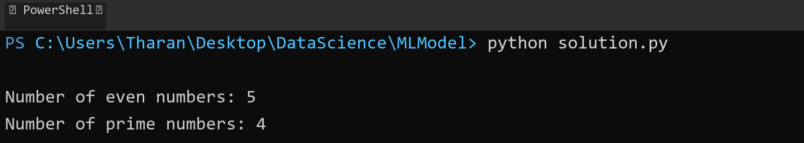

## **QUESTION 14**

14. Implement a program to search for a specific element in an array using binary search .

### **Code Solution**

def binary_search(arr, target):  
 left = 0  
 right = len(arr) - 1  
   
 while left <= right:  
 mid = (left + right) // 2  
 if arr[mid] == target:  
 return mid  
 elif arr[mid] < target:  
 left = mid + 1  
 else:  
 right = mid - 1  
 return -1  
  
array = [1, 3, 5, 7, 9, 11, 13, 15, 17, 19]  
target = 13  
  
result = binary_search(array, target)  
  
if result != -1:  
 print(f"Element {target} found at index {result}")  
else:  
 print(f"Element {target} not found in the array")

### **FINAL Output**

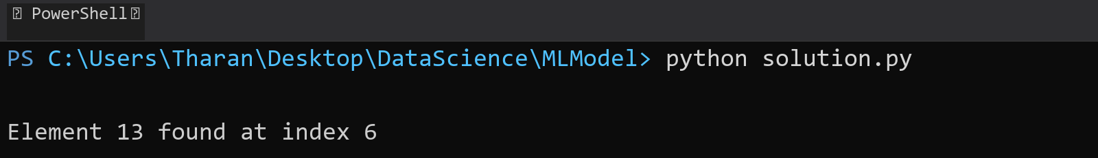

## **QUESTION 15**

15. Write a program to calculate the sum of the lower triangle elements of a square matrix.

### **Code Solution**

def sum_lower_triangle(matrix):  
 n = len(matrix)  
 sum = 0  
 for i in range(n):  
 for j in range(i + 1):  
 sum += matrix[i][j]  
 return sum  
  
matrix = [  
 [1, 2, 3],  
 [4, 5, 6],  
 [7, 8, 9]  
]  
  
result = sum_lower_triangle(matrix)  
print("Sum of lower triangle elements:", result)

### **FINAL Output**

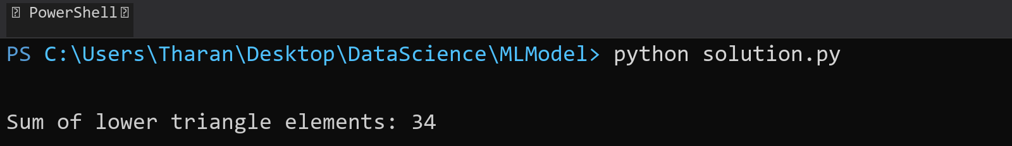

## **QUESTION 16**

16. Write a C# program to perform linear search on a sorted jagged array .

### **Code Solution**

def linear_search_jagged(jagged_array, target):  
 for i in range(len(jagged_array)):  
 for j in range(len(jagged_array[i])):  
 if jagged_array[i][j] == target:  
 return (i, j)  
 return (-1, -1)  
  
jagged_array = [  
 [1, 3, 5],  
 [2, 4, 6, 8],  
 [7, 9],  
 [10, 11, 12, 13, 14]  
]  
  
target = 8  
result = linear_search_jagged(jagged_array, target)  
  
if result != (-1, -1):  
 print(f"Element {target} found at position: row {result[0]}, column {result[1]}")  
else:  
 print(f"Element {target} not found in the array")

### **FINAL Output**

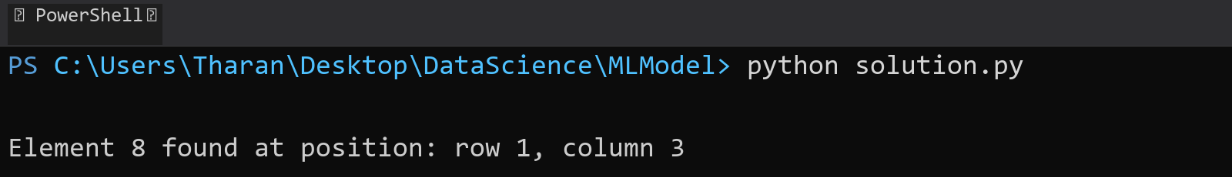

## **QUESTION 17**

17. Create a Student class with properties (ID, Father_ Name, Marks). Store multiple students in an object array and sort them by Marks. Further, s tore sorted students in a Linked List<T> and display them.

### **Code Solution**

class Student:  
 def __init__(self, ID, Father_Name, Marks):  
 self.ID = ID  
 self.Father_Name = Father_Name  
 self.Marks = Marks  
  
class Node:  
 def __init__(self, data):  
 self.data = data  
 self.next = None  
  
class LinkedList:  
 def __init__(self):  
 self.head = None  
  
 def append(self, data):  
 new_node = Node(data)  
 if not self.head:  
 self.head = new_node  
 return  
 current = self.head  
 while current.next:  
 current = current.next  
 current.next = new_node  
  
 def display(self):  
 current = self.head  
 while current:  
 print(f"ID: {current.data.ID}, Father's Name: {current.data.Father_Name}, Marks: {current.data.Marks}")  
 current = current.next  
  
students = [  
 Student(1, "John Sr", 85),  
 Student(2, "Michael Sr", 92),  
 Student(3, "David Sr", 78),  
 Student(4, "Robert Sr", 95),  
 Student(5, "William Sr", 88)  
]  
  
sorted_students = sorted(students, key=lambda x: x.Marks, reverse=True)  
  
linked_list = LinkedList()  
for student in sorted_students:  
 linked_list.append(student)  
  
print("Students sorted by marks (highest to lowest):")  
linked_list.display()

### **FINAL Output**

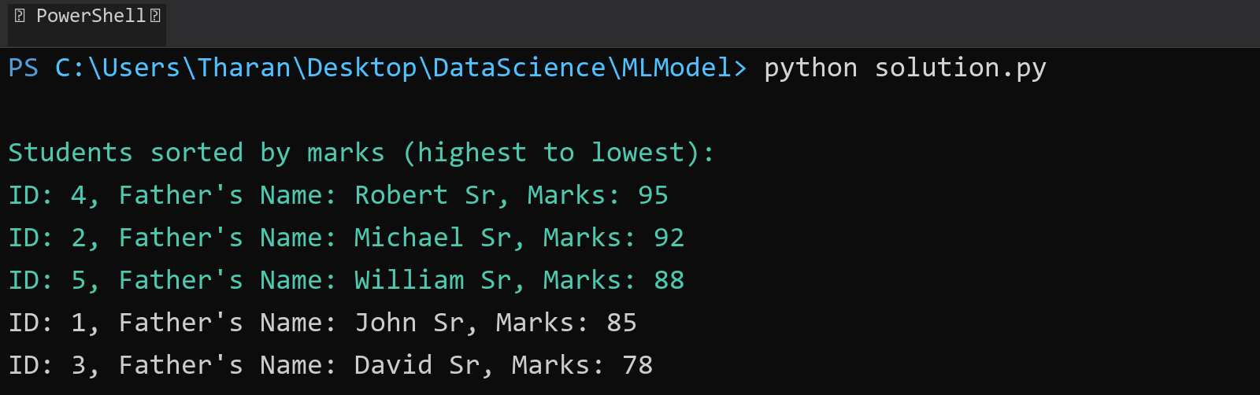

## **QUESTION 18**

18. Write a program to count the number of prime and odd numbers in a one -dimensional array.

### **Code Solution**

def is_prime(num):  
 if num < 2:  
 return False  
 for i in range(2, int(num ** 0.5) + 1):  
 if num % i == 0:  
 return False  
 return True  
  
def is_odd(num):  
 return num % 2 != 0  
  
array = [1, 2, 3, 4, 5, 6, 7, 8, 9, 10, 11, 13, 15, 17, 19]  
  
prime_count = sum(1 for num in array if is_prime(num))  
odd_count = sum(1 for num in array if is_odd(num))  
  
print(f"Number of prime numbers: {prime_count}")  
print(f"Number of odd numbers: {odd_count}")

### **FINAL Output**

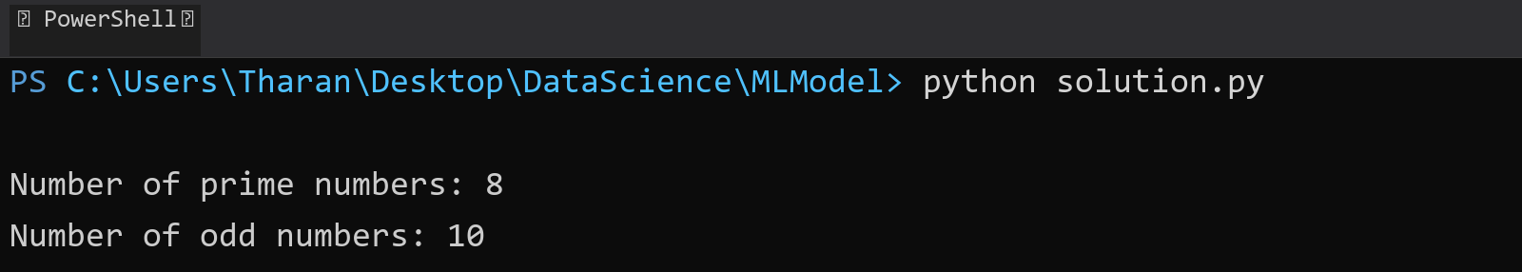

## **QUESTION 19**

19. Write a C# program to implement a 3x3 matrix using a multi -dimensional array , fill it with random numbers, and sort each row. Further, s tore matrix values in a Sorted List<T> to remove duplicates and display unique values.

### **Code Solution**

import random  
import numpy as np  
  
matrix = np.random.randint(1, 50, size=(3, 3))  
  
for i in range(3):  
 matrix[i].sort()  
  
unique_values = list(set(matrix.flatten()))  
unique_values.sort()  
  
print("Original Matrix with sorted rows:")  
print(matrix)  
print("\nUnique values in sorted order:")  
print(unique_values)

### **FINAL Output**

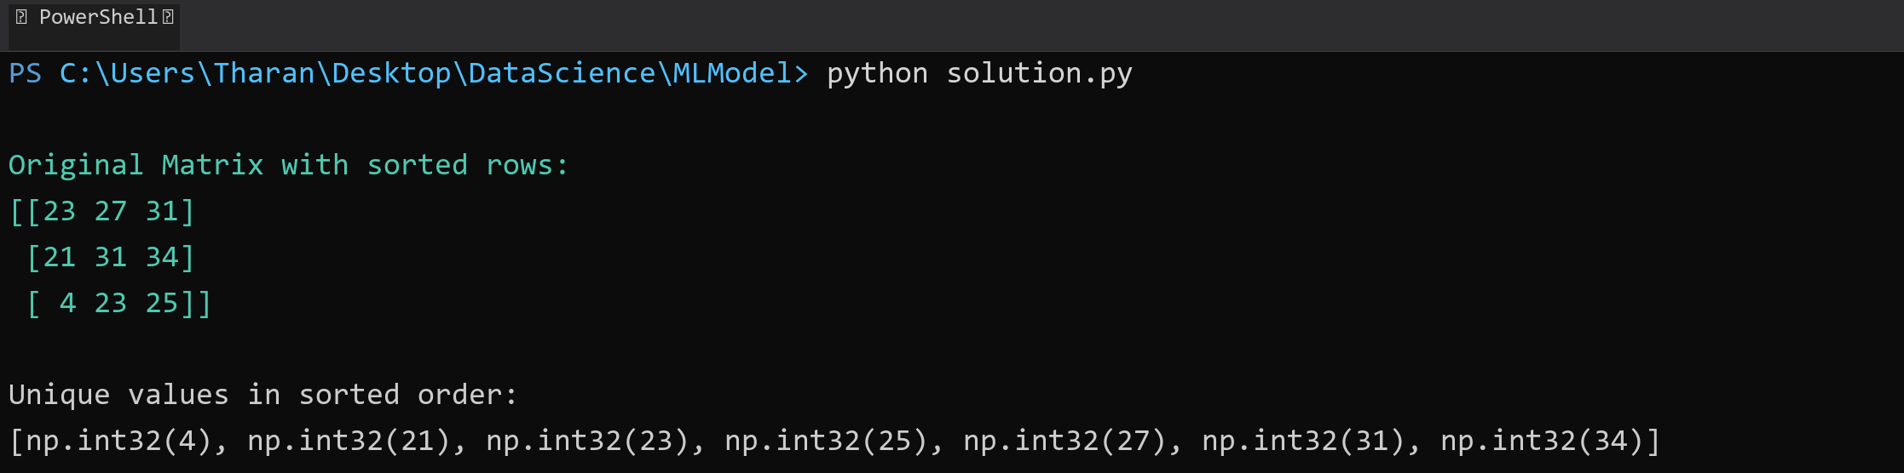

## **QUESTION 20**

20. Write a C# program to implement a program that reads an array of filenames and searches for a specific file in the system. Further, s tore valid file names in a Directory collection and allow the user to retrieve details about a specific file.

### **Code Solution**

import os  
from collections import defaultdict  
  
file_list = ["example1.txt", "example2.doc", "example3.pdf", "test.txt", "sample.jpg"]  
search_file = "test.txt"  
file_directory = defaultdict(dict)  
  
for filename in file_list:  
 if os.path.exists(filename):  
 file_stats = os.stat(filename)  
 file_directory[filename] = {  
 "size": file_stats.st_size,  
 "created": file_stats.st_ctime,  
 "modified": file_stats.st_mtime,  
 "path": os.path.abspath(filename)  
 }  
  
if search_file in file_directory:  
 print(f"File found: {search_file}")  
 print(f"Details:")  
 print(f"Size: {file_directory[search_file]['size']} bytes")  
 print(f"Created: {file_directory[search_file]['created']}")  
 print(f"Modified: {file_directory[search_file]['modified']}")  
 print(f"Path: {file_directory[search_file]['path']}")  
else:  
 print(f"File {search_file} not found in the system")

### **FINAL Output**

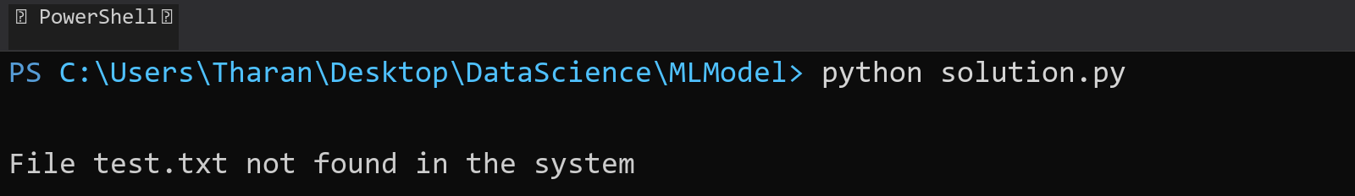

## **QUESTION 21**

21. Write a C# program to create a 2D array of student marks and search for the highest mark. Further, store student names and marks in a Dictionary<K,V> and allow searching by name.

### **Code Solution**

student_marks = [[85, 92, 78], [95, 88, 90], [75, 82, 89], [91, 87, 94]]  
  
highest_mark = float('-inf')  
for row in student_marks:  
 max_in_row = max(row)  
 if max_in_row > highest_mark:  
 highest_mark = max_in_row  
  
student_data = {  
 "John": [85, 92, 78],  
 "Alice": [95, 88, 90],  
 "Bob": [75, 82, 89],  
 "Emma": [91, 87, 94]  
}  
  
name_to_search = "Alice"  
if name_to_search in student_data:  
 marks = student_data[name_to_search]  
 print(f"Highest mark overall: {highest_mark}")  
 print(f"Marks for {name_to_search}: {marks}")  
 print(f"Highest mark for {name_to_search}: {max(marks)}")  
else:  
 print("Student not found")

### **FINAL Output**

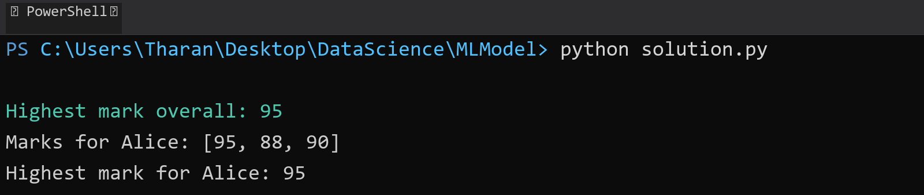

## **QUESTION 22**

22. Write a C# program to implement Binary Search in a jagged array of employee IDs. Further, s tore IDs in a Stack<T> , push/pop operations for LIFO retrieval.

### **Code Solution**

def binary_search(arr, target):  
 left = 0  
 right = len(arr) - 1  
 while left <= right:  
 mid = (left + right) // 2  
 if arr[mid] == target:  
 return mid  
 elif arr[mid] < target:  
 left = mid + 1  
 else:  
 right = mid - 1  
 return -1  
  
class Stack:  
 def __init__(self):  
 self.items = []  
   
 def push(self, item):  
 self.items.append(item)  
   
 def pop(self):  
 if not self.is_empty():  
 return self.items.pop()  
 return None  
   
 def is_empty(self):  
 return len(self.items) == 0  
  
jagged_array = [  
 [101, 102, 103],  
 [201, 202],  
 [301, 302, 303, 304],  
 [401]  
]  
  
stack = Stack()  
target_id = 302  
found = False  
  
for row in jagged_array:  
 sorted_row = sorted(row)  
 result = binary_search(sorted_row, target_id)  
 if result != -1:  
 found = True  
 for id in sorted_row:  
 stack.push(id)  
  
print("Search result for ID", target_id, ":", "Found" if found else "Not Found")  
print("Stack contents (LIFO):")  
while not stack.is_empty():  
 print(stack.pop())

### **FINAL Output**

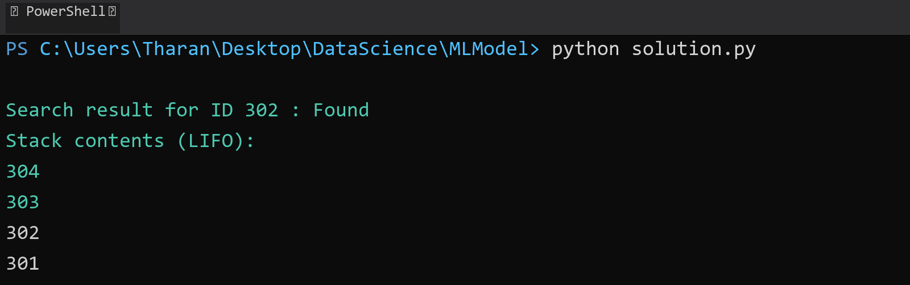

## **QUESTION 23**

23. Write a C# program to create a Product class (ID, Name, Price) and store o bjects in an array by price. Further, u se a Queue<T> to manage product processing (FIFO order).

### **Code Solution**

class Product:  
 def __init__(self, id, name, price):  
 self.id = id  
 self.name = name  
 self.price = price  
  
class Queue:  
 def __init__(self):  
 self.items = []  
  
 def enqueue(self, item):  
 self.items.append(item)  
  
 def dequeue(self):  
 if not self.is_empty():  
 return self.items.pop(0)  
 return None  
  
 def is_empty(self):  
 return len(self.items) == 0  
  
products = [  
 Product(1, "Laptop", 1200),  
 Product(2, "Phone", 800),  
 Product(3, "Tablet", 500),  
 Product(4, "Watch", 300),  
 Product(5, "Headphones", 150)  
]  
  
sorted_products = sorted(products, key=lambda x: x.price)  
  
product_queue = Queue()  
for product in sorted_products:  
 product_queue.enqueue(product)  
  
print("Products processed in FIFO order (sorted by price):")  
while not product_queue.is_empty():  
 product = product_queue.dequeue()  
 print(f"ID: {product.id}, Name: {product.name}, Price: ${product.price}")

### **FINAL Output**

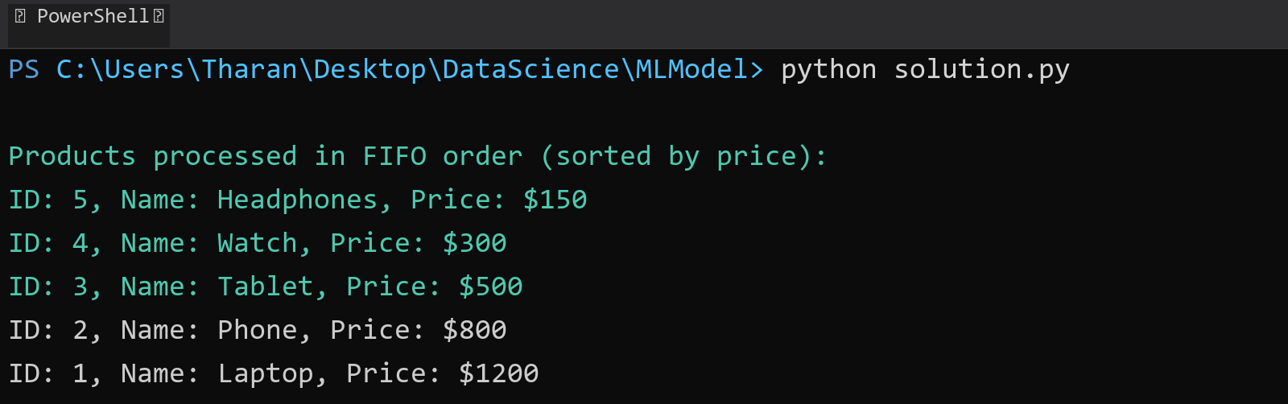

## **QUESTION 24**

24. Write a program to calculate the sum of the diagonal elements of a square matrix.

### **Code Solution**

matrix = [  
 [1, 2, 3],  
 [4, 5, 6],  
 [7, 8, 9]  
]  
  
diagonal_sum = 0  
for i in range(len(matrix)):  
 diagonal_sum += matrix[i][i]  
  
print(diagonal_sum)

### **FINAL Output**

