## **QUESTION 1**

1.Write a program to print the numbers from 1 to 50 using a for loop.

### **Code Solution**

using System;  
  
class Program  
{  
 static void Main()  
 {  
 for (int i = 1; i <= 50; i++)  
 {  
 Console.WriteLine(i);  
 }  
 }  
}

### **FINAL Output**

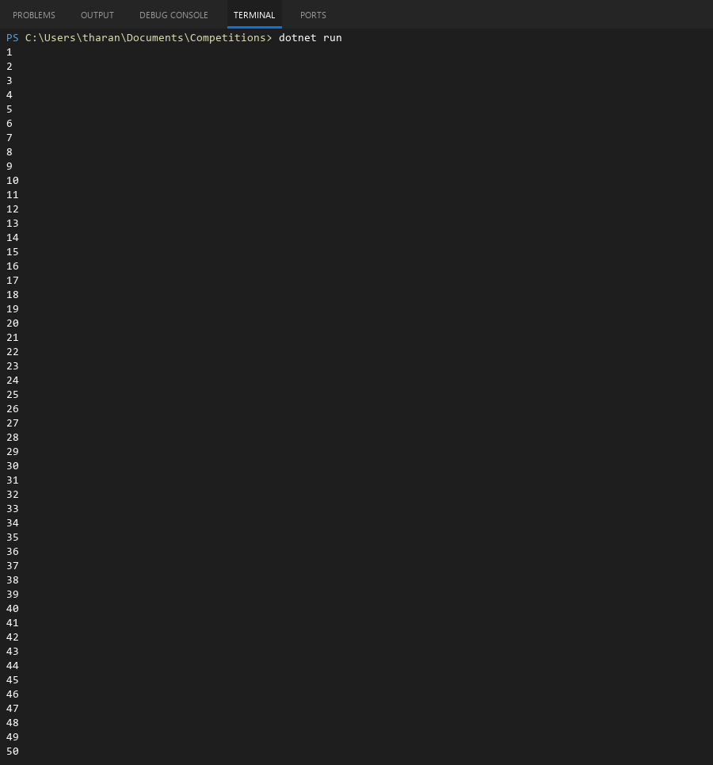

## **QUESTION 2**

2.Write a program that takes an integer as input and checks if it is even or odd.

### **Code Solution**

using System;  
  
class Program  
{  
 static void Main()  
 {  
 int number = 6;  
 if (number % 2 == 0)  
 {  
 Console.WriteLine("Even");  
 }  
 else  
 {  
 Console.WriteLine("Odd");  
 }  
 }  
}

### **FINAL Output**



## **QUESTION 3**

3.Create a program that prints a right -angled triangle pattern of * with a height of 5.

### **Code Solution**

using System;  
  
class Program  
{  
 static void Main()  
 {  
 int height = 5;  
 for (int i = 1; i <= height; i++)  
 {  
 for (int j = 1; j <= i; j++)  
 {  
 Console.Write("*");  
 }  
 Console.WriteLine();  
 }  
 }  
}

### **FINAL Output**

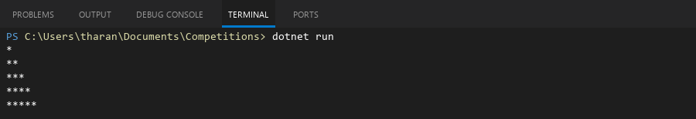

## **QUESTION 4**

4.Write a program that takes a number (1 -7) as input and prints the corresponding day of the week using a switch statement.

### **Code Solution**

using System;  
  
class Program  
{  
 static void Main()  
 {  
 int dayNumber = 4;  
 string dayName;  
 switch (dayNumber)  
 {  
 case 1:  
 dayName = "Monday";  
 break;  
 case 2:  
 dayName = "Tuesday";  
 break;  
 case 3:  
 dayName = "Wednesday";  
 break;  
 case 4:  
 dayName = "Thursday";  
 break;  
 case 5:  
 dayName = "Friday";  
 break;  
 case 6:  
 dayName = "Saturday";  
 break;  
 case 7:  
 dayName = "Sunday";  
 break;  
 default:  
 dayName = "Invalid day";  
 break;  
 }  
 Console.WriteLine(dayName);  
 }  
}

### **FINAL Output**



## **QUESTION 5**

5.Write a program to calculate the sum of all numbers from 1 to n using a while loop.

### **Code Solution**

using System;  
  
class Program  
{  
 static void Main()  
 {  
 int n = 10;  
 int sum = 0;  
 int i = 1;  
   
 while (i <= n)  
 {  
 sum += i;  
 i++;  
 }  
   
 Console.WriteLine("The sum of numbers from 1 to " + n + " is: " + sum);  
 }  
}

### **FINAL Output**



## **QUESTION 6**

6.Write a program to check if a given number is prime or not using a for loop and if conditions.

### **Code Solution**

using System;  
  
class Program  
{  
 static void Main()  
 {  
 int number = 17;  
 bool isPrime = true;  
   
 if (number <= 1)  
 {  
 isPrime = false;  
 }  
 else  
 {  
 for (int i = 2; i <= number / 2; i++)  
 {  
 if (number % i == 0)  
 {  
 isPrime = false;  
 break;  
 }  
 }  
 }  
   
 if (isPrime)  
 {  
 Console.WriteLine(number + " is a prime number.");  
 }  
 else  
 {  
 Console.WriteLine(number + " is not a prime number.");  
 }  
 }  
}

### **FINAL Output**

